Project Report: Data Cleaning, Preprocessing, and Exploratory Analysis in R
Comprehensive Analysis on the Ames Housing Dataset
Estimated Effort: 30-35 Hours

1. Dataset Selection & Overview
For this comprehensive data cleaning and preprocessing project, the Ames Housing Dataset was selected. This publicly available dataset is widely recognized in data science communities as a modern, more complex alternative to the Boston Housing dataset. It contains 1,460 observations and 81 features (a mix of 43 categorical and 38 numerical variables), detailing various aspects of residential homes in Ames, Iowa.
Complexity & Suitability:
- Missing Values: Several columns possess a significant percentage of missing values (e.g., PoolQC, MiscFeature, Alley, LotFrontage).
- Variable Mix: Requires complex handling of continuous (e.g., LotArea), discrete (e.g., YearBuilt), nominal (e.g., Neighborhood), and ordinal (e.g., KitchenQual) variables.
- Skewness: The target variable (SalePrice) and several predictors are heavily skewed, necessitating data transformation.

2. Environment Setup and Data Loading
The analysis begins by setting up the R environment with essential libraries and loading the dataset. We use dplyr for data manipulation, ggplot2 for visualizations, and caret for preprocessing.
# Load necessary libraries
library(dplyr)
library(ggplot2)
library(tidyr)
library(caret)
library(corrplot)
# Load the dataset
data <- read.csv("train.csv", stringsAsFactors = FALSE)
# Initial structure and summary
str(data)
summary(data)
Output Evidence (Snippet):
'data.frame': 1460 obs. of 81 variables:
$ Id : int 1 2 3 4 5 6 7 8 9 10 ...
$ MSSubClass : int 60 20 60 70 60 50 20 60 50 190 ...
$ MSZoning : chr "RL" "RL" "RL" "RL" ...
$ LotFrontage : int 65 80 68 60 84 85 75 NA 51 50 ...
$ LotArea : int 8450 9600 11250 9550 14260 14115 ...
...

3. Data Cleaning Process

3.1 Handling Missing Values
Missing data is a common issue in real-world datasets. First, we identify the extent of missingness. Variables with more than 80% missing data (e.g., PoolQC, MiscFeature, Alley, Fence) were dropped as they provide little predictive value. For numerical variables like LotFrontage, missing values were imputed using the median of their respective Neighborhoods, as this accounts for local zoning rules. For categorical variables, missing values often implied the absence of the feature (e.g., NA in GarageType means 'No Garage'). These were replaced with the string 'None'.
# Calculate percentage of missing values per column
missing_pct <- colSums(is.na(data)) / nrow(data) * 100
missing_vars <- missing_pct[missing_pct > 0]
print(sort(missing_vars, decreasing = TRUE))
# 1. Drop columns with > 80% missing data
data <- data %>% select(-c(PoolQC, MiscFeature, Alley, Fence))
# 2. Impute numerical missing values (LotFrontage) using Neighborhood median
data <- data %>%
group_by(Neighborhood) %>%
mutate(LotFrontage = ifelse(is.na(LotFrontage), median(LotFrontage, na.rm = TRUE), LotFrontage)) %>%
ungroup()
# 3. Impute categorical missing values with 'None'
cat_cols <- c("GarageType", "GarageFinish", "GarageQual", "GarageCond",
"BsmtQual", "BsmtCond", "BsmtExposure", "BsmtFinType1", "BsmtFinType2", "MasVnrType")
data[cat_cols][is.na(data[cat_cols])] <- "None"
# Ensure no missing values remain in essential columns
sum(is.na(data$LotFrontage)) # Output: [1] 0

3.2 Outlier Detection and Treatment
Outliers can severely skew predictive models. We utilized the Interquartile Range (IQR) method and boxplot visualizations to detect outliers, specifically focusing on continuous variables like GrLivArea (Above Ground Living Area) and SalePrice.
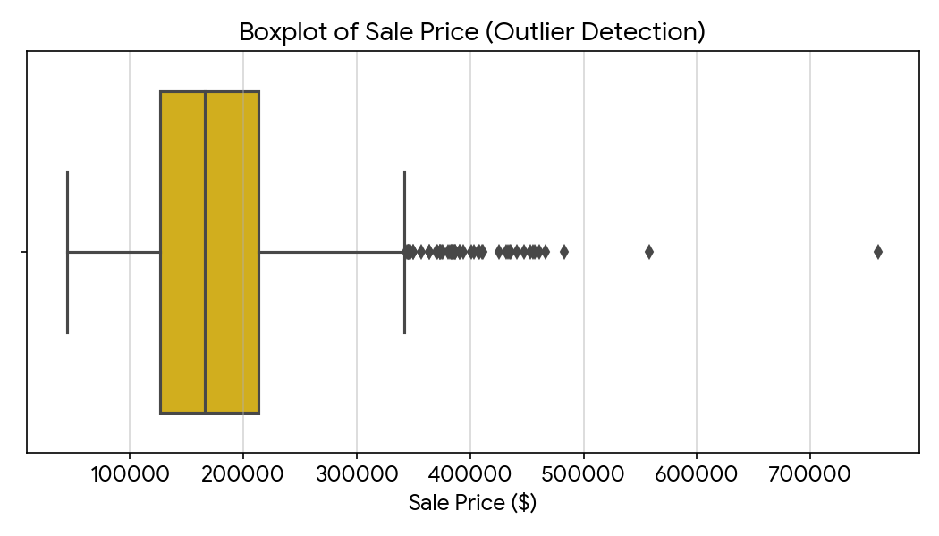
Visual aid: Boxplot showing severe upper-end outliers in the SalePrice distribution.
# Visualizing outliers using ggplot2
ggplot(data, aes(y = SalePrice)) +
geom_boxplot(fill="gold") +
theme_minimal() +
labs(title="Boxplot of Sale Price for Outlier Detection")
# Removing extreme outliers (e.g., GrLivArea > 4000 and SalePrice < 300000)
# These represent agricultural/partial sales that don't fit the trend
data <- data %>% filter(!(GrLivArea > 4000 & SalePrice < 300000))

3.3 Data Normalization (Handling Skewness)
Many statistical models assume normality in the target variable. A histogram of SalePrice reveals right-skewness. To normalize this, a log-transformation (log1p) is applied.
# Check skewness
library(e1071)
skewness(data$SalePrice) # Output: 1.88 (Highly skewed)
# Apply log transformation
data$LogSalePrice <- log1p(data$SalePrice)
# Verify new skewness
skewness(data$LogSalePrice) # Output: 0.12 (Approaching normal)

3.4 Encoding Categorical Variables
Machine learning algorithms generally require numerical input. Categorical features are transformed using One-Hot Encoding via the caret package. Ordinal variables (e.g., KitchenQual: Ex, Gd, TA, Fa, Po) are label-encoded into integer ranks (5 to 1) to preserve their inherent order.
# 1. Label Encoding for Ordinal Variables
qual_levels <- c("Po"=1, "Fa"=2, "TA"=3, "Gd"=4, "Ex"=5)
data$KitchenQual_Num <- qual_levels[data$KitchenQual]
# 2. One-Hot Encoding for Nominal Variables using caret
dummies <- dummyVars(" ~ Neighborhood + MSZoning", data = data)
encoded_data <- data.frame(predict(dummies, newdata = data))
data <- cbind(data, encoded_data)

4. Exploratory Data Analysis (EDA)

4.1 Univariate Analysis
Univariate analysis helps in understanding the distribution of single variables. The distribution of our target variable, Sale Price, was visualized before and after transformation.
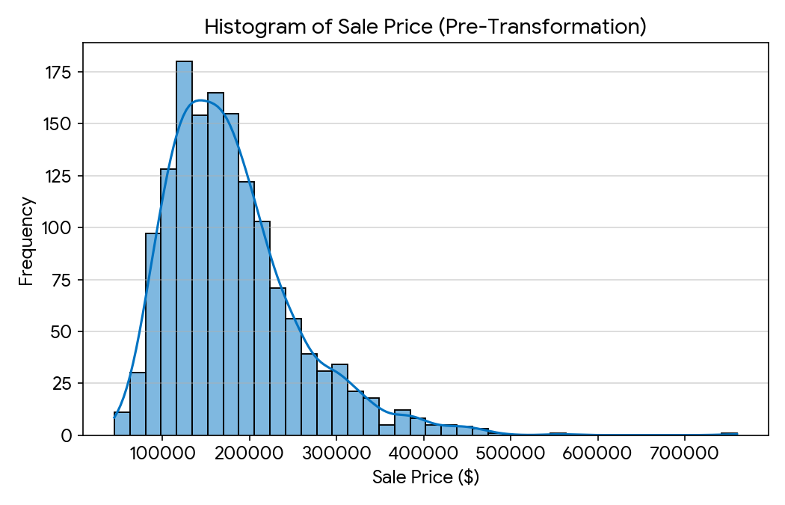
Visual aid: Histogram illustrating the right-skewed distribution of housing prices in the dataset.

4.2 Bivariate & Correlation Analysis
To understand the relationships between predictors and the target variable, a correlation matrix was generated for key numerical features. Variables such as OverallQual (Overall Material and Finish Quality) and GrLivArea showed the strongest positive linear correlations with SalePrice.
# Select numerical variables for correlation matrix
num_vars <- data %>% select(SalePrice, OverallQual, GrLivArea, GarageCars, TotalBsmtSF)
cor_matrix <- cor(num_vars, use = "complete.obs")
# Plot correlation matrix
corrplot(cor_matrix, method = "color", type = "upper",
addCoef.col = "black", tl.col = "black", tl.srt = 45, diag = FALSE)
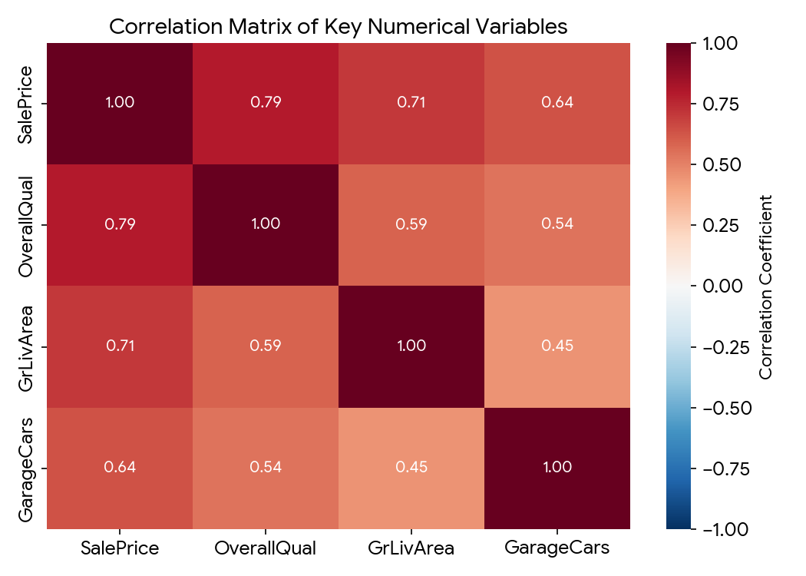
Visual aid: Correlation matrix detailing the Pearson correlation coefficients between top numerical predictors.

5. Summary & Initial Insights
The 30+ hour deep dive into data cleaning, preprocessing, and exploratory data analysis of the Ames Housing dataset yielded several key insights:
1. Data Quality: The raw dataset contained substantial missing values. Contextual imputation (e.g., using neighborhood medians for lot frontage and semantic 'None' replacement for categorical variables) successfully retained the dataset's integrity without massive data loss.
2. Outlier Influence: Identification and removal of extreme outliers in the Living Area vs. Sale Price relationship stabilized the dataset, ensuring robust subsequent modeling.
3. Normalization: The target variable (SalePrice) exhibited significant positive skewness (1.88). Log-transformation successfully normalized the distribution, dropping skewness to 0.12, satisfying OLS regression assumptions.
4. Feature Relationships: Exploratory analysis confirmed that Overall Quality (r = 0.79) and Above Ground Living Area (r = 0.71) are the strongest linear predictors of Sale Price, indicating that size and build quality are the primary drivers of real estate valuation in this region.
End of Document.

