HEXA CARE HOSPITALS
Work Flow:
The following describes the normal workflow our application.
Main page:
This is our home page which provides four options like our Doctors, our specializations, your appointments and Book your appointments.
URL: localhost: 8082/hexacare/main or localhost: 8082/hexacare/

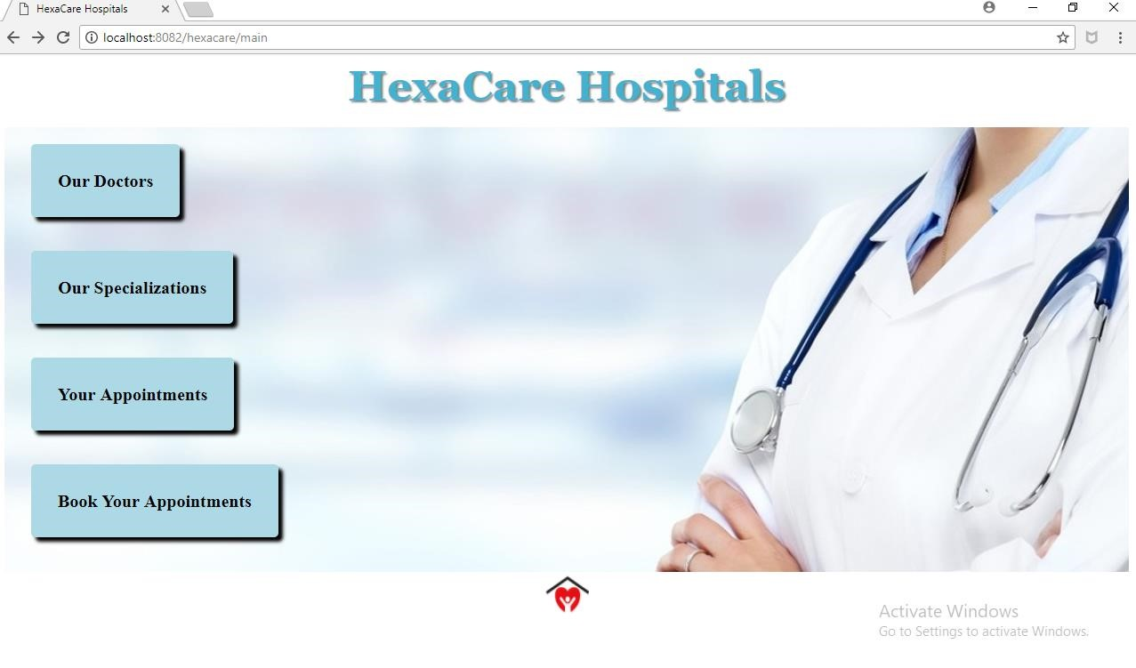
View Doctors
To view Doctors click on our Doctors in the main page which intern calls the respective controller method and displays the doctor details such as Doctor ID, Doctor Name, Doctor Email, Doctor Contact number and Specialization with the respective Jsp file.
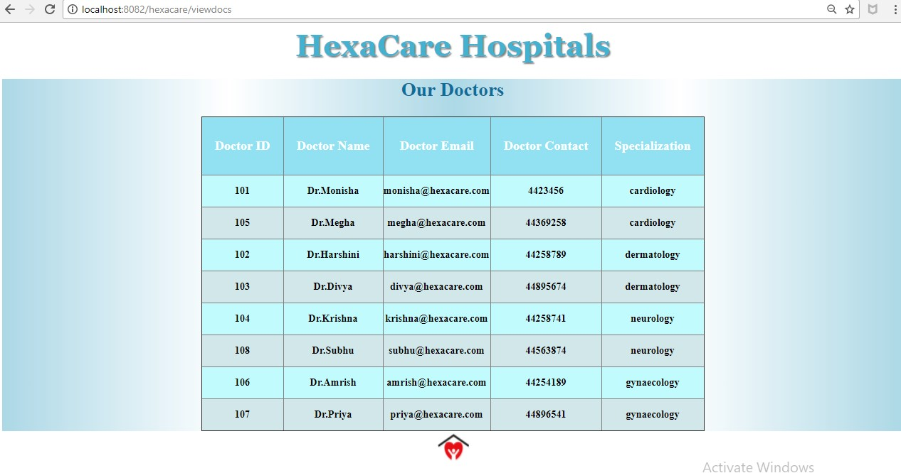
View Specializations:
To view Specialization click on our Specialization in the main page which intern calls the respective controller method and displays the Specialization details such as Specialization ID, Specialization Name with the respective Jsp file.
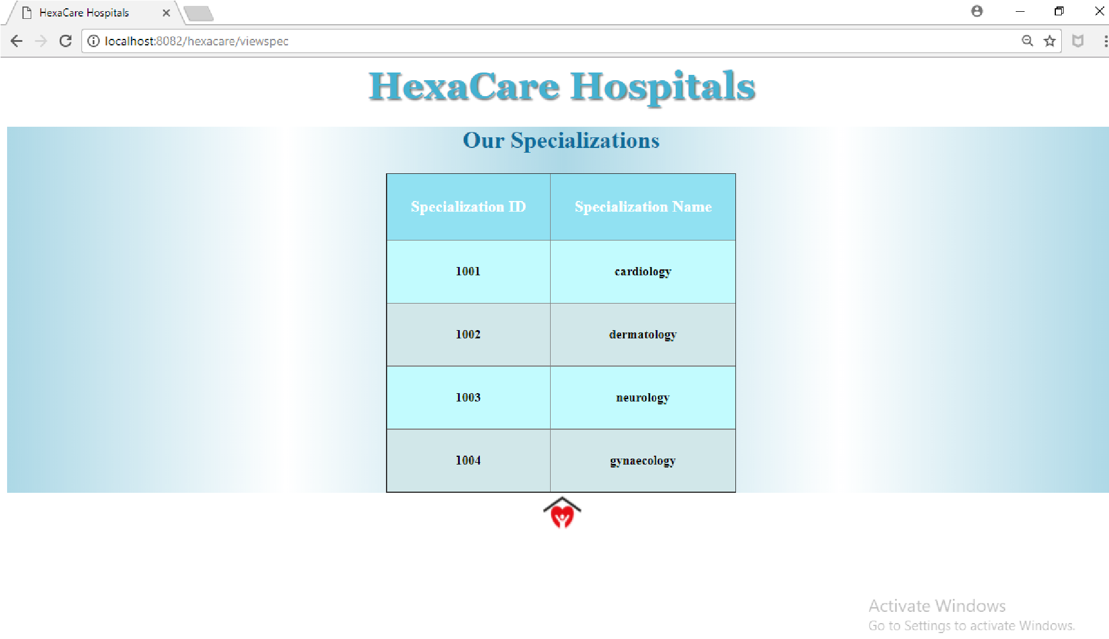
Check patient appointment:
To view the patient’s appointment details, click on the Your appointments in the main page which navigates to another page asking for contact number of the patient.
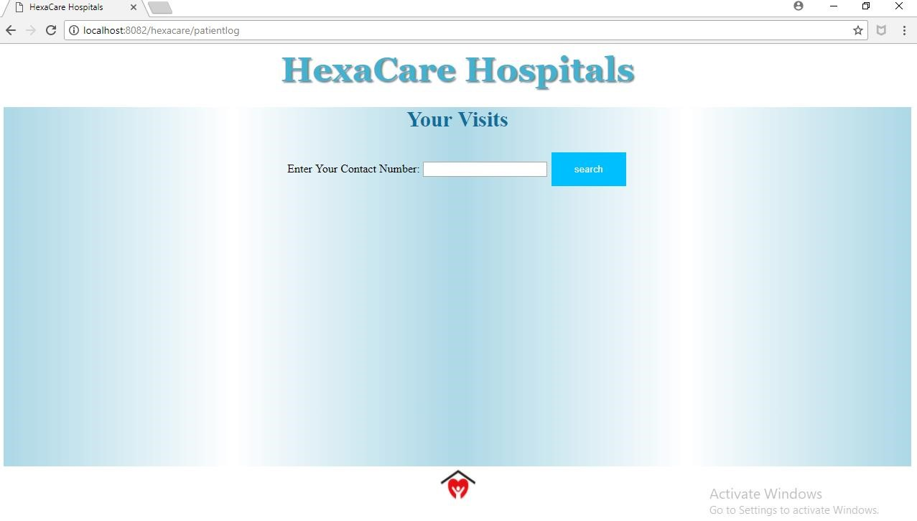
If no contact is entered or if the contact is entered in invalid format then the below alert will be displayed for the user.
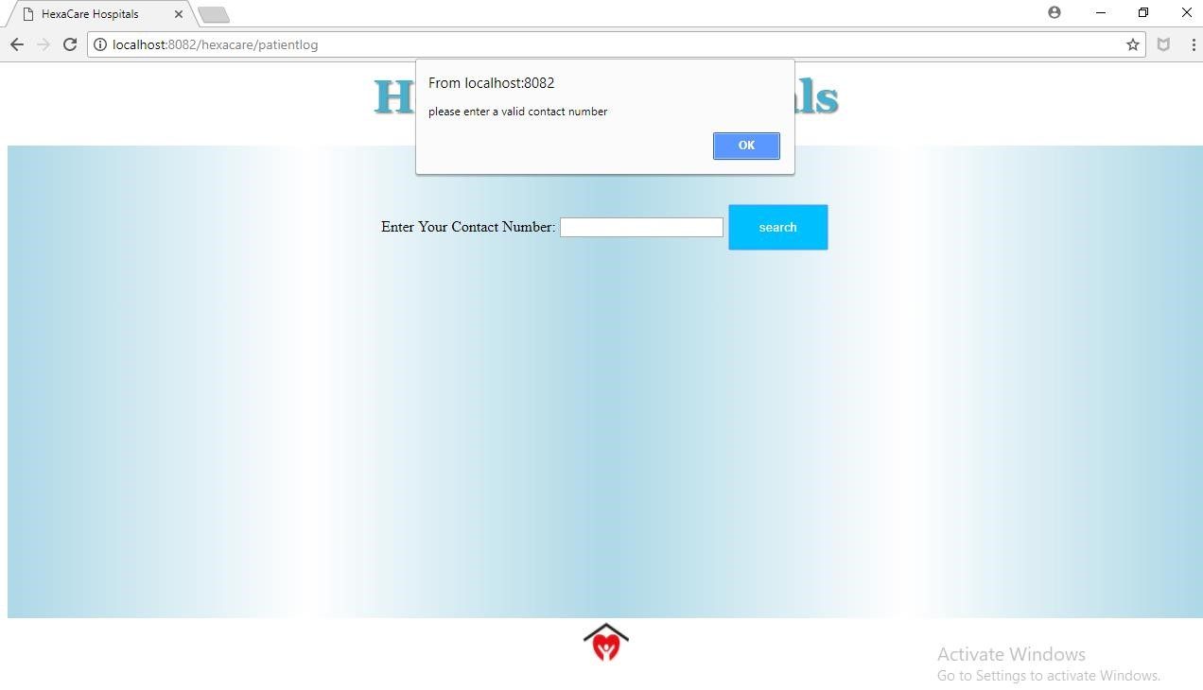
If the contact number has no related appointment then the following page will be displayed.
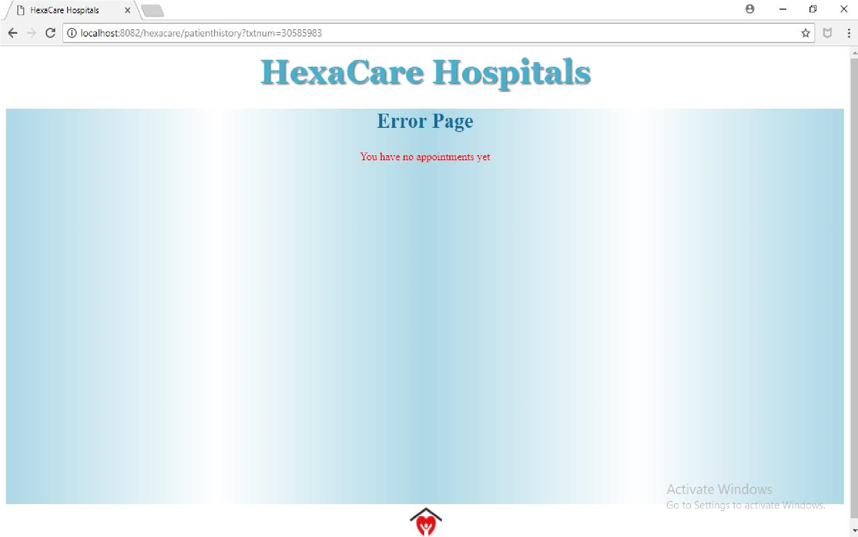

If the contact number has an appointment history then the respective controller method is called and the required details such as appointment id, patient name, patient contact number, doctor name, specialization and appointment date is displayed for the user.

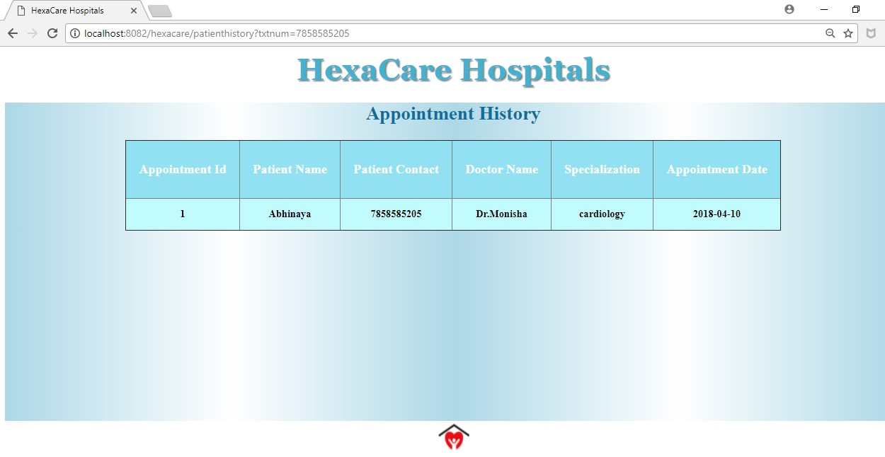

Booking an appointment:
If the user wants to book an appointment then click on the Book your appointments in the main page which takes the user to the booking form which contains patient name, patient contact number, specialization, Doctor and Available dates in the doctor is available.
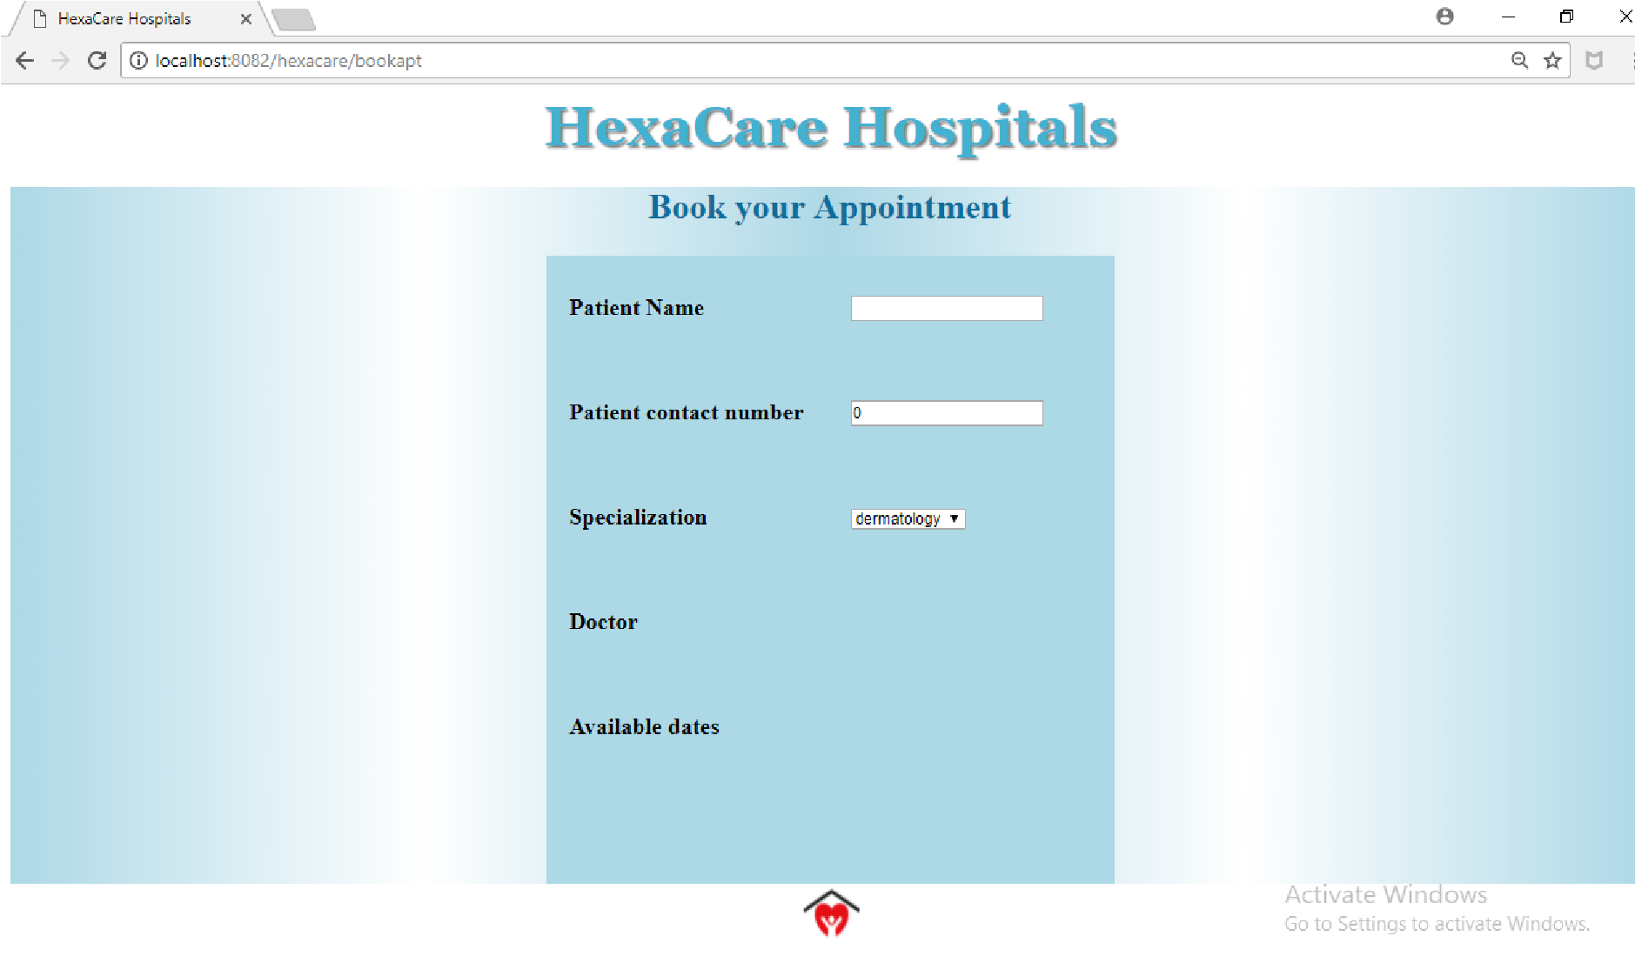
Filling all details then only submit button will appear:
If all the details are properly filled then only the confirm button will be available for the user to book the appointments.
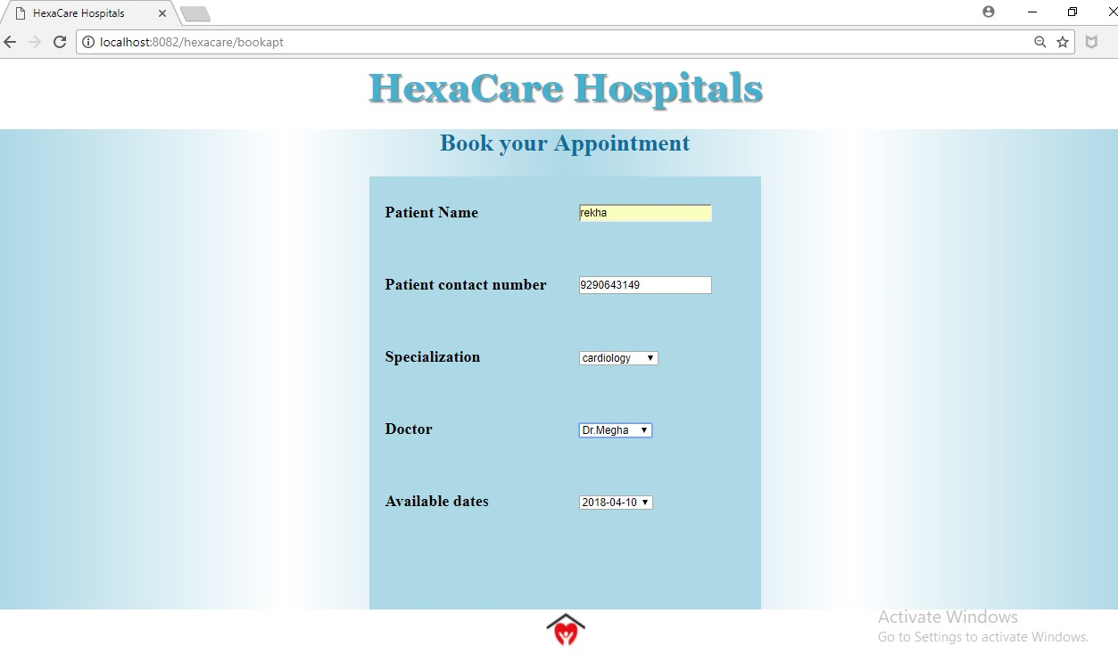
If all the input are fine and given in correct way then after pressing confirm button the following is displayed on main page confirming the appointment with user preferred doctor and dates.



If proper and required inputs are not given then the appointment will not be booked guiding user how to give the inputs.

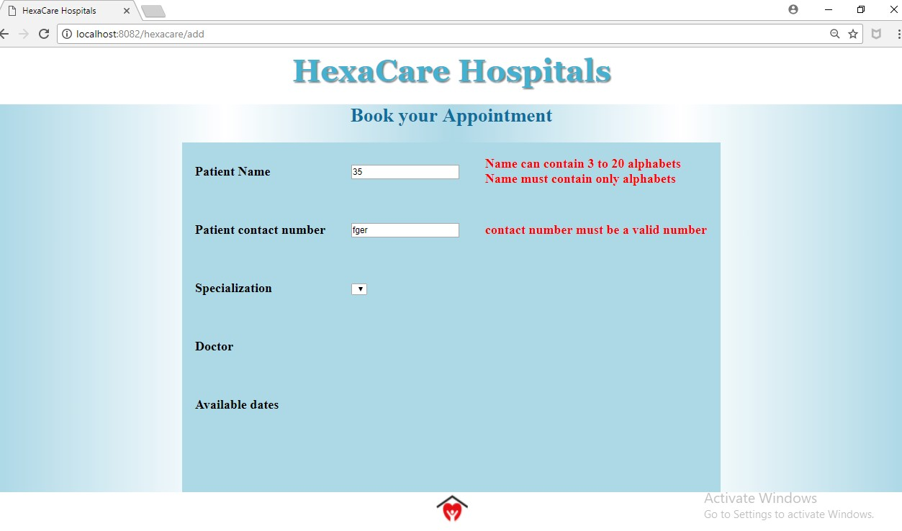

If the doctor’s appointments are already booked then the user is specified with the following message.


