|  |  |  |  |  |  |  |  |  |
| --- | --- | --- | --- | --- | --- | --- | --- | --- |
|  |  | |  | | |  |  | |
|  |  | |  | | |  |  | |
|  | | | | | | | | |
| http://4.bp.blogspot.com/-SotLIkzmscA/UqQLE9BjdPI/AAAAAAAAARc/-SF46qFfVE0/s1600/daffodil-international-university-logo.png  Object Oriented Software Development  SWE331 | | | | | | | | |
|  | | | | | | | | |
| Employment Application Review System | | | | | | | | |
|  | | NAME: Md.Alamgir Hossain | |  | ID:151-35-920 | | |  |
| Supervisor Name | | ： | Md. Alamgir Kabir | | |
| Department: | | ： | Software Engineering | | |
| Faculty of Science and Information Technology | | | | | |
|  | |  |  | | |
| December 2017 | | | | | | | | |

**Final Approval**

A dissertation submitted to the Department of Software Engineering, Daffodil International University in partial fulfillment of the requirement for the Object Oriented Software Development of Bachelor of Science in Software Engineering.

**Dedication**

Heroes of 1971

**Acknowledgement**

Professor S. Xu

Md. Alamgir Kabir

**Project in Brief**

Project Title: Employment Application Review System

**Undertaken by:**

Name: Md. Alamgir Hossain

ID: 151-35-920

**Supervised by:**

Md. Alamgir Kabir

Lecturer

Department of Software Engineering

Daffodil International University

Date Started: October 2017

Date Completed: December 2017

Operating System: Microsoft

**Abstract**

Table of Contents

Chapter 1 2

1. Introduction 3

1.1 About the System 3

1.2 Purpose 3

1.3 Scope 3

1.4 Vision 3

1.5 Why this system is necessary? 3

1.6 Proposed Solution 3

Chapter 2 4

2. System Analysis 5

2.1 Use Case Model 5

2.2 Actor Goal List 6

2.3 Use Case Description (Brief) 7

2.3.1 Manage Users 7

2.3.2 Review Applicants 8

2.3.3 List Applicants 9

2.3.4 Set Account 10

2.3.5 Apply Job 11

2.4 Use Case Description (Detailed) 12

2.4.1 Manage Users 12

2.4.2 Review Applicants 13

2.4.3 List Applicants 14

2.4.4 Set Account 15

2.4.5 Apply Job 16

2.5 System Sequence Diagrams 17

2.5.1 Manage Users 17

2.5.2 Review Applicants 18

2.5.3 List Applicants 19

2.5.4 Set Account 20

2.5.5 Apply Job 21

2.6 Domain/Conceptual Model 22

2.7 Activity diagram 23

Chapter 3 24

3. System Design 25

3.1 Sequence Diagrams 25

3.1.1 Set Account, Manage User 26

3.1.2 List Application, Review Applicant, Set Account 27

3.1.3 Apply Job, Set Account 28

3.2 Class Diagram 29

3.3 Entity Relationship Diagram 30

Chapter 4 31

4. Implementation 32

4.1 Tools &Technologies 32

4.2 Project Link 32

Chapter 6 33

5. Conclusion 34

5.1 Good Features of the System 34

5.2 Limitations of the System 34

5.3 Future Enhancements 34

Figure 1 Use Case Model 5

Figure 2 Use Case for Manage User 7

Figure 3 Use Case for Review Applicants 8

Figure 4 Use Case for List Applicants 9

Figure 5 Use Case for Set Account 10

Figure 6 Use Case for Apply Job 11

Figure 7 SSD for Manage User 17

Figure 8 SSD for Review Applicants 18

Figure 9 SSD for List Applicants 19

Figure 10 SSD for Set Account 20

Figure 11 SSD for Apply Job 21

Figure 12 Domain Model for EARS 22

Figure 13 Activity Diagram for EARS 23

Figure 14 SD for Admin 26

Figure 15 SD for Faculty 27

Figure 16 SD for Applicants 28

Figure 17 Class Diagram for EARS 29

Figure 18 ER Diagram for Ears 30

**Chapter 1**

Introduction

# Introduction

## About the System

EARS is an intranet-based Employment Application Review System. The system is designed so that school faculty members can review applicants and collaborate asynchronously in order to find the best applicant for a given job opening. This system reduces the overhead of the process and lightens the workload for the search chairperson

## Purpose

To find the best applicant for a given job opening. This system reduces the over head of the process and lightens the workload for the search chairperson

## Scope

Faculty members can review applicants and review their posts .And EARS helps to find out the best applicants.

## Vision

Make an easy and smart solution for the applicant selection.

## Why this system is necessary?

EARS is an online based system. Here applicants post their resumes and simply the faculty members review them. According to their review they can find out the best applicants. It’s an easy and smart way to find out the best applicants.

## Proposed Solution

EARS make the top reviewed applicants list in ascending order. The faculty members just review them and the list of the applicants made automatically by following the reviewed order.

# 

Chapter 2

**System Analysis**

# System Analysis

## Use Case Model

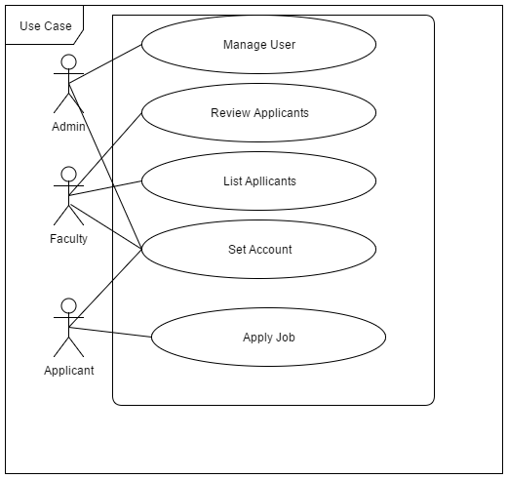

Figure Use Case Model

## Actor Goal List

|  |  |
| --- | --- |
| **Actor** | **Goal** |
| Admin | Manage Users |
| Applicants | Apply for Job  Manage His Own Account  See Reviews |
| Faculty | Review Applications  Manage List of Applications  Manage His Own Accounts |

## Use Case Description (Brief)

### Manage Users

An admin can add a faculty or applicants and he can delete their account. He can update faculty information and applicant’s information.

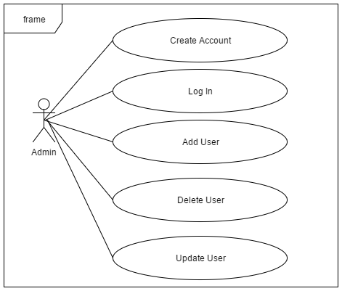

Figure Use Case for Manage User

### Review Applicants

Here faculty review the applicant’s posts according to their posts. Faculty selects their desired applicants by reviewing their posts.

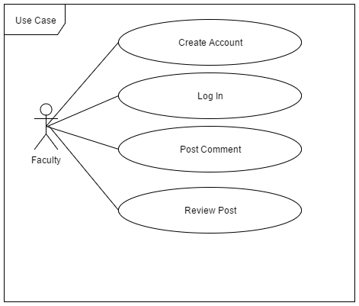

Figure Use Case for Review Applicants

### List Applicants

According to faculty review they make list of the applicants. And the list made by the given reviews.

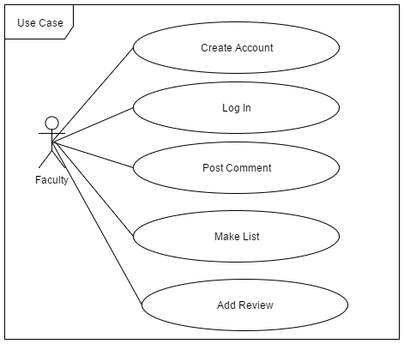

Figure Use Case for List Applicants

### Set Account

Almost every actor of the system need to set their account .Every account need a registration for accessing their account .After completing their registration all three account have a login access. Remember that one email can register an account. All three actor have an individual email account by the authority.

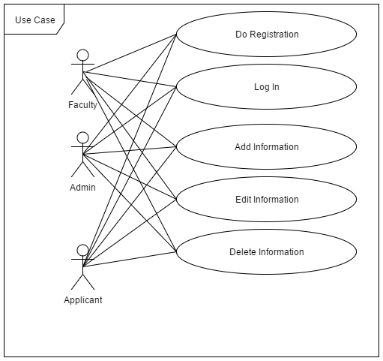

Figure Use Case for Set Account

### Apply Job

This use case for the applicant’s only .An applicant’s needs to drop his cv’s. So by this he can drop his post mentioned as cv. Applicant post are reviewed by the faculty. Applicant see their posts status. And he can the reviews.

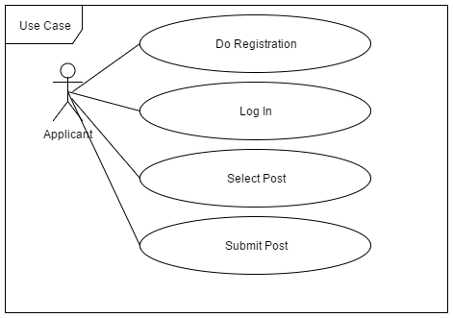

Figure Use Case for Apply Job

## Use Case Description (Detailed)

### Manage Users

|  |  |
| --- | --- |
| **Topics** | **Details** |
| ID | 1 |
| Name | Manage Users |
| Primary Actor | Admin |
| Secondary Actor | User |
| Goal | Admin manages the user |
| Pre-Condition | Every user must need a valid id, password and authorized from authority |
| Post Condition | Admin allowed users for next steps like posting and reviewing |
| Main Success Scenario | * 1. User needs a verified account   2. Admin collect the database and sent to the authority   3. Admin can’t edit update to every option. Only for specific fields   4. If some change occurred ,user must be notified |
| Scenario Extension | * 1. User input invalid id or password   2. Admin allows something without authority permission   3.1 Admin change some confidential data of the user  4.1 User not notified about his update |

### Review Applicants

|  |  |
| --- | --- |
| **Topics** | **Details** |
| ID | 2 |
| Name | Review Applicants |
| Primary Actor | Faculty |
| Secondary Actor | User |
| Goal | Manage the user |
| Pre-Condition | Applicant post their applications |
| Post Condition | Have a status after faculty review |
| Main Success Scenario | * + 1. Faculty Login their account     2. View applicants profile for review     3. Post comments on applicants post and review him     4. Update applicants status |
| Scenario Extension | * 1. Failed to login the system   2. Not a valid faculty account   3. System failure so they can’t view applicants profile   4. Faculty not post a comment   5. Comment posted but status not updated |

### List Applicants

|  |  |
| --- | --- |
| **Topics** | **Details** |
| ID | 3 |
| Name | List Applicants |
| Primary Actor | Admin |
| Secondary Actor | Applicant |
| Goal | Admin made a list of the applicants |
| Pre-Condition | Application should submitted |
| Post Condition | List are made for the applicants |
| Main Success Scenario | * + 1. Applicants post their applications     2. Faculty comments are posted     3. Review confirm     4. List of the eligible applicants are made |
| Scenario Extension | * 1. No application are posted   2. Invalid applications   3. Faculty not commented in the post   4. Faculty not reviewed the applications   5. Due to system failure some review are post later |

### Set Account

|  |  |
| --- | --- |
| **Topics** | **Details** |
| ID | 3 |
| Name | Set Account |
| Primary Actor | Admin |
| Secondary Actor | Admin |
| Goal | Admin will manage accounts |
| Pre-Condition | System admin must be logged in to manage the account. |
| Post Condition | Admin provide information to the authority |
| Main Success Scenario | * 1. System user must need log in   2. System admin will confirm the applicant information.   3. System admin will provide the information to the authority. |
| Scenario Extension | * 1. System user not logged in.   2. Applicant give wrong information   3.1 Admin can’t confirm information |

### Apply Job

|  |  |
| --- | --- |
| Topics | Details |
| ID | 5 |
| Name | Apply Job |
| Primary Actor | Applicant |
| Secondary Actor | Admin |
| Goal | Apply for the job |
| Pre-Condition | He should be qualified for the post. |
| Post Condition | Reviewed and see name in the list |
| Main Success Scenario | 1. Applicant should meet the requirements for the post 2. Create an account for applying the job 3. Post in proper way 4. Approved by admin |
| Scenario Extension | * 1. Requirement are not meets   2.1 Not logged in  2.1 False information input  3.1 Doesn’t post in the correct pole   * 1. Admin denied profile for not posted in proper way. |

## System Sequence Diagrams

### Manage Users

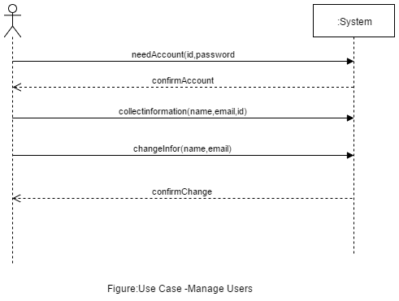

Figure SSD for Manage User

### Review Applicants

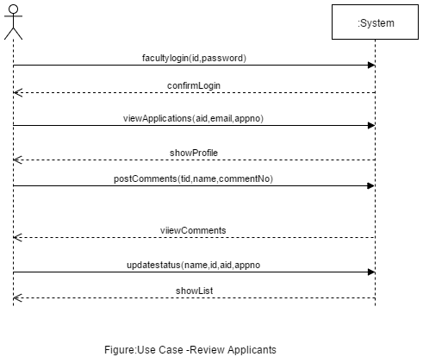

Figure SSD for Review Applicants

### List Applicants

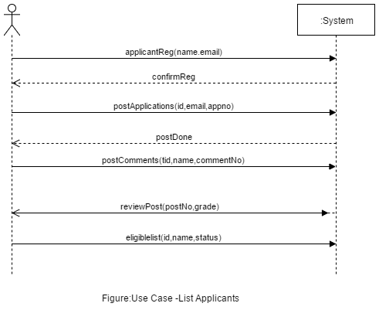

Figure SSD for List Applicants

### Set Account

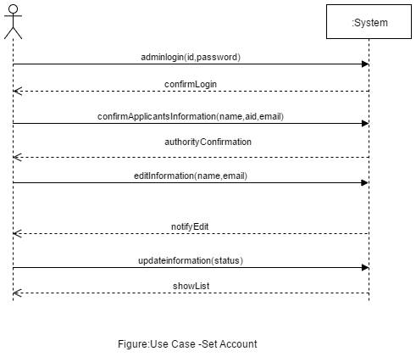

Figure SSD for Set Account

### Apply Job

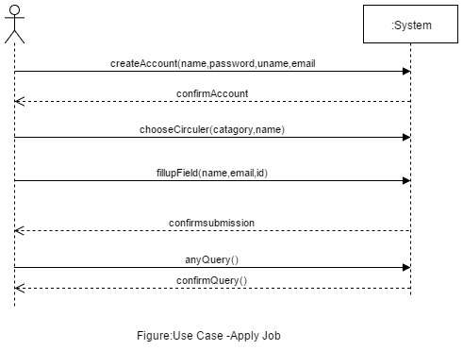

Figure SSD for Apply Job

## Domain/Conceptual Model

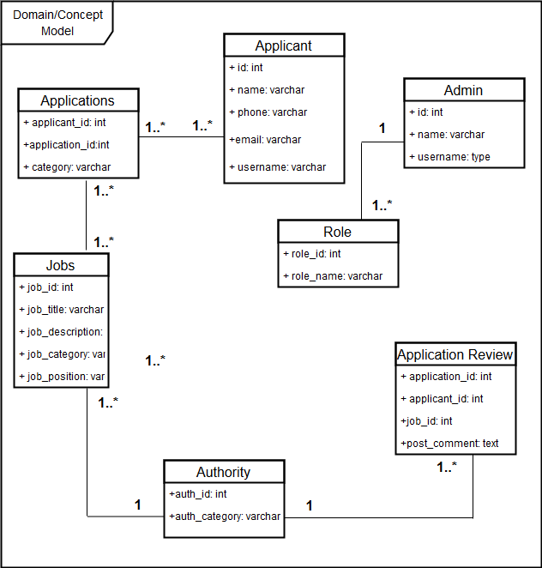

Figure Domain Model for EARS

## Activity diagram

Activity diagrams are graphical representations of workflows of stepwise activities and actions with support for choice, iteration and concurrency.

In the system workflows starts from the stage when an applications enters the area of Federal Shariat Court i.e. uploaded in the system to last activity that is a judgment comes or the case is dismissed .This whole process is shown in the below diagram.

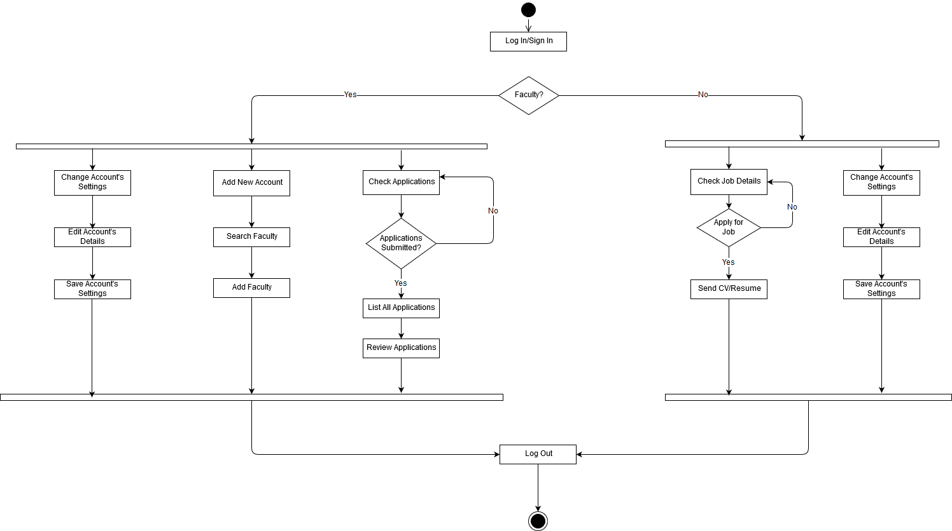

Figure Activity Diagram for EARS

Chapter 3

**System Design**

# System Design

Design is a process that uses the product of analysis to produce a specification for implementing a system. Design is the logical description of how a system will work.

Design emphasizes a conceptual solution that fulfills the requirements, rather than its implementation. For example, a description of a database schema and software objects. Design ideas often exclude low-level or "obvious" details obvious to the intended consumers. Ultimately, designs can be implemented, and the implementation (such as code) expresses the true and complete realized design. The term is best qualified, as in object-oriented design or database design.

## Sequence Diagrams

The UML includes interaction diagrams to illustrate how objects interact via messages. They are used for dynamic object modeling. The term interaction diagram is a generalization of two more specialized UML diagram types:

### Set Account, Manage User

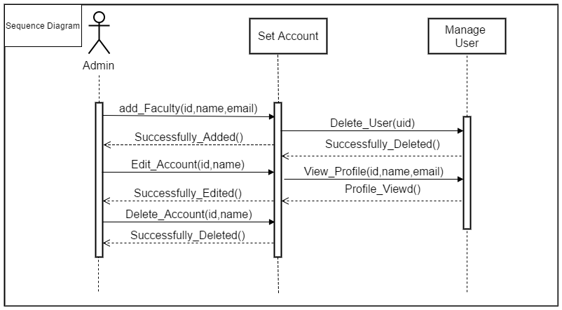

Figure SD for Admin

### List Application, Review Applicant, Set Account

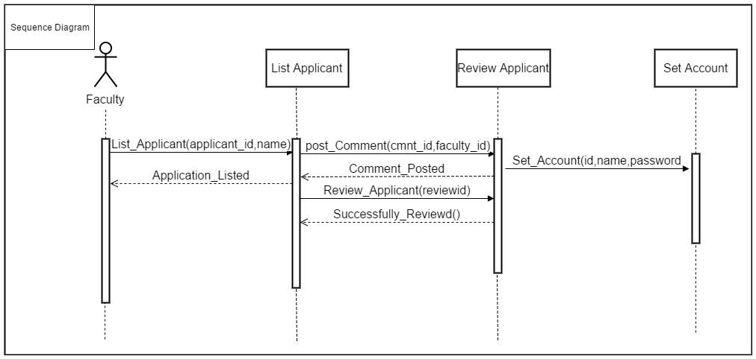

Figure SD for Faculty

### Apply Job, Set Account

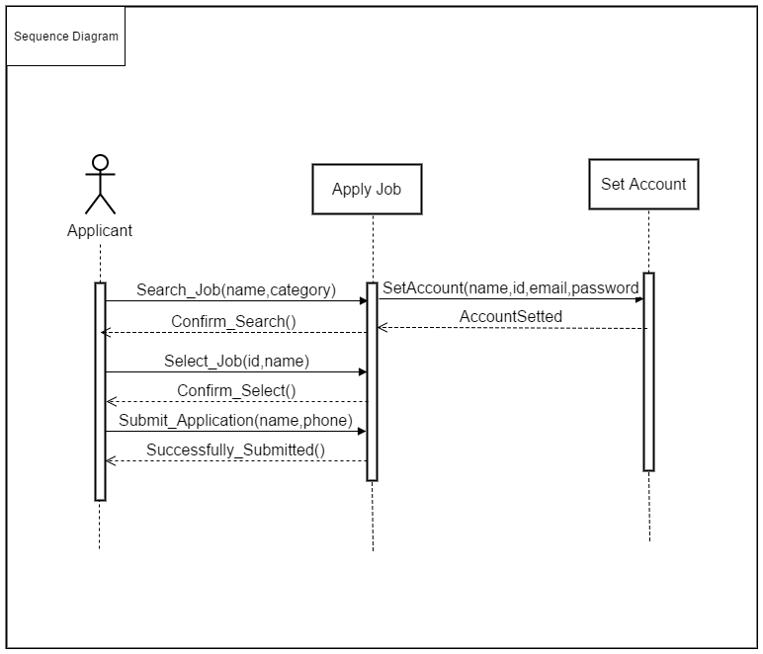

Figure SD for Applicants

## Class Diagram

Class or structural diagrams define the basic building blocks of a model. They are used for static object modeling, describing what attributes and behavior it has rather than detailing the methods for achieving operations.

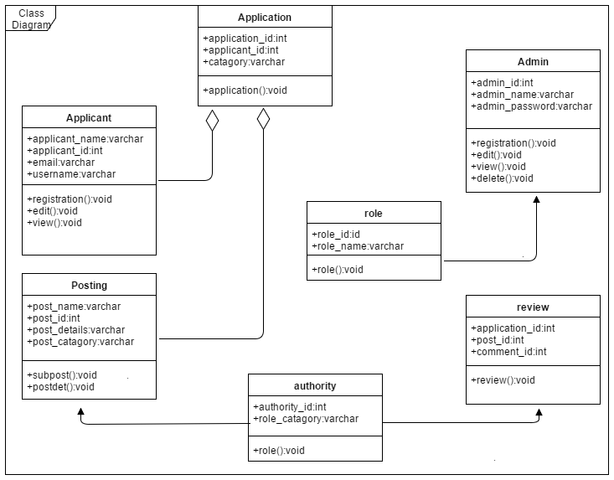

Figure Class Diagram for EARS

## Entity Relationship Diagram

An entity-relationship model is an abstract and conceptual representation of data. Entity-relationship modeling is a database modeling method, used to produce a type of conceptual schema or semantic data model of a system, often a relational database, and its requirements in a top-down fashion. Diagrams created by this process are called Entity-Relationship Diagrams.

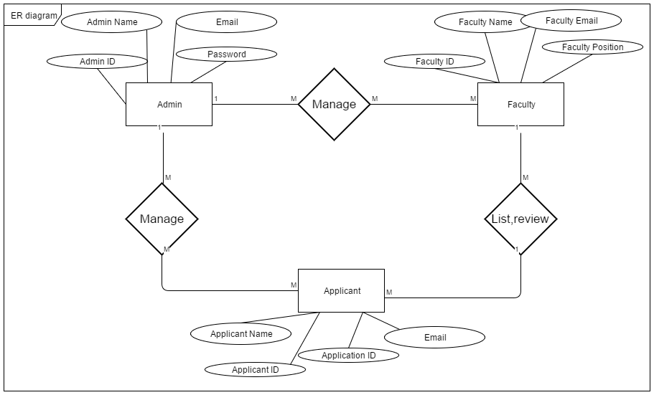

Figure ER Diagram for Ears

Chapter 4

**Implementation**

# Implementation

Implementation (software) perspective describes software implementations in a particular technology (such as C#). In the UP, Implementation means programming and building the system, not deploying it.

In the implementation phase, the developer builds the components either from scratch or by composition given the architecture document from the design phase and the requirement document from the analysis phase. The architecture document should give guidance. Sometimes, this guidance is found in the requirement document. The implementation phase deals with issues of quality, performance and debugging. The end deliverable of implementation phase is the product itself.

## Tools &Technologies

* Sublime Text
* HTML5
* CSS3
* JavaScript
* Bootstrap
* JQuery

## Project Link

They provide github repository link after uploading the project there.

Chapter 6

**Conclusion**

# Conclusion

## Good Features of the System

Employment Application Review System is for reviewing applications. Here a list of selected candidate made automatically.

## Limitations of the System

A few user can use this system.

## Future Enhancements

In future we add a feature where an email will sent to the selected applicants. It will found in android and iOS in later.

The End