clc; clear; close all;
format compact;
% Declare Numerator and Denumerator of the Impulse response
num = [1 0 0]; den = [1 -1/2 -1/2];
[h,n] = impz(num,den); % impulse response
stem(n,h,'Linewidth',2);grid on;title('Impulse Response of the fucntion');
K = SchurCohn(den); % Stability Test
function [K] = SchurCohn(A)
%%SchurCohn Test Function
L = length(A);
K = zeros(1,L);
stability = 1;
for i = 1:L
K(L-i+1)=A(end);
if abs(K(L-i+1))>1
disp('Unstabale System');
stability = 0;
break;
end
A = (A - K(L-i+1)*fliplr(A))/(1-K(L-i+1)^2);
A(end)=[];
end
if stability == 1
disp('Stable System');
end
end
Stable System
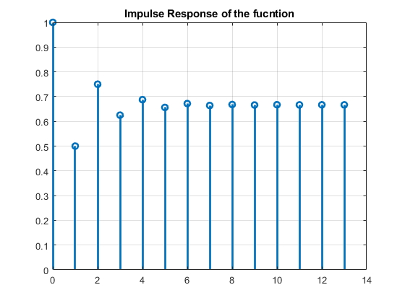
Published with MATLAB® R2021a

