Assignment for EEE 309
Submitted by –
Name: Md. Alamgir Hossain
ID: 1806186

Matlab Code:
clc; clear; close all;
format compact;
m = [.6,0.3,0.4,0.8,1.6,2.3,3,2.8,2.7,2.1,0.8,-0.7,-2,-2.5,-2.55,-2.58,-2.59,-2.7,-2.8,-2,0,1,0,-1,-1.5,-2.5];
%%Generating Analog Signal from the message signal
%%================================
ti = 0:(length(m)-1); % Initial time
t_message = ti.*0.1; % assuming sampling rate of array was 10 Hz
tc = linspace(0,t_message(end),1001); % Continuous Time
m_interp = interp1(t_message,m, tc,'spline'); % Interpolated message signal
% Sampling Analog message signal with different sample frequency
Fs = 60; % Sampling frequency in Hz
Ts = 1/Fs; % sampling period
ts = linspace(0,t_message(end),(Fs*t_message(end))+1); % Sampling time
m_sample = interp1(tc,m_interp, ts); % Sampled message signal
m = m_sample;
%%Finiding best delta
%%============================
mq = zeros(1,length(m)); % Initializing Quantized message signal
dq = mq; % Initializing Modulated signal
d = mq; % Initializing Error signal
mq(1) = 0; % Assume 1st value is 0
delta = 0:0.1:1; % Step sizes
best_delta = 0; % Initial Step size
min_mse = 1; % Initial MSE loss
for j = 1:length(delta)
del = delta(j);
for i = 1:length(m)-1
d(i) = m(i)-mq(i);
if d(i) > 0
dq(i) = del;
else
dq(i) = -del;
end
mq(i+1) = mq(i)+dq(i);
end
MSE = sum((m-mq).^2)/length(m);
fprintf('For Delta: %.2f Loss is: %f \n',del, MSE);
% Plotting the signals
figure();
plot(ts,m,'Linewidth',2), title(sprintf("Message signal and DM signal at delta: %.2f",del)),xlabel('Time(second)'), grid on;
hold on;
stairs(ts,mq,'g','Linewidth',2),legend("m(t)","m_q(t)")
hold off;
if MSE < min_mse
min_mse = MSE;
best_delta = del;
end
end
fprintf('Best delta: %.2f and Minimum MSE loss is: %f \n',best_delta,min_mse);
%%Generate DM Signal with Minimum MSE Loss
%%=========================================
del = best_delta; % Step size
for i = 1:length(m)-1
d(i) = m(i)-mq(i); % Calculating error
if d(i) > 0 % If error is +ve, delta will be added to the previous value
dq(i) = del;
else
dq(i) = -del; % If error is -ve, delta will be subtracted to the previous value
end
mq(i+1) = mq(i)+dq(i);
end
%%Plotting the final results
%%======================================
figure()
subplot(321), plot(tc, m_interp),title("Message Signal: m(t)"), xlabel("Time(second)"), grid on;
subplot(322), stem(ts, m_sample), title(sprintf('Sampled Message signal m(nT) at %d Hz', Fs)), grid on;
subplot(323),plot(ts,m,'Linewidth',2), title(sprintf("Message signal and DM signal at delta: %.2f",del)),xlabel('Time(second)'), grid on;
hold on;
stairs(ts,mq,'g','Linewidth',2),legend("m(t)","m_q(t)")
hold off;
subplot(324),stem(ts,dq,'Linewidth',2), title("Modulated Signal: d_q(t)"),xlabel('Time(second)'), grid on;
subplot(325),stairs(ts,d,'Linewidth',2), title("Error: d(t)"),xlabel('Time(second)'), grid on;
% Calculating Final MSE Loss
MSE = sum((m-mq).^2)/length(m); % MSE
fprintf('MSE loss is: %f \n',MSE);
For Delta: 0.00 Loss is: 3.774520
For Delta: 0.10 Loss is: 1.151965
For Delta: 0.20 Loss is: 0.175545
For Delta: 0.30 Loss is: 0.061557
For Delta: 0.40 Loss is: 0.071886
For Delta: 0.50 Loss is: 0.114996
For Delta: 0.60 Loss is: 0.138903
For Delta: 0.70 Loss is: 0.173923
For Delta: 0.80 Loss is: 0.223533
For Delta: 0.90 Loss is: 0.304269
For Delta: 1.00 Loss is: 0.356368
Best delta: 0.30 and Minimum MSE loss is: 0.061557
MSE loss is: 0.061557

Output for different values of Delta:
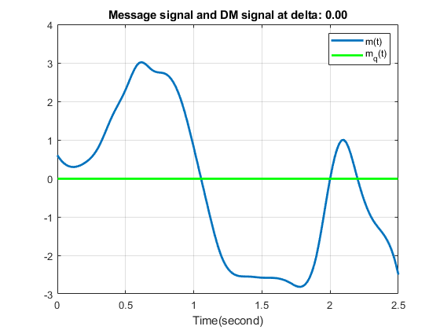
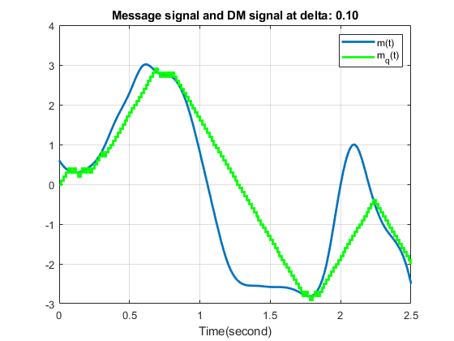
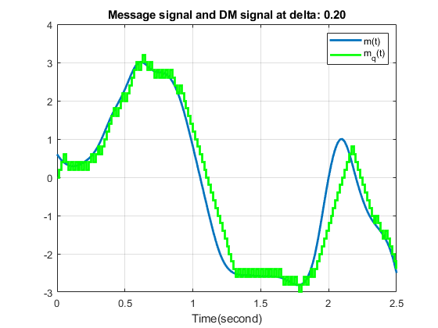
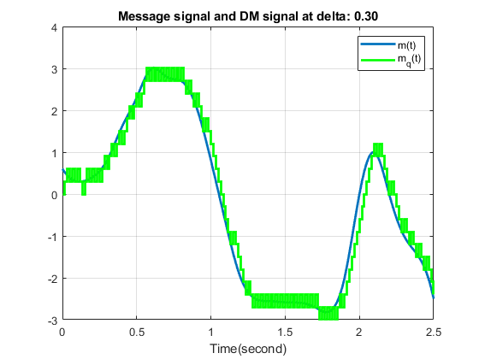
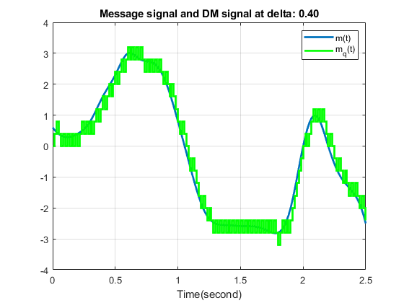
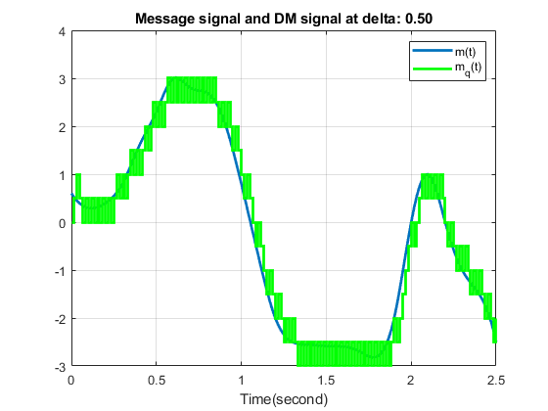
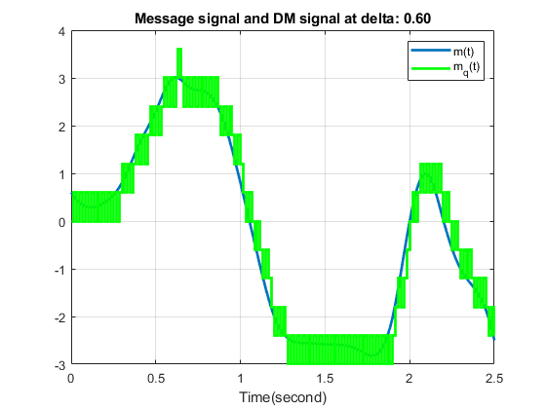
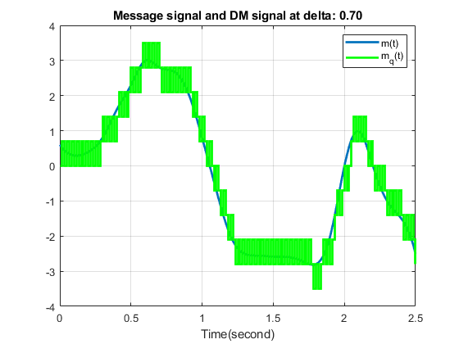
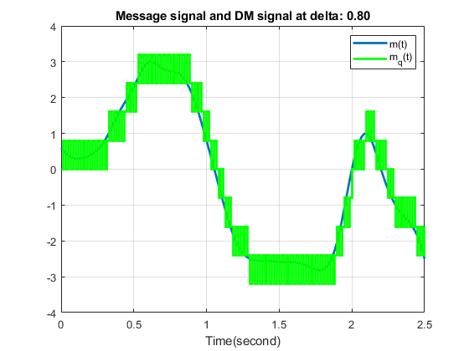
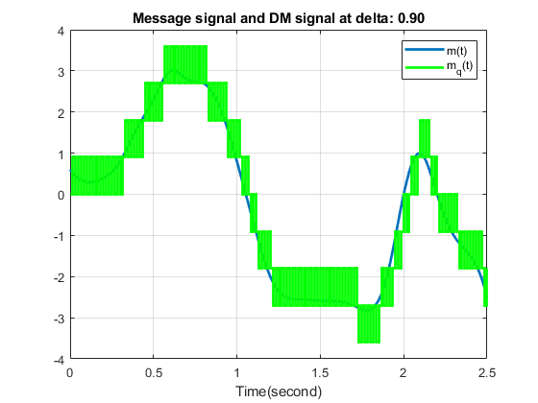

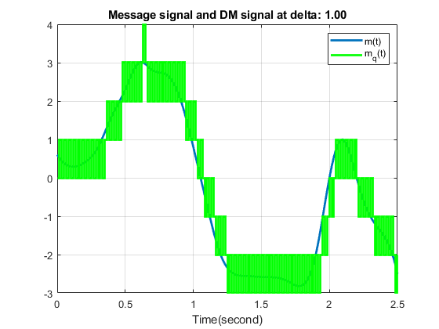
Final output for the Optimized value of Delta:
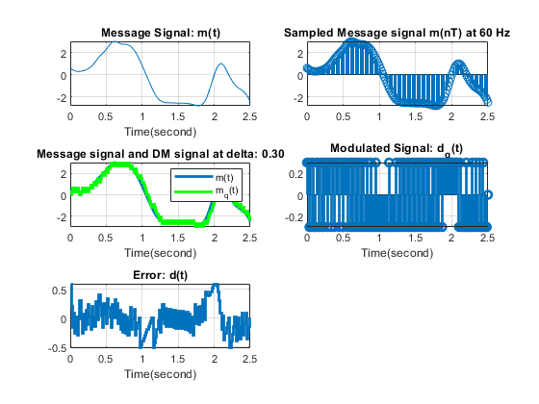
Published with MATLAB® R2021a

