Start from here…

Procedure:
- From Kronig-Penny Model, we get,

For the simulation, P is taken as 10, and ga is taken from -6π to 6π.
- Then we plot the right side of the equation in point 1 against (ga/π). And, cos(ka)=1 and cos(ka)= -1 are simultaneously plotted as dashed lines in the same plot.
- Since values of E are only allowed when -1 ≤ cos(ga) ≤ 1, we extracted an array of the allowed values of ga. Forbidden values of ga are replaced with NaN(not a number). Since the plotting values are discrete, cos(ka) does not exactly take values of 1 and -1. So, we considered ±0.02 to find allowed values of ga, so the upper value was 0.98 and the lower value was -0.98. Below are the allowed values of ga within the interval [0, 6π];

First band = 0.836π to 0.999π Second band = 1.689π to 1.999π Third band = 2.567π to 2.999π Fourth band = 3.472 π to 3.999π Fifth band = 4.398π to 4.999π Sixth band = 5.343π to 5.998π

- Now we plot the Extended Zone Plot. Since ka=cos⁻¹ (RHS), it only takes value between 0 and π. However, for forbidden values of ga, ka returns NaN, thus showing discontinuities in the graph. So, for smooth plotting,
- We stored the indices of NaN values in an array.
- The breaking points of ga values were located to distinguish intervals of ka.
- Using a loop, values were adjusted so that repeating values of ka is transformed into several unique intervals. Such as, first 0 to π values of ka (increasing with E) were changed into -6π to -5π, second π to 0 values (decreasing with E) were changed to -5π to -4π, and so on.
For 5 energy bands, [-5π,5π] was taken. Then ^{𝐸∗8m0(a}2) vs ka is plotted to
ℎ^2
produce extended zone plot.

- Finally, reduced zone plot is plotted. RHS values exceeding 1 or -1 are excluded, and ka is found from ka = cos⁻¹(RHS). Then for x axis, negative of ka
was concatenated with ka. For y axis, ^{𝐸∗8m0(a}2) was concatenated with itself,
ℎ^2
since it is a symmetric function with respect to the y axis.

- To find N crystal momentum states in each band, N equidistant points were chosen using a loop. Here N=10 was taken. Then the states were pointed out as point circles in the same graph as the Reduced Zone Plot. Here, upon mathematical simplification, it was found that ^{𝐸∗8m0(a}2) = (g²a²)/π² and so was
ℎ^2
used in the y axes of the plots.

clc; clear; close all;
format compact
% Defining variables
coeff = 10;
n = 2000000;
Ga = linspace(-6*pi,6*pi,n);
Rs = cos(Ga) + coeff*sinc(Ga/pi); % RHS of the equation
% Plotting Results - 01
plot(Ga/pi, Rs, Ga/pi, Ga./Ga, '--r', Ga/pi, -Ga./Ga, '--b'),
xlabel('ga/pi'), ylabel('cos(ga) + 10sinc(ga/pi)'),
title('Sinc graph and allowed values of ga'),
legend('cos(ga) + 10sinc(ga/pi)','cos(ka)=1','cos(ka)=-1')
Rs(Rs<-1) = NaN; % values exceeding 1 are excluded
Rs(Rs>1) = NaN; % values below -1 are excluded
Gal = [];
for i = 1:length(Rs)
if Rs(i) > 0.998 || Rs(i) < -0.998
temp = Ga(i)/pi;
Gal = [Gal temp];
end
end
i=1;
while i<length(Gal)
if abs(Gal(i)-Gal(i+1))<1e-2
Gal(i+1)=[];
else
i = i + 1;
end
end
% Second problem
k = acos(Rs);
idx = find(isnan(k)); % finding the positions
idx_diff = diff(idx);
y_break = find(idx_diff~=1); % finding the positions of discontinuities
y_break = [y_break length(idx)];
t = [];
for i=1:length(y_break)
t1 = idx(y_break(i)) +1;
if i == length(y_break)
t2 = length(k);
else
t2 = idx(y_break(i)+1);
end
if rem(i,2)~=0
k(t1:t2) = (i + 1)*pi - k(t1:t2) - Ga(end);
else
k(t1:t2) = i*pi + k(t1:t2) - Ga(end);
end
end
t = [t t1 t2];
figure(2)
plot(k/pi, Ga.^2/pi^2, Ga/pi, Ga.^2/pi^2, '--'), xlabel('ka/pi'),...
ylabel('E/(h^{2}/8m_{0}a^{2})'), ...
title('Extended-zone plot of energy for the first five allowed energy bands'),...
ylim([0 25]) , legend('Energy plot','E-k relation for a free electron')
% Third Problem
ka_N = acos(Rs);
ka_1 = [-ka_N ka_N]; % creating symmetric y values
y = Ga.^2/pi^2;
y = [y y]; % creating symmetric x values figure
figure(3)
plot(ka_1/pi, y), xlabel('ka/pi'), ylabel('E/(h^{2}/8m_{0}a^{2})'),...
title('Reduced Zone Plot of energy'), ylim([0 25]), hold on
n = 10; % number of crystal momentum states in each band for
i = 1:2:length(t);
t1 = t(i); t2 = t(i+1);
x = ka_N(t1:ceil(t2-t1)/(n/2):t2); x = [-x x]/pi;
y = Ga(t1:ceil(t2-t1)/(n/2):t2).^2/pi^2; y = [y y];
scatter(x,y), hold on
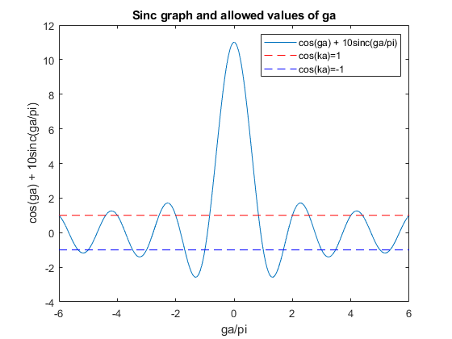
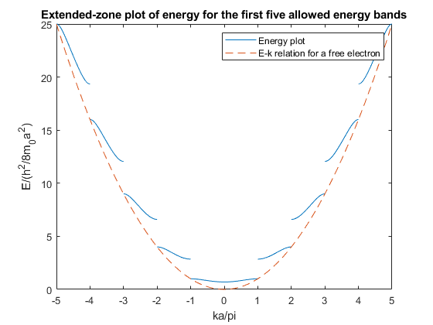
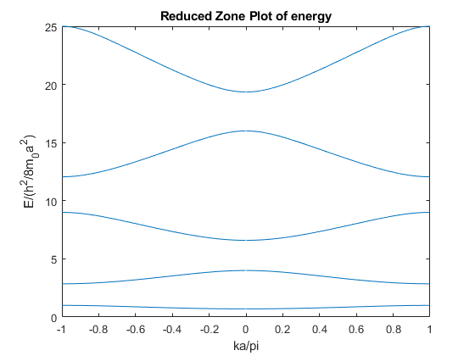
Published with MATLAB® R2021a

