clear; clc; close all;
format compact;
set(0,'defaulttextinterpreter','latex');
s = tf('s');
open_sys = 1/(s^2+6*s+25);
x = pole(open_sys);
%%Moving the pole vertically
for k=2:7
num =1;
den = conv([1 3-k*i],[1 3+k*i]);
open_sys = tf(num,den);
time = 0:0.1:10;
response = step(open_sys,time);
% Legend
p1 = num2str(-3+k*i);
p2 =num2str(-3-k*i);
p = strcat(p1," & ",p2);
plot(time,response,'DisplayName',p,'LineWidth',3);
hold on;
grid('on'),xlabel('Seconds'),ylabel('Amplitude');
legend;
title("Responses for vertically moving poles", 'FontSize',22)
% Print Values
info = stepinfo(open_sys);
Ts= info.SettlingTime;
OS = info.Overshoot;
Tp = info.PeakTime;
fprintf('For the poles: %s --> Settling Time: %.2f s; Overshoot: %.2f; Peak Time: %.2f s \n',p,Ts, OS, Tp)
end
For the poles: -3+2i & -3-2i --> Settling Time: 1.12 s; Overshoot: 0.90; Peak Time: 1.57 s
For the poles: -3+3i & -3-3i --> Settling Time: 1.41 s; Overshoot: 4.32; Peak Time: 1.04 s
For the poles: -3+4i & -3-4i --> Settling Time: 1.19 s; Overshoot: 9.48; Peak Time: 0.78 s
For the poles: -3+5i & -3-5i --> Settling Time: 1.35 s; Overshoot: 15.18; Peak Time: 0.63 s
For the poles: -3+6i & -3-6i --> Settling Time: 1.25 s; Overshoot: 20.79; Peak Time: 0.52 s
For the poles: -3+7i & -3-7i --> Settling Time: 1.10 s; Overshoot: 26.01; Peak Time: 0.45 s
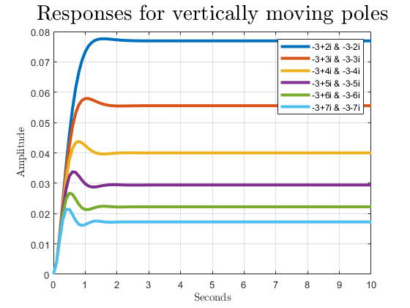
Published with MATLAB® R2021a

