clear; clc; close all;
format compact;
set(0,'defaulttextinterpreter','latex');
%%Finding pole
s = tf('s');
open_sys = 1/(s^2+6*s+25);
x = pole(open_sys);
%%Moving the pole Horizontally keeping imaginary part constant
for k=-4:3
num =1;
den = conv([1 -k-4*i],[1 -k+4*i]);
open_sys = tf(num,den);
time = 0:0.01:1.1;
response = step(open_sys,time);
% Legend
p1 = num2str(k+4*i);
p2 =num2str(k-4*i);
p = strcat(p1," & ",p2);
% Plotting
plot(time,response,'DisplayName',p,'LineWidth',2);
hold on;
grid('on'),xlabel('Seconds'),ylabel('Amplitude');
legend;
title("Responses for horizontally moving poles", 'FontSize',20)
% Print Values
info = stepinfo(open_sys);
Ts= info.SettlingTime;
OS = info.Overshoot;
Tp = info.PeakTime;
fprintf('For the poles: %s --> Settling Time: %.2f s; Overshoot: %.2f; Peak Time: %.2f s \n',p,Ts, OS, Tp)
end
For the poles: -4+4i & -4-4i --> Settling Time: 1.05 s; Overshoot: 4.32; Peak Time: 0.78 s
For the poles: -3+4i & -3-4i --> Settling Time: 1.19 s; Overshoot: 9.48; Peak Time: 0.78 s
For the poles: -2+4i & -2-4i --> Settling Time: 1.87 s; Overshoot: 20.79; Peak Time: 0.78 s
For the poles: -1+4i & -1-4i --> Settling Time: 3.43 s; Overshoot: 45.59; Peak Time: 0.78 s
For the poles: 0+4i & 0-4i --> Settling Time: NaN s; Overshoot: NaN; Peak Time: Inf s
For the poles: 1+4i & 1-4i --> Settling Time: NaN s; Overshoot: NaN; Peak Time: Inf s
For the poles: 2+4i & 2-4i --> Settling Time: NaN s; Overshoot: NaN; Peak Time: Inf s
For the poles: 3+4i & 3-4i --> Settling Time: NaN s; Overshoot: NaN; Peak Time: Inf s
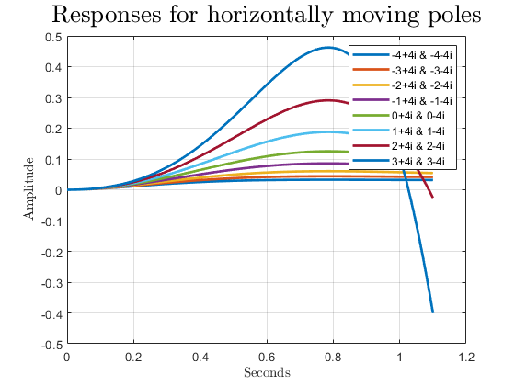
Published with MATLAB® R2021a

