clear; clc; close all;
format compact;
set(0,'defaulttextinterpreter','latex');
num = 1;
%%keeping costheta constant
for k=1:4
num =1 ;
den = conv([1 3*k-4*k*i],[1 3+4*k*i]);
open_sys = tf(num,den);
time = 0:0.1:10;
response = step(open_sys,time);
% Legend
p1 = num2str(3*k+4*k*i);
p2 =num2str(3*k-4*k*i);
p = strcat(p1," & ",p2);
% Plotting
plot(time,response,'DisplayName',p,'LineWidth',1);
hold on;
grid('on'),xlabel('Seconds'),ylabel('Amplitude');
legend;
title("Responses moving poles by keeping cos(theta) constant", 'FontSize',20)
% Print Values
info = stepinfo(open_sys);
Ts= info.SettlingTime;
OS = info.Overshoot;
Tp = info.PeakTime;
fprintf('For the poles: %s --> Settling Time: %.2f s; Overshoot: %.2f; Peak Time: %.2f s \n',p,Ts, OS, Tp)
end
For the poles: 3+4i & 3-4i --> Settling Time: 1.19 s; Overshoot: 9.48; Peak Time: 0.78 s
Warning: The numerator or denominator of this transfer function has
complex-valued coefficients.
Warning: Imaginary parts of complex X and/or Y arguments ignored.
For the poles: 6+8i & 6-8i --> Settling Time: 1.14 s; Overshoot: 0.00; Peak Time: 0.40 s
Warning: The numerator or denominator of this transfer function has
complex-valued coefficients.
Warning: Imaginary parts of complex X and/or Y arguments ignored.
For the poles: 9+12i & 9-12i --> Settling Time: 1.14 s; Overshoot: 0.00; Peak Time: 0.27 s
Warning: The numerator or denominator of this transfer function has
complex-valued coefficients.
Warning: Imaginary parts of complex X and/or Y arguments ignored.
For the poles: 12+16i & 12-16i --> Settling Time: 1.13 s; Overshoot: 0.00; Peak Time: 0.20 s
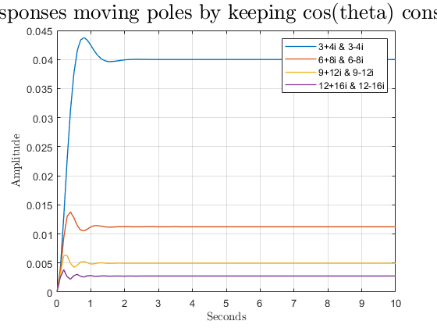
Published with MATLAB® R2021a

