clc; clear; close all;
format compact;
% Defining variables
t = 0:0.01:25; % Time
% Defining systems
s = tf('s');
G_s= 100/(s*(s+10));
H_s = 1/(s+5);
close_sys = feedback(G_s, H_s);
input = ones(length(t),1);
% Finding the responses
step_res = step(close_sys, t); % Step response
plot(t, step_res), title('Step Response'), xlabel("Time(s)"), ylabel("Response");
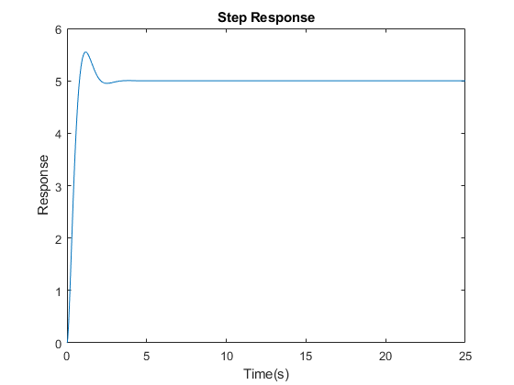
Published with MATLAB® R2021a

