Find the Lead Controller 1
Now we need to find k_comp as the shape gets changed 2
Plotting results for Lead compensator 3
Lag Control for error compensation 4
Now check the Error after Lag Compensation 5
% Overshoot is 10% and setting time is reduced by factor of 2
clc; clear; close all;
format compact;
s= tf('s');
sys = 1/((s+1)*(s+8)*(s+6)); % uncompensated system
OS = 0.10; % Given %OS
zeta = -log(OS)/(pi^2+(log(OS))^2)^0.5;
rlocus(sys);
sgrid(zeta,0);
axis([-10 5 -5 5])
[k,] = rlocfind(sys)
uncomp_sys = k*sys;
Select a point in the graphics window
selected_point =
-2.2454 + 3.0890i
k =
105.7649
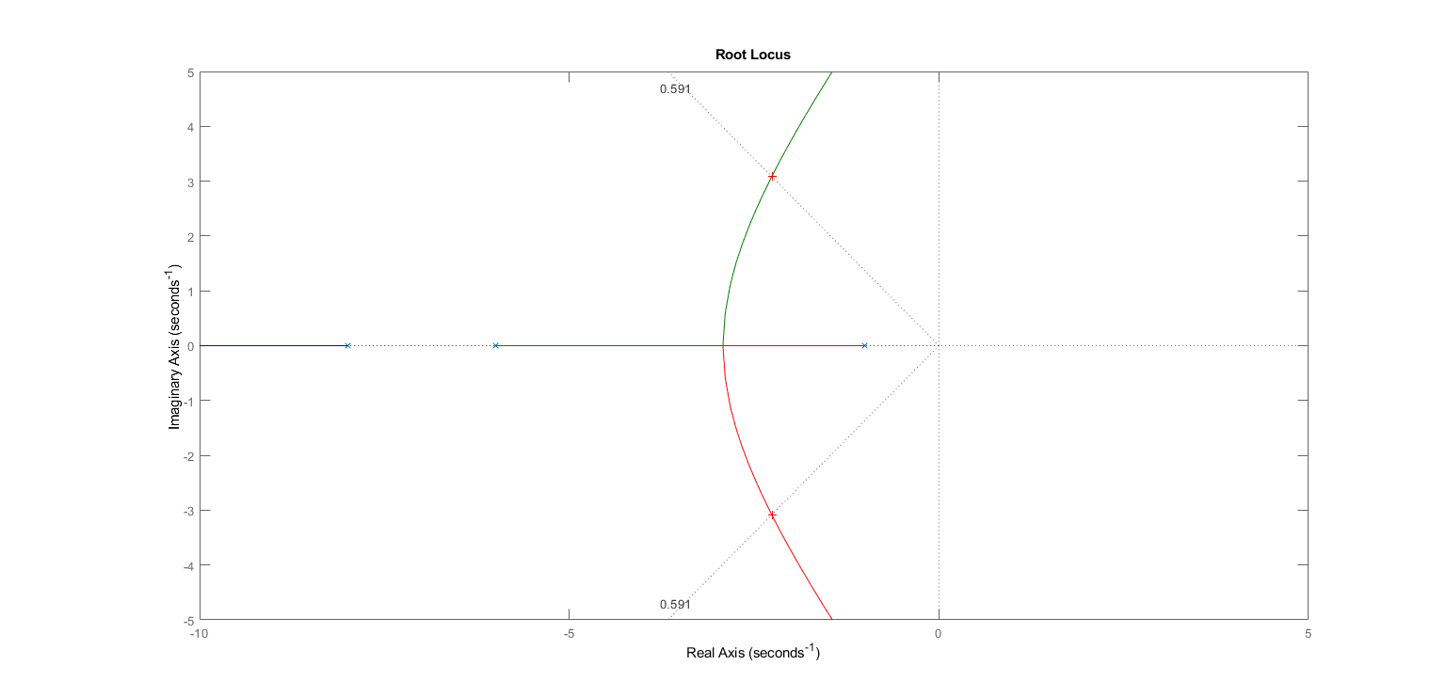

Find the Lead Controller
New Operating point --> 4.511+j*6.17 Let zero at -6. So the position of pole is -469.63
controller_zero = (s+6);
controller_pole = 1/(s+469.63);
lead_comp_sys = uncomp_sys*controller_zero*controller_pole;
%let's see the root locus now again
figure()
subplot(211), rlocus(sys),title('Uncompensated Root Locus')
subplot(212), rlocus(lead_comp_sys),title('Root locus after adding pole and zero')
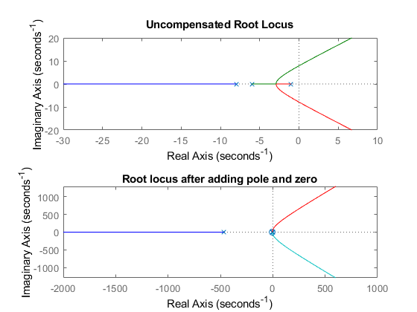

Now we need to find k_comp as the shape gets changed
figure();
rlocus(lead_comp_sys);
sgrid(zeta, 0);
axis([-10 20 -20 20])
[k_comp,] = rlocfind(lead_comp_sys);
comp_sys = lead_comp_sys*k_comp;
Select a point in the graphics window
selected_point =
-4.4297 + 6.0548i
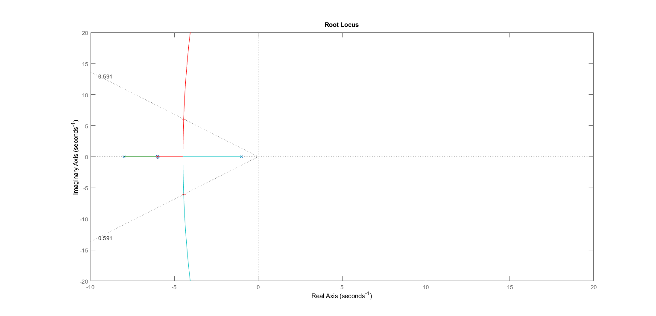

Plotting results for Lead compensator
t = 0:0.01:10;
R_s = 1;
%Uncompensated Response
uncomp_Open_s = uncomp_sys;
uncomp_Close_s = uncomp_Open_s/(1+uncomp_Open_s);
uncomp_C_s = uncomp_Close_s*R_s;
% Compensated Response
comp_Open_s = comp_sys;
comp_Close_s = comp_Open_s/(1+comp_Open_s);
comp_C_s = R_s*comp_Close_s;
%Plotting result
figure()
step(uncomp_C_s,t,"r");
hold on
step(comp_C_s,t,'g')
xlabel("Time(Second)"); ylabel("Amplitude");
legend('Uncompensated Response','Compensated response');
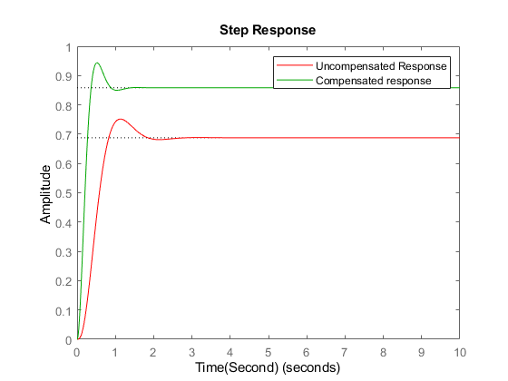

Lag Control for error compensation
base_sys = comp_sys;
zero = s+0.003667;
pole = 1/(s+0.001);
lag_compensated_sys = base_sys*zero*pole;

Now check the Error after Lag Compensation
%Uncompensated error
t = 0:0.01:100;
R_s = 1/s;
Open_s = uncomp_sys;
Close_s = Open_s/(1+Open_s);
C_s = R_s*Close_s;
E_s = R_s - C_s;
uncomp_error = impulse(E_s, t);
% Compensated Error
Open_s = lag_compensated_sys ;
Close_s = Open_s/(1+Open_s);
C_s = R_s*Close_s;
E_s = R_s - C_s;
comp_error = impulse(E_s, t);
%Plotting result
figure()
plot(t,uncomp_error,"r",t,comp_error,"b"),title("Error Analysis");
xlabel("Time(Second)"); ylabel("Amplitude");
legend('Uncompensated error','Compensated Error');
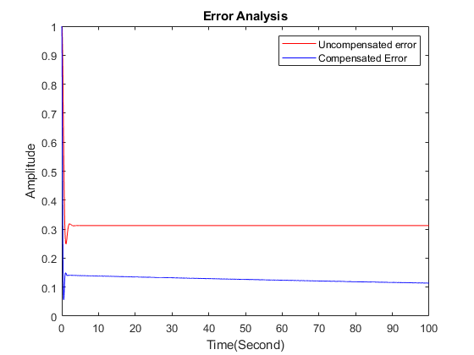
Published with MATLAB® R2021a

