Deliverable 02 – Feasibility Assessment: Instructor Consultation Booking System
Author: Md Alamgir Hossain · October 2026 · Illustrative case study: Walter Dvorak is the course instructor who acted as stakeholder. The interview answers and all figures here are illustrative examples prepared by the student team, not his actual statements.
The project is feasible. The recommended option, configuring Microsoft Bookings under the college’s existing Microsoft 365 licence, pays back in about 8 months and can be live for the Winter 2027 term. All figures are illustrative estimates for the practice scenario.

1. Alternatives considered
The team assessed four options against the requirements in Deliverable 05.
Option | Description
A. Do nothing | Keep booking by email and the paper door sheet
B. Configure Microsoft Bookings (recommended) | Set up Microsoft Bookings, included in the college’s Microsoft 365 licence, with Outlook and Teams integration
C. Build a custom web app in-house | Develop a booking app from scratch (e.g., ASP.NET or Power Apps with a SharePoint list)
D. Buy a commercial booking service | Subscribe to an outside scheduling service such as Calendly

2. Operational feasibility
The system is operationally feasible: both user groups want it, and it fits how the instructor already works.
Question (Chapter 2) | Finding
Does management support the project? | Yes. Walter is the requestor; the program head is expected to approve because it improves student service at low cost.
Will users accept it? | Yes. 70% of surveyed students prefer self-booking, and Walter asked for it (Deliverable 03).
Will it change current procedures? | Yes, for the better: the email loop and paper sheet are replaced. Walter keeps using Outlook and Teams.
Is training needed? | Minimal. A one-page quick reference guide (Deliverable 06) and a 10-minute demo in class.
Will performance improve? | Yes. Booking time falls from 2–4 email rounds to one online step; reminders target fewer than 5% missed meetings.
Any resistance expected? | Low. Some students may still email; Walter will reply with the booking link.

Further question (Chapter 2) | Finding
Will the new system result in a workforce reduction? | No. It frees instructor time for teaching and advising; no jobs are cut.
Do legal or ethical issues need to be considered? | Yes. Student data is covered by FOIP privacy rules (see section 3).

Option | Operational rating
A. Do nothing | Low: problems continue
B. Microsoft Bookings | High: familiar Microsoft tools, students already use their college accounts
C. Custom app | Medium: new interface to learn, depends on in-house support
D. Commercial service | Medium: separate account for every student

3. Technical and legal feasibility
Option B is technically feasible with the college’s existing technology, and it is the only option that clearly meets the privacy rules.
Question (Chapter 2) | Finding for Option B
Does the college have the technical resources? | Yes. Microsoft Bookings is part of Microsoft 365, which the college already licenses.
Is the hardware and software in place? | Yes. Runs in a web browser on any device; no new servers.
Can it integrate with current systems? | Yes. Bookings syncs with Outlook and creates Teams links automatically; sign-in uses college accounts (SSO).
Does the team have the skills? | Yes, with IT Services’ help to enable Bookings for the instructor’s account.
Will it meet performance needs? | Yes. 150 users and about 50 bookings a week is well within Microsoft 365 capacity.

Further question (Chapter 2) | Finding for Option B
Does the platform have enough capacity for future needs (scalability)? | Yes. Microsoft 365 already serves the whole college, so the system could grow to other instructors without redesign.
Will a prototype be required? | Yes. A design (throwaway) prototype, Deliverable 08, is used to confirm the screens with Walter before setup.
Legal feasibility: Student names, emails and meeting notes are personal information under Saskatchewan’s privacy law for public institutions (FOIP). Options B and C keep data inside college-approved systems. Option D would store student data with an outside vendor, possibly outside Canada, and would need a privacy review and contract before use.
Option | Technical rating | Legal rating
A. Do nothing | n/a | Risk: student names posted on the door
B. Microsoft Bookings | High | Low risk: college-approved system
C. Custom app | Medium: needs development and hosting | Low risk if hosted by the college
D. Commercial service | High | High risk: outside data storage, privacy review needed

4. Economic feasibility
Option B returns about $10,170 net over 3 years and pays back in about 8 months. Option C costs more than it saves over the same period.
Assumptions (illustrative): instructor time valued at $50/hour; IT staff time at $45/hour; 30 teaching weeks a year; 3.5 hours a week saved = 105 hours a year = $5,250 a year in tangible benefits.
Option B costs (total cost of ownership)
Cost item | One-time | Per year
Microsoft Bookings licence | $0 (included in Microsoft 365) | $0
Setup and configuration (40 h IT) | $1,800
Outlook/Teams integration and testing (16 h IT) | $720
Quick reference guide and demo (8 h) | $360
Ongoing support (20 h IT a year) |  | $900
Total | $2,880 | $900
TCO components checked (Chapter 2)
TCO component | Option B
People (IT staff and users) | 56 h IT setup, 20 h IT a year; about 2 h of Walter’s time for testing
Hardware and equipment | $0 (existing computers and phones)
Software | $0 (Microsoft Bookings is in the existing licence)
Formal and informal training | $360 (quick reference guide and class demo)
Licences and fees | $0
Consulting and facility costs | $0
Cost of not developing or postponing | About $5,250 a year in lost instructor time, plus continued missed meetings
Intangible costs: a short learning period for Walter and students, some students continuing to email at first, and reliance on IT Services’ availability.
Cost-benefit comparison over 3 years
Option | One-time cost | Annual cost | Annual benefit | Payback | 3-year net
A. Do nothing | $0 | $0 | $0 | n/a | $0 (keeps losing $5,250 a year in staff time)
B. Microsoft Bookings | $2,880 | $900 | $5,250 | About 8 months | +$10,170
C. Custom app (200 h development) | $9,000 | $3,300 | $5,250 | About 4.6 years | −$3,150
D. Commercial service | $360 | $650 | $5,250 | About 1 month | +$13,440, but fails the legal check
Option B calculations
- Net annual benefit = $5,250 − $900 = $4,350
- Payback period = $2,880 ÷ $4,350 = 0.66 years (about 8 months)
- 3-year costs = $2,880 + (3 × $900) = $5,580; 3-year benefits = 3 × $5,250 = $15,750
- 3-year net = $15,750 − $5,580 = $10,170
- ROI = $10,170 ÷ $5,580 = 182%
Intangible benefits: better student experience, fewer missed meetings, a searchable meeting history, and no student names posted publicly.

5. Schedule feasibility
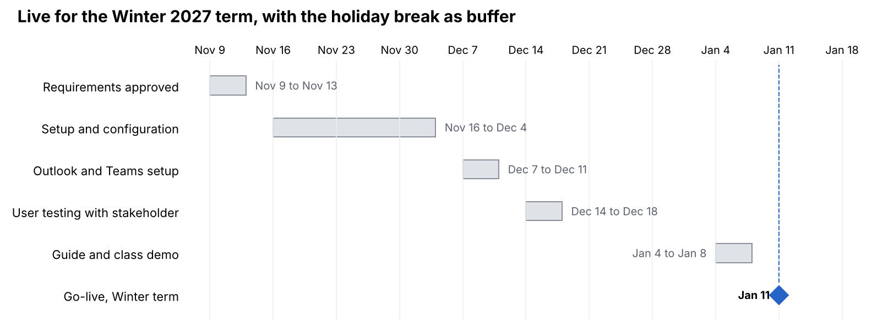
Option B schedule · 5 tasks, go-live Jan 11, 2027
Option B schedule · 5 tasks, go-live Jan 11, 2027
Option B takes about 9 weeks, including the holiday break, so it can go live in the first week of the Winter 2027 term. If setup slips, the 2-week break absorbs the delay.
Schedule question (Chapter 2) | Finding
Can the team control the factors that affect the schedule? | Partly. Setup is in our control; IT Services approval is not, so it is requested first.
Has management set a firm timetable? | Yes. The system must be live for the first week of the Winter 2027 term.
What conditions must be met? | Bookings enabled for Walter’s account; prototype approved; testing passed.
Would an accelerated schedule add risk? | Yes. Cutting the testing week could let booking errors reach students.
Are project management techniques available? | Yes. The timeline above, weekly check-ins and a task list track progress.

6. Feasibility summary and recommendation
Recommendation: Option B, configure Microsoft Bookings. It is the only option that passes all five feasibility tests.
Option | Operational | Technical | Economic | Schedule | Legal | Overall
A. Do nothing | Low | n/a | Low | n/a | Risk | Not feasible
B. Microsoft Bookings | High | High | High | High | Low risk | Feasible (recommended)
C. Custom app | Medium | Medium | Low | Low: 200 h will not fit before Winter 2027 | Low risk | Not feasible now
D. Commercial service | Medium | High | High | High | High risk | Not feasible without a privacy review
The team recommends that the program head approve Option B and that IT Services enable Microsoft Bookings for Walter’s account. These findings feed the Preliminary Investigation Report (Deliverable 04).

← Back to the case study overview

