Required Assignment:
Below is an example of a movie rental system:
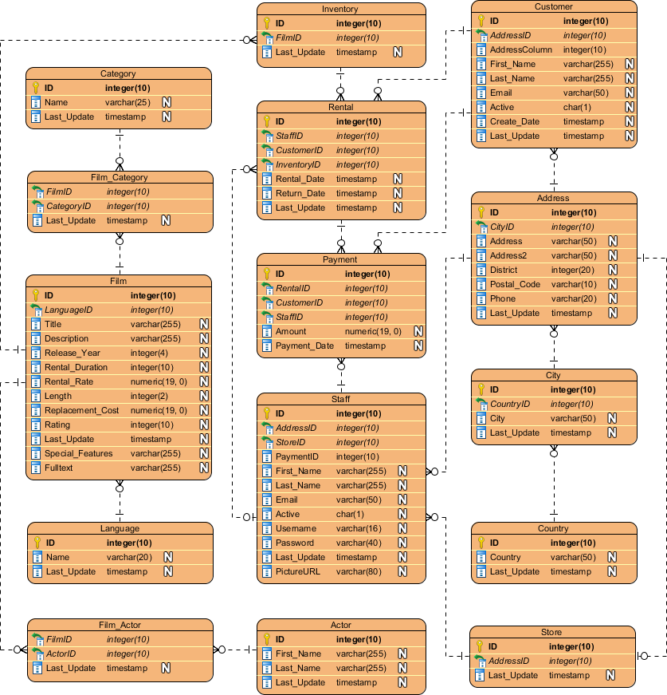

In a Word document answer the following questions:
- What shape usually represents an Entity?
Ans. An entity is typically represented by a rounded rectangle
- The diagram above represents what type of ERD?
Ans. It is a physical ERD. It has the most required details, for example, column names, data types, and primary/foreign key designations.
- What is a Primary Key?
Primary Key is a special attribute inside an entity that uniquely identifies a record in a table (entity). There is only one primary key in a table, and it is always unique and not null.
- What is a Foreign Key?
Foreign key is an attribute that represents a link or association between two entities. It connects a child table (entity) to the primary key of a parent table (entity)
- In the above example, what is the cardinality between:
  - Film_Actor and Actor?
Ans. The cardinality is zero or Many-to-One . Symbol on the Film_Actor side indicates “Zero or Many” while the symbol on the Actor side indicates “One (and only one)”.
  - Store and address?
Ans. The cardinality is Many-to-One. The symbol on the Store side indicates “Zero or Many”, and the Address side indicates "One (and only one)” symbol.
- List the attributes of the Rental entity
Ans. ID, StaffID, CustomerID, InventoryID, Rental_Date, Return_Date, and Last_Update.
- What is the datatype of the attribute city?
Ans. Varchar(50)
- What is the PK for the Film_Actor entity?
Ans. The PK is a composite key consisting of FilmID and ActorID. These are indicated by the gold key icons at the top of the attribute list.
- What are the FK attribute's in the Rental entity?
Ans. The FK attributes are StaffID, CustomerID, and InventoryID. These are identified by the green/blue "tiny key" icons.
- If I had a customer ID, what entities would I have to go through to get the first name of their favorite Actor?
Ans. To bridge the gap between a Customer and an Actor, you would navigate through this path:
Customer (Starting point)
Rental
Film_Actor
Film
Inventory
Actor (Destination to find First_Name)

