Deliverable 05 – Final Requirements: Instructor Consultation Booking System
Author: Md Alamgir Hossain · October 2026 · Illustrative case study: Walter Dvorak is the course instructor who acted as stakeholder. The interview answers and all figures here are illustrative examples prepared by the student team, not his actual statements.
These are the final requirements for the Instructor Consultation Booking System, the input for the team’s GUI prototype (Deliverable 08). They are based on an illustrative scenario.

1. Purpose and scope
The system lets students and project groups book consultations with an instructor online, without email back-and-forth. It replaces the current email and paper door-sheet process.
- System: Instructor Consultation Booking System
- Requestor and primary user: Walter Dvorak, Instructor, Business Information Systems
- Other users: Students and project groups in Walter’s course sections (about 120–150 a term)
- Business objective: Cut instructor scheduling time by 3–4 hours a week, reduce missed meetings and keep a record of every consultation
In scope:
- Publishing the instructor’s available time slots
- Student self-booking, rescheduling and cancelling
- Confirmations and reminders
- Instructor dashboard and private meeting notes
- Basic usage reports
Out of scope (this release):
- Use by other instructors or departments
- Grading or course content (stays in D2L Brightspace)
- Mobile app (the web interface must still work on phones)

2. Fact-finding techniques used
The requirements come from two techniques, which meets the assignment’s “no less than two techniques” rule.
Technique | Who | What it gave us | Reference
Interview | Walter Dvorak (30 min, during class time) | Duties, current systems, pain points, must-have and nice-to-have features | Deliverable 03, interview summary Q1–Q10
Questionnaire | 30 students | 80% find email booking slow; 70% prefer self-booking; 60% have missed a meeting | Deliverable 03, questionnaire results
In the tables below, the Source column points back to these: “INT-Q6” means interview question 6, and “QST” means the student questionnaire.

3. Requirements checklist (Chapter 4 categories)
The system requirements checklist groups the needs into the five categories from the textbook’s Chapter 4.
Outputs
- The booking page must show the instructor’s open slots for the next 4 weeks.
- The system must send a booking confirmation by email within 1 minute of booking.
- The system must send a reminder email 24 hours before each meeting.
- The instructor dashboard must list today’s and this week’s meetings.
- The system must produce a monthly summary report (meetings held, cancellations, no-shows) and an exception report of no-shows.
Inputs
- The instructor must be able to enter office hours, slot lengths (15 or 30 minutes) and blocked dates.
- Students must book by choosing a slot and entering a meeting type, a short topic (up to 200 characters) and, for groups, the group name.
- Student name, email and ID must come from the the college login, not be typed in.
- The instructor must be able to enter private notes after each meeting.
Processes
- The system must prevent double-booking of the same slot.
- Students must be able to cancel or reschedule up to 2 hours before a meeting.
- The system must create a Teams link automatically for online meetings.
- The system must sync confirmed meetings to the instructor’s Outlook calendar.
- The instructor must be able to mark each meeting as held, cancelled or no-show.
Processing method (Chapter 8 input technology): booking, cancelling, double-booking checks and confirmations use online processing, so results are immediate. Reminder emails, monthly reports and backups run as scheduled batch processing.
Performance
- Pages must load in under 3 seconds.
- The system must support up to 150 student users a term and 50 bookings a week.
- The system must be available 99% of the time during the academic term.
Controls
- Users must sign in with their college account (single sign-on).
- Students must see only their own bookings; meeting notes must be visible only to the instructor.
- Student data must be handled under provincial privacy law (FOIP).
- The system must log every booking, change and cancellation with a date and time.

4. Functional requirements
Functional requirements say what the system must do. Nine are Must have; the prototype must show all of them.
ID | Requirement | Source | Priority | Acceptance criterion
FR-01 | Show the instructor’s available slots for the next 4 weeks | INT-Q6, QST | Must have | Students see only open slots; booked slots are hidden
FR-02 | Let the instructor set office hours, slot length (15 or 30 min) and blocked dates | INT-Q4, INT-Q5 | Must have | A change shows on the booking page immediately
FR-03 | Let a student or group book a slot with a meeting type and short topic | INT-Q6, QST | Must have | The booking is saved and the slot is no longer available
FR-04 | Prevent double-booking of a slot | INT-Q3 | Must have | If two users pick the same slot, the second sees “This slot is no longer available”
FR-05 | Send a booking confirmation email | INT-Q6 | Must have | Sent within 1 minute, with date, time and location or Teams link
FR-06 | Send a reminder email 24 hours before the meeting | INT-Q6, QST | Must have | Sent 24 hours (±15 min) before every confirmed meeting
FR-07 | Let students cancel or reschedule up to 2 hours before | INT-Q6 | Must have | The slot is released and the instructor is notified
FR-08 | Give the instructor a dashboard of today’s and this week’s meetings | INT-Q1 | Must have | Meetings are listed in time order with student or group name and topic
FR-09 | Let the instructor add private notes to each meeting | INT-Q6, INT-Q8 | Must have | Notes are saved, searchable and visible only to the instructor
FR-10 | Let the instructor mark a meeting as held, cancelled or no-show | INT-Q10 | Should have | The status is saved and used in the reports
FR-11 | Create a Teams link automatically for online meetings | INT-Q7 | Should have | Every online booking’s confirmation includes a working Teams link
FR-12 | Sync confirmed meetings to the instructor’s Outlook calendar | INT-Q2 | Should have | The meeting appears in Outlook within 5 minutes
FR-13 | Show the full meeting history for one project group | INT-Q7 | Could have | Filtering by group name lists all of that group’s meetings
FR-14 | Produce a monthly summary report and a no-show exception report | INT-Q10 | Could have | Reports can be viewed on screen and exported to Excel or PDF
FR-15 | Support booking for other instructors | Scope decision | Won’t have (this release) | Deferred to a later release

5. Non-functional requirements
Non-functional requirements say how well the system must work. Usability and privacy matter most, because students will use it without training and it holds student data.
ID | Category | Requirement | Source | Priority
NFR-01 | Usability | A first-time student can book a meeting in under 2 minutes with no training | QST | Must have
NFR-02 | Usability | The interface follows the Chapter 8 guidelines: consistent layout, clear labels, dimmed unavailable options, easy error correction | Course guidance | Must have
NFR-03 | Security | Sign-in uses the college account (single sign-on); no separate passwords | INT-Q9 | Must have
NFR-04 | Privacy | Students see only their own bookings; notes are instructor-only; data handled under FOIP | INT-Q8 | Must have
NFR-05 | Compatibility | Works with Microsoft 365 (Outlook, Teams) already licensed by the college | INT-Q9 | Must have
NFR-06 | Performance | Pages load in under 3 seconds for up to 150 users a term | Team estimate | Should have
NFR-07 | Accessibility | Works on phones, tablets and desktops (responsive design) and meets basic accessibility standards | QST | Must have
NFR-08 | Reliability | Available 99% of the time during the term; bookings backed up daily | Team estimate | Should have
NFR-09 | Scalability | Can grow to other BIS instructors (up to about 20 instructors and 2,000 students) without redesign or loss of speed | INT-Q11 | Should have
NFR-10 | Integration | Booking page reachable from the instructor’s Brightspace course page and the college portal; works with Outlook and Teams | INT-Q12 | Should have

6. User stories
The user stories restate the Must-have requirements from each user’s point of view, in the standard “As a…, I want…, so that…” format.
ID | User story | Linked requirements
US-01 | As a student, I want to see the instructor’s open time slots, so that I can pick a time without emailing back and forth. | FR-01
US-02 | As a student, I want to book a slot myself and get a confirmation, so that I know my meeting is set. | FR-03, FR-05
US-03 | As a student, I want a reminder the day before, so that I don’t miss the meeting. | FR-06
US-04 | As a student, I want to cancel or reschedule online, so that the slot is freed for someone else. | FR-07
US-05 | As a project group lead, I want to book a 30-minute group meeting, so that the whole team can meet the instructor. | FR-02, FR-03
US-06 | As an instructor, I want to set my office hours and block dates, so that students only book when I’m available. | FR-02
US-07 | As an instructor, I want a dashboard of today’s meetings, so that I can prepare without searching my email. | FR-08
US-08 | As an instructor, I want private notes on each meeting, so that I can follow up on what we discussed. | FR-09
US-09 | As an instructor, I want double-bookings blocked, so that I’m never scheduled for two meetings at once. | FR-04

7. Use case diagram
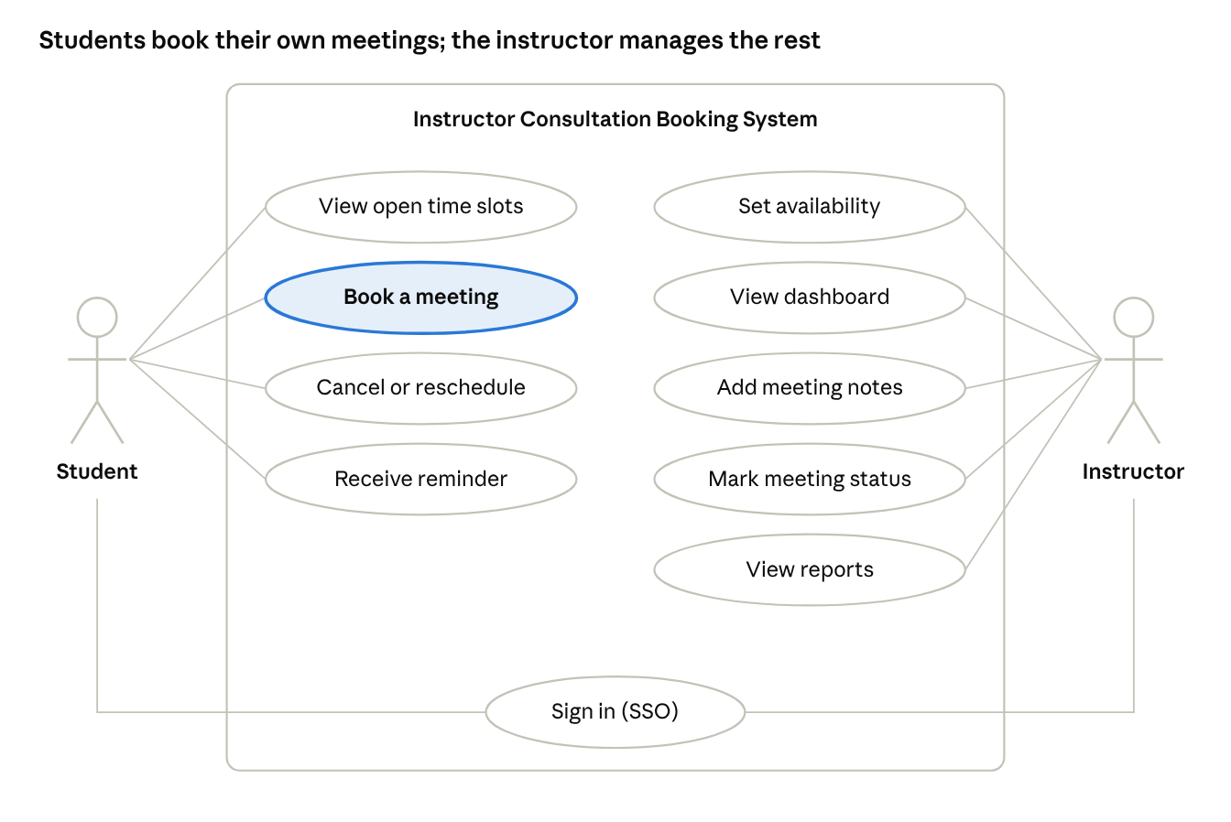
use case diagram · 2 actors, 10 use cases
use case diagram · 2 actors, 10 use cases
Both actors sign in with their college account. “Book a meeting” is the core use case; the other student use cases support it, and the instructor’s use cases replace today’s email and Excel work.
Use case | Actor | Main steps | Linked requirements
Book a meeting | Student | 1. Sign in. 2. Pick an open slot. 3. Choose meeting type and enter topic. 4. Confirm. 5. Receive confirmation email. | FR-01, FR-03, FR-04, FR-05
Cancel or reschedule | Student | 1. Open My bookings. 2. Choose Cancel or Reschedule. 3. Pick a new slot if rescheduling. 4. Receive updated confirmation. | FR-07
Set availability | Instructor | 1. Open Availability settings. 2. Set office hours and slot length. 3. Block dates. 4. Save. | FR-02
Add meeting notes | Instructor | 1. Open a meeting from the dashboard. 2. Type notes. 3. Mark status. 4. Save. | FR-09, FR-10

8. Traceability to the GUI prototype (Deliverable 08)
Every Must-have requirement maps to at least one prototype screen, so the GUI team knows exactly what each screen has to show.
Screen | User | Key elements | Requirements covered
S1 Booking calendar | Student | Week view, open slots highlighted, booked slots dimmed, meeting-type filter | FR-01, FR-04, NFR-01, NFR-02
S2 Booking form and confirmation | Student | Selected slot, meeting type (individual or group), topic box, group name, Confirm button, confirmation message | FR-03, FR-05, FR-11
S3 My bookings | Student | Upcoming meetings list, Reschedule and Cancel buttons, cut-off warning | FR-06, FR-07
S4 Instructor dashboard | Instructor | Today and this week, meeting cards, status buttons (held, cancelled, no-show) | FR-08, FR-10, FR-12
S5 Availability settings | Instructor | Office hours, slot length, blocked dates | FR-02
S6 Meeting notes and history | Instructor | Notes box, search, filter by group | FR-09, FR-13
S7 Reports | Instructor | Monthly summary, no-show exception report, export | FR-14
Screens S1–S6 cover all the Must-have requirements, so they are the minimum set for the prototype; S7 can be added if time allows.

9. Assumptions, constraints and open questions
Assumptions
- Students and the instructor all have college Microsoft 365 accounts.
- Meetings are 15 minutes for individuals and 30 minutes for groups.
- Office hours are Tuesdays and Thursdays, 1–3 pm, plus extra slots the instructor adds.
Constraints
- Little or no budget; the solution should use tools the college already licenses.
- It must be ready before the Winter 2027 term.
- Student data must stay within college-approved systems (FOIP).
Open questions (to confirm with the stakeholder)
- ☐ Is a 2-hour cancellation cut-off acceptable?
- ☐ Should students be limited to a number of bookings per week?
- ☐ Does Walter want walk-ins recorded in the system too?
- ☐ Will IT Services allow Outlook and Teams integration?

10. Validation, verification and requirements challenges
The requirements were checked in two ways before being used for the prototype (Chapter 4: V&V).
Check | Question | How we did it
Validation | Are the correct requirements stated? (Is this the system Walter really wants?) | Walk Walter through the user stories and the prototype screens, and ask him to sign off (section 12)
Verification | Are the requirements stated correctly? (Clear, testable, consistent?) | Every requirement has an ID, a source and an acceptance criterion; the traceability table links each one to a screen

Challenge (Chapter 4) | Risk here | How we handle it
Imprecision | Vague wishes like “easy booking” | Measurable acceptance criteria (e.g., “book in under 2 minutes”)
Agreement | Walter and students may want different things | Interview plus questionnaire; MoSCoW priorities agreed with Walter
Creep | New features added late (e.g., other instructors) | Out-of-scope list and “Won’t have (this release)” priority; scalability (NFR-09) keeps the door open for later

11. Glossary of terms
Plain-language meanings of the technical terms and abbreviations used in this document.
Term | Meaning
Acceptance criterion | A clear, testable condition that shows a requirement has been met (e.g., “email sent within 1 minute”).
Actor | In a use case diagram, a person or system that interacts with the system (here: Student and Instructor).
D2L Brightspace | The college’s learning management system, where course content, dropboxes and grades are kept.
Dashboard | A single screen that summarizes key information at a glance, such as today’s meetings.
Exception report | A report that shows only records needing attention, such as meetings marked as no-show.
FOIP | Saskatchewan’s Freedom of Information and Protection of Privacy rules, which govern how public institutions collect, use and protect personal information such as student names and emails.
FR / NFR | Functional requirement (what the system must do) / non-functional requirement (how well it must do it: speed, security, usability).
INT-Q / QST | Source codes in this document: INT-Q6 = interview question 6 with Walter; QST = the student questionnaire.
Microsoft 365 | The college’s suite of Microsoft tools, including Outlook (email and calendar) and Teams (online meetings).
MoSCoW | A way to prioritize requirements: Must have, Should have, Could have, Won’t have (this release).
No-show | A booked meeting the student or group did not attend without cancelling.
Responsive design | A layout that adjusts automatically to the screen size, so the same system works on phones, tablets and computers.
Single sign-on (SSO) | Signing in once with your existing college username and password, instead of creating a separate account and password for this system.
Slot | A fixed block of time the instructor makes available for booking (15 minutes for individuals, 30 minutes for groups).
Summary report | A report showing totals rather than individual records, such as meetings held per month.
Traceability | Linking each requirement to its source and to the screen that delivers it, so nothing is missed or added without reason.
Use case | A description of one task a user performs with the system, step by step (e.g., “Book a meeting”).
User story | A short requirement written from the user’s view: “As a [user], I want [goal], so that [reason].”
99% availability | The system is working and usable at least 99% of the time during the term (about 7 hours of downtime a month at most).
Integration point | A place where the system connects to another system the college already uses, such as Brightspace, the college portal, Outlook or Teams.
Online / batch processing | Online: each transaction is processed immediately (booking a slot). Batch: transactions are grouped and processed on a schedule (reminders, monthly reports).
Scalability | The system’s ability to handle more users, data and transactions without slowing down or being redesigned.
Validation / verification (V&V) | Validation: are the correct requirements stated? Verification: are the requirements stated correctly?

12. Sign-off
The requirements are final once the user confirms them below.
Role | Name | Signature | Date
User / requestor | Walter Dvorak, Instructor BIS
Prepared by | Md Alamgir Hossain, project team

← Back to the case study overview

