Hossain, Md Alamgir
Saskatchewan Polytechnic
AWS Lab 3: Designing and Implementing a Multi-Tier VPC Architecture

Contents
Initial Setup: 1
Step 01: Creating the VPC (The Container) 2
VPC created: 2
Step 2: Subnetting (The Rooms) 3
2.a: Public Subnet: 3
2.b: Private Subnet: 3
02.c: Two Subnets Created 4
Step-3: I Created two NACLs inside my Canb_BIS VPC. 4
3.1: Selecting VPC to create NACL inside it. 4
3.2.1: Creating public NACL 4
3.2.2: Setting up inbound rules: 5
3.2.3: inbound rules set up done: 5
3.2.4: Setting up inbound rules: 5
3.2.5: Outbound rules set up done: 5
3.2.6: Public NACL with public subnet: 6
3.2.7: Associate public NACL with public subnet: 6
3.3.1: Creating private NACL Private_NACL_Canb_BIS 6
3.3.2: Setting up inbound rules: 6
3.3.3: Inbound rules set up done: 7
3.3.4: Setting up outbound rules: 7
3.3.5: outbound rules set up done: 7
Step-4: Internet Gateway (IGW): 8
4.1: IGW created 8
4.2: Attached IGW with public subnet inside VPC: 8
4.3: Attachment completed: 8
Step 5: Route Tables: 9
5.2: Public Routing Table created: 9
5.3: Creating Private Routing Table: 9
5.4 Private Routing Table created: 9
Bonus: 11

Initial Setup:
This is the VPC creation interface to create a VPC from Scratch. The VPC dashboard showing the starting environment before creating the new resources.
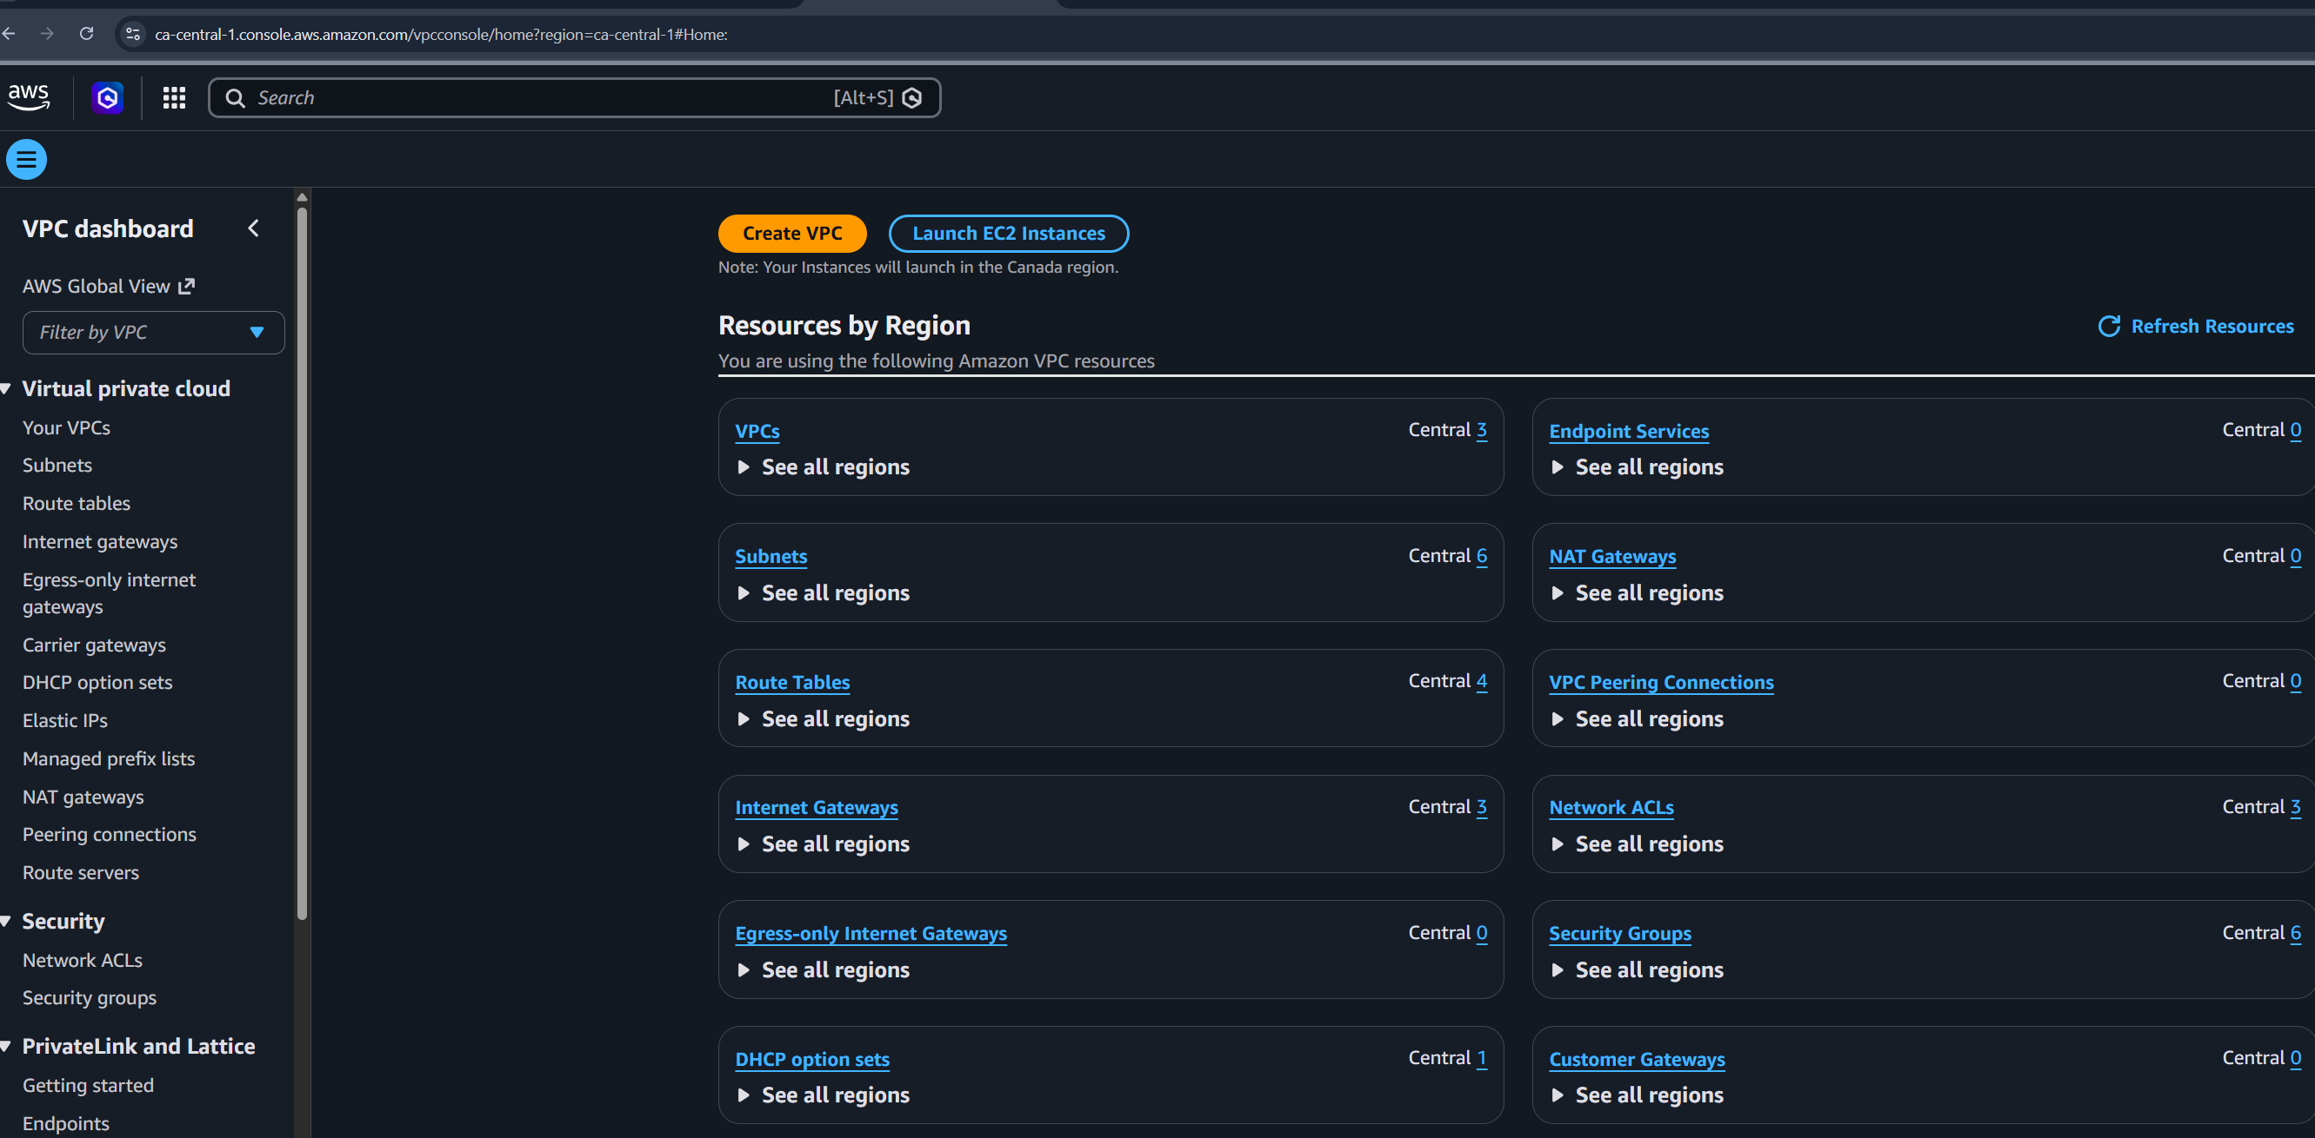
My existing VPC before starting LAB3 assignment 695471417
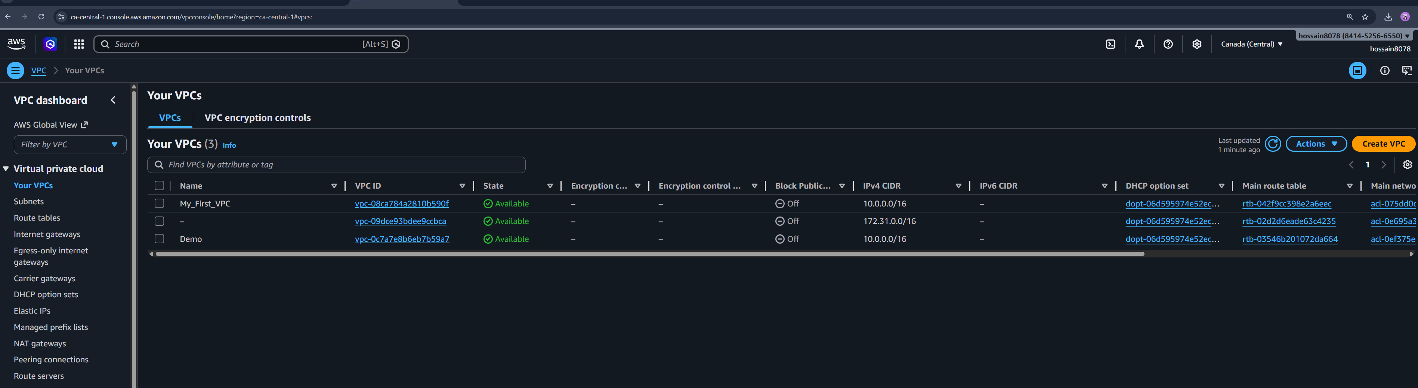

Step 01: Creating the VPC (The Container)
Creating the VPC: Defining the "container" for your network using CIDR block 172.16.0.0/16, providing 65,536 private IP addresses.
You defined a Virtual Private Cloud (VPC) with the CIDR block 172.16.0.0/16.
- The Logic: This is your isolated slice of the AWS cloud. By setting the CIDR to /16, you've reserved 65,536 private IP addresses that you can later carve up into smaller subnets. It's like buying a plot of land before you start building specific rooms.
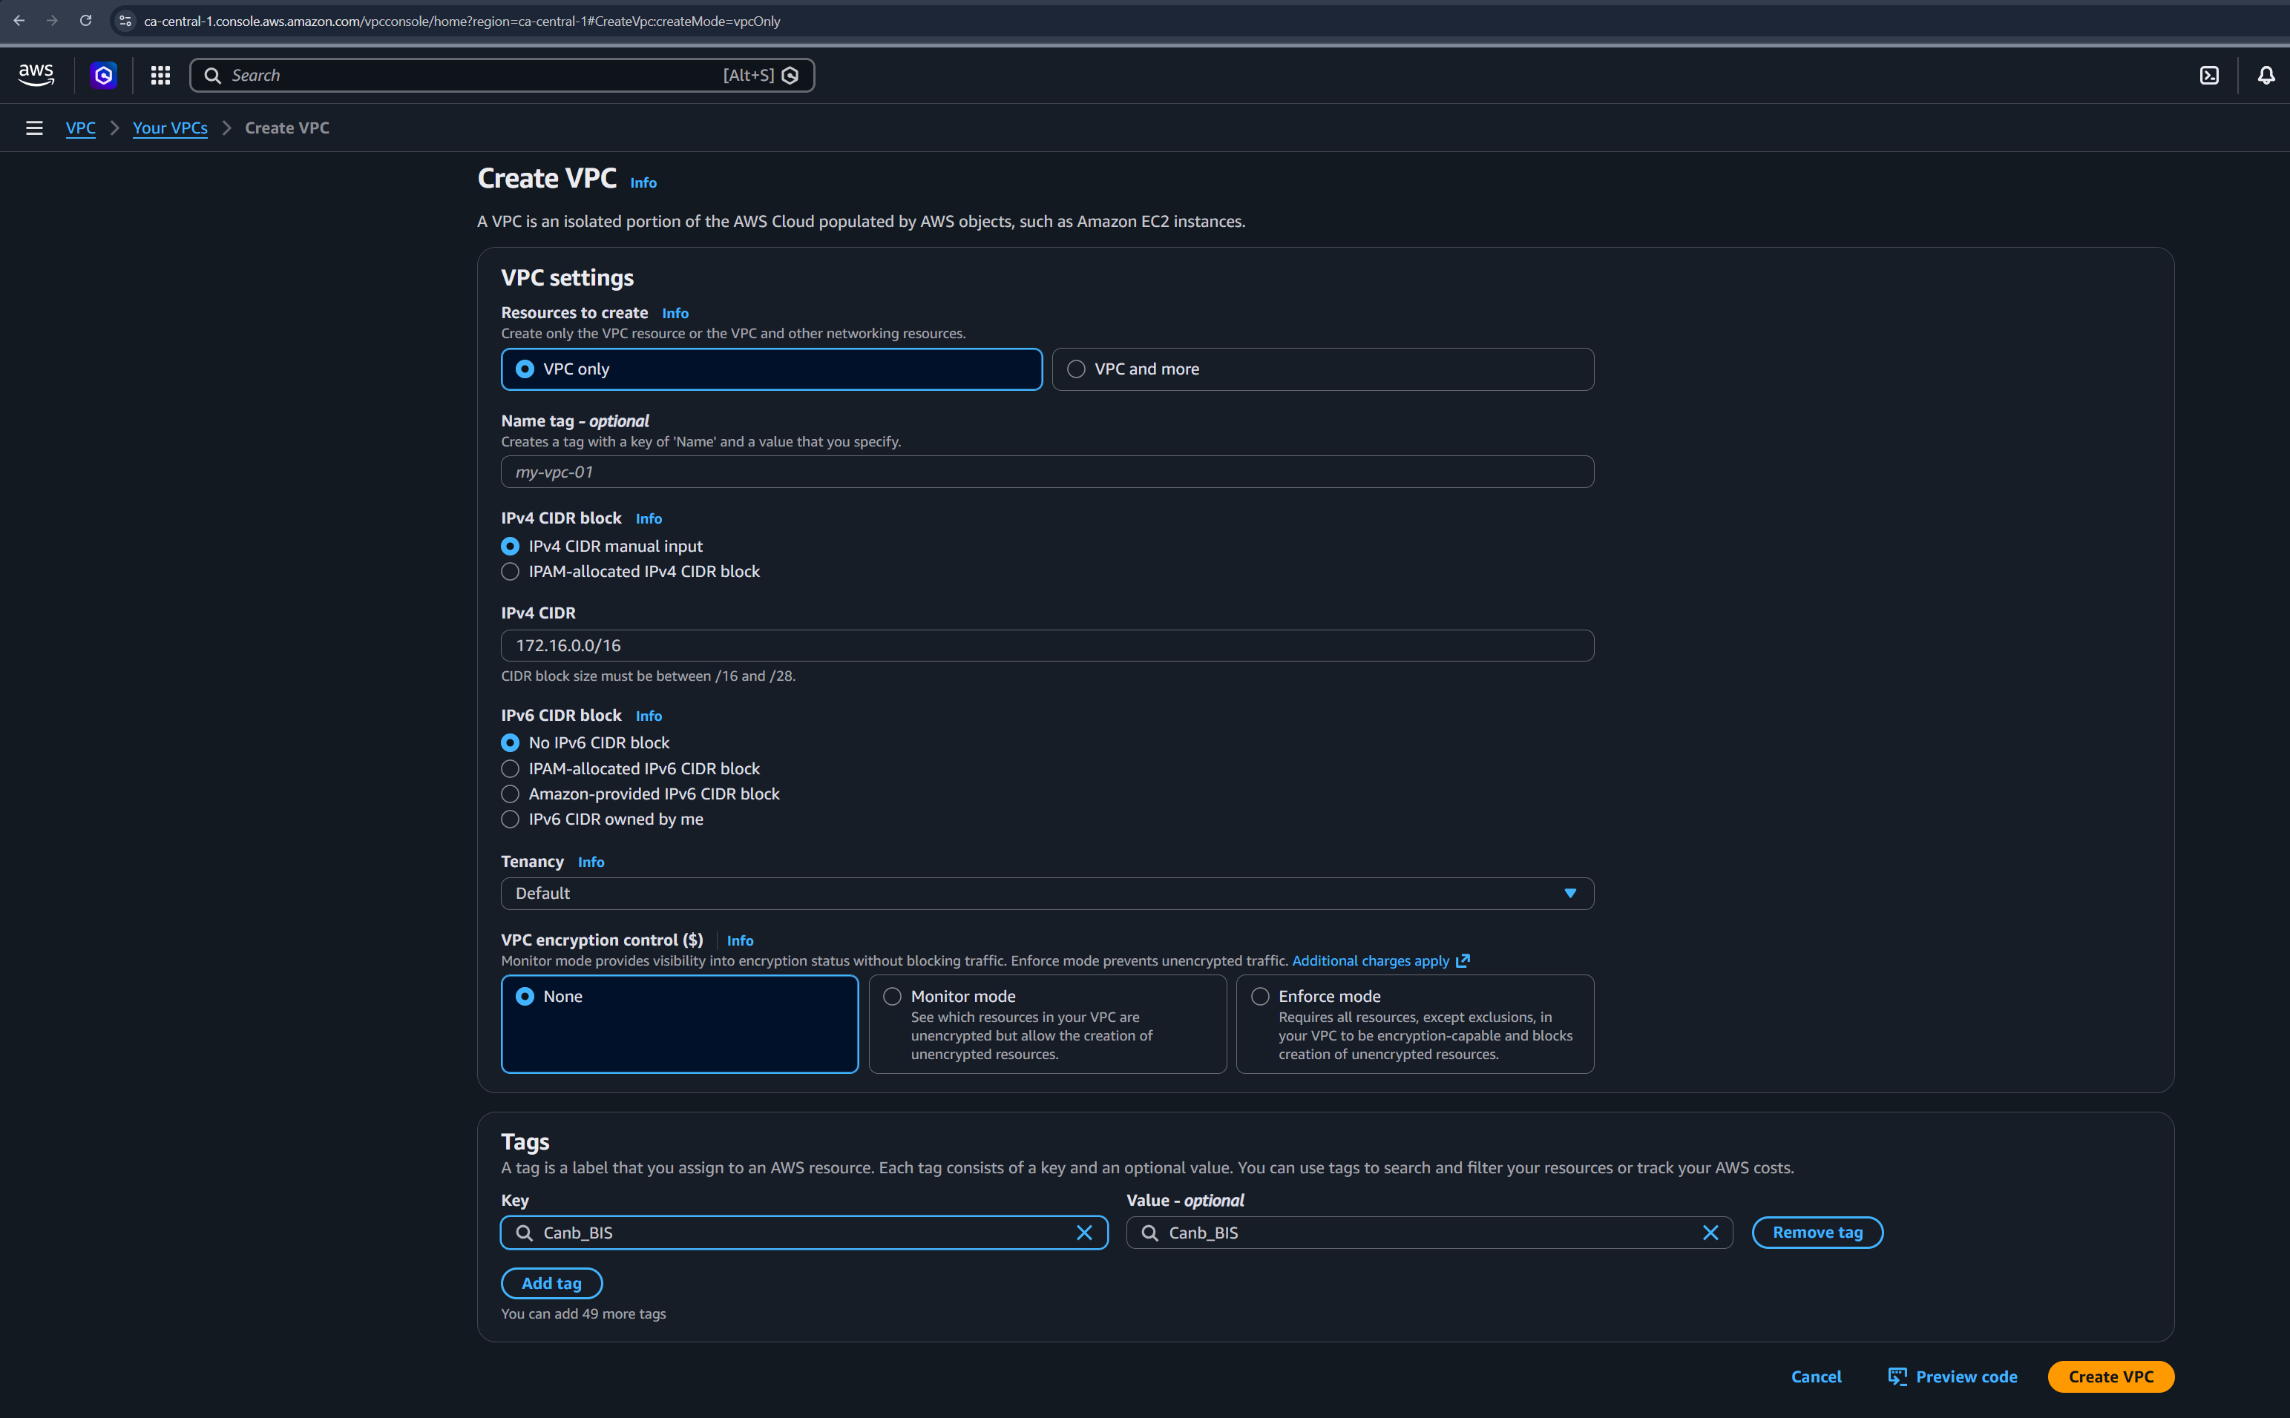

VPC created:
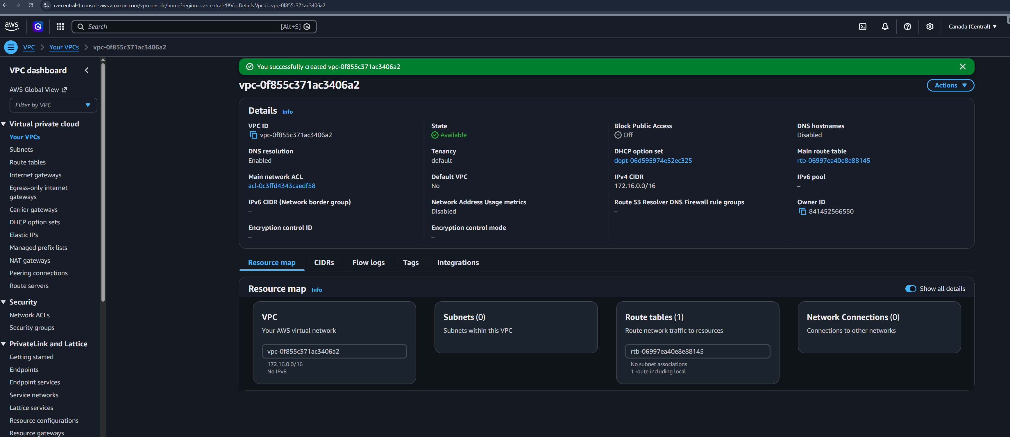

Step 2: Subnetting (The Rooms)
Subnetting: Carving the VPC into two specific "rooms"—Public1 (172.16.1.0/24) for web services and Private1 (172.16.2.0/24) for protected resources like databases.
I created two subnets: Public1 (172.16.1.0/24) and Private1 (172.16.2.0/24).
- The Logic: Subnetting allows you to group resources based on their security needs.
  - The Public subnet is for "front-door (entry door)" services (like web servers).
  - The Private subnet is for "back-office (no direct entry)" services (like databases) that should never be visible to the public internet.
Creating two subnets inside my Canb_BIS VPC:

2.a: Public Subnet:
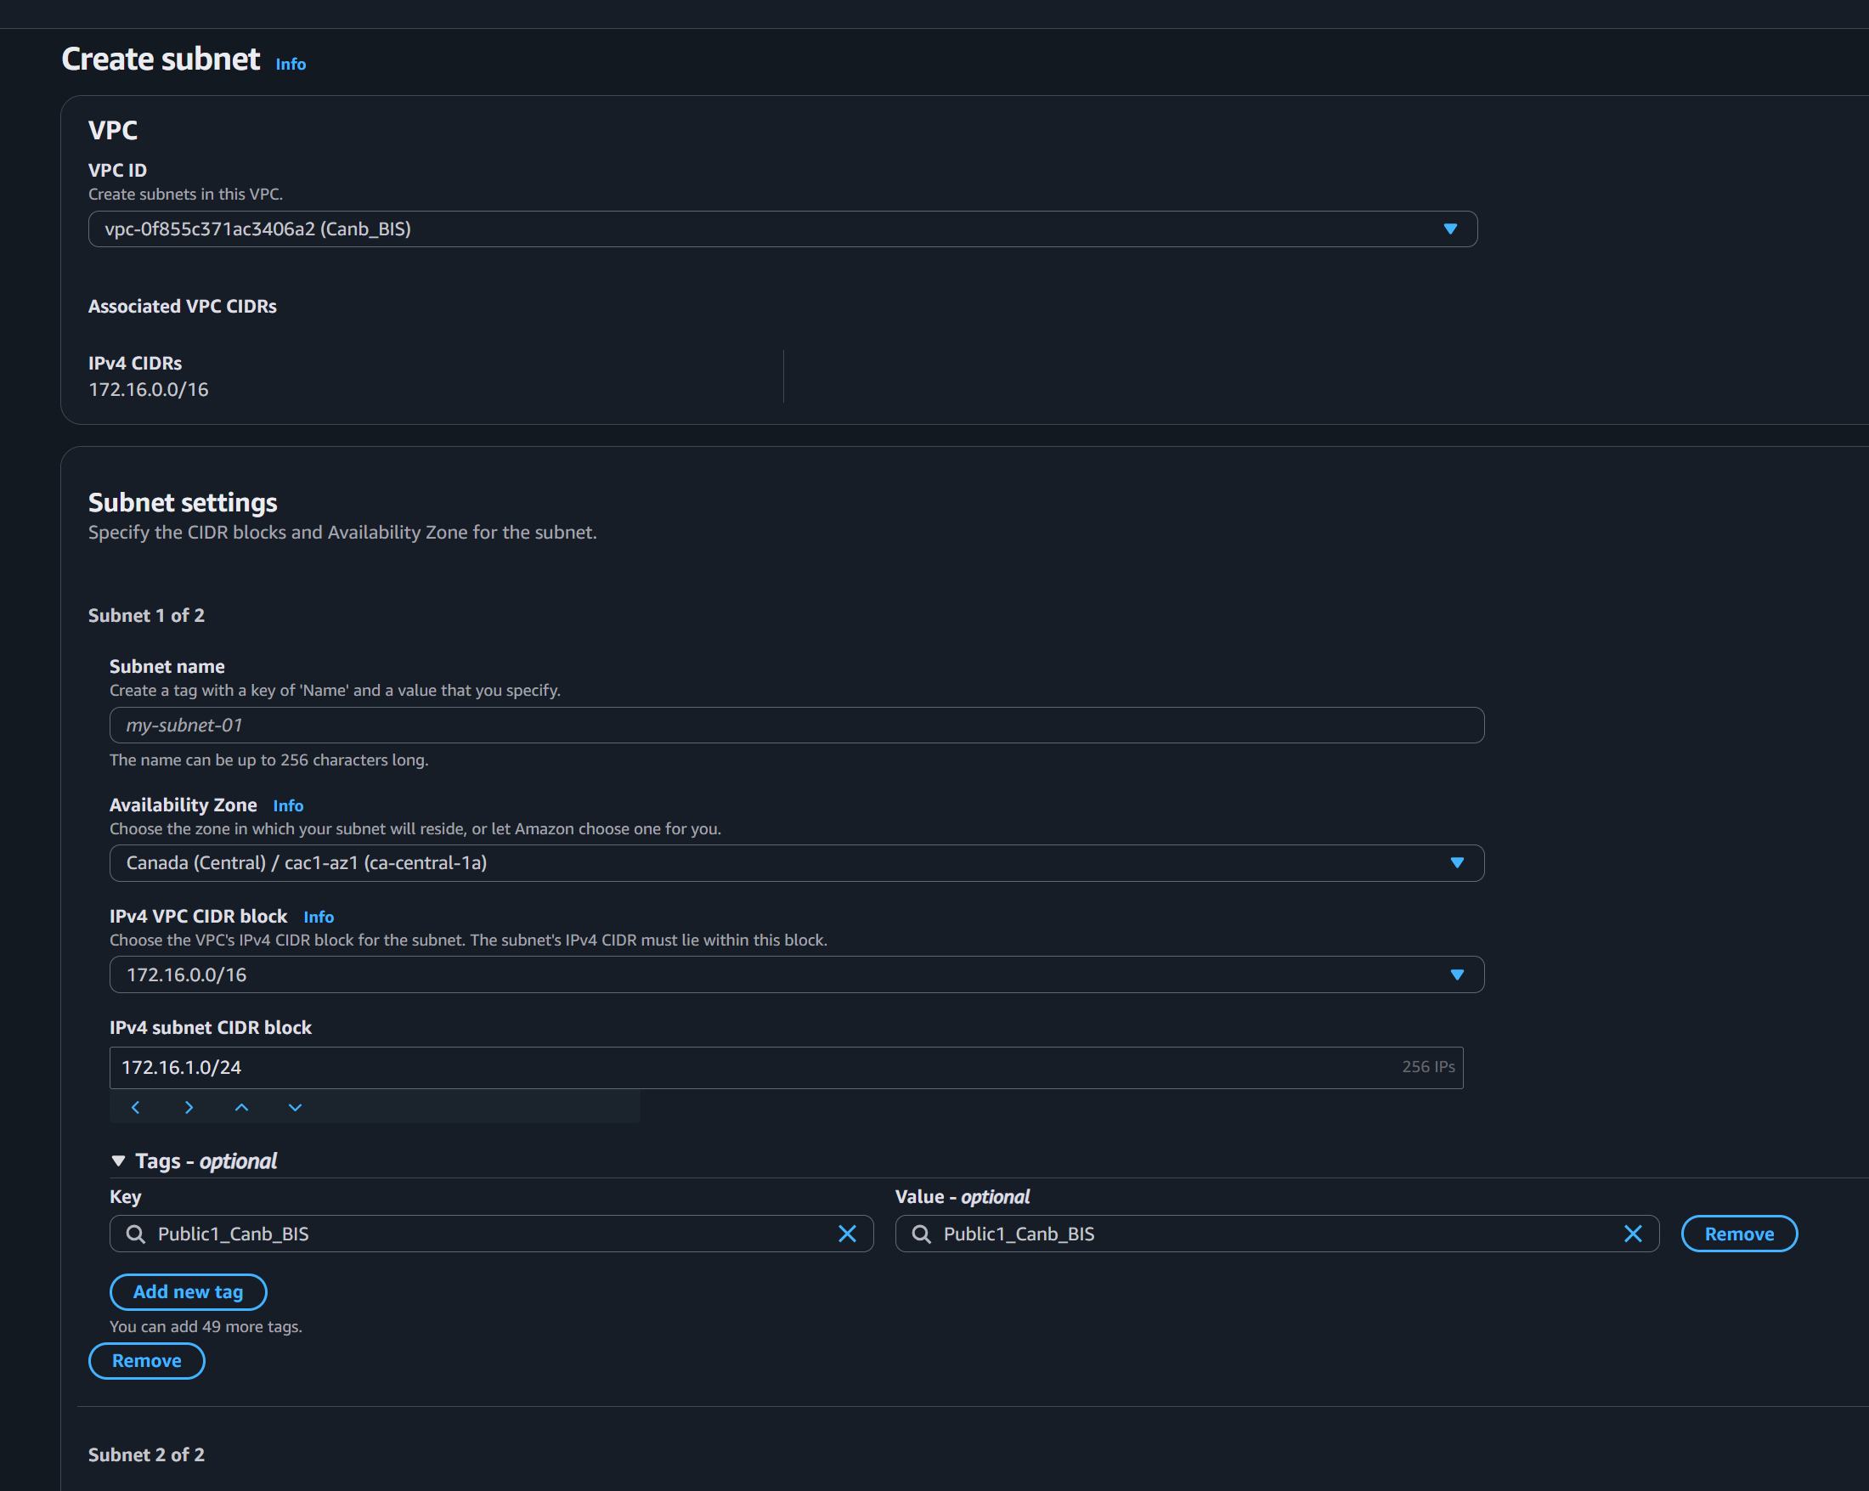

2.b: Private Subnet:
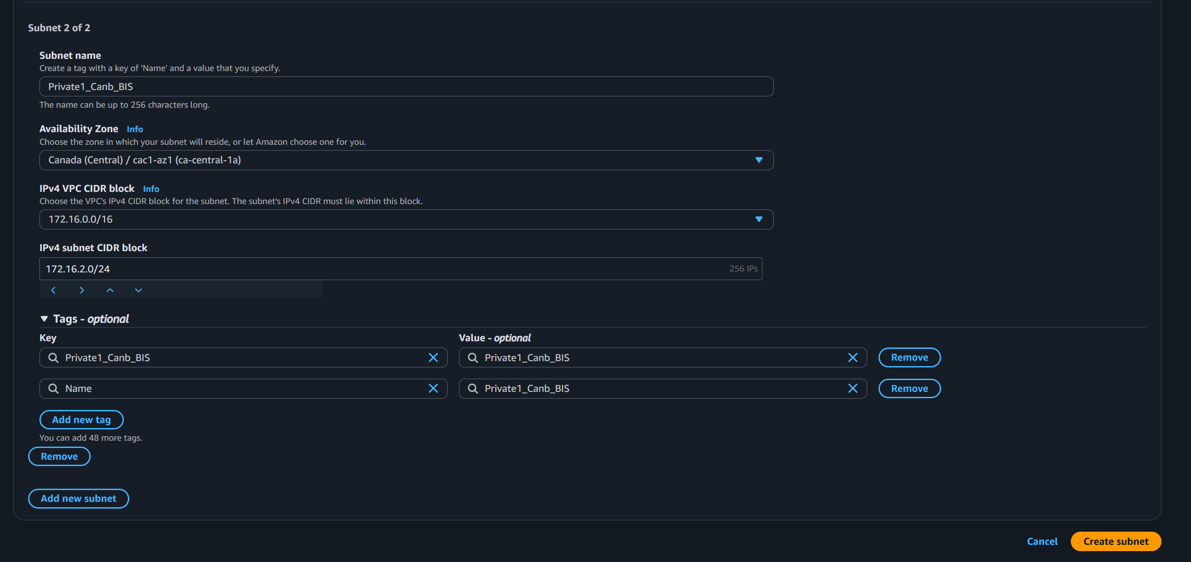

02.c: Two Subnets Created
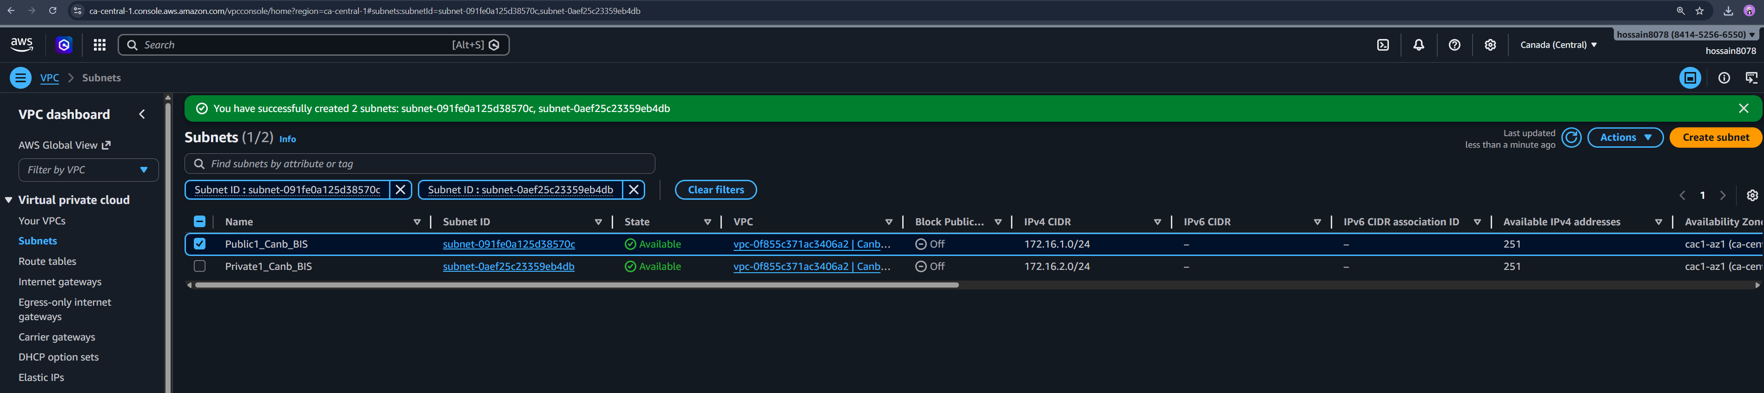

Step-3: I Created two NACLs inside my Canb_BIS VPC.
Network Access Control Lists (NACLs) set up stateless security control at the subnet level to control inbound and outbound traffic flow.

3.1: Selecting VPC to create NACL inside it.
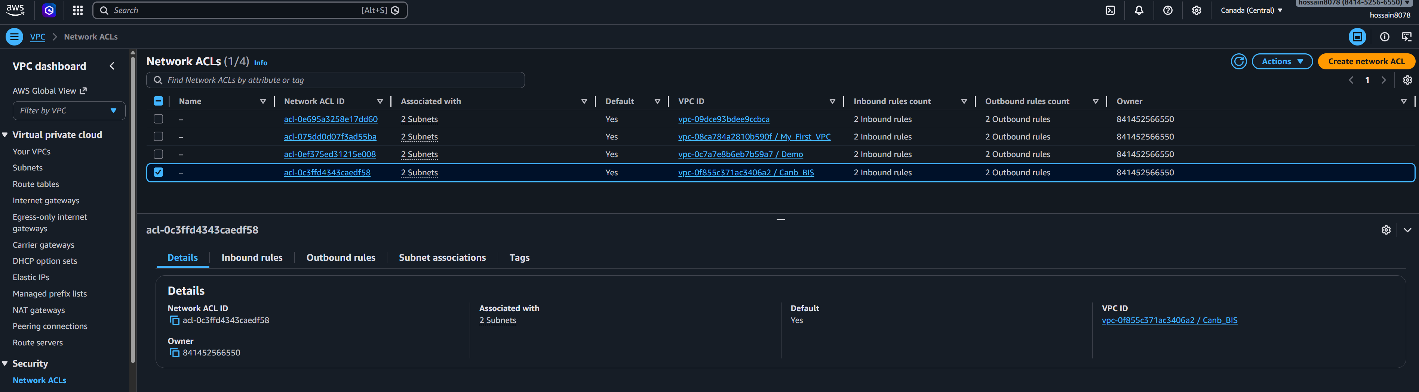

3.2.1: Creating public NACL
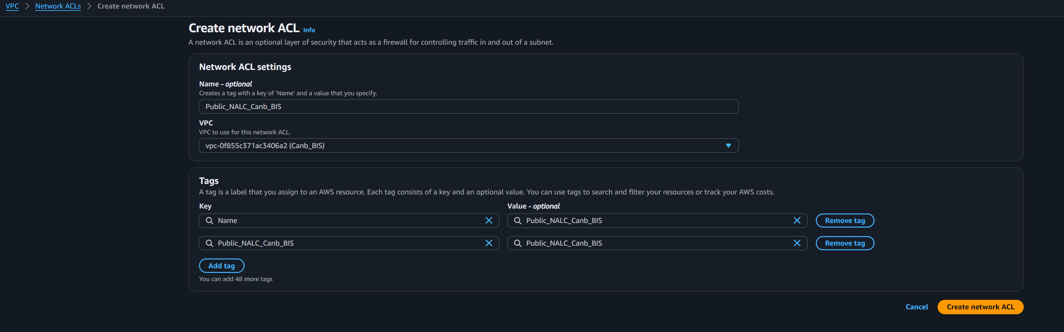

3.2.2: Setting up inbound rules:
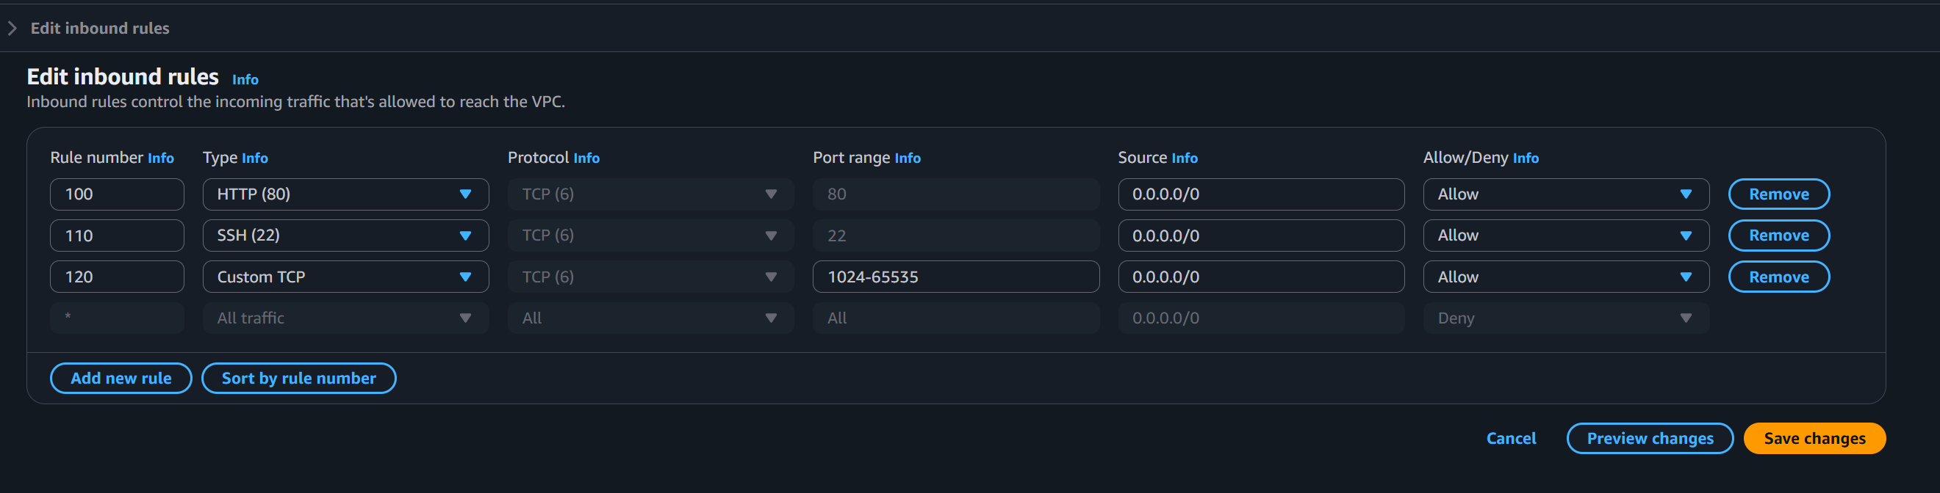

3.2.3: inbound rules set up done:
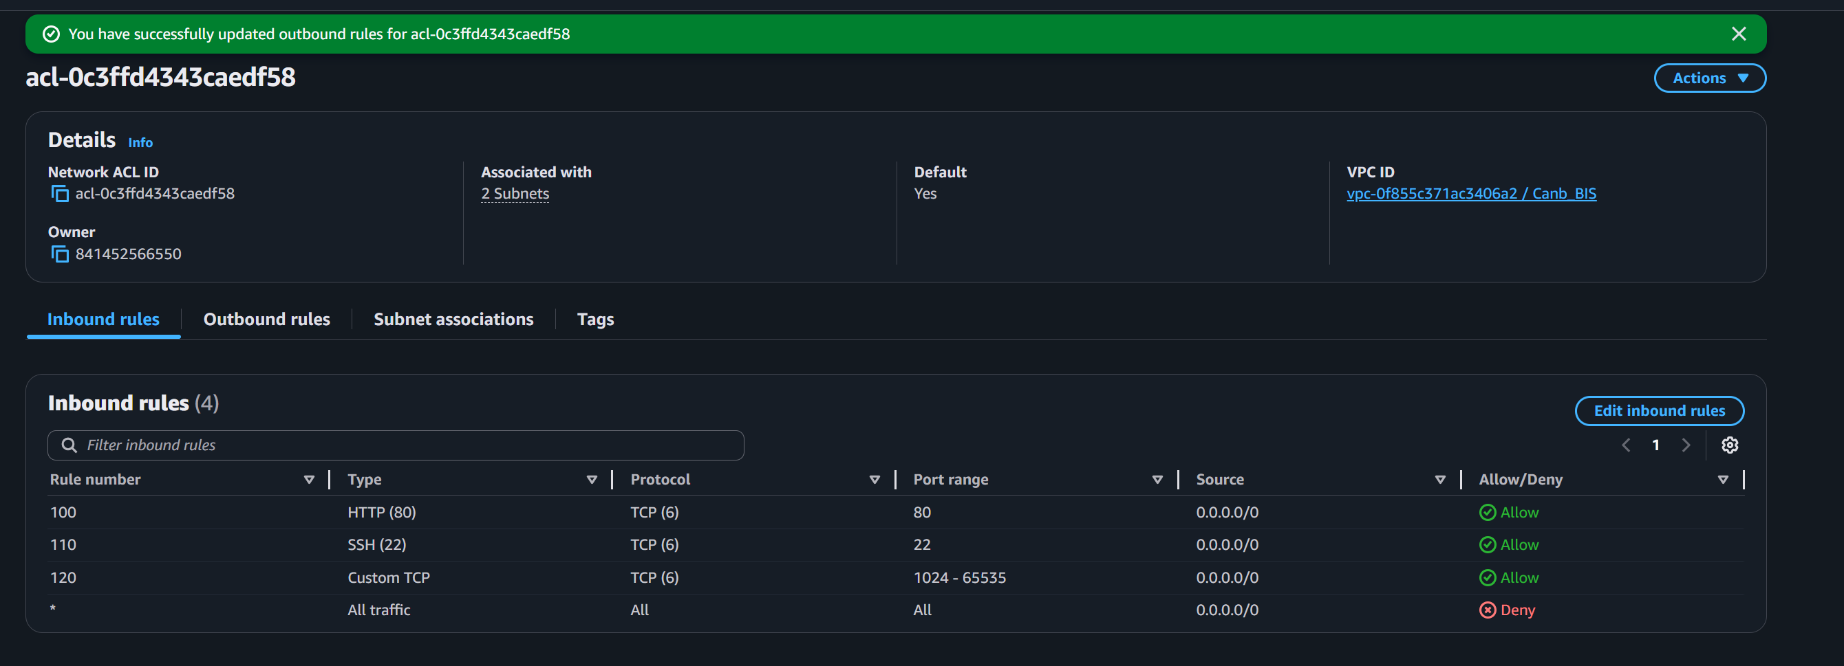

3.2.4: Setting up inbound rules:
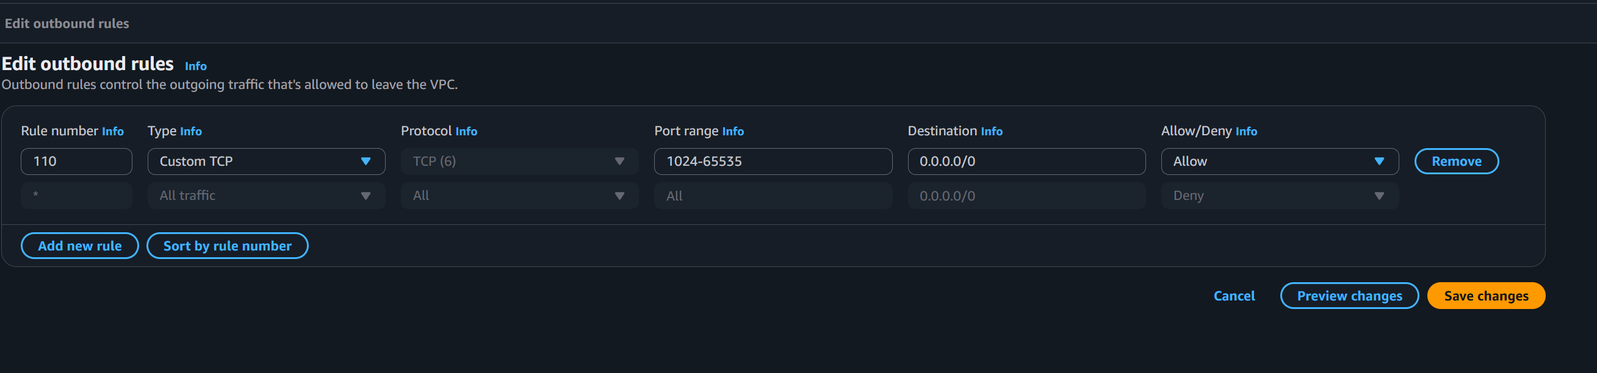

3.2.5: Outbound rules set up done:
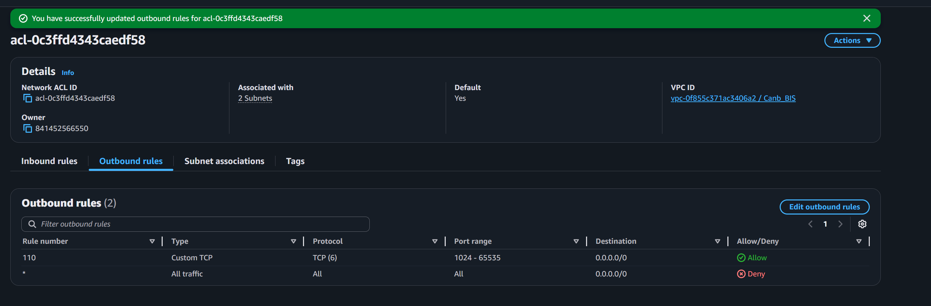

3.2.6: Public NACL with public subnet:
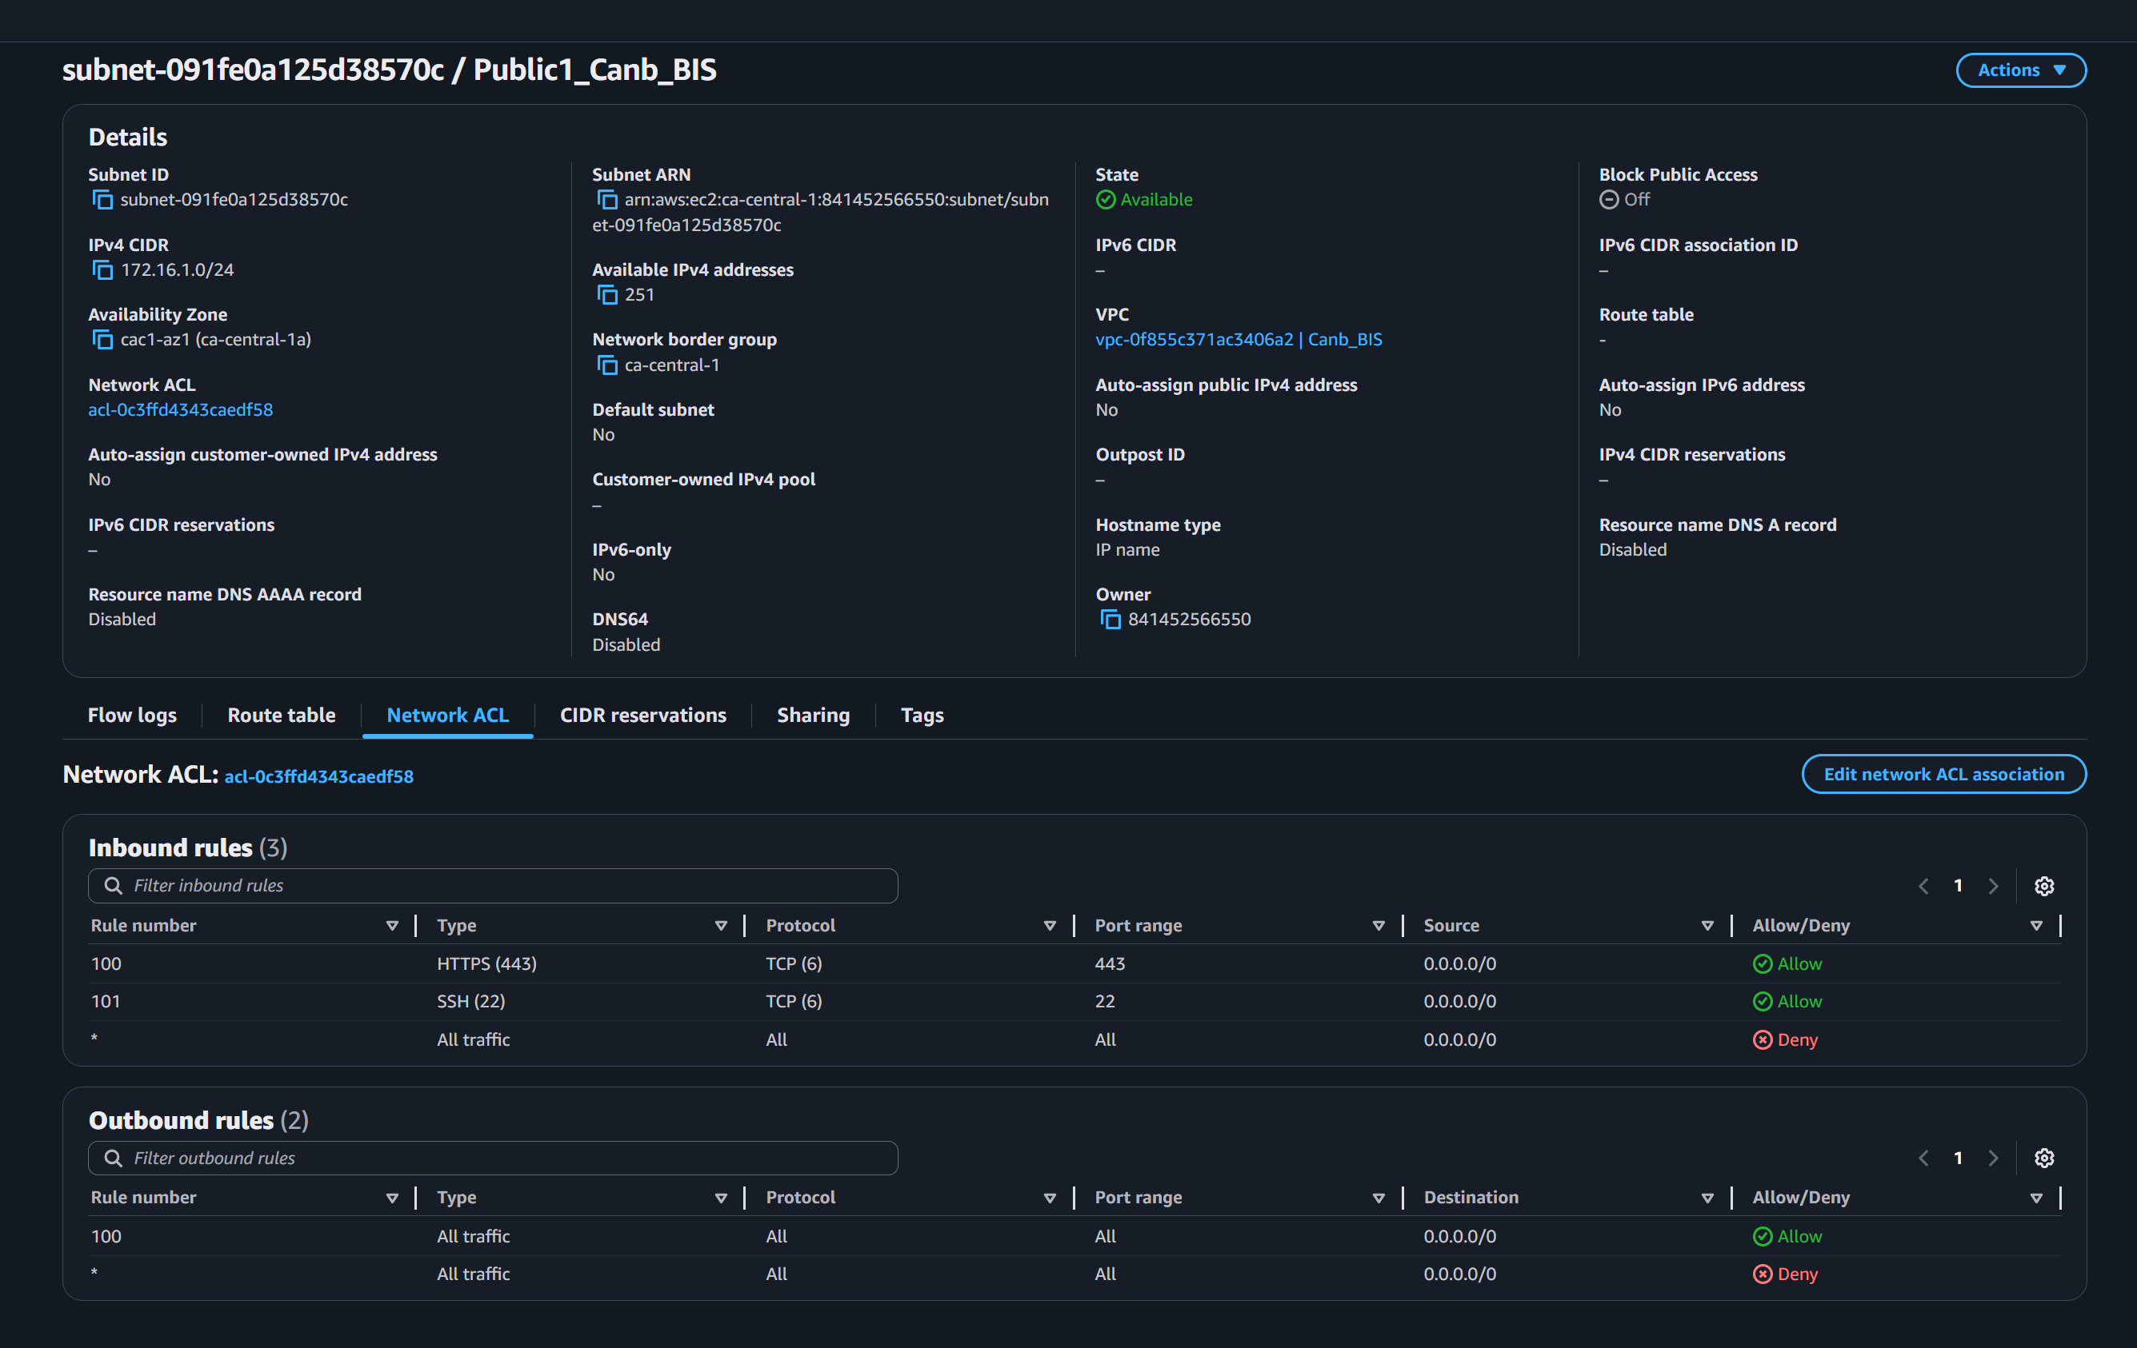

3.2.7: Associate public NACL with public subnet:
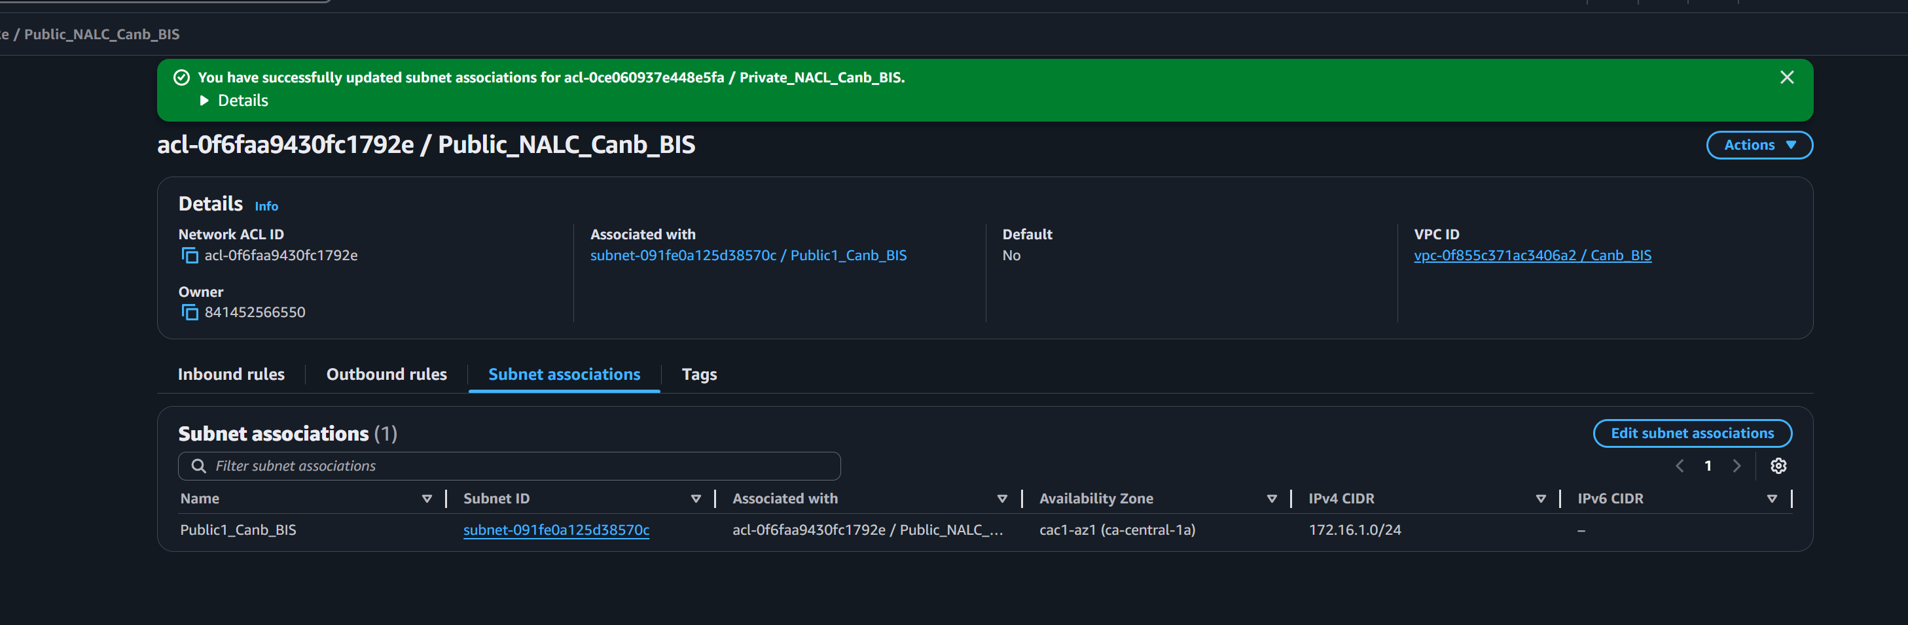

3.3.1: Creating private NACL Private_NACL_Canb_BIS

3.3.2: Setting up inbound rules:
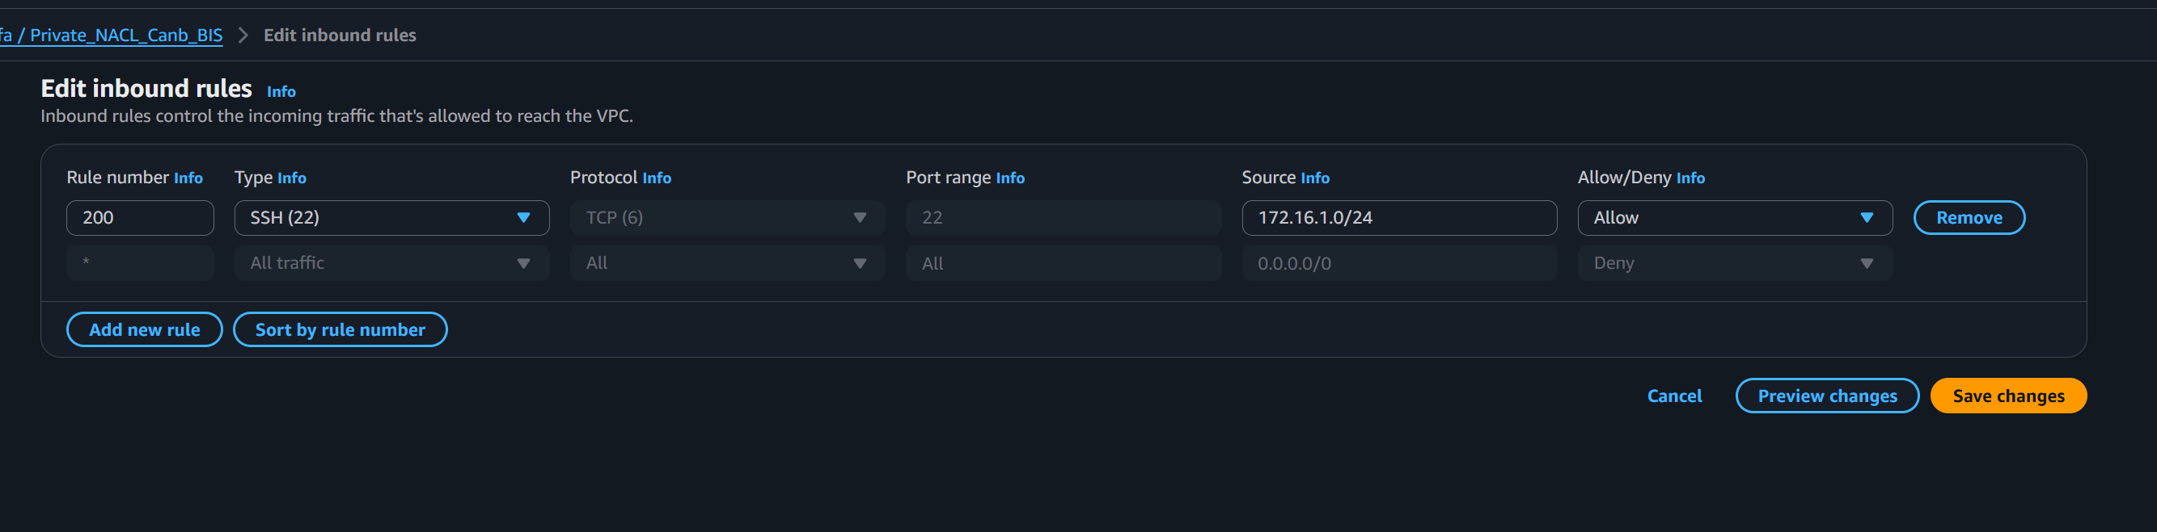

3.3.3: Inbound rules set up done:
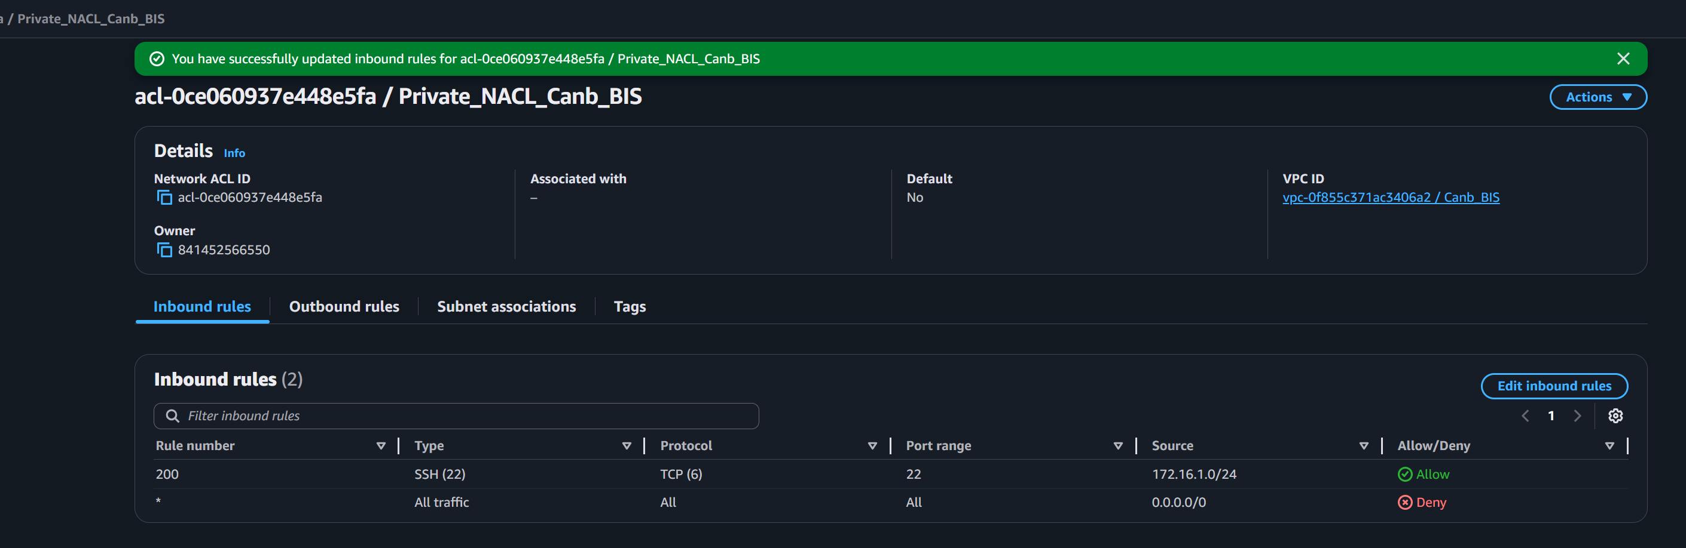

3.3.4: Setting up outbound rules:
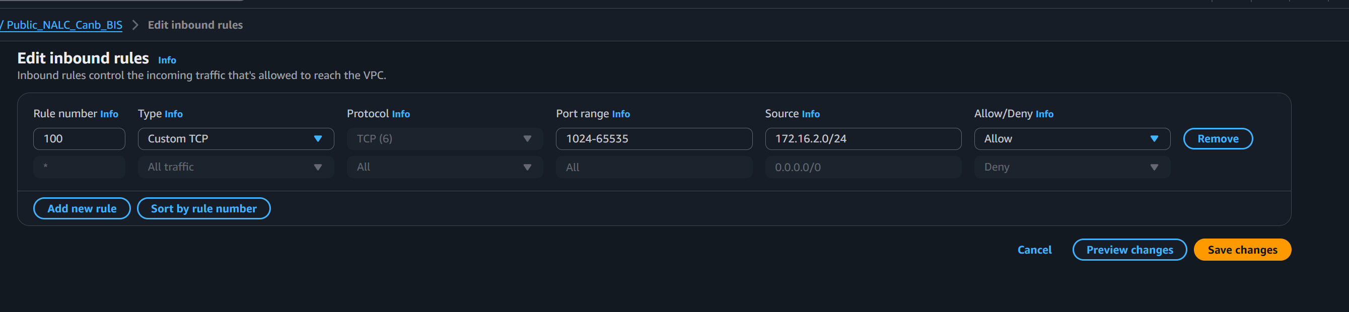

3.3.5: outbound rules set up done:
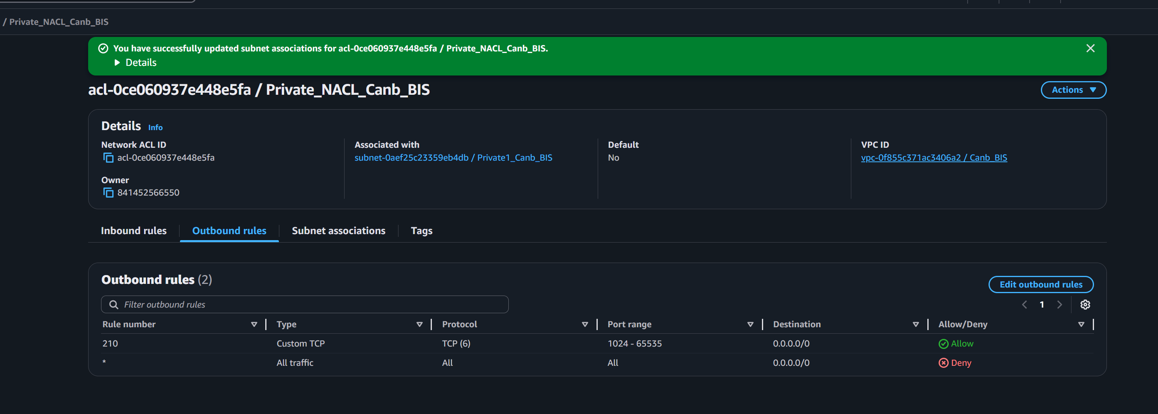
3.3.6: Associate private NACL with private subnet
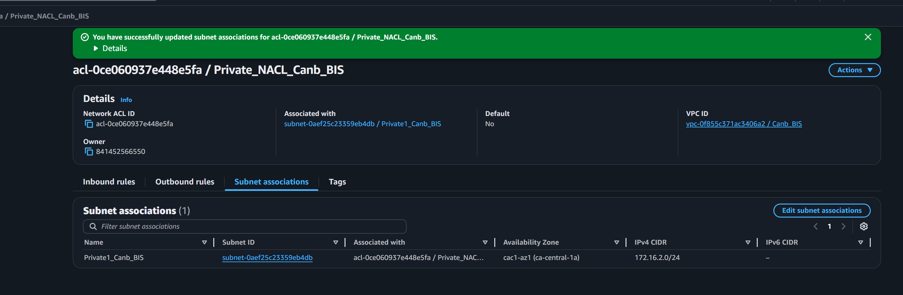

Step-4: Internet Gateway (IGW):
Creating and attaching an IGW to allow communication between your VPC and the internet.
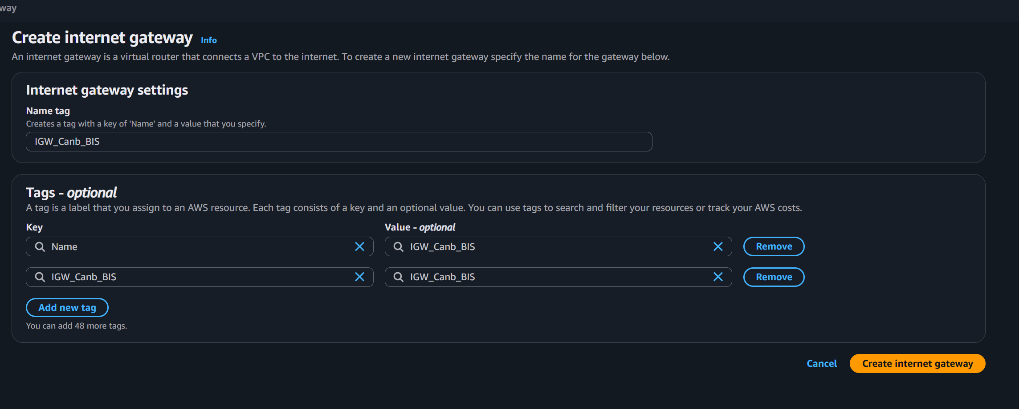

4.1: IGW created
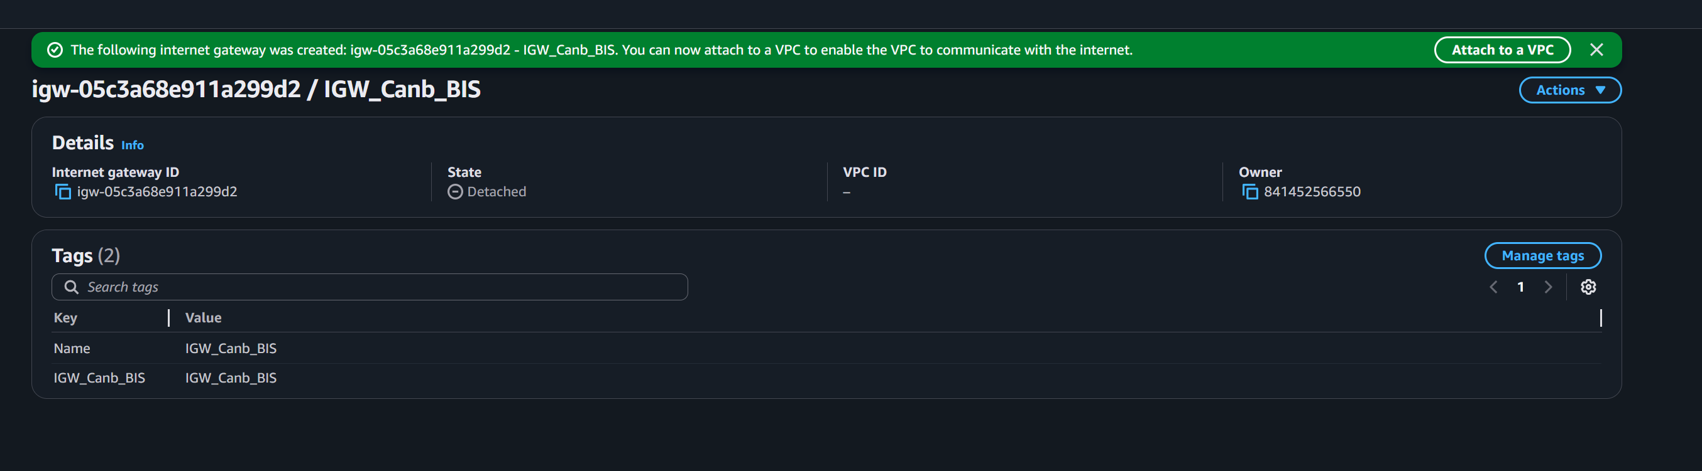

4.2: Attached IGW with public subnet inside VPC:
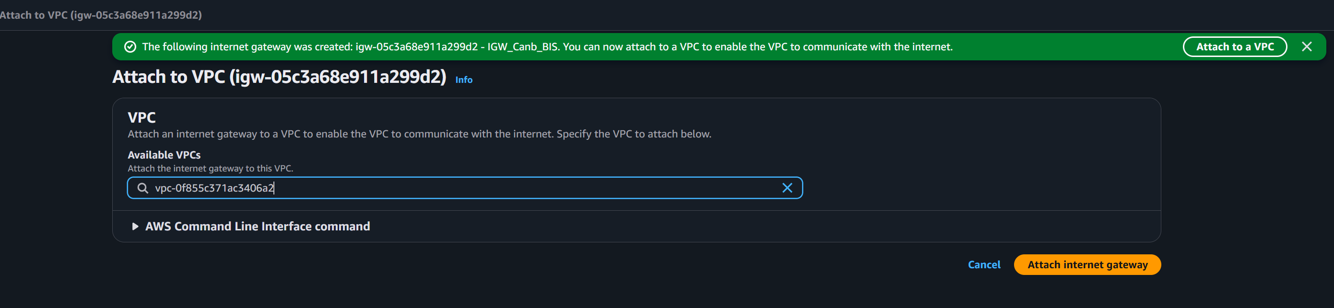

4.3: Attachment completed:
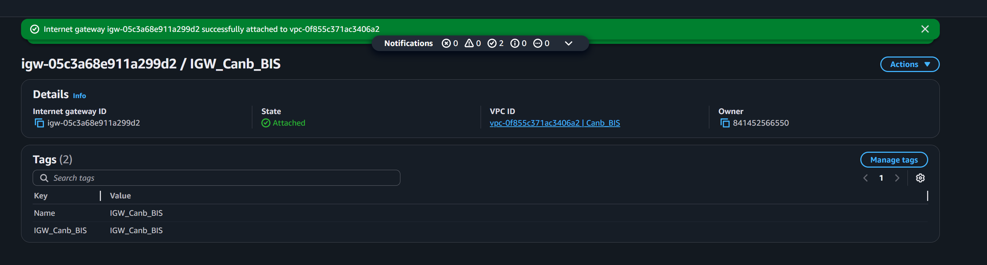

Step 5: Route Tables:
Configuring routing rules to direct traffic, with the Public Route Table using a default route to the IGW and the Private Route Table remaining isolated.
5.1: Creating Public Routing Table:
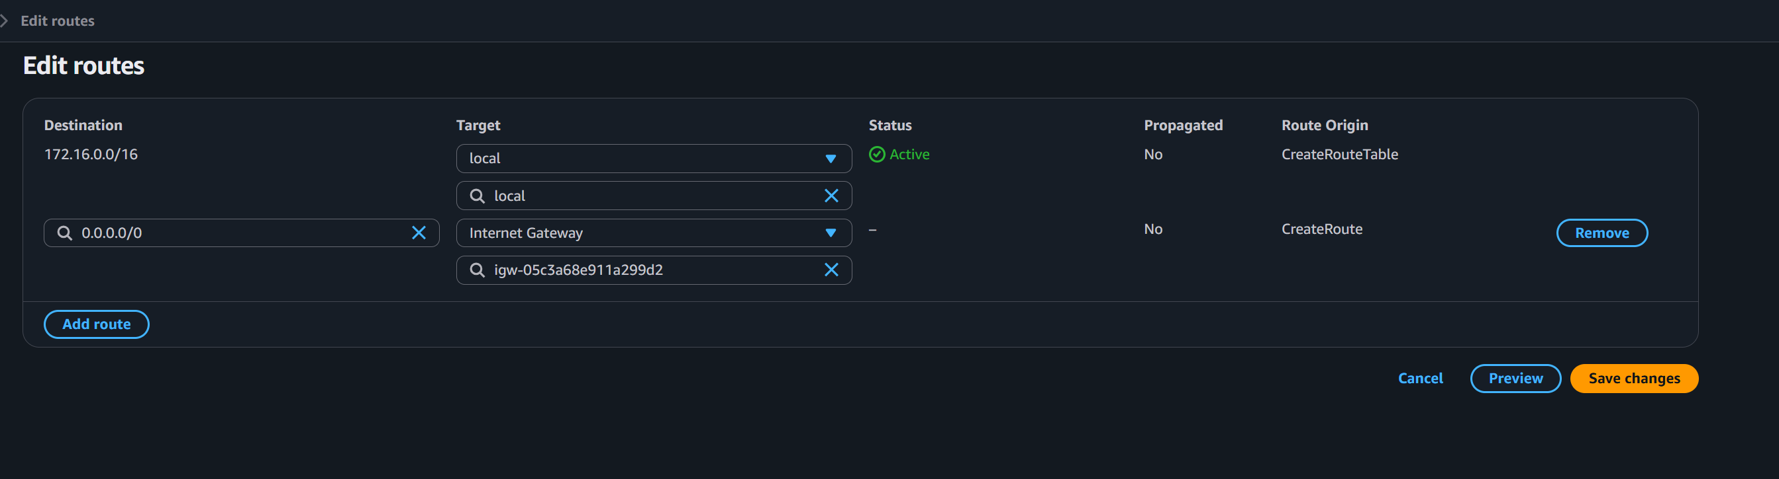

5.2: Public Routing Table created:
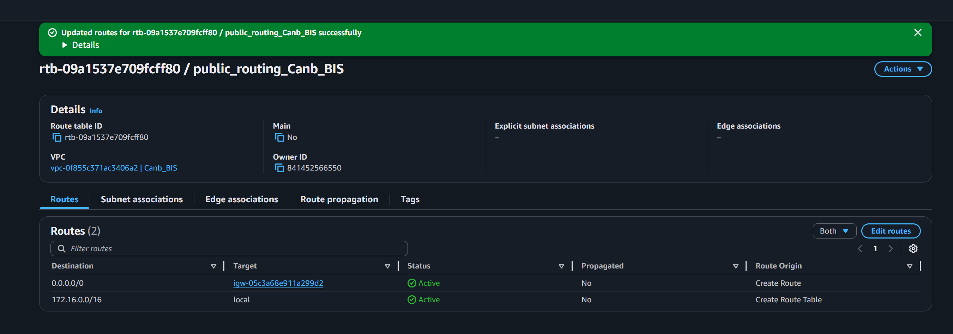

5.3: Creating Private Routing Table:
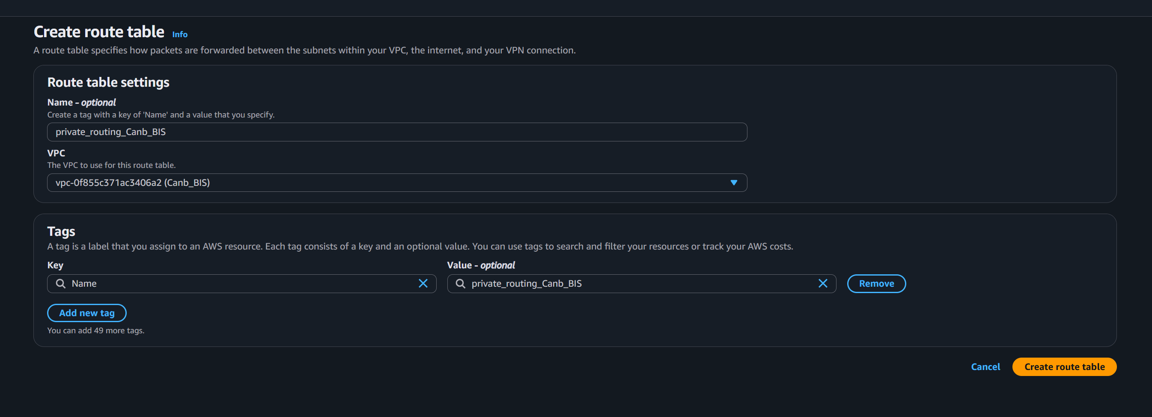

5.4 Private Routing Table created:
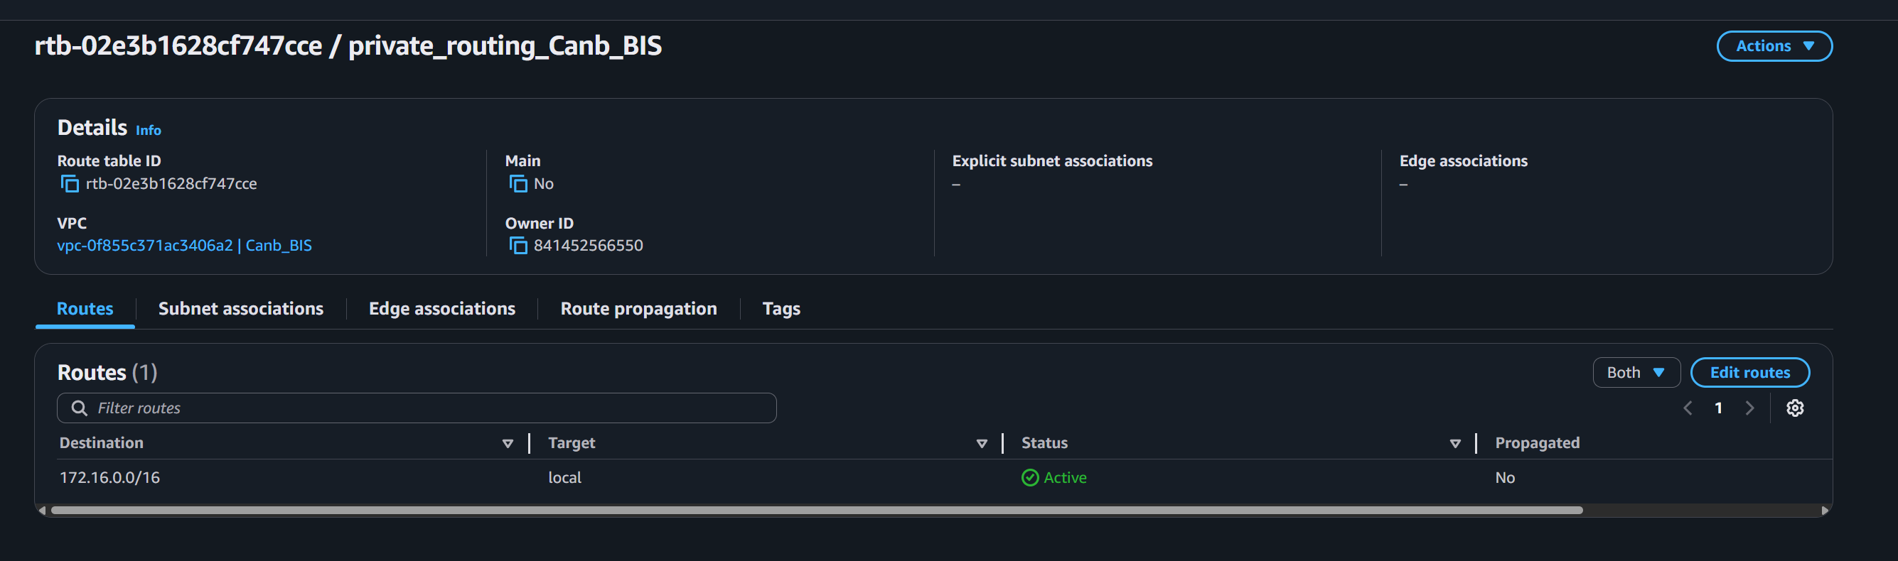
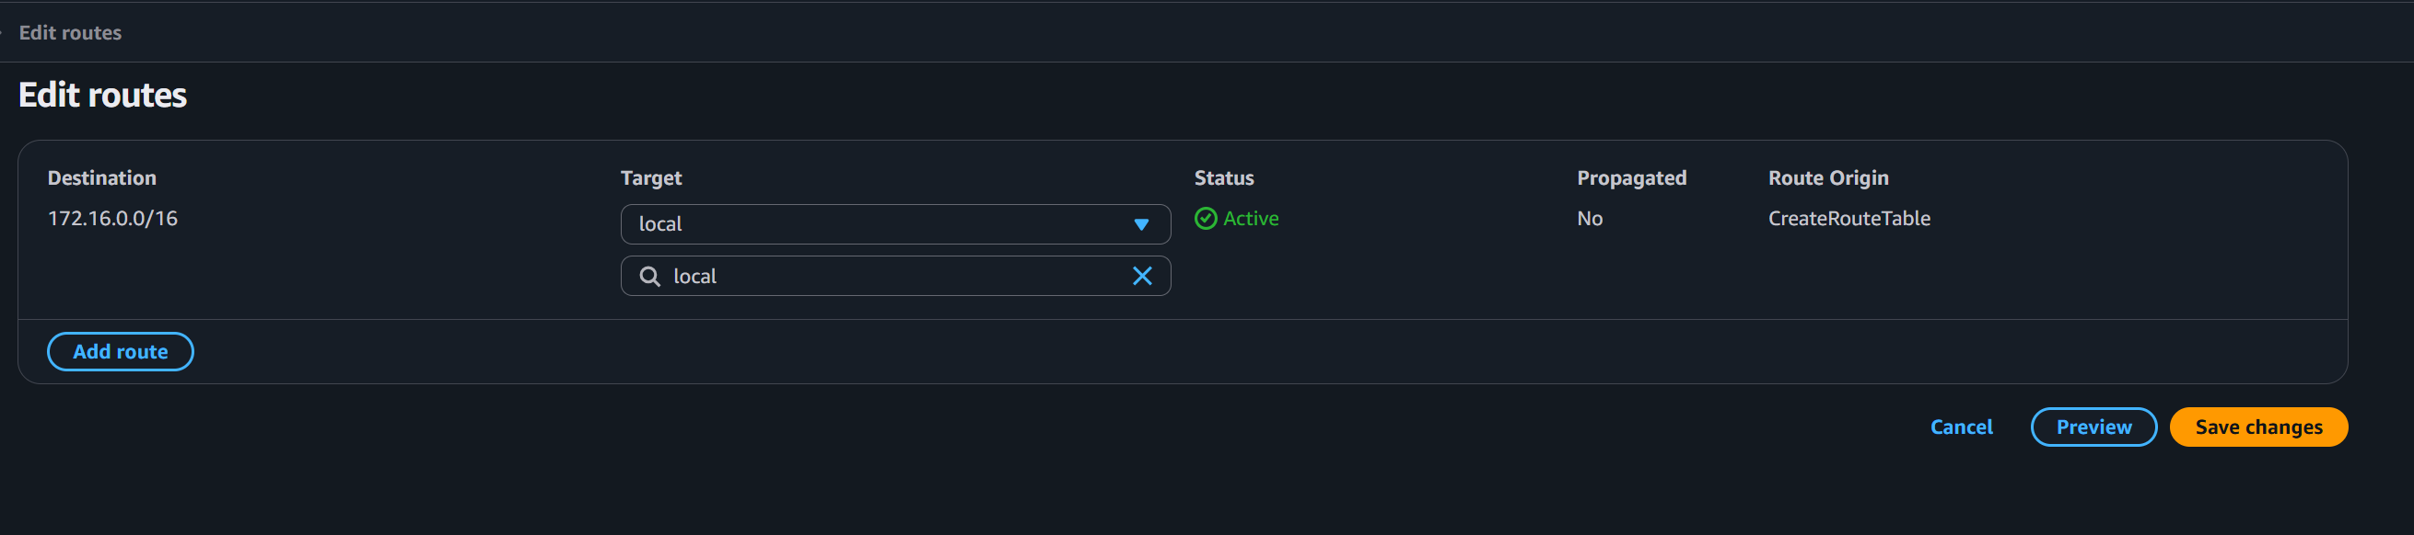
- What are the security benefits of this type of VPC layout?
This "DMZ" style layout provides defense in depth. By isolating sensitive resources in a private subnet, they are not reachable from the internet, reducing the attack surface. Security is further layered by using both Route Tables (to control traffic flow) and NACLs (to act as a stateless firewall at the subnet level).
2. What types of resources might be housed in the public subnet (2 examples)?
- Bastion Hosts (Jump Boxes): Used to securely manage instances in private subnets.
- External Load Balancers: To receive and distribute incoming web traffic from the internet.

3. What types of resources might be housed in the private subnet (2 examples)?
- Database Servers: Such as RDS instances or self-managed MySQL/PostgreSQL servers.
- Application Servers: Backend logic that should only communicate with the load balancer or internal services.

4. How would you allow database traffic between the two subnets?
You would need to update the Security Groups of the database instances to allow inbound traffic on the specific database port (e.g., 3306 for MySQL or 5432 for PostgreSQL) originating from the Security Group or CIDR of the public subnet. Additionally, the NACLs for both subnets must permit traffic on those specific ports and the corresponding ephemeral port ranges.

Bonus:
Creating Public security group allowing HTTP, SSH and HTTP for inbound traffic and all traffic for outbound:
Creating public instance attached it to public security group:
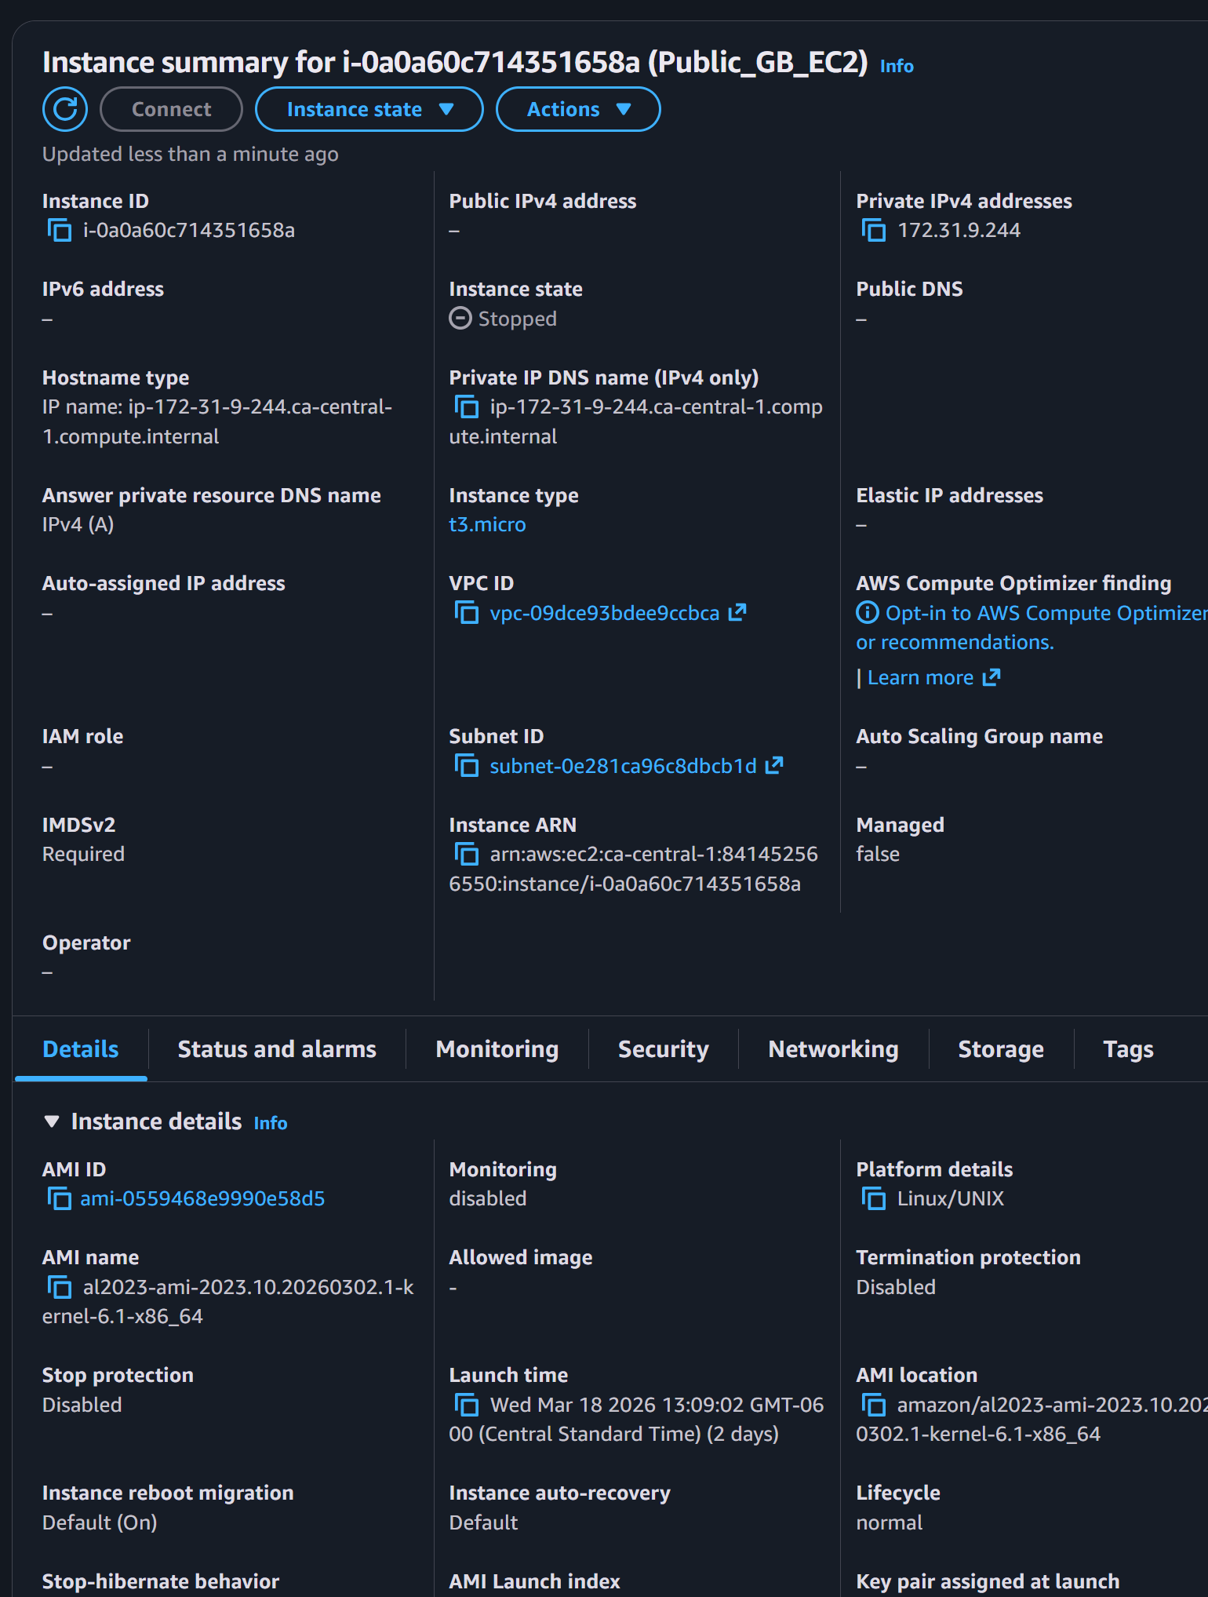
Creating private EC2 for connecting endpoint
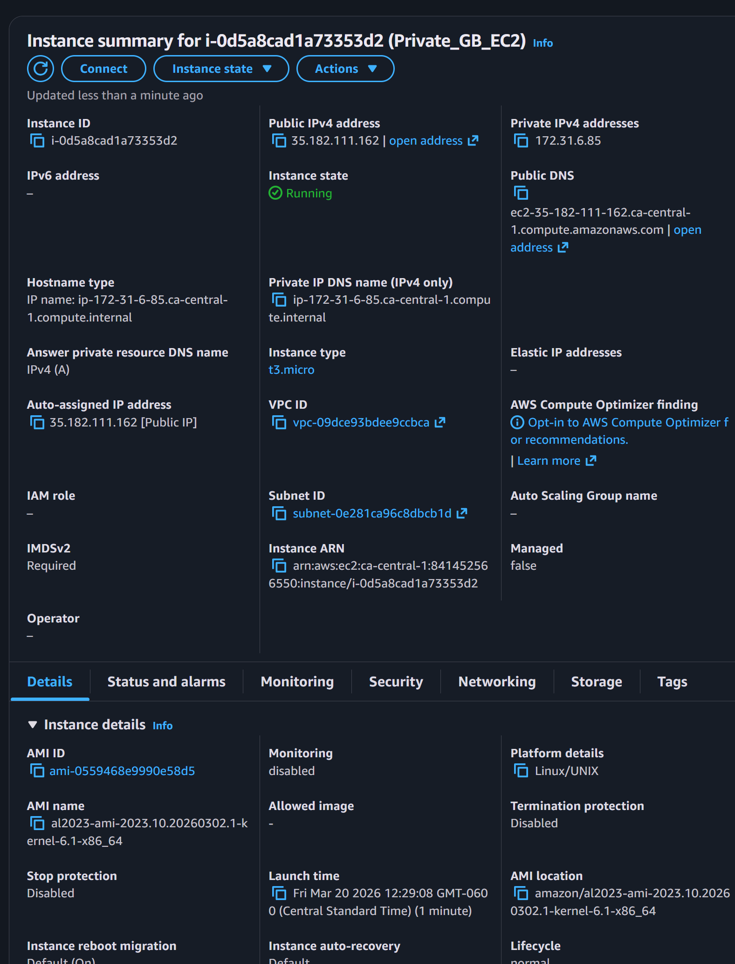

Creating public security groupd
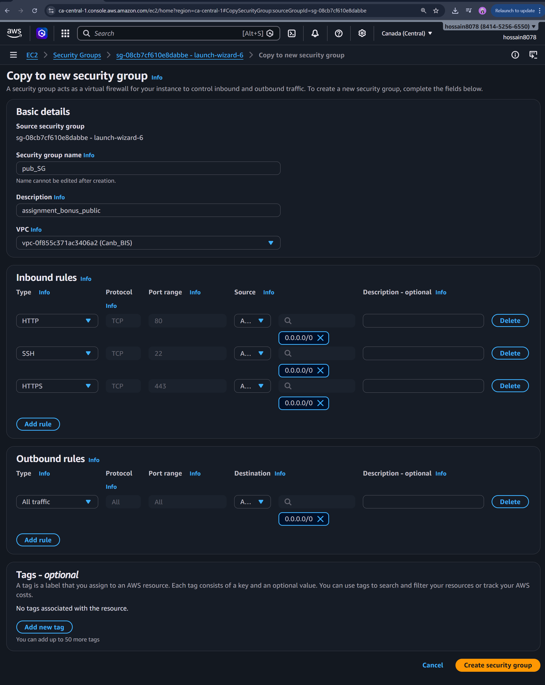
Public security group created:
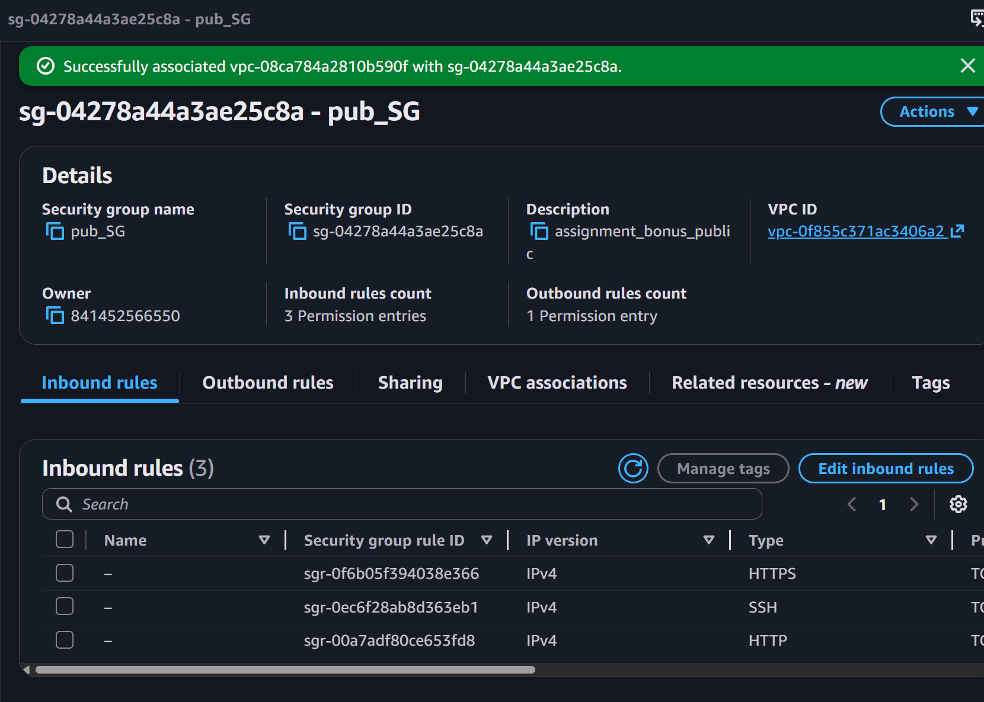

Creating Private Security Group: allowing source only my public network (inbound) and outbound for all traffic.
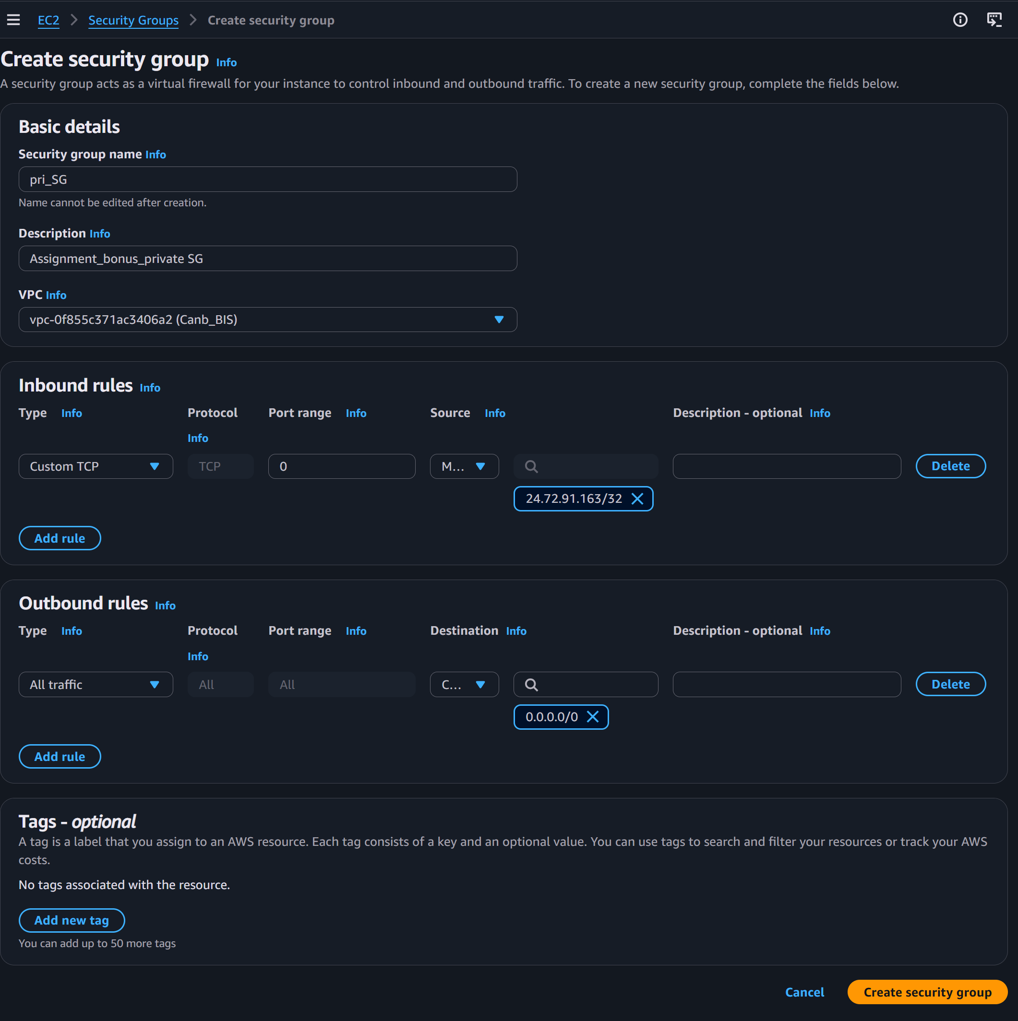
Private security group created:
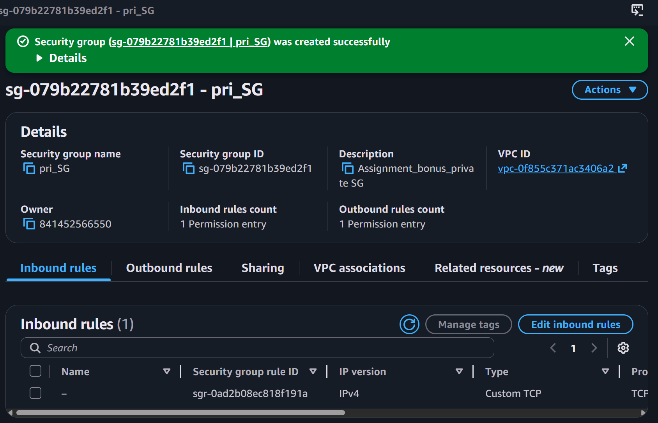

Creating Endpoint to connect public and private subnets. Public and private subnet will communicate through endpoint:
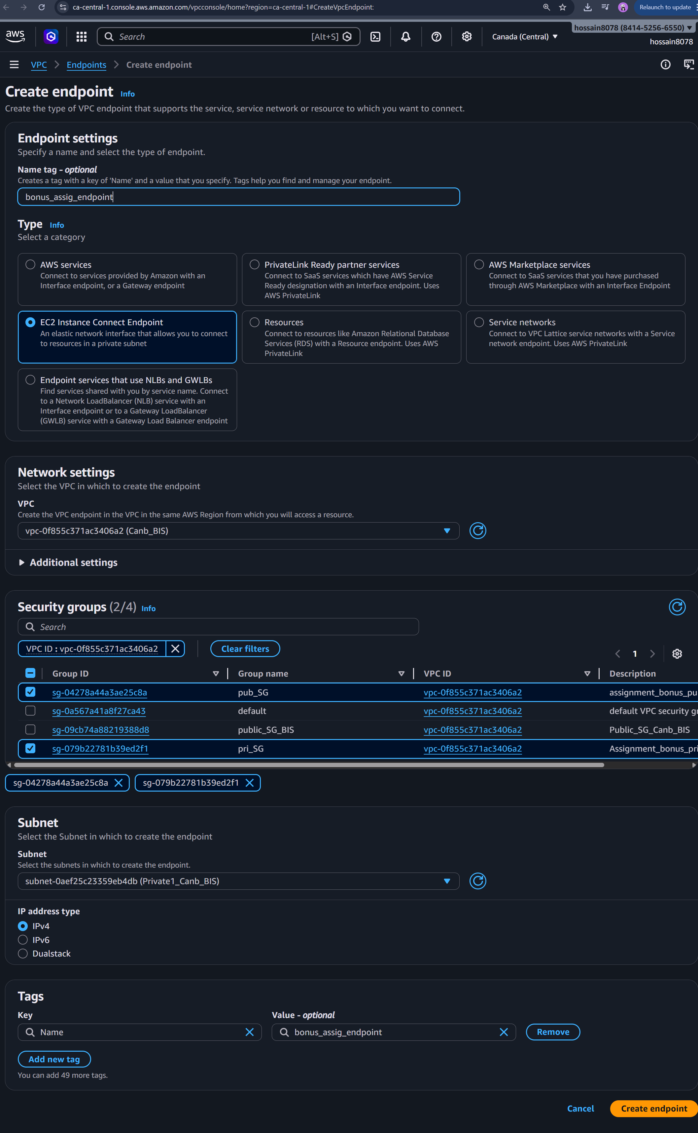
Endpoint created:
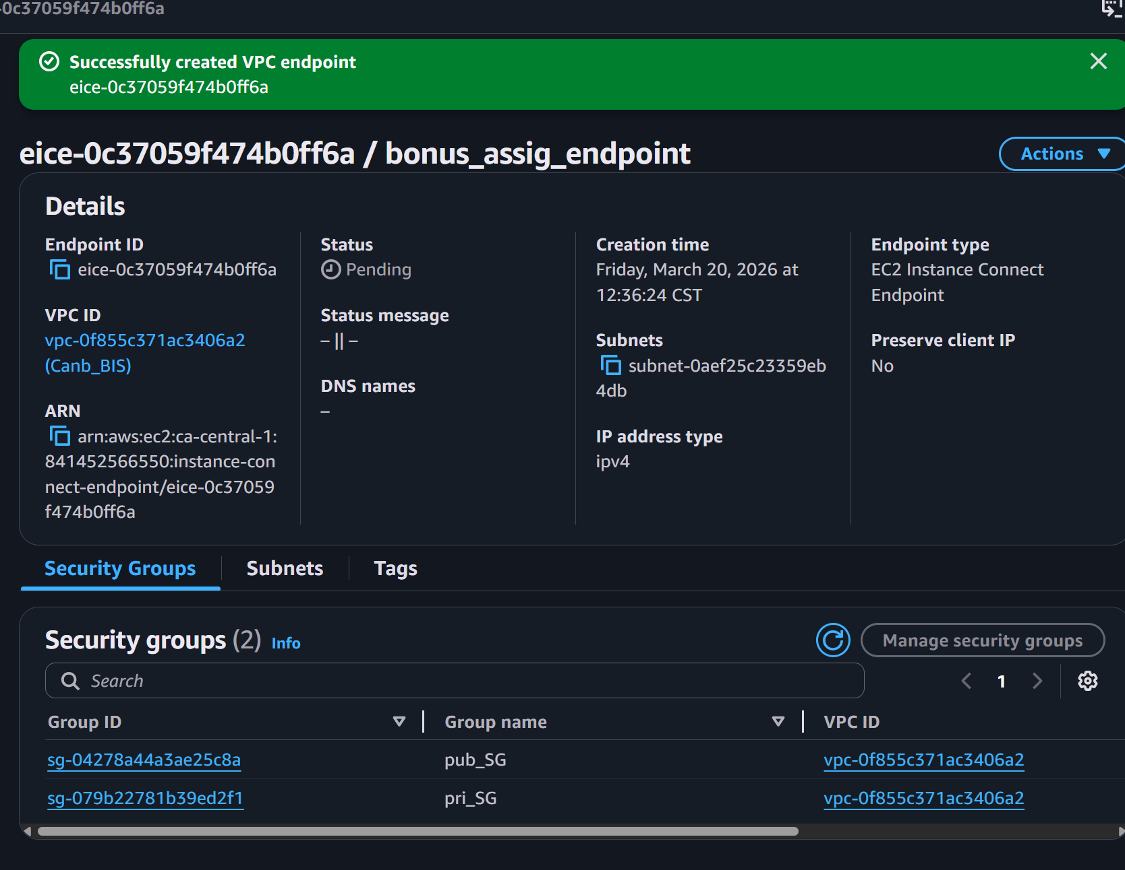
Note: here private instance will be connected to endpoint to communicate to public network to get access to other networks.
------------------------------------------------------------------------------------------------------------------------------

