Lab 6: Docker
Md Alamgir Hossain

01. Installing Docker
1.1 Signing up for Docker Account
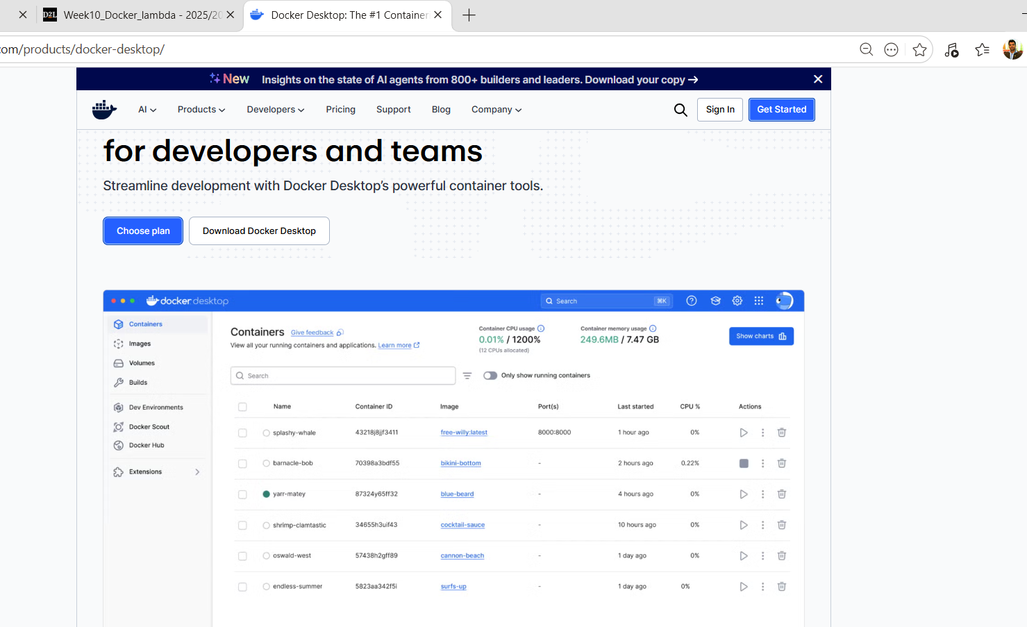
1.2 Creating Docker Account.
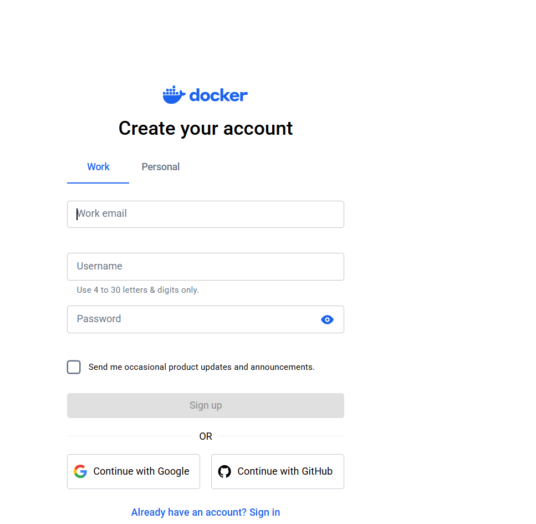

1.3 Signing in into Docker Account.
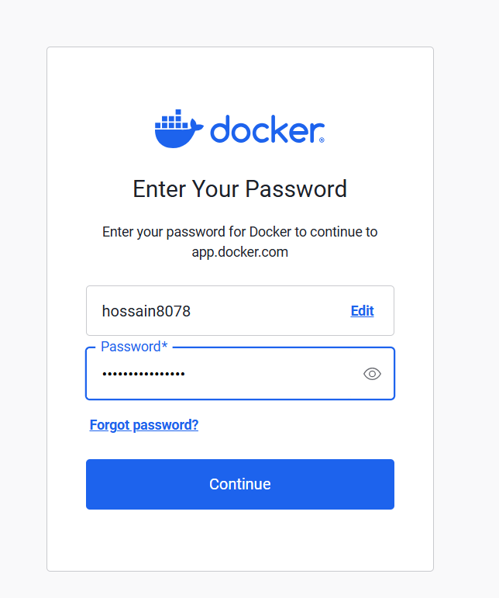
1.4 Signed in successfully.
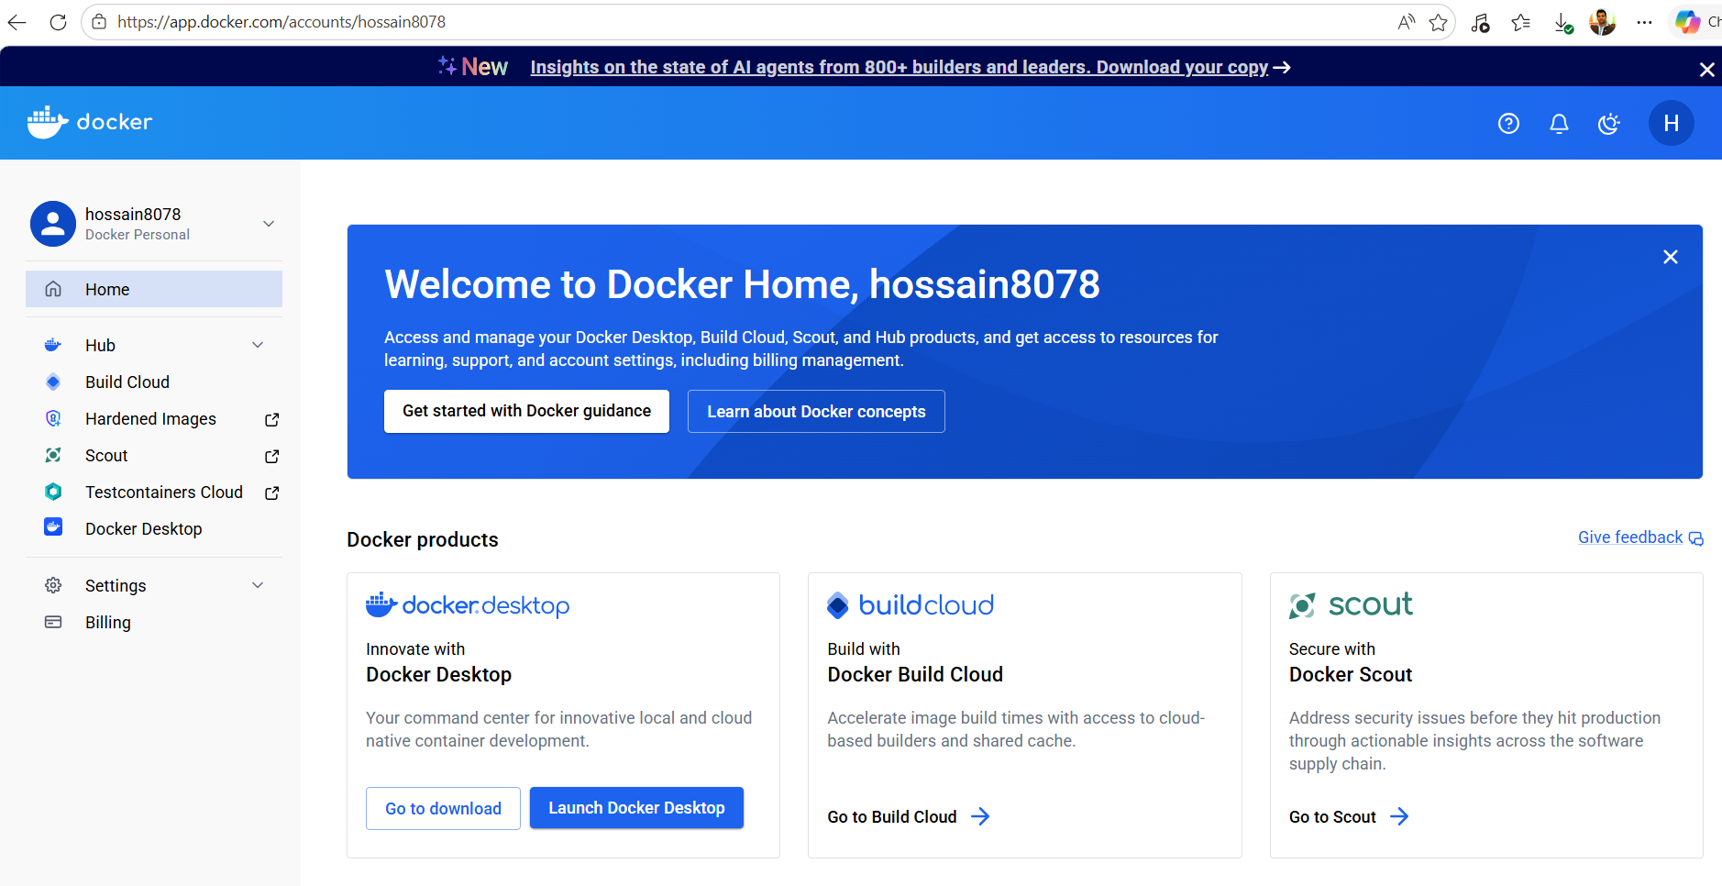
1.5 Downloading and Installing Docker Desktop
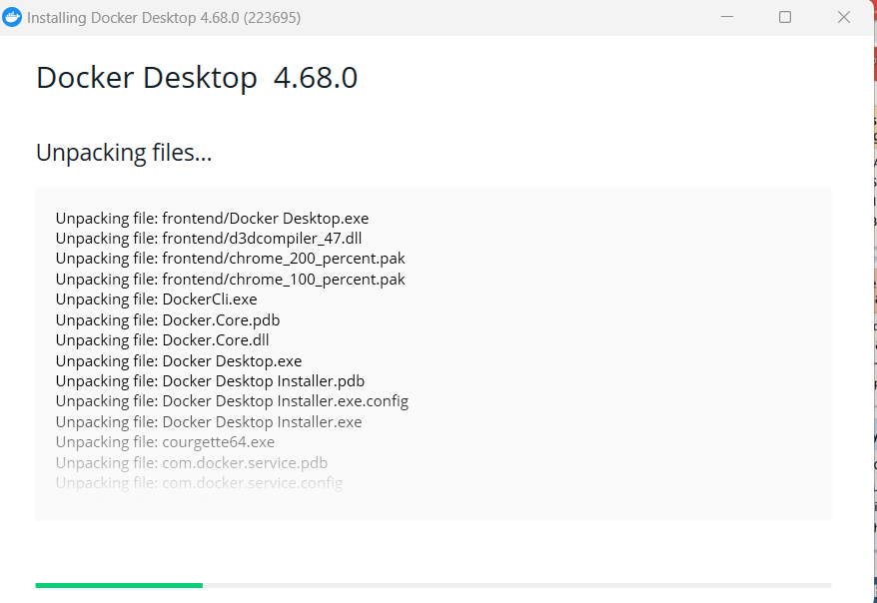
1.6 Installation Successful.
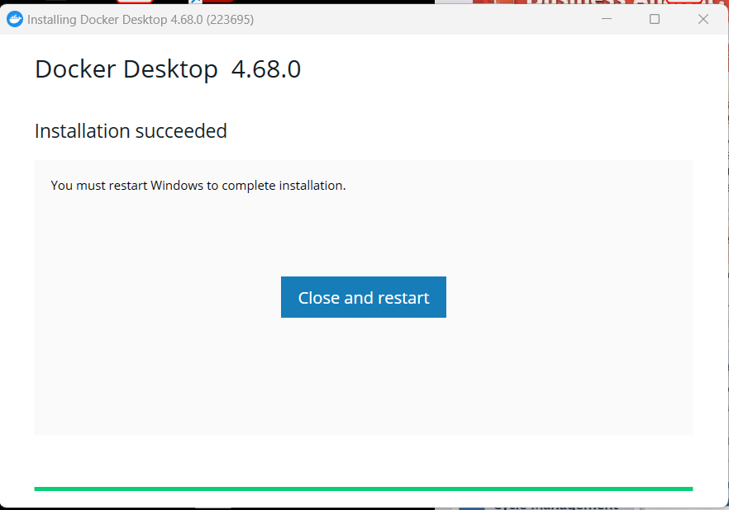

1.7 Signing in docker desktop with my user id and password.
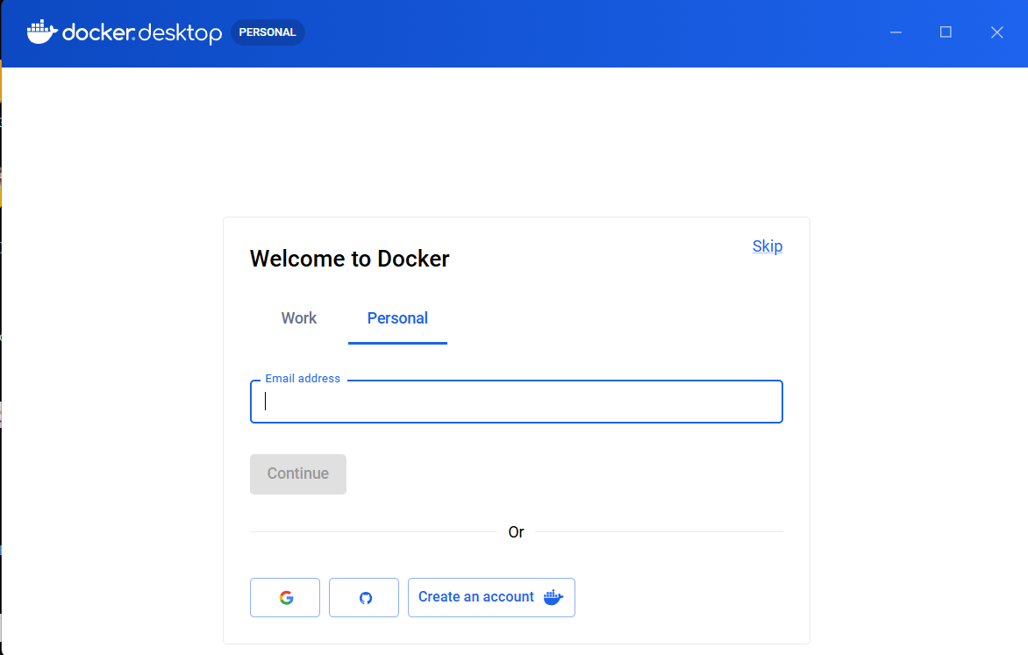

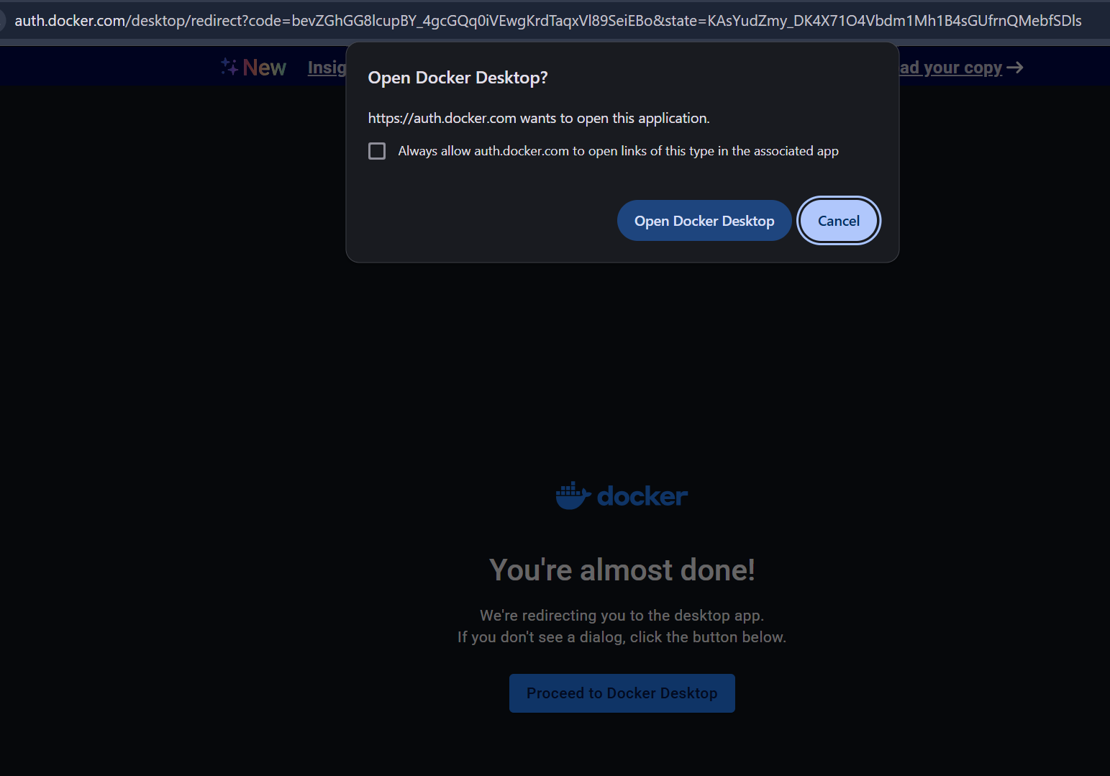

1.8 showing error to update wsl.
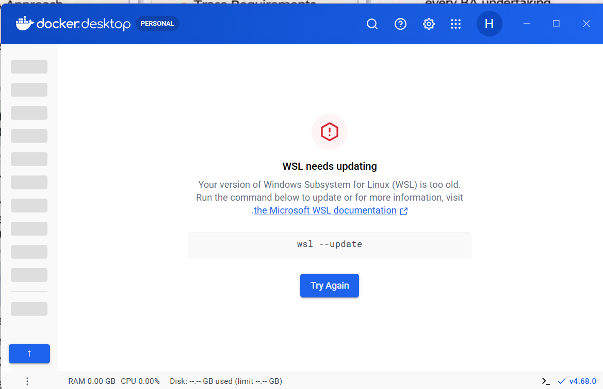

1.9 wsl updated
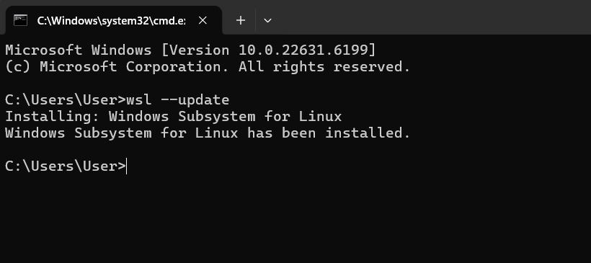

1.10 WSL opened:

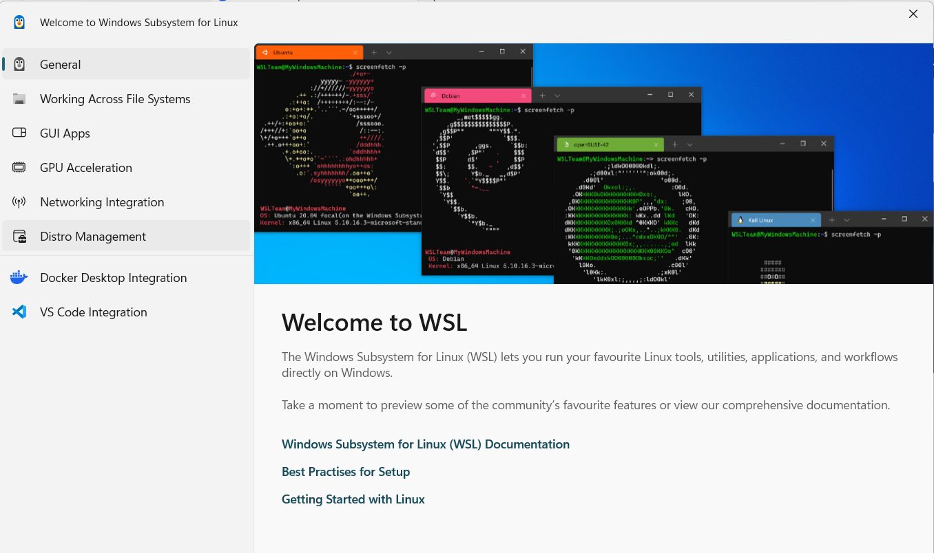
1.11 docker. Desktop opened with empty container.
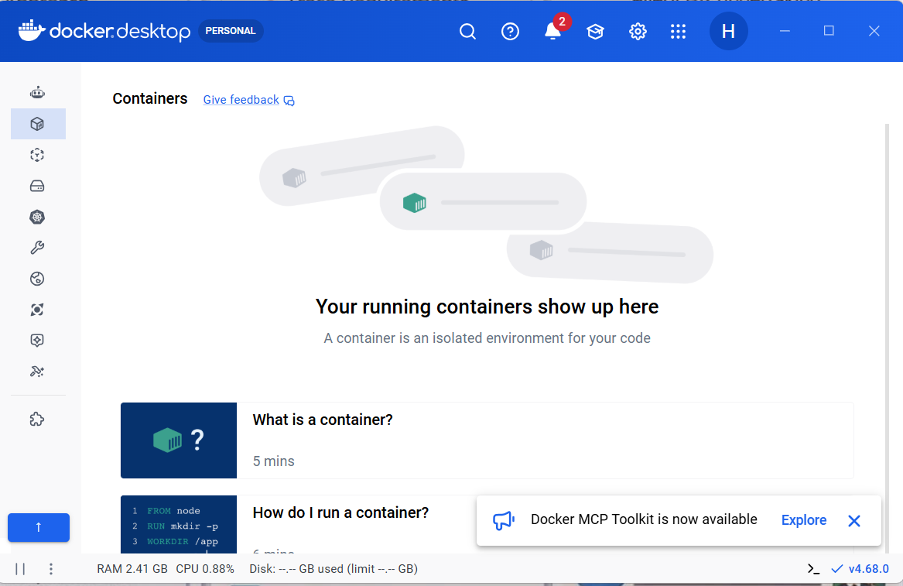

1.12 Run docker to verify it is working and create a container named hello-world.
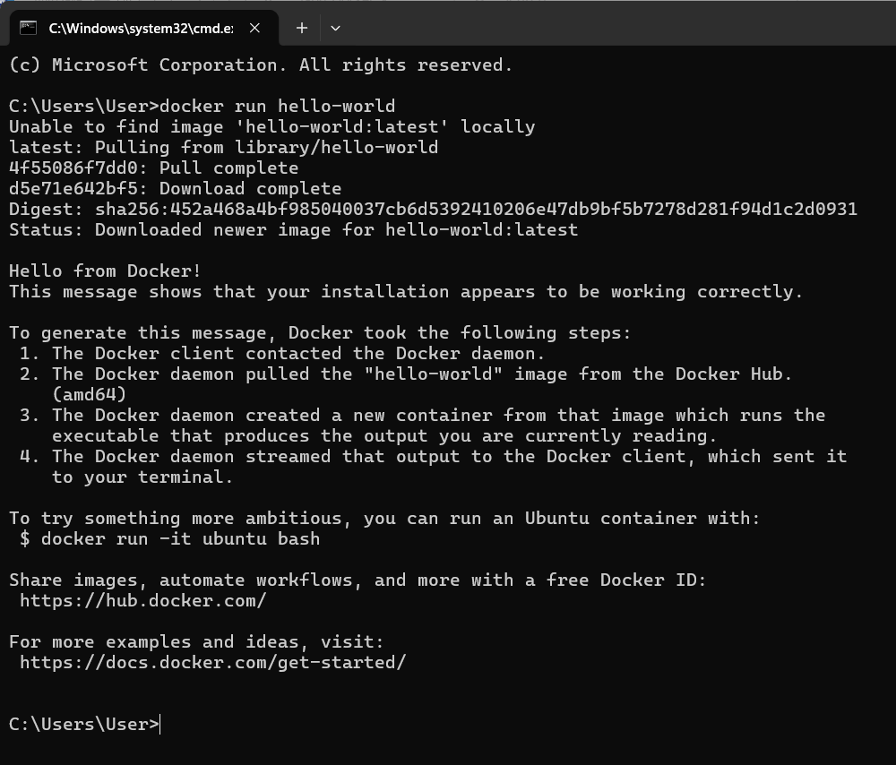
1.13 hello-world container created.
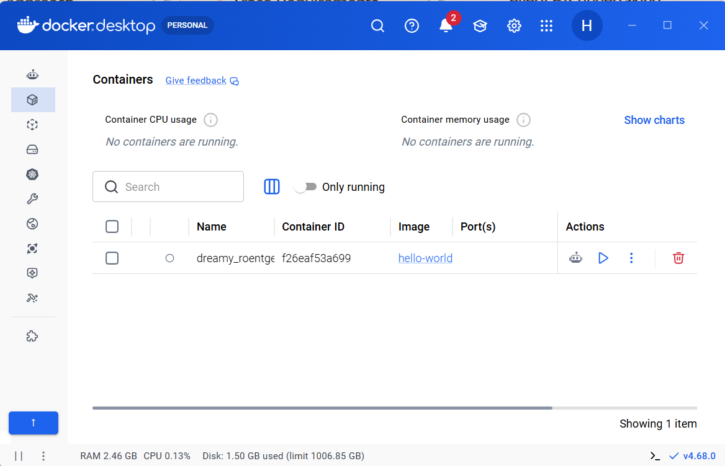

2.1 start by searching for buybox
docker run busybox
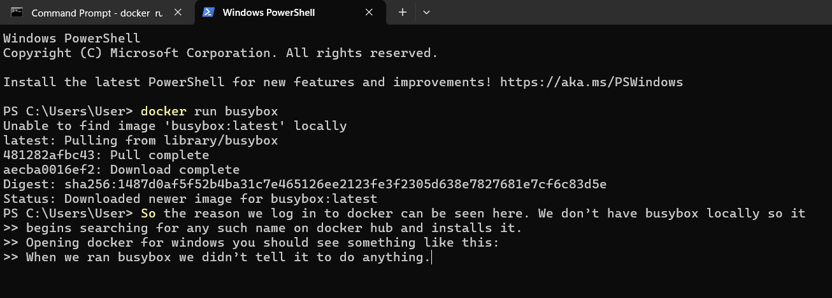
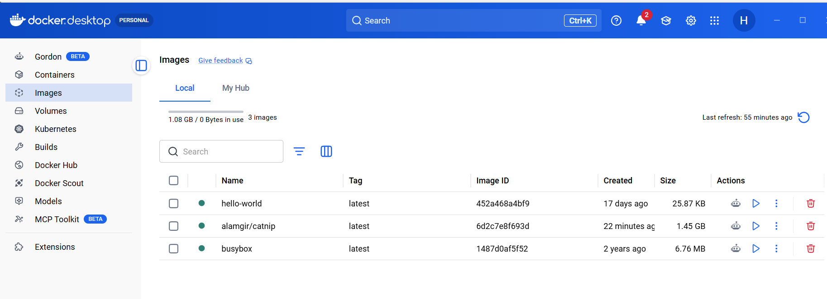
2.2 Docker run busybox echo “Hello from busybox”
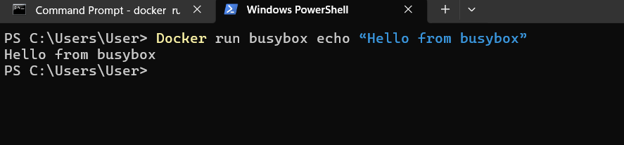

2.3 Look at what containers we have running
docker ps (zero container running), then run the code: (docker ps -a. It shows a timeline of when my containers have run.
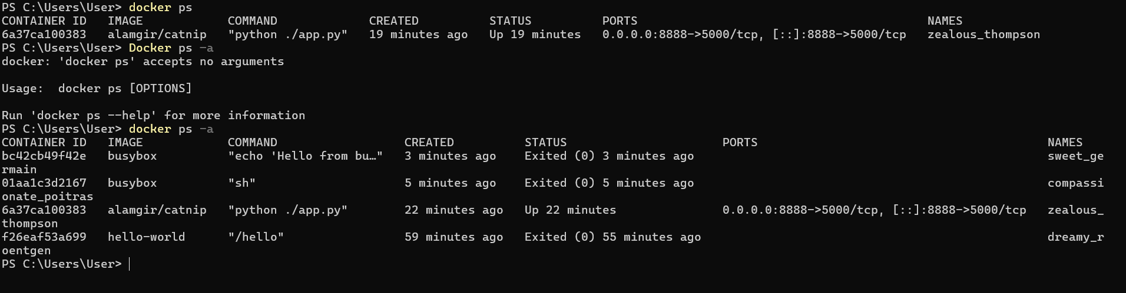

2.3 Remove the Image Now that the "house" is gone, we can delete the "blueprint":
docker rmi busybox
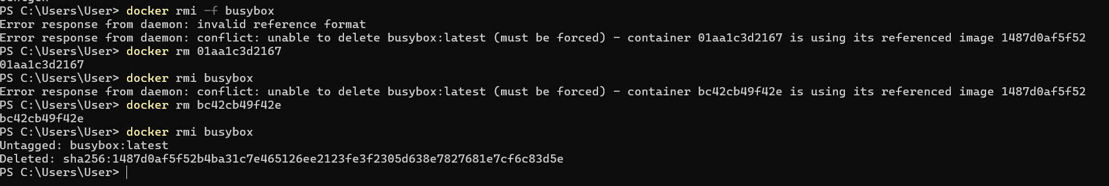

2.4 Now that we pulled the image we can run it:
docker run --rm prakhar1989/static-site 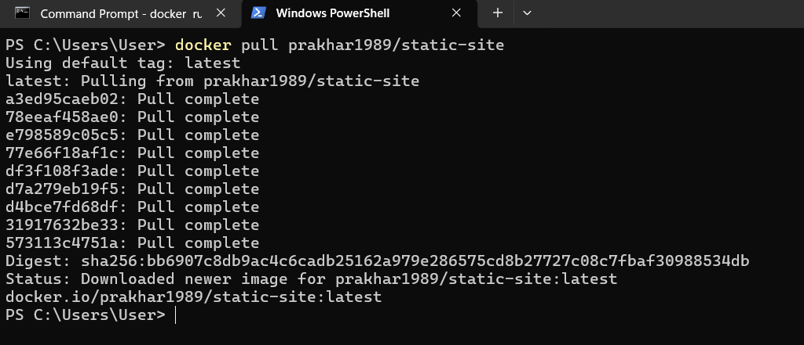
--rm tells docker to delete container on exit
Tells us NGINX is running? What is NGINX?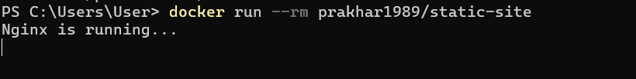
2.5 Lets run this command:
docker run -d -p --name static-site prakhar1989/static-site
-d detaches from terminal so it can run in background
-P assigns random ports to be exposed
--name x assigns a name to process
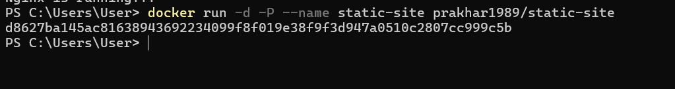
2.6 Find the port that was assigned:
docker port static-site
Internal container port 443 running on external (our computer) 32769
Internal container port 80 running on external (our computer) 32768
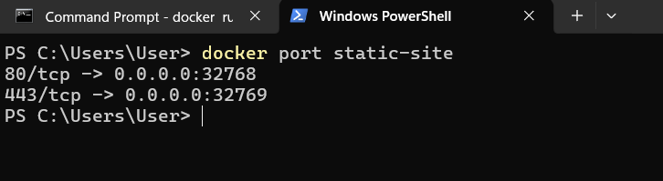
What is port 80 for? (browse 32768:80 port to verify the result)
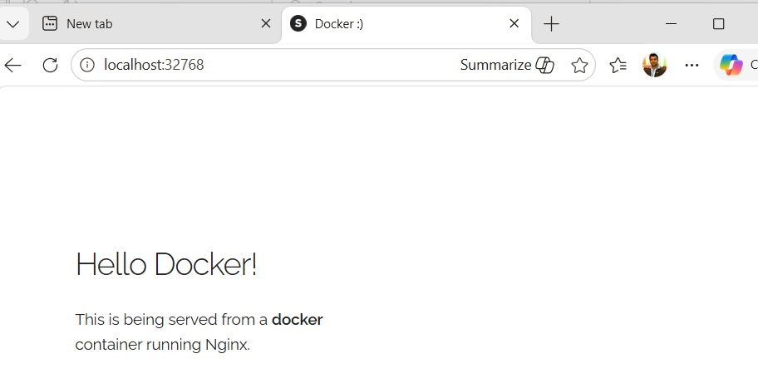
2.7 We can define the port used beforehand lets try that:
Docker run –p 8889:80 prakhar1989/static-site (changed my local host external port to 8889 because my 8888 external port is already engaged)
We are mapping the container port 80 to our external port 8889
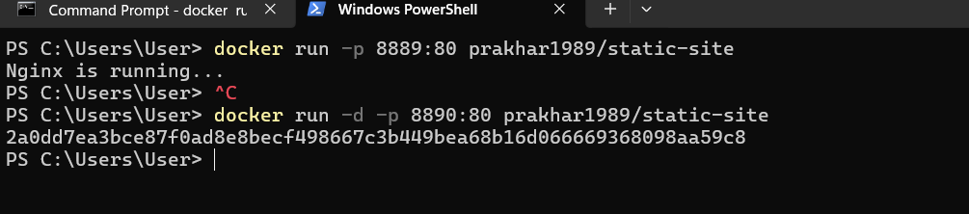
2.8 browse localhost:8889 to see the result
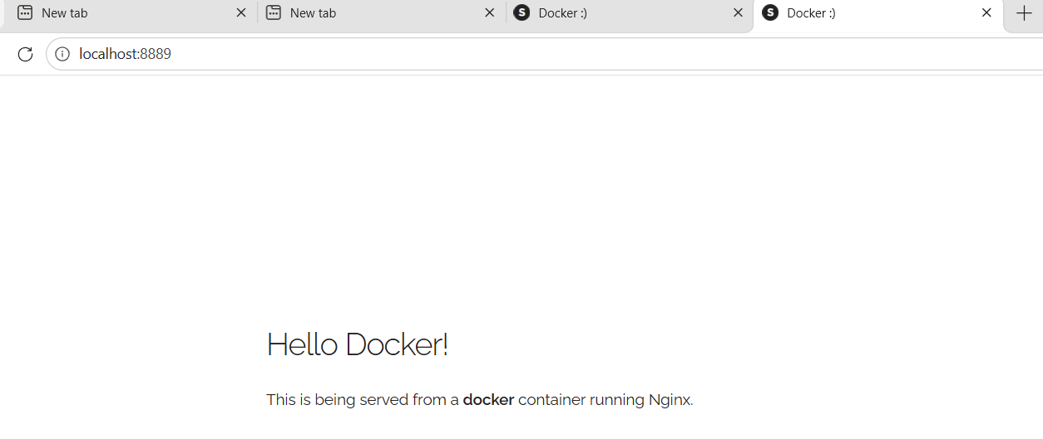
2.8 To stop background docker site:
docker stop static-site
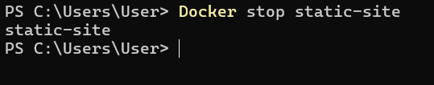

3.0 To clone git repositories to my docker.
3.1 installing git-scm and check the version.
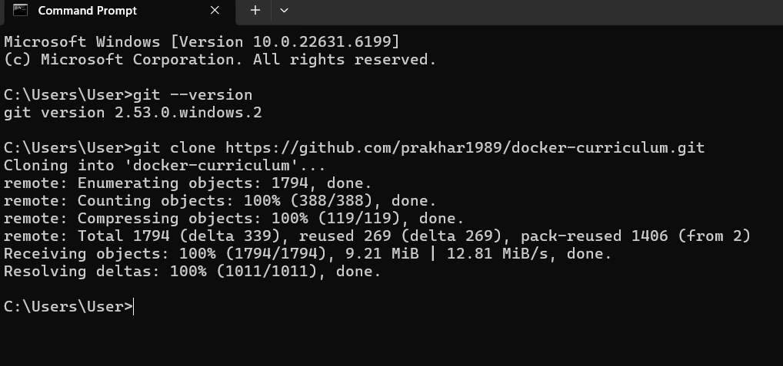
3.2 run the command: git clone https://github.com/prakhar1989/docker-curriculum.git
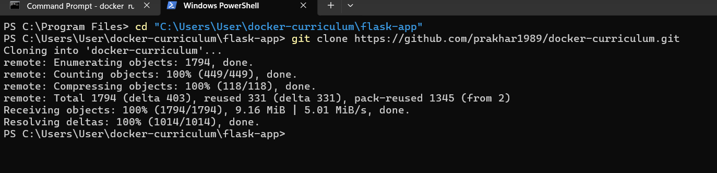
3.3 to show the result: prakher1989 container created inside my docker.
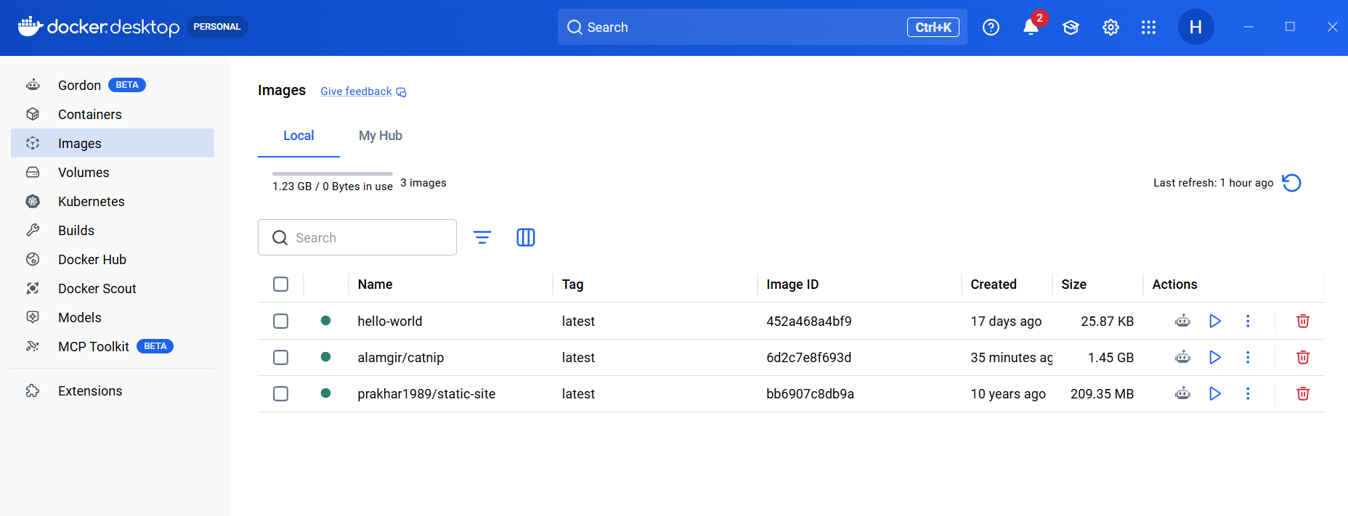

3.4 manually navigate inside my clone docker to check all properties.
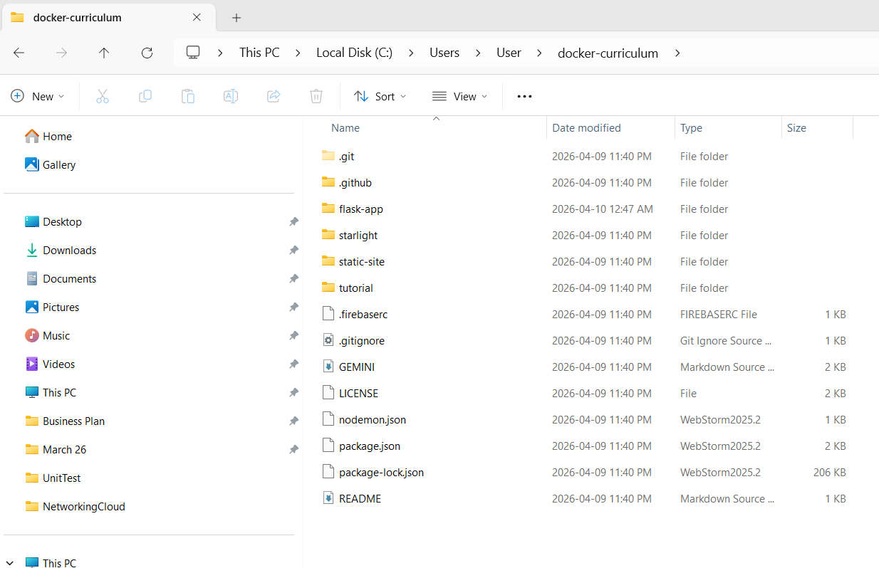
3.5 Inside the new docker-curriculum folder you will find a folder called static-site:
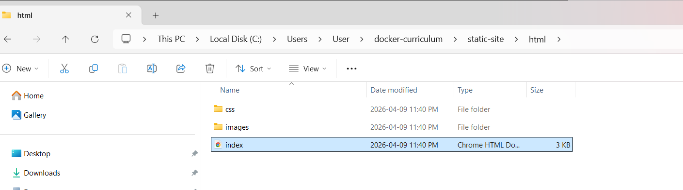
3.6 Double click the index.html to verify the result is same that I found when I run my port.
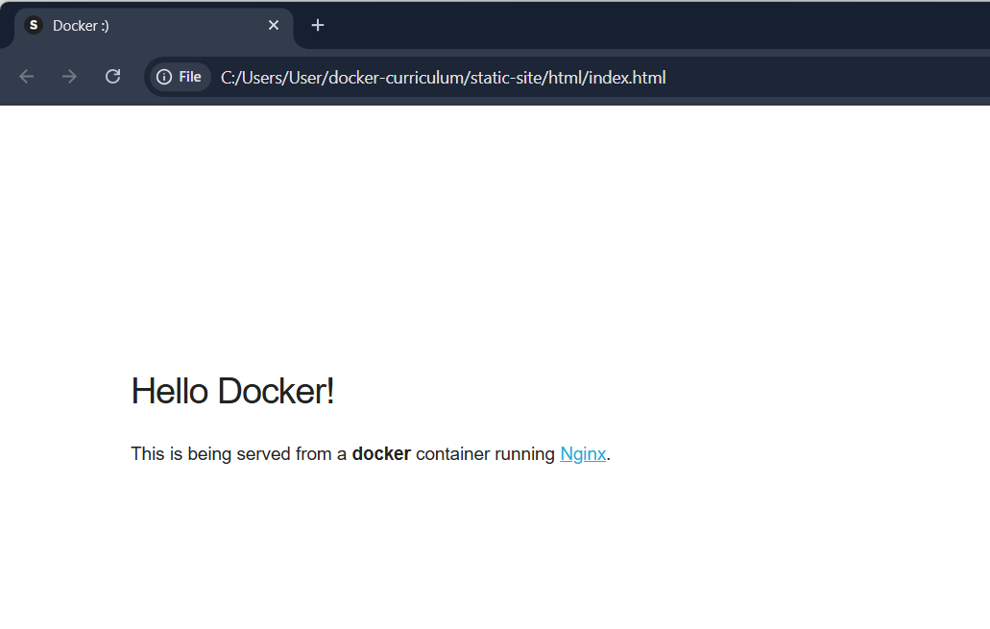

3.7. Looking at the flask-app and changing the requirement.txt file value to Flask == 2.2
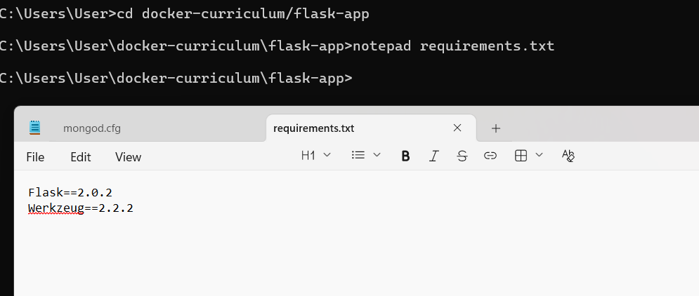

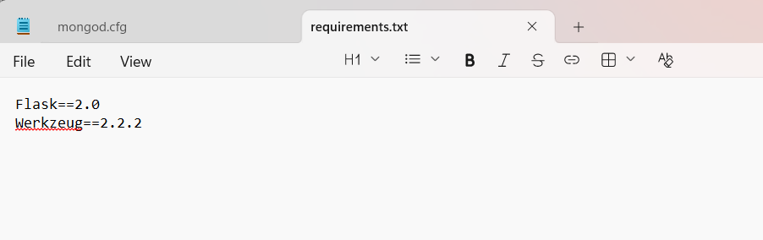

3.8 Build the Docker Image
Now, use the docker build command. Make sure you are still inside the folder where you cloned the repository (the folder containing the Dockerfile).
Run the following command (replacing alamgir with your preferred handle):
docker build -t alamgir/catnip .
What this command does:
- docker build: Tells Docker to create a new image.
- -t alamgir/catnip: The "tag" flag. It names your image so you can find it later. The format is usually [username]/[repository-name].
- . (The Period): This is the context. It tells Docker to look for the Dockerfile in the current directory.
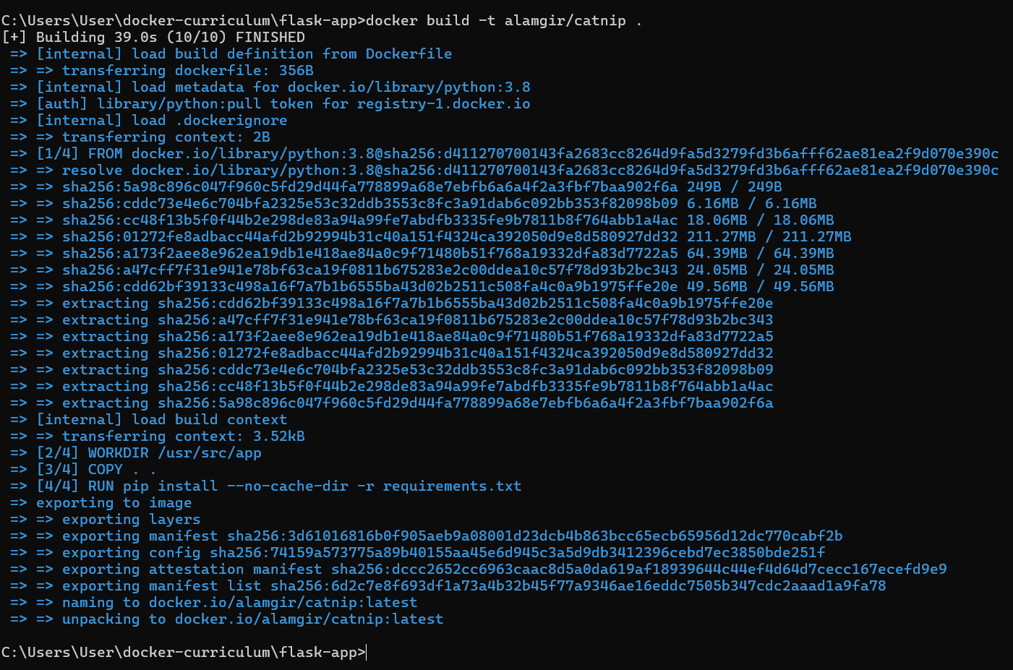
3.9 Verification: Once the build finishes, you can verify that your image exists by running:
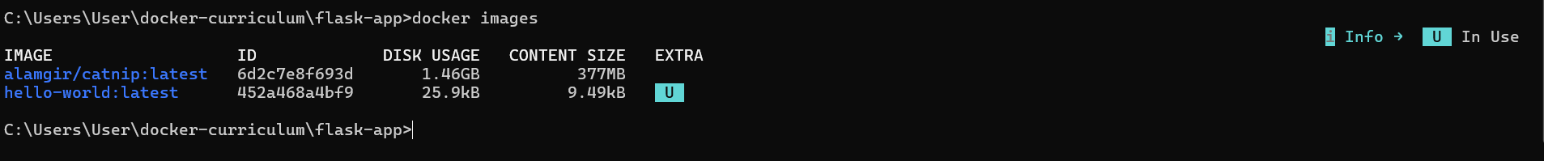

3.10 Navigate in docker Desktop and a folder is created.
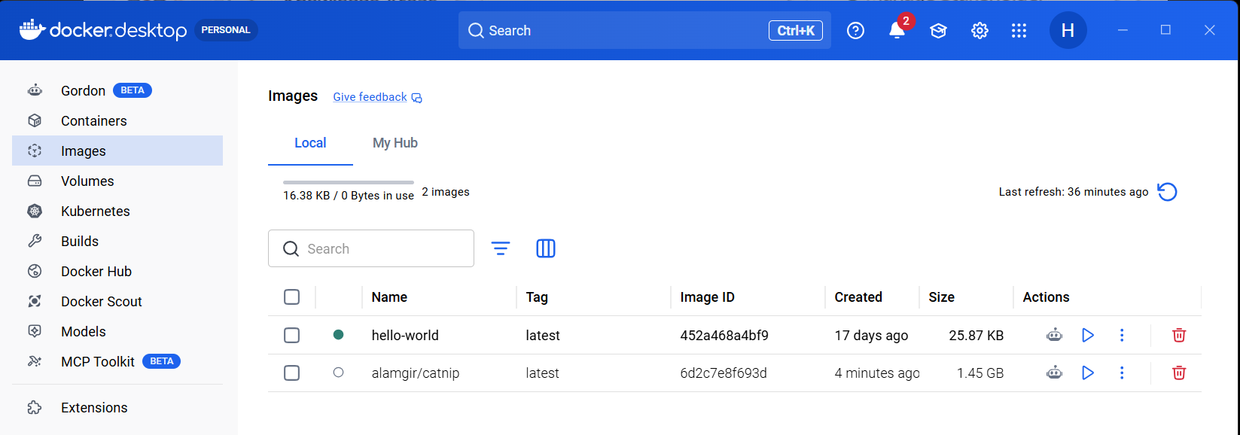

3.11 If we go inside now, we see all file inside my directory
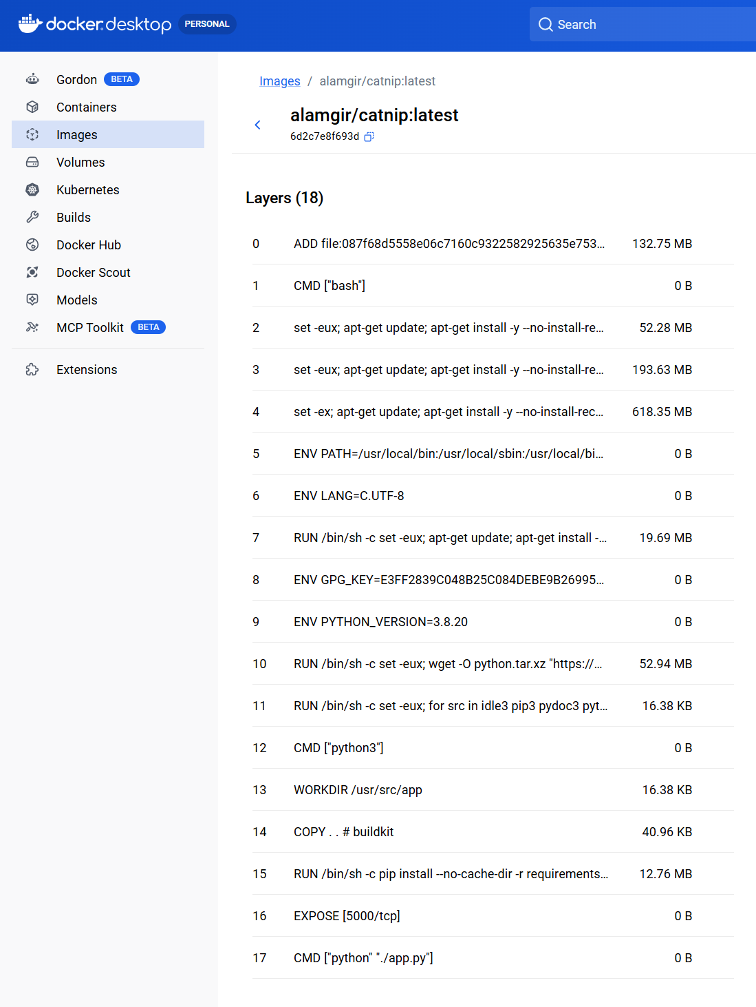

3.12 Run the Container
Execute this command in your terminal:
docker run -p 8888:5000 alamgir/catnip
What is happening here?
- -p 8888:5000: This is Port Mapping. Docker containers are isolated. This command tells Docker to take traffic from your computer's port 8888 and funnel it into the container's port 5000 (where Flask runs by default).
- alamgir/catnip: This tells Docker which image to use to start the container.

How to see the result
- Once you run the command, the terminal will stay active (it's "following" the logs).
- Open your web browser (Chrome, Edge, etc.).
- Go to the address: localhost:8888
we should see your "Catnip" app running!
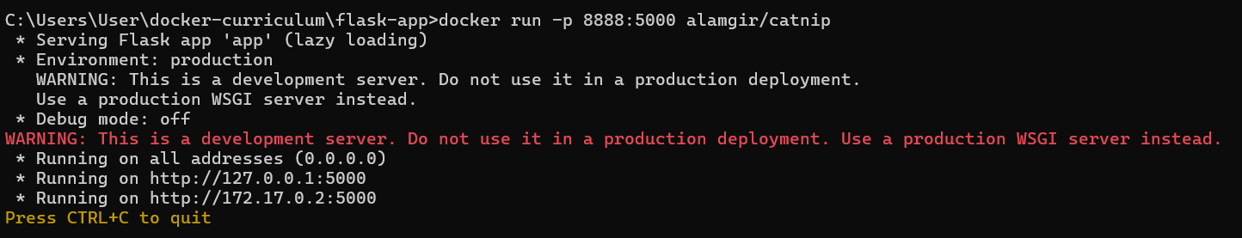
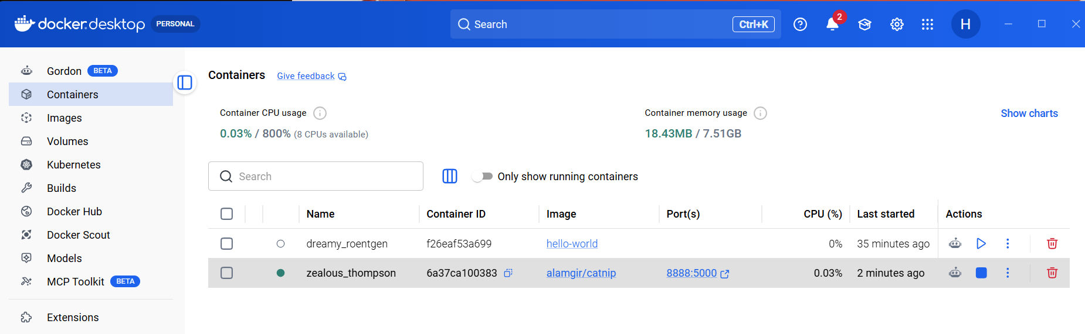

3.13 Running and Verification
- Execute: Map the internal port (5000) to your computer's port (8888):
docker run -p 8888:5000 [alamgir]/catnip.
- Verify: Open your browser and go to http://localhost:8888/.
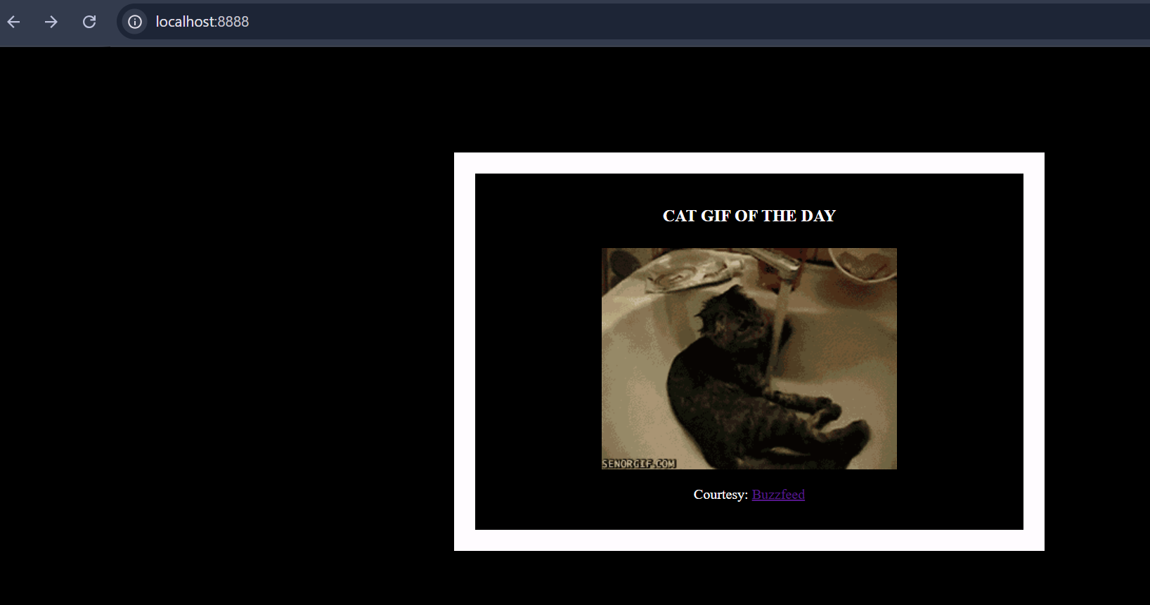

3.14 Use Ctrl+C or docker stop to end the process.

----------------------------------- ----------------------- -----------------------------------------------------------

