Data Mining
06-88-590-05

Final Report on the project titled:
Missing Data Imputation using Singular Value Decomposition

Project Id: C18

Submitted by
Mohammed Alamgir
(id# 103702520)

August 18, 2015

Department of Electrical and Computer Engineering
University of Windsor
Introduction:
This report contains details on data imputation using Singular Value Decomposition technique. Replacing the missing data with an estimated value from other data in a given data set, known as imputation, has numerous applications in data mining. Among the various techniques reported in the literature Principal Component Analysis, K-Nearest Neighbor, row averaging and Singular Value Decomposition are commonly used. This project imputes missing data using Singular Value Decomposition, and reports its performance.
Problem of Missing Data:
Given a number of attributes and their values, it is frequent in real-life that some values are absent. There can be multiple reasons for the missing values. For example, the sensor that captured the data malfunctioned, the respondent didn't answer a question, an error occurred during transmission etc. Table 1 shows an example of missing data where one person didn't disclose his age, and another person didn't specify his income.
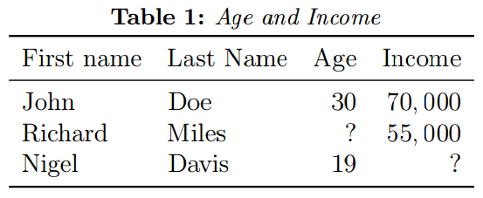
Ideally one would want to repeat the process of data acquisition and fill the missing data. This however could be difficult, costly and even impossible in certain cases. Sometimes it is simply not possible to repeat the process. Algorithms that take these data as input and do further processing most likely expect that there is no missing values. If there is, the algorithm is prone to fail.
The straight forward way to deal with the missing data is to discard the entire row. This will avoid the problem but the size of data sample is now reduced. In case of few sparse missing values, the deletion might significantly reduce the data size and introduce bias. Therefore there is a need to replace the missing data with some value, preferably representative of the unknown value.
Pattern of Missing Data:
Sometimes it helps to characterize the pattern of missing data. In the literature there are three patterns that have been highlighted:
- Uni-variate: here the missing data is only present in a certain feature or column. No other columns have missing values.
- Monotone: here the missing values are looked at row or instance wise. If an instance has a missing value for some feature, all other features following that are also missing. Moreover, the following row should at least have the same or more missing values.
- Arbitrary: any other pattern or absence of pattern.
Obviously the pattern of missing data is dependent on the order of instances and features.

Replacing Missing Data:
The simplest approach to replacing the missing data is to use some default value, say zero. Another approach is to use the mean (or mode) value obtained from the present values. In a formal manner, a statistical model can be assumed and the missing data can be estimated using a statistical estimation method such as maximum likelihood estimation.

Yet another class of techniques for estimating missing data includes machine learning based methods. K-nearest neighbour (KNN), Fuzzy K-means (FKM), Support Vector Machine (SVM), Principal Cpmponent Analysis (PCA) and Singular Value Decomposition (SVD) based imputation methods have been reported in the literature. In this work, we limit our attention to SVD based imputation.

Singular Value Decomposition:
The Singular Value Decomposition [1] of a matrix R is R=UΣV’, where U and V are unitary matrices and Σ is a diagonal matrix with positive real elements known as singular values of the matrix R. In an equivalent relationship, the singular values are the positive squared roots of the eigenvalues of the matrix RR’ or R’R.

In our present case of data mining, the matrix R is the co-variance matrix obtained from the given data [2][3]. Since the matrix R has missing values, it is not straight forward to compute R from it. In [3] the missing values are replaced with mean value as an initial guess.

A missing data is estimated in the following manner:
  - Some strongest singular values are chosen. Depending on application this cane be from 5-25% of the singular values. Generally more the singular values picked the better is the estimation.
  - Once the most significant singular values are chosen, we set the other singular values to zero in the matrix Σ.
  - Using this reduced-rank Σ we calculate the matrix
R=UΣV’. This R matrix represents the reduced-rank approximation of the original matrix R. This R matrix now contains the estimated values at he missing positions.
To improve the accuracy of the estimation one could choose a larger number of singular values, and even, iterate the same process for a number of times.

Project Requirements:
As per the instructions provided the project requirements are:
- Read some given data. Dimension of the data is arbitrary but has practical limit.
- Locate the missing data, and possibly identify the missing pattern.
- Implement the imputation algorithm described in previous section.
- Compare the estimated value of the missing data with the ground truth value and compute the error.
Implementation:
The imputation algorithm has been implemented as a MATLAB tool, represented as a simple GUI. In addition to the core function of imputation, the tool also performs discretization and de-discretization of categorical data. Imputed data cal also be saved for further need. If the ground truth data is available, the tool can compare the imputed data and calculate normalized root-mean-square (NRMS) error.

Demonstration:
Once run the GUI will present itself as shown in Fig. 1. One would click on the Browse button and select the data file to be imputed. Both CSV and Excel files are supported. After selecting the file, we need to press the Read Data button that will analyze the data and perform some pre-processing functions. A summary of the dataset will be shown. If the dataset contains categorical data, they need to be first discretized before any imputation. Clicking the Discretize button will do that.

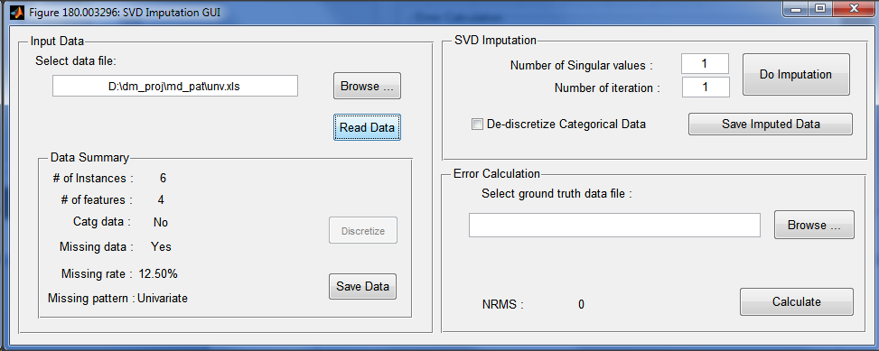
Fig. 1: GUI of the imputation tool.

If the pattern of the missing data could be detected, then it will be shown in the Data Summary area. The dataset at this stage can be saved to disk file by clicking on the Save Data button. This will save all numeric data as well as the discretized categorical data.

To initiate the imputation, one needs to select the number of singular values to use, and the number of iterations to perform. Number of singular values chosen can not be larger than the data dimension. Clicking on the Do Imputation button will perform the imputation process. The imputed data (along with de-discretized data) can be stored to disk by clicking on Save Imputed Data button.

To calculate the NRMS, one would click on Browse button and select the ground truth data file. Clicking on Calculate will calculate the error and display the value.

Processing Given Datasets:
A number of datasets have been provided to test the performance and effectiveness of the imputation tool. It was found that not all the datasets are readily usable. For example, the definition of NRMS does not apply to categorical data. To compute the NRMS one must do so on the discretized version of the dataset.

Other issues on individual dataset are given in the following table:

Dataset | Type | Comment | Action
Iris | Orig | The last column (5) has text values or categorical data. | Delete the last column from ground truth dataset.
Iris | Missing | Column 5 is absent altogether. | Delete the last column from ground truth dataset.
Wine | Orig | No issue.
Wine | Missing | No issue.
Glass | Orig | No issue.
Glass | Missing | No issue.
BUPA | Orig | No Issue.
BUPA | Missing | No Issue
S Heart | Orig | No issue.
S Heart | Missing | No Issue.
4-gauss | Orig | No Issue.
4-gauss | Missing | No Issue.
DifDoug | Orig | No Issue.
DifDoug | Missing | No Issue.
PID | Orig | No Issue.
PID | Missing | No Issue.
BCW | Orig | Has ? values. | Replaced with 1.
BCW | Missing | No Issue. | Replaced with 1.
Yeast | Orig | No Issue.
Yeast | Missing | No Issue.
DERM | Orig | No Issue.
DERM | Missing | No Issue.
CNP | Orig | No Issue.
CNP | Missing | No Issue.
Abalone | Orig | Categorical data in column 1. | No easy fix.
Abalone | Missing | Column 1 has been discretized. | No easy fix.
Ionosp | Orig | No Issue.
Ionosp | Missing | No Issue.
Chess | Orig | Categorical data in the middle. | This tool’s limitation.
Chess | Missing | Categorical data in the middle. | This tool’s limitation.
TTTEG | Orig | No Issue.
TTTEG | Missing | No Issue.
Sonar | Orig | No Issue.
Sonar | Missing | No Issue.
Zoo | Orig | No Issue.
Zoo | Missing | No Issue.
Adult | Orig | Categorical data in the middle. | Tool’s limitation.
Adult | Missing | Categorical data in the middle. | Tool’s limitation.
HOV | Orig | No Issue.
HOV | Missing | No Issue.
WS | Orig | Column 1 is extra. | Deleted column 1.
WS | Missing | No Issue. | Deleted column 1.

NRMS:
NRMS values are reported in the Excel sheet provided and attached with this report.

Conclusions:
This report discusses the development and use of a tool to impute missing data using MATLAB. Results are reported as required. Future improvement could include comparing the NRMS values with other method of imputation.

References:
[1] G. H. Golub and C. F. Van Loan, “Matrix Computations,” Jhons Hopkins University Press, Baltimore, MD, 1996.

[2] T. Hastie, R. Tibshirani, G. Sherlock, M. Eisen, P. Brown, and D. Botstein, “Imputing missing data for gene expression arrays,” Division of Biostatistics, Stanford University, Tech. Rep., 1999.

[3] O. Troyanskaya, M. Cantor, G. Sherlock, P. Brown, T. Hastie, R. Tibshirani, D. Botstein, and R. B. Altman, “Missing value estimation methods for dna microarrays,” Bioinformatics, vol. 17, no. 6, pp. 520525, 2001.

