Jala Alamin, Christian Svinth, Andrea Brici

SDD

Virtual Cookbook

October 21, 2018

**Activity Diagram: (Swim lane)**



**Structural Diagram:**

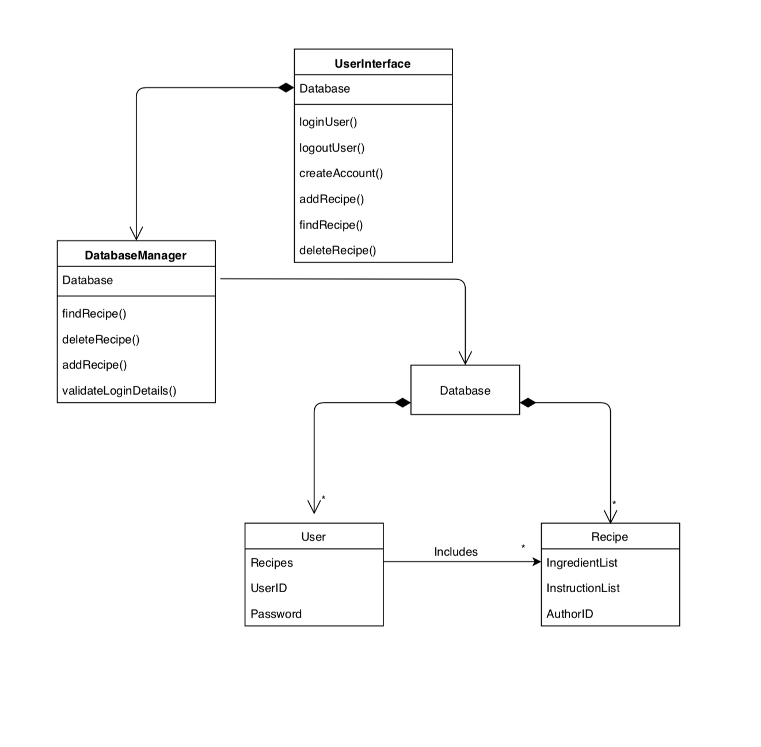

**Behavior Modeling: (Sequence Diagram)**

/Users/andreabrici/Library/Containers/com.apple.mail/Data/Library/Mail Downloads/B19F4A58-2951-4D83-8FBE-066CE4B3383B/Virtual Cookbook.pdf