- In MP Education:
This should be redesigned.
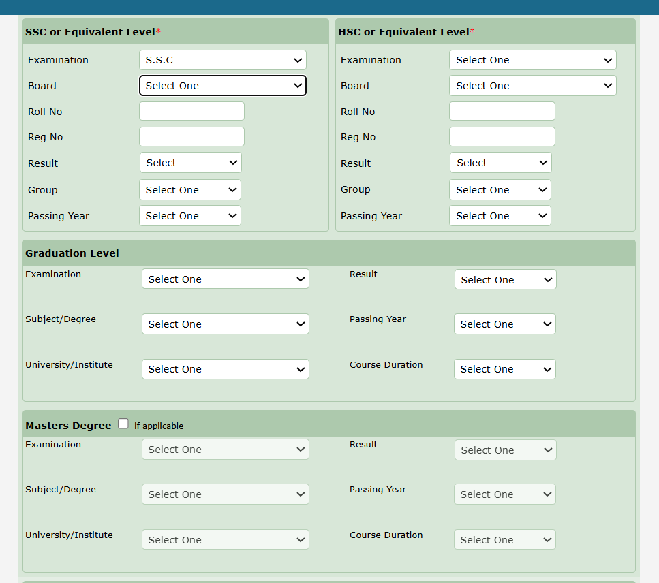
Nothing will be Mandatory. PhD level needs to be added at the end in same way. And another part self-educated part needs to be added. All data is managed from master data. In SSC and HSC add institute. Result – it will first show the type (Class, Division, GPA, CGPA- based on selection a new field will appear to input the result).
Level wise dropdown needs to be aligned. Examination type for SSC and Graduation level not same-it will be managed by Master data.
- http://localhost/parliament/constituency/ - here if any field is updated it returns to the 1st page. Already may be I am in 4th page 15 row. It is hard to edit like this way.
- http://localhost/travel/create/ - this part need to word again. It need to be easy- at the beginning “Tour Type” will be there to select (like personal or official-managed by master data). Then purpose and GO Info. And now there is a second page but it should be done in one page-you may split the page side by side for better view. Right now, accompanying officer designation comes from dropdown-it should be text field.
the details page of http://localhost/travel/ - view page does not showing GO that is uploaded already.
- The sidebar collapses/resets after each navigation. Please keep the sidebar state (expanded menus and active selection) persistent across page changes.
- When adding committee members (http://localhost/committee/create/), it would be better if everyone were added as a regular member by default, and only the Chairperson's role needed to be changed.
- The " Institution" field can be changed from a dropdown to a text field (http://localhost/institution/create/).Since there can be many different organizations, a text field would be more flexible.
- For the Family Members Report, only the PRP ID and Name is currently displayed. It would be better to also display Constituency. (http://localhost/reports/family-report/)
- When printing a report, the search bar is also included in the print output.
When exporting a report to PDF, the alignment and page fitting are not correct, causing some columns to overflow beyond the page. Additionally, clicking the PDF option opens the print dialog instead of downloading the PDF

