1. Clip the following polygon using suitable polygon clipping algorithm.

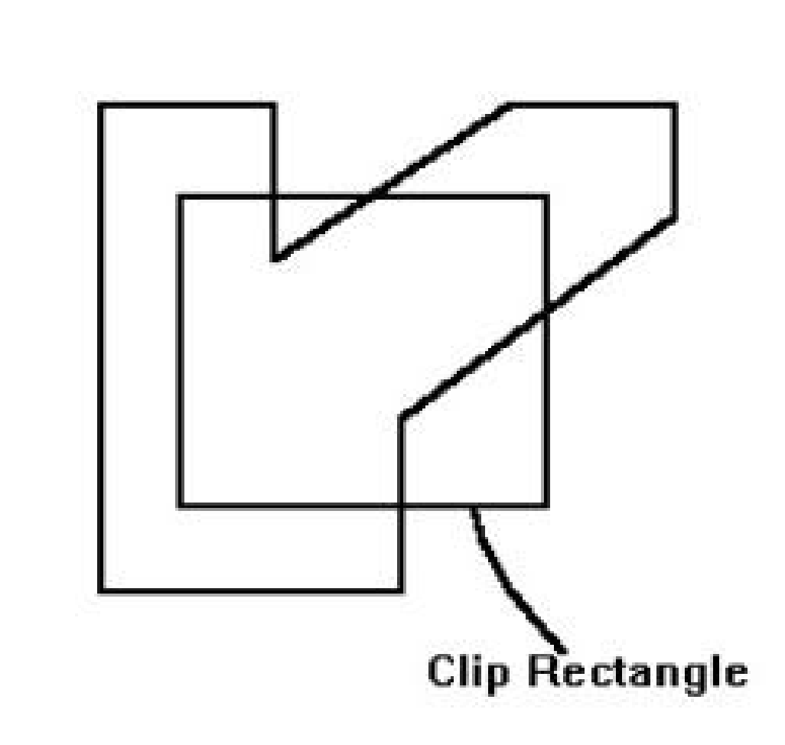

1. Perform a 45-degree rotation on the triangle A(4, 5, 6), B(2, 3 ,4), C(10, 8, 5) for X, Y and Z axis.
2. With respect to origin
3. With respect to point B
4. Scale the Triangle mentioned in question number 2 with scaling factor 3.
5. Clip the following lines using Cohen Sutherland line clipping algorithm.

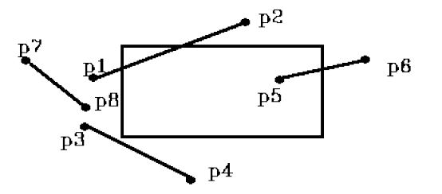

5. a. What do you understand by additive color model? Why RGB is called additive color model?

b. Why CMY color model is widely used for printing purpose?