* Find out the actual TPS for if 10000 users can give load within 1 hour  
  **URL:**[**https://demoqa.com/BookStore/v1/Books**](https://demoqa.com/BookStore/v1/Books)  
  For 60s, 300s and 600s load, add JMeter UI screenshot and for 900s generate html report and the screenshot given below.

**Using GUI mode**

1) 60 Seconds for 167 Users – 0.00% fail and 100% pass

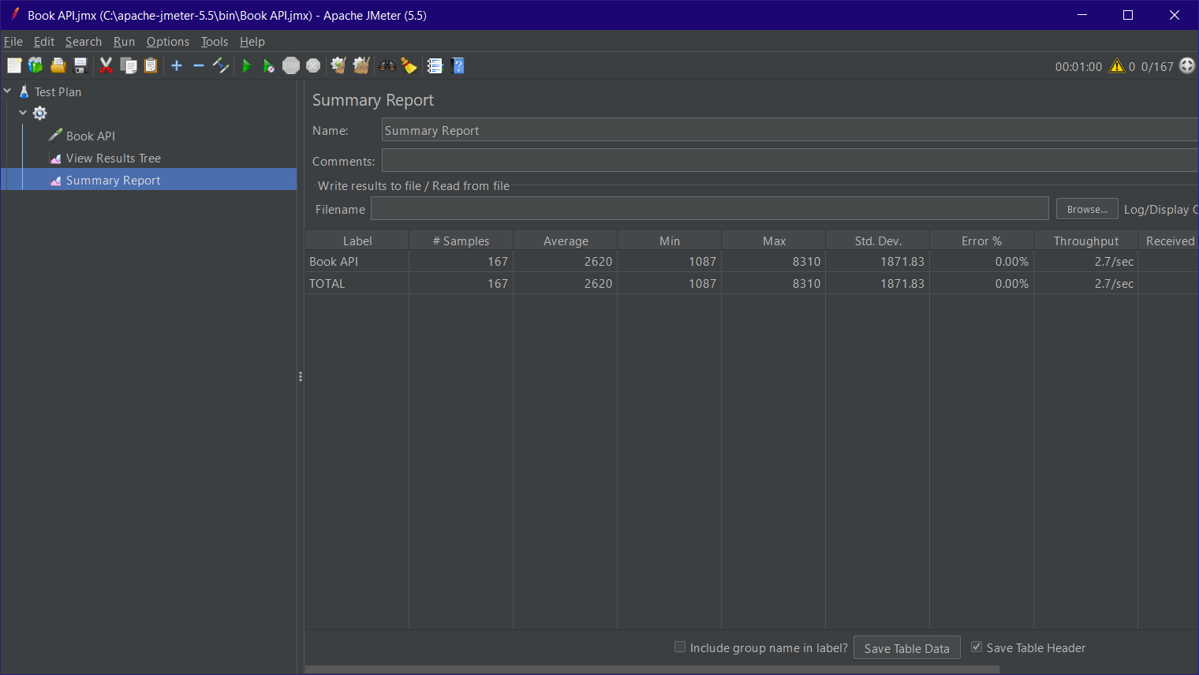

2) 5 Minute (300 Seconds) for 834 users – 0.00% fail and 100% pass

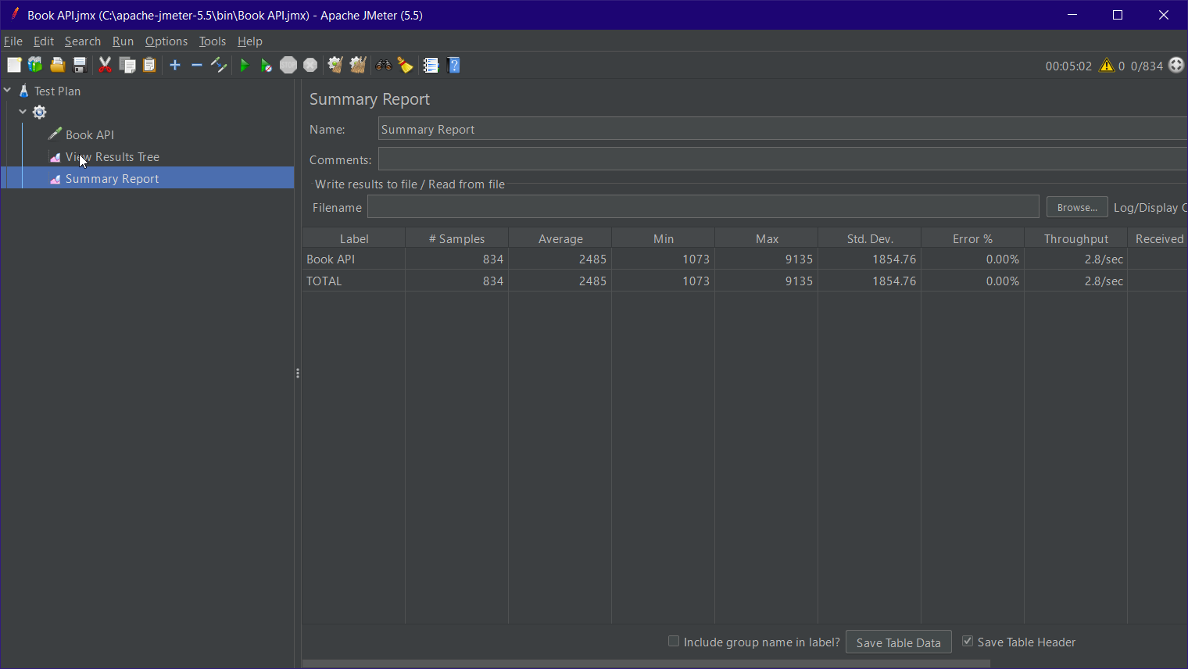

3) 10 Minute (600 Seconds) for 1667 Users – 0.00% fail and 100% pass

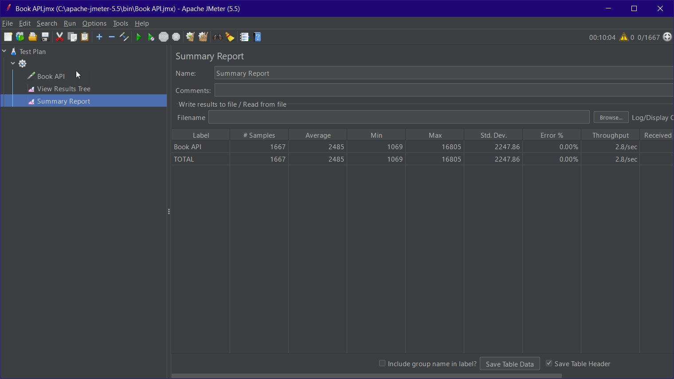

**Using Non GUI mode**

4) 15 Minute (900 seconds) for 2500 users – 0.12% fail and 98.88% pass

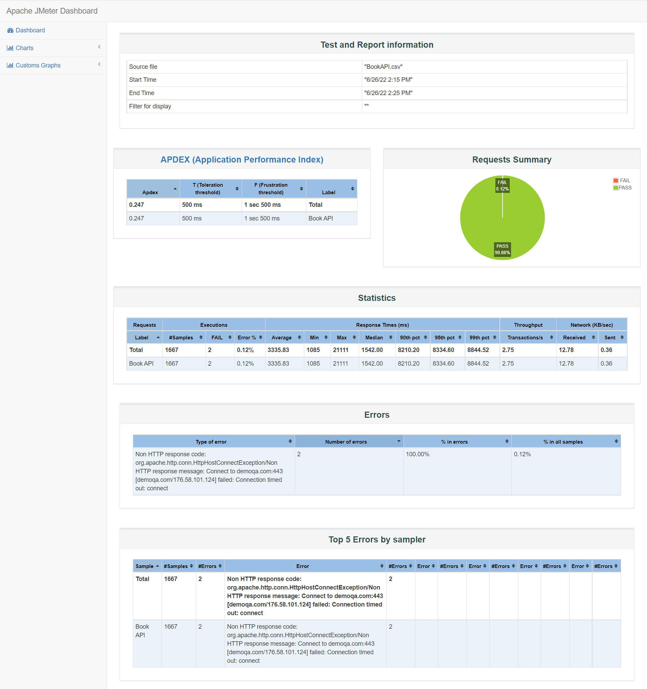

5) 15 Minute (900 seconds) for 2500 users – 0.00% fail and 100% pass

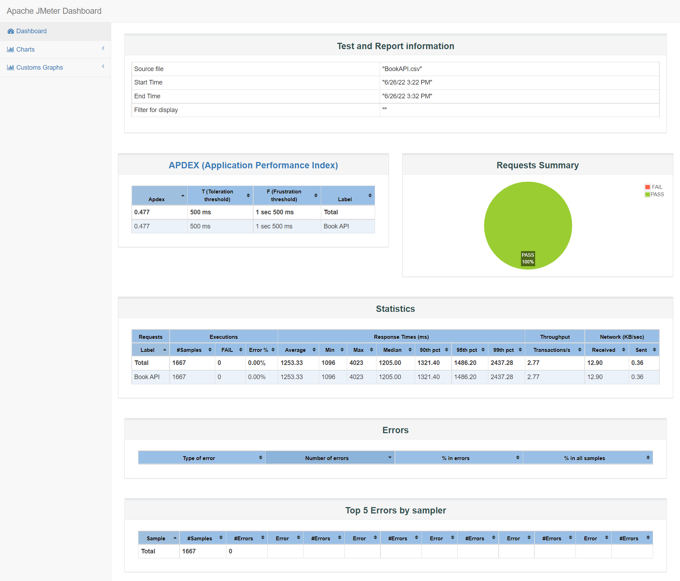

6) 30 Minute (1800 seconds) for 5000 users – 0.00% fail and 100% pass 