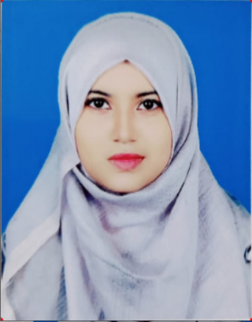**CURRICULUM VITAE**

**Tajnin Sultana**

Contact number: 01718-675706

Email: [tajnin93@gmail.com](mailto:tajnin93@gmail.com)

Address: Gacha, Boardbazar, Gazipur

**CAREER OBJECTIVE**

A passionate and dedicated educator seeking a challenging teaching position where I can leverage my education and skills to inspire and motivate students to reach their full potential. As a fresher, I am eager to bring fresh ideas, enthusiasm and a willingness to learn and grow in the field of education.

**PERSONAL INFORMATION**

Father’s Name : F.M. Babor Ali

Mother’s Name : Rijiya Khanam

Mailing Address : Gacha, Boardbazar, Gazipur.

Permanent Address : Vill-Kumirdanga, P.O.-Mirerkodla, Tana-Terokhada, District- Khulna.

Date of birth : 13-Nov-2001

Marital status : Unmarried

Religion : Islam

Nationality : Bangladesh by birth

**EDUCATIONAL QUALIFICATION**

1. **B.SC. IN COMPUTER SCIENCE AND ENGINEERING**

University : Uttara University

Major : Software Engineering

Passing Year : 2022

Result : CGPA-3.96 Out of 4.00

1. **HIGHER SECONDARY SCHOOL CERTIFICATE**

Institute : Gazipur Presidency College

Group : Science

Board : Dhaka

Passing Year : 2018

Result : GPA-3.50 Out of 5.00

1. **SECONDARY SCHOOL CERTIFICATE**

Institute : Gacha High School

Group : Science

Board : Dhaka

Passing Year : 2016

Result : GPA-4.22 Out of 5.00

**SKILLS**

* Strong communication skills, both verbal and written.
* Excellent problem-solving and critical-thinking abilities.
* Ability to manage classroom behavior and create a positive learning environment.
* Familiarity with various teaching methods and strategies.
* Proficient in Microsoft Office (Word, Excel, PowerPoint) and Google Classroom.

**EXPERIENCE**

* Presently as a teacher teaching in a school and teaching various subjects to students of different age groups.
* Conducted extra-curricular activities for students to enhance their learning experience.
* Assisted in organizing school events and participated in teacher meetings and professional development programs.

**REFERENCE**

|  |  |
| --- | --- |
| **Prof. Dr. Saifullah Sadi**  Chairman  Uttara University  Cell: 01648563522 | **Associate Prof. Mr. Md. Shafiul Alam Chowdhury**  Uttara University  Cell: 01712167639 |



|  |
| --- |
| **Signature** |