60 Seconds, 167 users

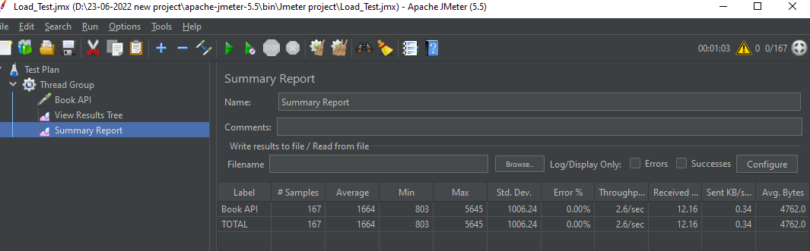

300 Seconds, 834 users

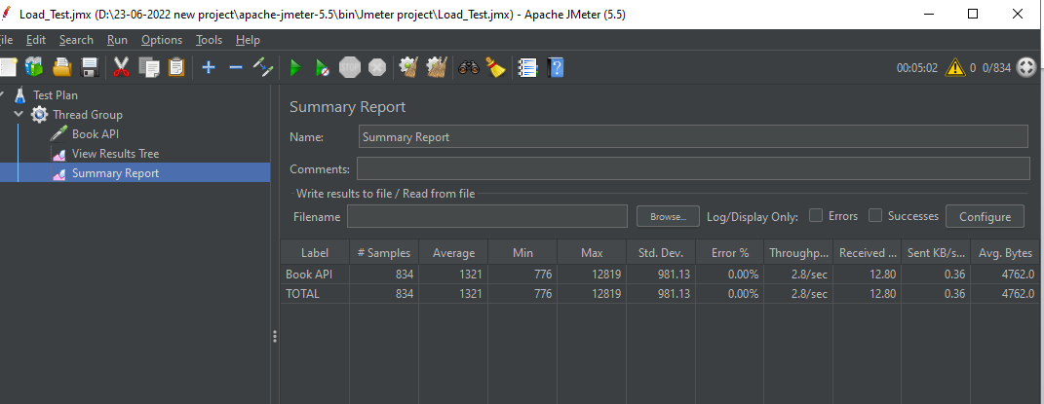

600 Seconds, 834 users

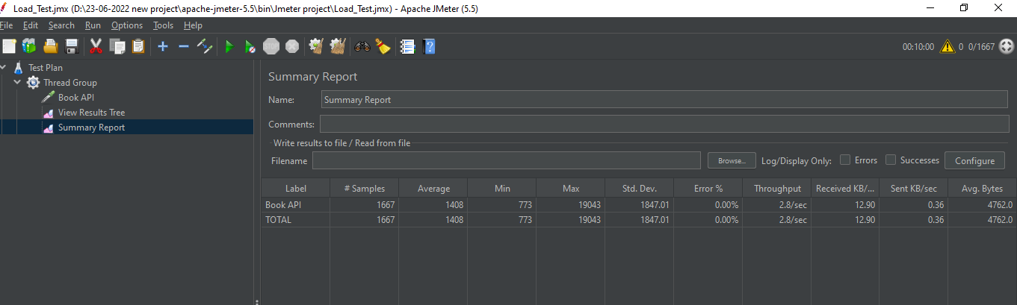

900 Seconds, 2500 users

