**Content List:**

1. **Introduction**
2. **Case Study**
3. **ER Diagram**
4. **Normalization**
5. **Table Creation**
6. **Data Insertion**
7. **Query Writing**
8. **Relational Algebra**
9. **Conclusion**

**Name: ID:**

1. **Rimon, Tajbiur Shahrior 18-38341-2**
2. **Fardit Ahmed 18-36119-1**
3. **Alamin Sheikh 18-39230-3**
4. **Kaif Al Kabid 18-38114-2**

**Security Guard Management System**

**Introduction:**

Best Security is a security guard company in Bangladesh which provides efficient and well-trained security personnel to its clients. Best Security uses a software application to record its guards, clients, owners along with other important information.

In out project we have used Database Management System.

**Case Study:**

Best security is owned by multiple owners. Owners will be defined by their unique owner id. Each owner has their name and phone number. The company, Best Security, which is owned by its owners will have its own unique name ‘Best Security’ along with the establish date. Best Security has recruited multiple security guards. However, each security can only be under Best Security. Security guards will be uniquely identified by guard id. Guards will also be consisted with first name, last name, age, date of birth, bonus, salary, phone number, hire date.  
Best Security, a security guard company can have contract with multiple clients. Clients will be identified uniquely with client id. Clients will also have client name, contract year which has a starting date and an ending date. After the contract security guards will be taken and instructed by their respective client. Each client can take and instruct multiple security guards and each guard will only provide service to only one client. If a client is not satisfied with a security personnel then that guard can be terminated by that client. For this reason, a starting date and an ending date will be recorded for each security guard. However, after the contract with Best Security, the ending date for each security guard will be up to the ending date of the contract with that client. Each security guard will have their job history which records their past activities. Job history includes security guards hire date along with their previous clients and history id uniquely. A client can be a large firm, so it can have many branches in different locations to operate and this indicates that those security guards who are instructed by their respective client will be posted to these locations. Security guards can be posted to a particular location for that client. Location will contain unique location id, postal code along with the client name, city name, and address which includes road number and street name. Client’s location must be located in a city. City will be uniquely identified by city id and also have the city name.

**Normalization:**

located: (city_name, location_id, postal_code, cname, street_name, road_no, city_id, city_name)  
  
1nf: No multivalued attribute.  
  
2nf: city_name, location_id, postal_code, cname, street_name, road_no, city_id  
 city_id, city_name  
  
3nf: location_id, cname, street_name, road_no, city_id, tid  
 city_id, city_name  
 tid, city_name, postal_code  
  
table: location_id, cname, street_name, road_no, city_id, tid  
 city_id, city_name  
 tid, city_name, postal_code

record: (gid, dob, bonus, l_name, hire_date, salary, phone_no, f_name, hist_id, hire_date,  
 prev_client)  
  
1nf: prev_client, phone_no are the multivalued attributes  
  
2nf: gid, dob, bonus, l_name, hire_date, salary, phone_no, f_name, hist_id  
 hist_id, hire_date, prev_client  
  
3nf: gid, dob, bonus, l_name, hire_date, salary, phone_no, f_name, hist_id  
 hist_id, hire_date, prev_client

table: gid, dob, bonus, l_name, hire_date, salary, phone_no, f_name, hist_id  
 hist_id, hire_date, prev_client

own:(name, establish_date, ow_id, ow_name, phone_no)  
  
1nf: phone_no is the multivalued attribute  
  
2nf: name, establish_date,  
 ow_id, ow_name, phone_no, name  
  
3nf: name, establish_date,  
 ow_id, ow_name, phone_no, name  
  
table: name, establish_date  
 ow_id, ow_name, phone_no, name

contract: (name, establish_date, cid, cname, start_date, end_date)  
  
1nf: no multivalued attribute.  
  
2nf: name, establish_date  
 cid, cname, start_date, end_date, name  
  
3nf: name, establish_date  
 cid, cname, start_date, end_date, name  
  
table: name, establish_date  
 cid, cname, start_date, end_date, name

recruit: (name, establish_date, gid, dob, bonus, l_name, hire_date, salary, phone_no, f_name)  
  
1nf: phone_no is the multivalued attribute  
  
2nf: name, establish_date  
 gid, dob, bonus, l_name, hire_date, salary, phone_no, f_name, name

3nf: name, establish_date  
 gid, dob, bonus, l_name, hire_date, salary, phone_no, f_name, name  
  
table: name, establish_date  
 gid, dob, bonus, l_name, hire_date, salary, phone_no, f_name, name

instruct: (gid, dob, bonus, l_name, hire_date, salary, phone_no, f_name, cid, cname,   
 start_date, end_date, grd_start_date, grd_end_date)  
  
1nf: phone_no is the multivalued attribute  
  
2nf: gid, dob, bonus, l_name, hire_date, salary, phone_no, f_name, cid   
 cid, cname, start_date, end_date  
 gc_id, cid, gid, grd_start_date, grd_end_date  
  
3nf: gid, dob, bonus, l_name, hire_date, salary, phone_no, f_name, cid   
 cid, cname, start_date, end_date  
 gc_id, cid, gid, grd_start_date, grd_end_date  
  
table: gid, dob, bonus, l_name, hire_date, salary, phone_no, f_name, cid  
 cid, cname, start_date, end_date  
 gc_id, cid, gid, grd_start_date, grd_end_date

post: (gid, dob, bonus, l_name, hire_date, salary, phone_no, f_name, city_name, location_id,  
 postal_code, cname, street_name, road_no)  
  
1nf: no multivalued attribute  
  
2nf: gid, dob, bonus, l_name, hire_date, salary, phone_no, f_name, location_id  
 city_name, location_id, postal_code, cname, street_name, road_no  
  
3nf: gid, dob, bonus, hire_date, salary, phone_no, location_id, f_name, l_name  
 location_id, cname, street_name, road_no, tid  
 tid, city_name, postal_code  
  
table: gid, dob, bonus, hire_date, salary, phone_no, location_id, f_name, l_name  
 location_id, cname, street_name, road_no, tid  
 tid, city_name, postal_code

**Total_table:**

* location_id, cname, street_name, road_no, city_id, tid
* city_id, city_name
* ~~tid, city_name, postal_code~~
* gid, dob, bonus, hire_date, salary, phone_no, hist_id, f_name, l_name
* hist_id, hire_date, prev_client
* name, establish_date
* ow_id, ow_name, phone_no, name
* ~~name, establish_date~~
* cid, cname, start_date, end_date, name
* ~~name, establish_date~~
* gid, dob, bonus, hire_date, salary, phone_no, f_name, l_name, name
* gid, dob, bonus, l_name, hire_date, salary, phone_no, f_name, cid
* ~~cid, cname, start_date, end_date~~
* gc_id, cid, gid, grd_start_date, grd_end_date
* gid, dob, bonus, hire_date, salary, phone_no, location_id, f_name, l_name
* ~~location_id, cname, street_name, road_no, tid~~
* tid, city_name, postal_code

**Final Table:**

* location_id, cname, street_name, road_no, city_id, tid
* city_id, city_name
* gid, dob, bonus, hire_date, salary, phone_no, hist_id, f_name, l_name
* hist_id, hire_date, prev_client
* name, establish_date
* ow_id, ow_name, phone_no, name
* cid, cname, start_date, end_date, name
* gid, dob, bonus, hire_date, salary, phone_no, f_name, l_name, name
* gid, dob, bonus, hire_date, salary, phone_no, f_name, l_name, cid
* gc_id, cid, gid, grd_start_date, grd_end_date
* gid, dob, bonus, hire_date, salary, phone_no, location_id, f_name, l_name
* tid, city_name, postal_code

**Table Creation:**

create table location_1

(

tid number(10),  
city_name varchar2(20),

postal_code number(10),

primary key(tid)

)

desc location_1

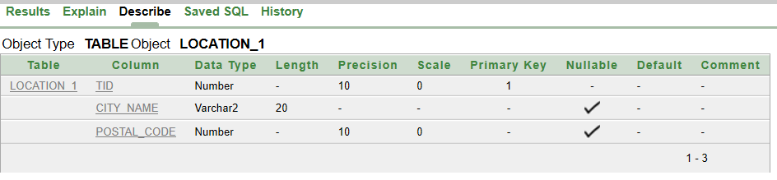

create table city

(

city_name varchar2(20),

city_id number(5),

primary key(city_id)

)

desc city

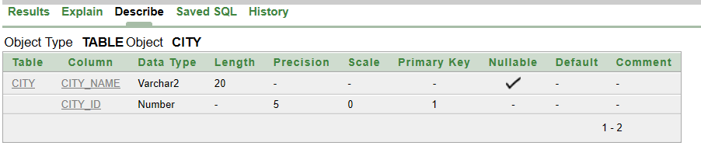

create table best_security

(

name varchar2(100),  
establish_date date,  
primary key (name)  
)  
  
desc best_security

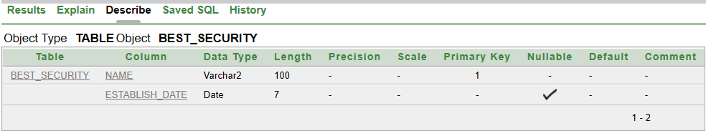

create table owner_info

(

ow_id number(5),

ow_name varchar2(20),

phone_no varchar2(25),

name varchar2(100),

primary key(ow_id),

constraint best_security_primary_key

foreign key (name)

references best_security (name)

);

desc owner_info

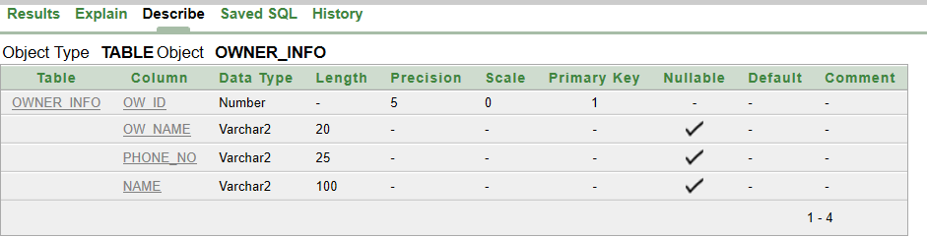

create table guard_location

(

location_id number(10),

cname varchar2(25),

street_name varchar2(10),

road_no number(10),

city_id number(5),

tid number(10),

primary key(location_id),

constraint location_1_primary_key

foreign key (tid)

references location_1 (tid),

constraint city_primary_key

foreign key (city_id)

references city (city_id)

)

desc guard_location

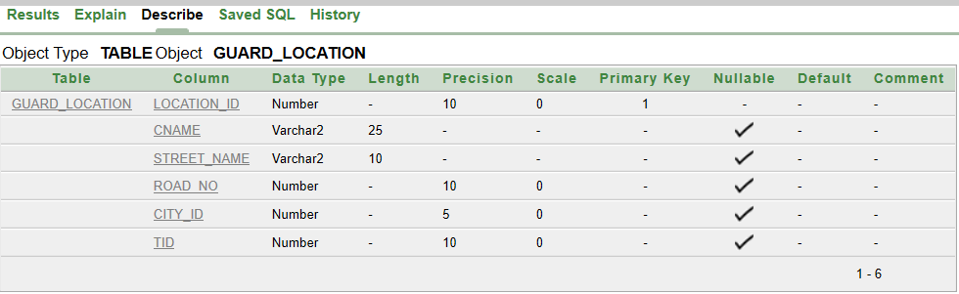

create table client_info

(

cid number(10),

cname varchar2(25),

start_date date,

end_date date,

name varchar2(100),

primary key (cid),

constraint best_security_2nd_primary_key

foreign key (name)

references best_security (name)

)

desc client_info

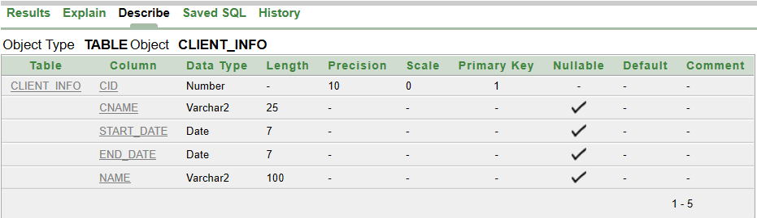

create table job_histories

(

hist_id number(20),

hire_date date,

prev_client varchar2(35),

primary key(hist_id)

)  
desc job_histories

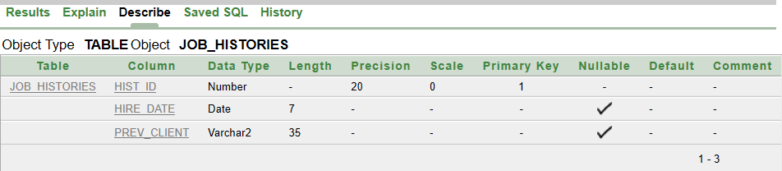

create table guard_info

(

gid number(5),

dob date,

bonus number(5),

hire_date date,

salary number(5),

phone_no varchar2(25),

hist_id number(20),

f_name varchar2(25),

l_name varchar2(25),

primary key (gid),

constraint job_histories_primary_key

foreign key (hist_id)

references job_histories (hist_id)

)

desc guard_info

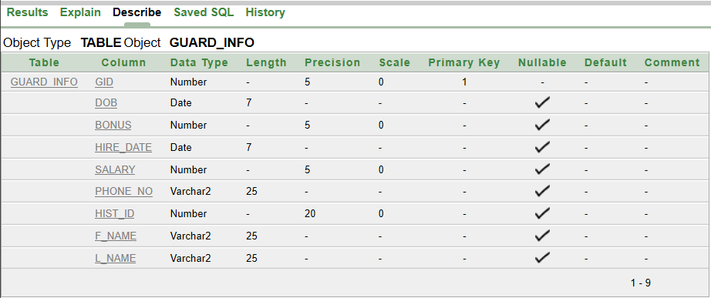

create table guard_recruit

(

gid number(5),  
  
dob date,

bonus number(5),

hire_date date,

salary number(5),

phone_no varchar2(25),

name varchar2(100),

f_name varchar2(25),

l_name varchar2(25),

primary key (gid),

constraint best_security_3rd_primary_key

foreign key (name)

references best_security (name)

)  
desc guard_recruit  
  
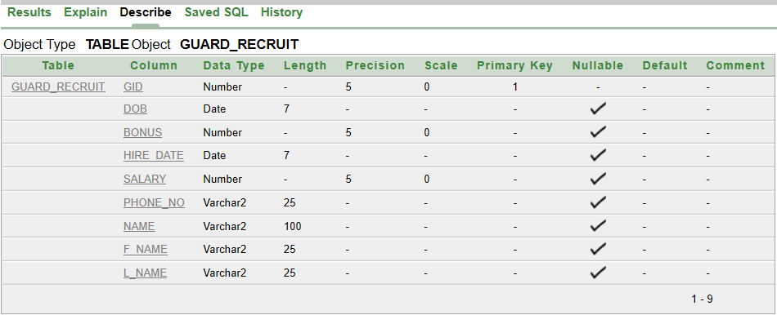  
  
create table guard_instruct

(

gid number(5),

dob date,

bonus number(5),

hire_date date,

salary number(5),

phone_no varchar2(25),

cid number(10),

f_name varchar2(25),

l_name varchar2(25),

primary key (gid),

constraint client_info_primary_key

foreign key (cid)

references client_info (cid)

)  
desc guard_instruct

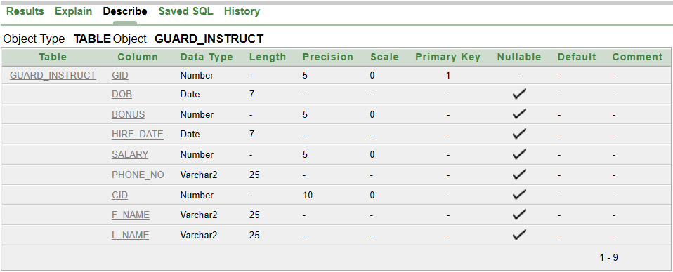

create table guard_post

(

gid number(5),

dob date,

bonus number(5),

hire_date date,

salary number(5),

phone_no varchar2(25),

location_id number(10),

f_name varchar2(25),

l_name varchar2(25),

primary key (gid),

constraint guard_location_primary_key

foreign key (location_id)

references guard_location (location_id)

)

desc guard_post

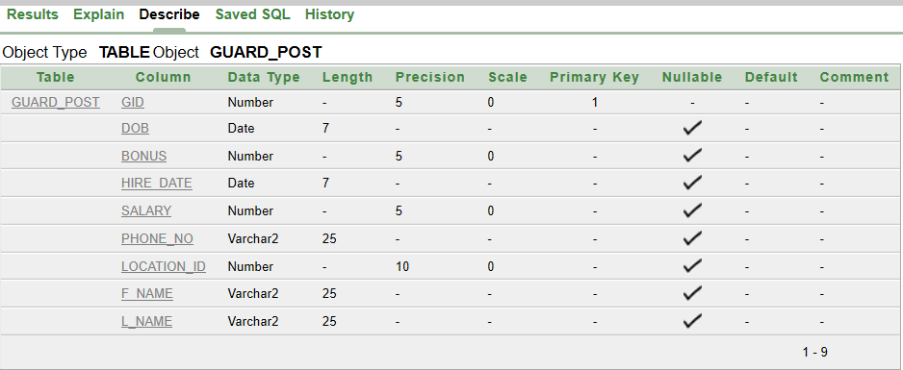

create table instruct

(

gc_id number(5),

gid number(5),

cid number(10),

grd_start_date date,

grd_end_date date,

primary key (gc_id),

constraint client_info_2nd_primary_key

foreign key (cid)

references client_info (cid),

constraint guard_instruct_primary_key

foreign key (gid)

references guard_instruct (gid)

)

desc instruct

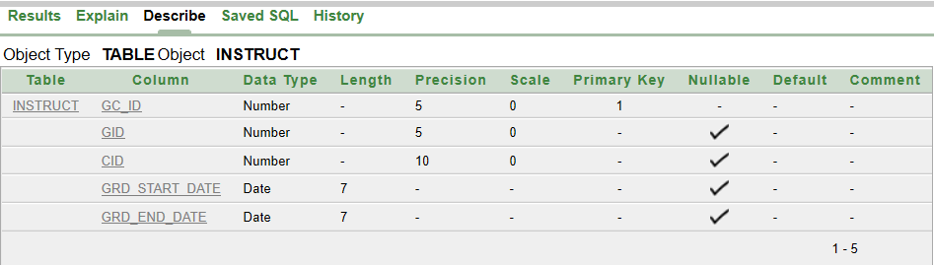

**Data Insertion:**

insert into location_1

(tid, city_name, postal_code)

values (101,'Dhaka',1230)

insert into location_1  
(tid, city_name, postal_code)  
values (102,'Khulna',1240)

insert into location_1

(tid, city_name, postal_code)

Values (103,'Gazipur',1250)

insert into location_1

(tid, city_name, postal_code)

Values (104,'Faridpur',1260)

insert into location_1  
(tid, city_name, postal_code)  
values (105,'Sylhet',1270)

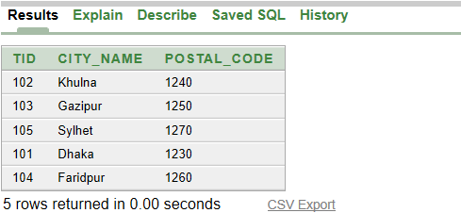

insert into city

(city_name,city_id)

Values ('Dhaka',303)

insert into city

(city_name,city_id)

values('Khulna',304)

insert into city

(city_name,city_id)

Values ('Faridpur',305)

insert into city

(city_name,city_id)

Values ('Gazipur',306)

insert into city

(city_name,city_id)

Values ('Sylhet',307)

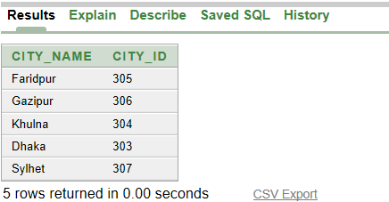

insert into best_security

(name, establish_date)

values('Best Security', to_date('01/06/1975', 'DD/MM/YYYY'))

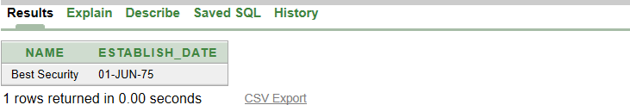insert into owner_info(ow_id, ow_name, phone_no, name)

values(901, 'Mohammed Hanif', '00582579, 00582510', 'Best Security')

insert into owner_info(ow_id, ow_name, phone_no, name)

values(902, 'Farid Ahmed', '00582959, 00582920', 'Best Security')  
  
insert into owner_info(ow_id, ow_name, phone_no, name)

values(903, 'Fahad Hossain', '00687239, 00687230', 'Best Security')

insert into owner_info(ow_id, ow_name, phone_no, name)

values(904,'Tanvir Ahmed','00362579, 00362549', 'Best Security')  
  
insert into owner_info(ow_id, ow_name, phone_no, name)

values(905, 'Shakil Shah', '00879579, 00879580', 'Best Security')

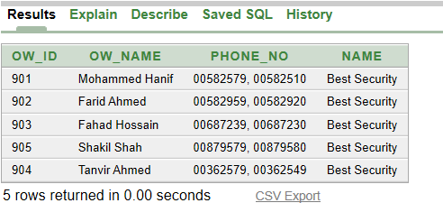

insert into guard_location

(location_id,cname,street_name,road_no,city_id,tid)

values(205,'Souteast Bank','Khalispur',02,304,102)

insert into guard_location

(location_id,cname,street_name,road_no,city_id,tid)

values(204, 'Prime Bank','Naopara',02,307,105)

insert into guard_location

(location_id,cname,street_name,road_no,city_id,tid)

values(201, 'City Bank','Gulshan',07,303,101)

insert into guard_location

(location_id,cname,street_name,road_no,city_id,tid)

values(202, ' Dhaka Bank’, 'Muzgunni',07,304,102)

insert into guard_location

(location_id,cname,street_name,road_no,city_id,tid)

values(203, 'Coffee House','Dhanmondi',09,303,101)  
  
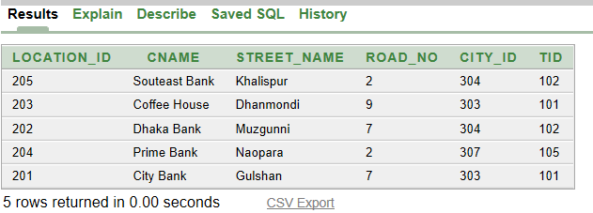

insert into client_info

(cid, cname, start_date, end_date, name)

values(401,'Dhaka Bank', to_date('01/JAN/2015', 'DD/MM/YYYY'),

to_date('01/JAN/2025', 'DD/MM/YYYY'), 'Best Security')

insert into client_info

(cid, cname, start_date, end_date, name)

values(403,'Prime Bank', to_date('01/JUL/2014', 'DD/MM/YYYY'),

to_date('01/JUN/2024', 'DD/MM/YYYY'), 'Best Security')

insert into client_info

(cid, cname, start_date, end_date, name)

values(402,'City Bank', to_date('01/JUL/2016', 'DD/MM/YYYY'),

to_date('01/JUN/2026', 'DD/MM/YYYY'), 'Best Security')

insert into client_info

(cid, cname, start_date, end_date, name)

values(404,'Southeast Bank', to_date('01/JAN/2014', 'DD/MM/YYYY'),

to_date('01/JUN/2022', 'DD/MM/YYYY'), 'Best Security')

insert into client_info

(cid, cname, start_date, end_date, name)

values(405,'Coffee House', to_date('01/JAN/2010', 'DD/MM/YYYY'),

to_date('01/JAN/2022', 'DD/MM/YYYY'), 'Best Security')

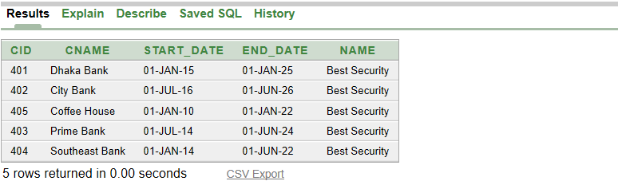

insert into job_histories

(hist_id, hire_date , prev_client)

values (803,to_date('17-JAN-2005', ‘DD/MM/YYYY’),'Gloria Jeans, ABC Cafe')

insert into job_histories

(hist_id, hire_date , prev_client)

values(801,to_date('01-JAN-2004', 'DD/MM/YYYY'),'Jamuna Bank, ABC Cafe')

insert into job_histories

(hist_id, hire_date , prev_client)

values(802,to_date('01-JUN-2008', 'DD/MM/YYYY'),'Jamuna Bank')

insert into job_histories

(hist_id, hire_date , prev_client)

values(804,to_date('01-AUG-2007', 'DD/MM/YYYY'),'Cafe Hello, World Cafe')

insert into job_histories

(hist_id, hire_date , prev_client)

values(805,to_date('01-MAR-2003', 'DD/MM/YYYY'),'Dutch Bangla Bank')   
  
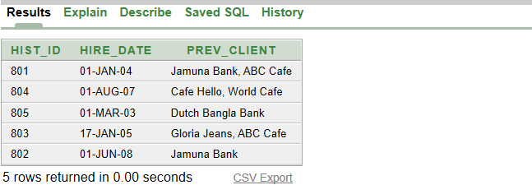

insert into guard_info

(gid, dob, hire_date, salary, bonus, phone_no, hist_id , f_name, l_name)

values(501, to_date('13/FEB/1981', 'DD/MM/YYYY'), to_date('01/JAN/2000', 'DD/MM/YYYY'), 10000, 2000, '66442',801,'Alamin','Sheikh')

insert into guard_info

(gid, dob, hire_date, salary, bonus, phone_no, hist_id , f_name, l_name)

values(502, to_date('19/FEB/1981', 'DD/MM/YYYY'), to_date('21/MAY/2003', 'DD/MM/YYYY'), 12000, 3000, '66392',802,'Akash','Ahmed')

insert into guard_info

(gid, dob, hire_date, salary, bonus, phone_no, hist_id , f_name, l_name)

values(503, to_date('29/AUG/1982', 'DD/MM/YYYY'), to_date('01/SEP/2003', 'DD/MM/YYYY'), 11000, 2500, '66388',803,'Mohammad','Kaif')

insert into guard_info

(gid, dob, hire_date, salary, bonus, phone_no, hist_id , f_name, l_name)

values(504, to_date('22/MAR/1979', 'DD/MM/YYYY'), to_date('01/FEB/1999', 'DD/MM/YYYY'), 14000, 4000, '66418, 66900',804,'Ahsan','Alif')

insert into guard_info

(gid, dob, hire_date, salary, bonus, phone_no, hist_id , f_name, l_name)

values(505, to_date('12/MAR/1980', 'DD/MM/YYYY'), to_date('01/MAY/2001', 'DD/MM/YYYY'), 11000, 3500, '66215, 66978',805,'Badhon','Hasan')

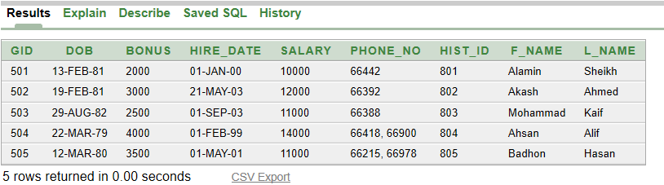

insert into guard_recruit

(gid, dob, hire_date, salary, bonus, phone_no, f_name, l_name, name)

values(501, to_date('13/FEB/1981', 'DD/MM/YYYY'), to_date('01/JAN/2000', 'DD/MM/YYYY'), 10000, 2000, '66442','Alamin','Sheikh', 'Best Security')

insert into guard_recruit

(gid, dob, hire_date, salary, bonus, phone_no, f_name, l_name, name)

values(502, to_date('19/FEB/1981', 'DD/MM/YYYY'), to_date('21/MAY/2003', 'DD/MM/YYYY'), 12000, 3000, '66392','Akash','Ahmed', 'Best Security')

insert into guard_recruit

(gid, dob, hire_date, salary, bonus, phone_no, f_name, l_name, name)

values(503, to_date('29/AUG/1982', 'DD/MM/YYYY'), to_date('01/SEP/2003', 'DD/MM/YYYY'), 11000, 2500, '66388','Mohammad','Kaif', 'Best Security')

insert into guard_recruit

(gid, dob, hire_date, salary, bonus, phone_no, f_name, l_name, name)

values(504, to_date('22/MAR/1979', 'DD/MM/YYYY'), to_date('01/FEB/1999', 'DD/MM/YYYY'), 14000, 4000, '66418, 66900','Ahsan','Alif', 'Best Security')

insert into guard_recruit

(gid, dob, hire_date, salary, bonus, phone_no, f_name, l_name, name)

values(505, to_date('12/MAR/1980', 'DD/MM/YYYY'), to_date('01/MAY/2001', 'DD/MM/YYYY'), 11000, 3500, '66215, 66978','Badhon','Hasan', 'Best Security')

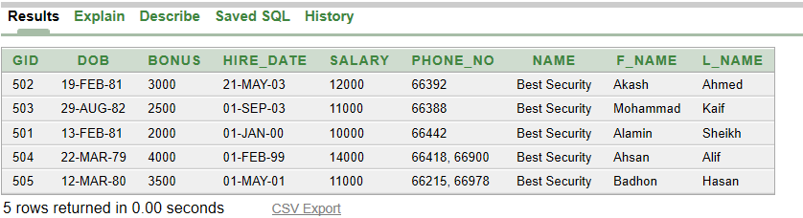

insert into guard_instruct

(gid, dob, hire_date, salary, bonus, phone_no, f_name, l_name, cid)

values(505, to_date('12/MAR/1980', 'DD/MM/YYYY'), to_date('01/MAY/2001', 'DD/MM/YYYY'), 11000, 3500, '66215, 66978','Badhon','Hasan', 401)

insert into guard_instruct

(gid, dob, hire_date, salary, bonus, phone_no, f_name, l_name, cid)

values(501, to_date('13/FEB/2000', 'DD/MM/YYYY'), to_date('01/JAN/2000', 'DD/MM/YYYY'), 10000, 2000, '66442','Alamin','Sheikh', 401)

insert into guard_instruct

(gid, dob, hire_date, salary, bonus, phone_no, f_name, l_name, cid)

values(502, to_date('19/FEB/1981', 'DD/MM/YYYY'), to_date('21/MAY/2003', 'DD/MM/YYYY'), 12000, 3000, '66392','Akash','Ahmed', 402)

insert into guard_instruct

(gid, dob, hire_date, salary, bonus, phone_no, f_name, l_name, cid)

values(503, to_date('29/AUG/1982', 'DD/MM/YYYY'), to_date('01/SEP/2003', 'DD/MM/YYYY'), 11000, 2500, '66388','Mohammad','Kaif', 403)

insert into guard_instruct

(gid, dob, hire_date, salary, bonus, phone_no, f_name, l_name, cid)

values(504, to_date('22/MAR/1979', 'DD/MM/YYYY'), to_date('01/FEB/1999', 'DD/MM/YYYY'), 14000, 4000, '66418, 66900','Ahsan','Alif', 404)

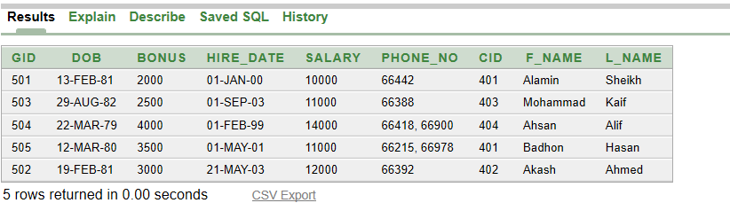

insert into guard_post

(gid, dob, hire_date, salary, bonus, phone_no, f_name, l_name, location_id)

values (505, to_date('12/MAR/1980', 'DD/MM/YYYY'), to_date('01/MAY/2001', 'DD/MM/YYYY'), 11000, 3500, '66215, 66978','Badhon','Hasan', 202)

insert into guard_post

(gid, dob, hire_date, salary, bonus, phone_no, f_name, l_name, location_id)

values(501, to_date('13/FEB/2000', 'DD/MM/YYYY'), to_date('01/JAN/2000', 'DD/MM/YYYY'), 10000, 2000, '66442','Alamin','Sheikh', 202)

insert into guard_post

(gid, dob, hire_date, salary, bonus, phone_no, f_name, l_name, location_id)

values(502, to_date('19/FEB/1981', 'DD/MM/YYYY'), to_date('21/MAY/2003', 'DD/MM/YYYY'), 12000, 3000, '66392','Akash','Ahmed', 201)

insert into guard_post

(gid, dob, hire_date, salary, bonus, phone_no, f_name, l_name, location_id)

values(503, to_date('29/AUG/1982', 'DD/MM/YYYY'), to_date('01/SEP/2003', 'DD/MM/YYYY'), 11000, 2500, '66388','Mohammad','Kaif', 204)

insert into guard_post

(gid, dob, hire_date, salary, bonus, phone_no, f_name, l_name, location_id)

values(504, to_date('22/MAR/1979', 'DD/MM/YYYY'), to_date('01/FEB/1999', 'DD/MM/YYYY'), 14000, 4000, '66418, 66900','Ahsan','Alif', 205)

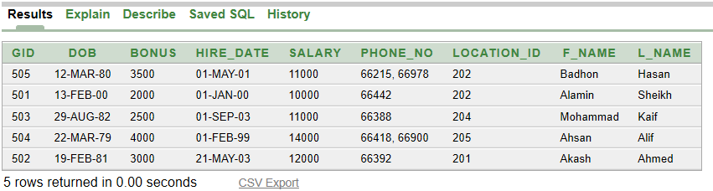

insert into instruct

(gc_id, gid, grd_start_date, grd_end_date, cid)

values(705, 505, to_date('01/MAR/2017', 'DD/MM/YYYY'), to_date('01/JAN/2025', 'DD/MM/YYYY'), 401)

insert into instruct

(gc_id, gid, grd_start_date, grd_end_date, cid)

values(701, 501, to_date('01/FEB/2015', 'DD/MM/YYYY'), to_date('01/JAN/2025', 'DD/MM/YYYY'), 401)

insert into instruct

(gc_id, gid, grd_start_date, grd_end_date, cid)

values(702, 502, to_date('01/AUG/2014', 'DD/MM/YYYY'), to_date('01/JUN/2026', 'DD/MM/YYYY'), 402)

insert into instruct

(gc_id, gid, grd_start_date, grd_end_date, cid)

values(703, 503, to_date('01/AUG/2014', 'DD/MM/YYYY'), to_date('01/JUN/2024', 'DD/MM/YYYY'), 403)

insert into instruct

(gc_id, gid, grd_start_date, grd_end_date, cid)

values(704, 504, to_date('01/MAR/2018', 'DD/MM/YYYY'), to_date('01/JUN/2022', 'DD/MM/YYYY'), 404)

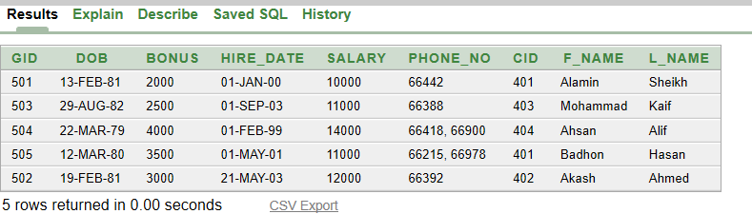

**Query Writing:**

Sub-Query:

1. Display those security guards guard id and first name who get less bonus than the employee Badhon (first name).

Ans: select gid, f_name from guard_info

where bonus < any

(select bonus from guard_info

where f_name = 'Badhon')

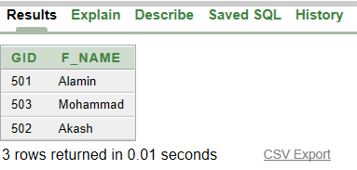

1. Display the guard id, last name and hire date for all guards who were hired after guard id 504.

Ans: select gid, l_name, hire_date from guard_info

where hire_date > any

(select hire_date from guard_info

where gid = 504)

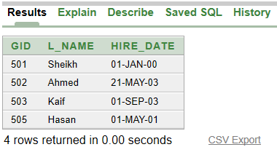

1. Display client id, client name and the start date of the contract with Best Security for all clients who were contracted(start date) after Prime Bank

Ans: select cid, cname, start_date from client_info

where start_date > any

(select start_date from client_info

where cname = 'Prime Bank')

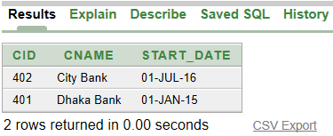

Joining:

1. Display the guard id, last name and previous clients for all guards.

Ans: select g.gid, g.l_name, j.prev_client

from guard_info g, job_histories j

where g.hist_id = j.hist_id

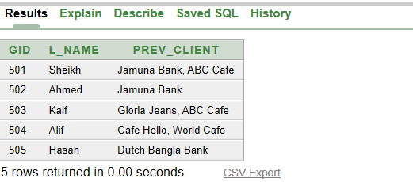

1. Display the guard id, last name salary, client name and client id for all guards

Ans: select g.gid, g.l_name, g.salary, c.cname, c.cid

from guard_instruct g, client_info c

where g.cid = c.cid

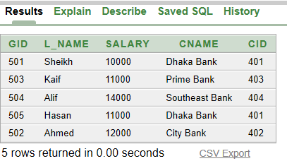

1. Display location id, street name, road number and city name for all guard located to its respective city.

Ans: select gl.location_id, gl.street_name, gl.road_no, c.city_name

from guard_location gl, city c

where gl.city_id = c.city_id

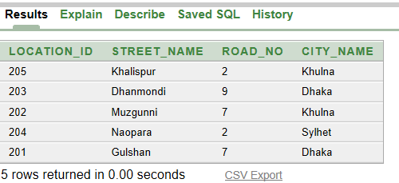

Group Function:

1. Show the number of security guard getting salary more than 10000.  
   Ans: select count(gid) from guard_info where salary > 10000  
     
   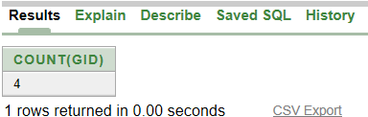
2. Show the sum of total salary along with bonus, paid to the security guards

Ans: select sum(salary + bonus) from guard_info

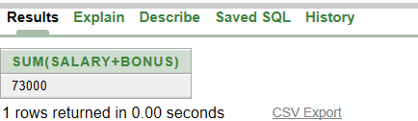

Single Row Function:

1. Display guard id, salary, hire date and the number of years in service for Best Security. Give appropriate column heading for it and round the figure

Ans: select gid, salary, hire_date, trunc((sysdate-hire_date)/365) as "Years of Service"

from guard_info

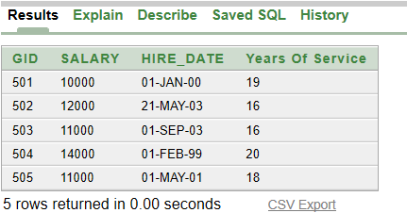

View:

1. Create a view to show guards first name, last name, phone number and date of birth for all employees. Name the view as “guard_personal_info”.

Ans: create or replace view guard_personal_info

as

select f_name, l_name, phone_no, dob

from guard_info

select * from guard_personal_info

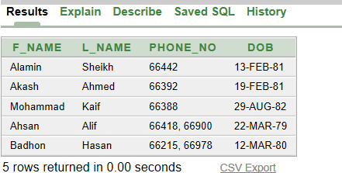

**Relational Algebra:**

Selection:

1. Find out all details of the owner whose owner id is 902  
   Ans: **σ**ow_id = 902 (owner_info)

Projection:

1. Find out owner name and phone number for all owners.

Ans: **∏**ow_name, phone_no(owner_info)

Selection + Projection:

1. Find out history id and hire date for guard whose guard id is 501

Ans: **∏**hist_id,hire_date[**σ**gid=101(guard_info)]

Selection + Projection and condition:

1. Find out guard id, first name and salary whose salary is greater than 11000

Ans: [**σ**salary > 11000 (guard_info)]  
 **∏**gid, f_name, salary

1. Find out client id and contract start date whose id is greater than 402  
   Ans: [**σ**gid > 402 (client_info)]

**∏**cid, start_date

Cartesian:

1. Find out guard id, first name, last name, previous client for all guards.

Ans: [**σ**guard_info.hist_id = job_histories.hist_id(guard_info  
 Xjob_histories)]

**∏**gid, f_name, l_name, prev_client

1. Find out location location id, city id and city name
2. Ans: [**σ**guard_location.cid = city.cid  (guard_location X city)]  
    **∏**location_id, city_id, city_name

Natural Join:

1. Find out guard id, first name, client name for all guards

Ans: **∏**gid, f_name, cname(guard_instruct ⋈ client_info)

1. Find out guard id, bonus and city name for all guards.

Ans: **∏**gid,bonus,city_name(guard_post ⋈ location_1)

Left outer Join:

1. Find out guard id, first name, client name for all guard along with those guards who don’t have any client.

Ans: **∏**gid,f_name,cname(guard_info ⟕ client_info)

1. Find out guard id, date of birth for all guards along with those locations which don’t have any guard.

Ans: **∏**gid, dob, cname(guard_location ⟕ guard_post)

Right Outer Join:

1. Find out location id, street name along with those cities which have no common location id.

Ans: **∏**location_id,street_name(city ⟖ guard_location)

1. Find out guard id and guard first name along with those guards who have no client

Ans: **∏**gid, f_name(client_info ⟖ guard_instruct)

Full Outer Join:

1. Find out guard id and guard first name along with those guards who have no history id.

Ans: **∏**gid, f_name(job_histories ⟗ guard_info)

1. Find out guard id, first name and also include those guards who are not posted to any location

Ans: **∏**gid,f_name(guard_location ⟗ guard_post)

**Conclusion:**

There are thousands of guards recruited in Best Security. Since only five tuples are selected in this project, that is why many information are missing. For example, there are many guards who joined recently and did not get job history (job id). We have faced some difficulties when doing the Relational Algebra, the Right Outer Join and Full Outer Join. Since in this project we are showing very low amount of information, along with, we don’t have any “many-to-many” relationship, it was difficult for us to create proper Relational algebra since other common

In the guard_instruct table, CID attribute contains only 4 distinct clients, but in client_info table, the CID attribute contains 5. This means that the five-information given for guards only work for among 4 clients, and the other client that is missing in guard_instruct table has other guards which is not mentioned in this “small” database.