Résumé OF
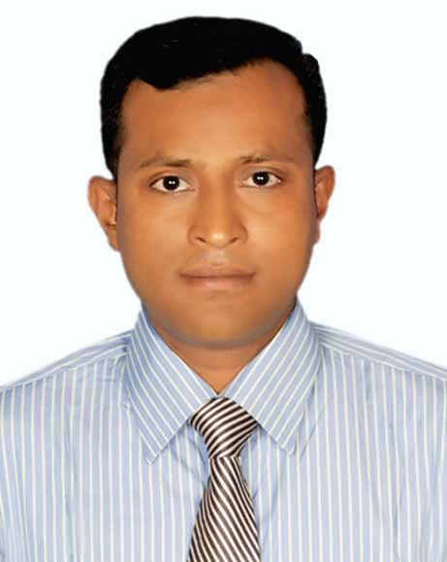
MOHAMMAD IMRAN HOSSAIN
Address: 10/1, west senpara parbata
Mirpur 10 - Dhaka 1216.
Phone: 01736339544
E-mail: imran80.bd@gmail.com

Career Objective:

A position with challenging responsibility where I may get an opportunity to utilize my educational training and experience while gaining exposure to a wide range of personnel functions with particular emphasis on sales and marketing sector.

Keyword:

I have more than 14 (Fourteen) years Practical Experience in Sales & Distribution of FMCG Sectors. Successfully setup manage and monitoring a large number of people like 40+ SO,10+ASE, 35+Distributor and their activities, rules and responsibility at a time. MBA in Marketing from America Bangladesh University and also M.com in Management from National University.

Career Summary:

1.Now presently I am doing the job of Unilever International at International Distribution Co. Bangladesh (PVT). As A Zonal Sales Manager From 1st January 2018 to continuing.

2. I have done the job of Baby Nutrition ltd at Lalmai Group as an Area Sales Manager From(1st August -2016 to 31st December-2018).

3. I have done the job of Transcom distribution Co. Ltd. (consumer brand division) As an Area Sales Executive (ASE) From (February -2007 to 31st July -2016.)

4. I have done the job of Kollal Group as a Regional Sales Officer.
From (January-2005 to December-2006).

5. I have done the job of Marico Bangladesh ltd. as a Sales representative.
From (March-2003 to June-2004).

Employment History:

Total Year of Experience: 14 Year(s)

Zonal Sales Manager (1st January,2018 to Continue)
International Distribution Company Bangladesh (PVT) Limited
159/C Tejgaon Industrial Area Dhaka-1208.
Brand: Skin Care & Personal Care Products.
Location: Dhaka Zone

Duties/Responsibility:
To promote a product, service or Idea the role includes sales planning, campaign, public relationship, organizing, events, product development and distribution, achieving target. Bellow has been given more details.

- To Plan and Design yearly sales budget & Setting Target Territory wise as par their Area Potential basis.
- Sales Operations - Highly competitive in achieving sales target through consistent drive and focus. Expert in engaging teams to believe in and drive for tangible results achievement and market share gain.
- Successfully leading a large number of team 40 + sales Officer, 10+ ASE, and 35 Distributor and their roles and responsibilities
- Channel & Distribution Development - Proven expertise on robust distribution strategy planning, e.g.- Distributor & Distribution set up, route planning focusing on trade channel, people & logistic issues, consumer & customer dynamics, etc.

- People Development - Solid track record of developing team members as well rounded managers.
- Manage and lead area RTM (route to Market) strategies & ensure sales & distribution Model in line with Company Strategies.
- Plan and implement trade marketing and B2B promotion activates in line with the business objective.
- Monitor and analyze business trends and other indicators to develop plan, strategies and activities aligned with Company objectives and guideline.
- Drive coverage expansion in-line with company direction and market requirement.
- Guide Distributors to ensure right and quality service level in assigned market.
- Review distributor’s ROI to monitor and facilitate distributor business profitability.

- Ares sales Manager (1st August, 2016 to 31st December-2018).

Baby nutrition ltd at Lalmai Group.
Company Location: 107, khan Manson Motijheel C/A, Dhaka -1000.
Department: Sales & Marketing.
Brand: Eldobaby - Maternal & Infant Nutrition.

Duties/Responsibility:

- Ensure growth and attain the market share objectives by identifying market needs appropriate strategy for assigned product.
- Develop short and long term sales plan and setting target for each team member and communicate to the sales force.
- Monitor performance of the members of the sales force in an organized and regular manner, provide feedback and take corrective preventive measures to mitigate the issue related performance.
- Achieve monthly primary and secondary sales as per given area target, and planning growth for the next year.
- Identify distribution gap of the area & build sustainable trade relationship with channel partner.
- Led, monitor & train the TSM, ANO, SR, DSR & their role and responsibilities.
- Monitor and follow up all sales promotion & campaigns to bring effective result.
- Follow up and update field sales plan for the assigned area, responsible for settings objective, leading negotiation process with distributors (or any others 3rd party partners). Execute daily monitoring of customer’s performance against difference KPIs (sales out, inventory level, order placement on- time etc).
- Settlements all kind of claim issue of distributors in the due time and maintain distributors expected ROI.
- Facilitate functional and professional capability development of the team members by coaching on the job training and guidance to prepare them for greater responsibilities, challenge and make them proactive in changing business situation.

- Area sales executive (February 03, 2007 to 31st July 2016.)
Transcom distribution company ltd.
Company Location: Gulshan Tower (6th Floor), Gulshan-2, Dhaka.
Department: consumer brand division

Brand: L’Oréal, Grainer, Bajaj Almond drops, Kumarika hair oil, Complan, Abbott Nutrition
etc.

Duties/Responsibility:
- Implement the strategic plan for develop relevant area sales & develop yearly sales plan.
- Increasing business opportunities through various routes to market coverage.
- Settings Sales Targets for individual raps and my team as a whole.
- Recruiting and training sales stuff and allocating areas to sales representative.
- Guide Aso, So, SR on day to day basis & monitoring forecast ordering.
- Manage distribution and retail Channel activities of the assigned area (geographic location) to ensure optimum availability of price products at maximum point of sales.
- To train and provide coaching for distributor sales team & Distributor management.
- Lead the Sales team of own Area for achieving the Sales target.
- Facilitate functional and professional capability development of the team members by coaching on the job training and guidance to prepare them for greater responsibilities.
- The incumbent is the expected to the result oriented and be able to ensure the sales as par given target.
- Develop customer relation plan and collect market information and channel to proper authority.
- Monitor performance of field force on a regular basis and provide structured.
- Feedback for development to business requirements.

Academic Qualification:

Exam Title | Concentration/Major | Institute | Result | Pass. Year | Duration
MBA | Marketing | America Bangladesh University | 3.31 | 2012 | 2 years
M.Com | Management | National University | Second Class | 2006 | 2 years
B.Com | Commerce | National University | Third Class | 2002 | 2 years
HSC | Commerce | Govt. Debendra University College, Manikgonj | Second Division | 1997 | 2 years
SSC | Science | Betila High School, Manikgonj | First Division | 1995 | -

Training Summary

Training Title | Topic | Institute | Country | Location | Year | Duration
Professional Expertise. | Essential selling skilling, Product knowledge & sales admin. | L’ORAL-INDIA | INDIA | KALKATA | 2008 | short course
Professional Expertise. | Essential selling skilling, Product knowledge & sales admin. | HEINZ-INDIA | INDIA | SHILONG | 2009 | short course

Professional Qualification:

Certificate | Institute | Location | From | to
“Computer Basic course” | Development of youth development ministry of youth & sports. | Manikgonj | July 02, 2006 | December 31, 2006

Career and Application Information

Looking for : Mid-Level Job
Available for : Full Time
Preferred Job Category : Sales, Distribution, Marketing.
Preferred District : Anywhere in Bangladesh.
Preferred Organization Types : FMCG, Distribution Telecommunication, Petroleum
Companies, and Personal Care Food & Beverage.

Language Proficiency:

Language | Reading | Writing | Speaking
Bangla | High | High | High
English | High | High | Medium
Hindi | No | No | Medium
Personal Details:

Father’s Name : SALIM UDDIN
Mother’s Name : LATE ASIYA BEGUM
Date of birth : August 05, 1980
Gender : Male
Marital Status : Married
Nationality : BANGLADESHI
Religion : ISLAM
Permanent Address : Vill: Bokjury, Post office: Jarina College,
Police station: Manikgonj, District: Manikgonj.
Current Location : Dhaka

Reference (s): references is available upon request.

Certification:

I severely declare that the information I have supplied in these curriculum vitae is correct if enrolled I shall confirm to the constitution norms condition rules & regulations of the institution.

Mohammad Imran Hossain

Date: ....................................

