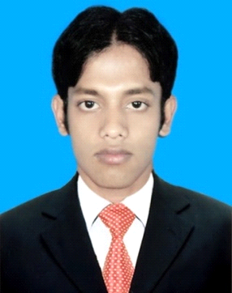
CURRICULUM VITAE
OF
Masudul Islam .
Email Address: masudislam112@gmail.com
Contact Number: +8801711206715

CAREER OBJECTIVE
Intend to pursue a career in an organization in where there is ample scope to learn, grow and achieve position in the higher echelon by one’s own performance and efforts.

WORKING EXPERIENCE
- Banglalink Call center five month experience at Gazipur. Joining
Date- 12/10/2015, Resign Date- 22/05/2016.
- Working Experience as a Asst. Teacher at Al- Amin Academic
School, kewa, sreepur, Gazipur from 14/12/16 to 14/02/2017.
EDUCATIONAL QUALIFICATION
Masters of Business Administration
Institute : Asian University of Bangladesh.
Study on : MBA
Major In : Accounting
Admission year : 2018
CGPA : 3.48 (Out of 4)
Bachelor of Business Administration.
Institute : Asian University of Bangladesh.
Study on : BBA
Major In : Accounting
Total credit : 135
CGPA : 3.256 (Out of 4)
Admission year : 2012
Higher Secondary Certificate (H.S.C).
Institute : Kendua Degree College.
Group : Business Studies.
GPA : 4.10 (out of 5).
Board : Dhaka.
Passing year : 2011.
Secondary School Certificate (S.S.C).
Institute : Shayma Shajahan Academy, Kendua
Group : Humanities.
GPA : 3.56 (out of 5)
Board : Dhaka
Passing year : 2009

LANGUAGE PROFICIENCY
- Fluent in Bengali and English.

COMPUTER EDUCATION & SKILLS

- Microsoft office, Excel, PowerPoint Internet browsing and Software Install Uninstall.

OTHER SKILLS & ABILITIES

- Strong multitasking skills.
- Excellent negotiation and communication skills.
- Natural ability to work alone or as part of team.

PERSONAL INFORMATION
Name : Masudul Islam
Father’s Name : Jakir Hossain
Mother’s Name : Fatema Begum
Date of Birth : 20th August 1993
Religion : Islam
Marital Status : Unmarried
Nationality : Bangladeshi (By birth)
Present Address : House No. 09, Lane: 10, Road: 10, Sector:11,
Mirpur, Pallabi- 1216 .
Permanent Address : Vill: Chartarotakya, P.O: Taltola Bazar,
P.S: Pakundia Dist: Kishorgonj.

REFERENCES

Md. Mahbub Alom
Prof. Asian University Of Bangladesh
Department Of CSE
Mobile: 01926877057

DECLARATION

I hereby declare that all information stated in the curriculum vitae is true and complete to the best of my knowledge.

----------------------------
Masudul Islam

