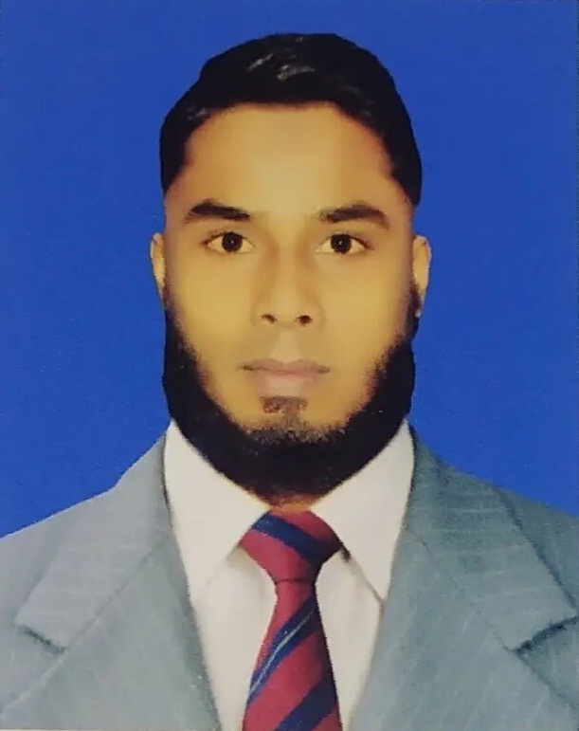
RESUME OF
MD. ARIFUR RAHMAN

Address:

Village: Charpaker daha, Post: Charpaker daha, Upazila: Madargonj,
District: Jamalpur.
Mobile : 01984942794.
Email #af.rahman375@gmail.com
Skype:mroshid70

Career Objective

I am looking for a job in such an organization where I shall find ample scope and opportunity to work and promote myself to a significant position and to obtain an executive level of position as well.

KEY SKILL

- Engine top overhauling. | - Starting system.
- Engine minor overhauling. | - Charging system.
- Engine major overhauling. | - Transmission system.
- Fuel System. | - Brake system.
- Lubricating system. | - Suspension system.
- Cooling system. | - Steering system.
- Ignition system. | - Alighting system & Horn system.

Special Qualification

Fields of Special Qualification
- Computer Operator.  - Internet Browsing.  - Email Communications. | - MS Office.  - Social Media.


Job Experience

- January, 2020 to Present. AnonTex Group, Tongi.
Generator Sub-Assistant Engineer.

Responsibilities:

- All Gas Generator, Diesel Generator, REB, Sub -Station Checking.
- Gas Generator & Cooling Tower Maintenance.
- Gas Generator, Diesel Generator, REB Sub-Station panel operating, Controlling & Maintenance.
- Power consumption & Fuel consumption report making.
- Gas line pressure reading note & controlling.
- Scheduled preventive maintenance of generators in accordance with the relevant Standard Operating Procedures as well as manufacturer's guidelines.
- Breakdown maintenance of the plant.
- Report any operational abnormalities to supervisor.

Academic Background

Exam Title | Concentration/Major | Institute | Result | Pas.Year
Diploma in Engineering. | Power Technology. | Mymensingh Polytenic Institute. | CGPA:3.48  out of 4 | 2019
SSC (Vocational). | General Electrical Works. | Khalequannessa Academy. | CGPA:4.79  out of 5 | 2015

Training Summary

Training Title | Topic | Institute | Location | Year | Duration
Engine & Classification,Servicing | Classification of IC Engine,Four Stroke Petrol Engine and Diesel Engine,Compression Between CI Engine & SI Engine. | Technical Training Center-TTC,Nitol Motors Ltd.(Service) | Gazipur | 2019 | 4 Months

Language Proficiency

Language | Good command in English and Bengali – both written and spoken.

Personal Information

Father's Name | : | Md.Abdus Samad.
Mother's Name | : | Maleka Begum.
Date of Birth | : | September 8, 1999
Gender | : | Male
Marital Status | : | Unmarried.
Nationality | : | Bangladeshi.
National Id No. | : | 5104283717
Religion | : | Islam.
Permanent Address | : | Village: Charpaker daha, Post: Charpaker daha,Thana: Madargonj, District: Jamalpur.
Current Location | : | Dhaka.

Reference

Name | : | Md. Saddam Hossain. | Md.Mamunur Roshid.
Organization | : | TTC,Nitol Motors Ltd.(Service). | Guardian Healthcare Ltd.
Designation | : | Sr.Officer. | Sr. IT Officer.
Address | : | Tongi-Gazipur. | 34, Lake Circus, Kalabagan, Dhaka 1205.
Mobile | : | 01817007190 | 01763365684
E-Mail | : | saddamied@gmail.com | Mroshid55@hotmail.com
Relation | : | Professional. | Brother.
Md.Arifur Rahman

Signature

