Jahid Hasan Himel 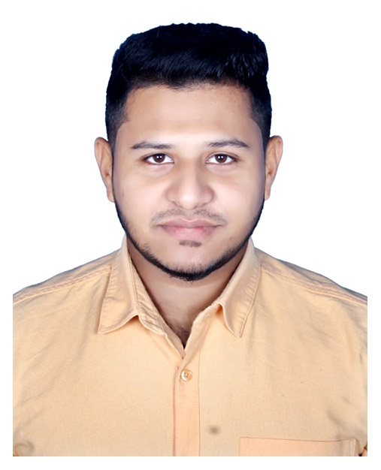
Mobile: 0184600992
Holding: 959/7
Chamurkhan, Kanchkura
Uttarkhan, Dhaka 1230

Career Objective

To work in an organization where I can utilize my interpersonal skills, creativity to develop my career as well contribute in the development of the organization.

Educational Qualification

Bachelor of Social Sciences

- University: Asian University
- Major: Social Work
- Year: 02nd Year (Continuing)

Higher Secondary Certificate (HSC)

- Institution: Kanchkura College
- Passing Year: 2019
- Result: GPA-3.42 (out of 5.00)
- Group: Science
- Board: Dhaka

Secondary School Certificate (SSC)

- Institution: Kanchkura High School
- Passing Year: 2015
- Result: GPA: 4.11 (out of 5.00)
- Group: Science
- Board: Dhaka

Language Proficiency

I have proper Communication skills in Bangla & English is acceptable

Experience
- Manage administration department in coaching center (01 March 2019 to 30 Sep 2019)

Fundamental & Hardware Strengths

- Good Communications skills
- Ability to cope up with different situation
- Co-operative
- Innovative

Personal Details

- Father Name : Johirul Islam Bulbul
- Mother Name : Farjana Akter Baby
- Date of Birth : 27 March 1999
- Nationality : Bangladeshi
- Religion : Islam
- Blood Group : AB+ (Positive)
- Permanent Address : Holding: 959/7, Chamurkhan
Kanchkura, Uttarkhan, Dhaka 1230

Interest

- Gardening
- Bike riding
- Traveling
- Music

Reference
02. Salina Akter Mukta
Sales & Distribution
Division Uttarkhan, Dhaka
DESCO
Contact: 01676031661
E-mail: mukta1390@gmail.com

01. S. M. Abdur Rauf Al Hossain
Admin Protocol Officer
United Group
United House, Madani Avenue
United City, Dhaka -1212
Contact: 01670167502
E-mail: rauf@united.com.bd

Jahid Hasan Himel
Signature

Date:

