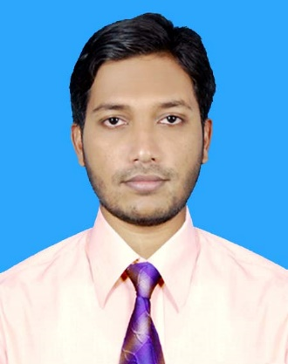**Resume**

**Of**

**S.M ISMAIL HOSSAIN RUBEL**

**Mailing Address**

Cha-148, Wireless more, Mohakhali, Dhaka-1212

Phone: **+8801670704770, +8801400445945**

E-mail:rubelsorder394@gmail.com

**Career Objective**

Looking for challenging duties in an expert environment that makes use of my analytical, problem-solving abilities, expertise and specialized information, for the mutual development of my career and the business.

**Academic Achievements**

**BSC in Computer Science & Engineering**

Institution Northern University Bangladesh

Result 3.16

Year of Passing 2017

**Higher Secondary Certificate (HSC):**

Institution Khulna Public College

Group Science

Board Jessore

Result 4.40

Year of Passing 2012

**Secondary School Certificate (SSC):**

Institution Kaligonj Pilot High School

Group Science

Board Jessore

Result 5.00

Year of Passing 2009

**Professional Course**

Institution American International University-Bangladesh (AIUB)

Course Name Cisco Certified Network Associate (CCNA)

Course Duration 6 month

Cisco ID No. CSCO13243569

**Technical Skills**

* Know networking topologies.
* Know networking concepts.
* Basic switch and router configuration.

-Understanding of bridging and switching concept of IP addressing .

* Routing Protocols: Static, Default, RIP, RIP v 2, OSPF, and EIGRP.
* Routing Concepts: ACL, NAT, PAT, and IPv6.
* Switching Concepts: STP, VLAN, VTP, Inter-VLAN, Port security.

**Employment History:**

**1. Junior Network Support Engineer (July 2018-Present)**

**Next Online Ltd**

URL: [http://www.nextonline.com.bd/](http://www.nextonline.com.bd/%20)

Address: Plot 325, Lane 22, New DOHS, Mohakhali Dhaka, Bangladesh

**Duties/Responsibilities:**

* Network maintenance
* Technical support for people using the network
* Fixing network faults
* Used Ticket management for Documentation –Office helpdesk Staff Ticket System
* Provided end-to-end computer and networking equipment installation, maintenance, and troubleshooting
* Managed and monitored all network devices
* Performed system software maintenance and product upgrades.
* Perform software install pushes using remote access tools
* Remotely support desktop technology platforms
* Establish connectivity via dial-up modem, DSL, or Cable modem
* Customer communication.
* Network management and planning.
* Find solutions to any problems found.
* Developed and applied testing and troubleshooting plans

**Language Skill**

Bengali (Mother Tongue)

English (Writing & Spoken)

**Computer Literacy**

MS Office, E-mail Management, Internet

**Personal Information**

Name **S.M Ismail Hossain Rubel**

Father's Name S.M Shahbaz Ali

Mother's Name Ferdaus Ara Begum

Date of Birth 20-07-1993

Nationality Bangladeshi (By Birth)

Religion Islam (Sunni)

Sex Male

Marital Status Unmarried

**Permanent Address**

Village Itagasa

Post Office Satkhira

Police Station SatkhiraSadar

District Satkhira

**References**

1. **Raihan-Ul-Masood**

Head of the Dept. of CSE,

Northern University Bangladesh

Mob: +8801720497315

1. **Bulbul Ahamed**

Head of the Dept. of CSE,

Sonargaon University

Mob: +8801755514691,+8801813370140

**Certification**

I hereby confess that all the information stated above is complete and true.



Date: Signature: _ _ _ _ _ _ _ _ _ _ _ _ _