**Chandan Das**

Mobile:+8801921297971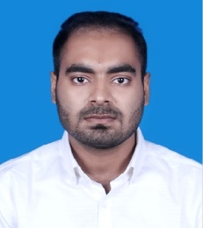

Email:chandan.d42@yahoo.com

House- 04, Post 1711, Hazi Nuab Ali Road, Tongi, Gazipur

**Career Objective:**

To obtain a creative and challenging position in an organization that gives me an opportunity for self-improvement and leadership, also be able to apply my knowledge and skills to contribute in the achievement of the organization’s goals as well as benefit the society through hard work and dedication.

**Academic Qualification:**

* **Northern University Bangladesh (2015-2018)**
* Bachelor of Business Administration
* Major in Finance & Minor in Accounting
* CGPA: 2.959 on a scale of 4
* **Alafadanga Degree College (2012-2013)**
* Higher Secondary Certificate
* Business Study
* GPA: 3.90 on a scale of 5
* **Alfadanga A.Z Pilot High School (2010-2011)**
* Secondary School Certificate
* Business Study
* GPA : 4.38 on a scale of 5

**Skills and Competences:**

Language skill: Proficient in speaking, writing and reading in English.

Computer skill: Well-exposed in office packages (MS Word, MS Excel, MS Power point, Access).

Adaptability and ability to work under pressure.

Voluntary on Business leadership club.

**Experience:**

3(three) months internship at Janata Bank Limited.

**Personal Details:**

Father’s name : Narayan Chandra Das

Mother’s name : Shantona Das

Present Address : House- 04, Post 1711, Hazi Nuab Ali Road, Tongi, Gazipur

Permanent Address : Village-Shyamnagar, Post-Konakola, Monirampur, Jessore

Date of Birth : 29-November,1997

Gender : Male

Marital Status : Unmarried

Religion : Sonaton

Nationality : Bangladeshi (By Birth)

**Reference:**

|  |
| --- |
| Benazir Rahman  Sr. Lecturer in Finance  Northern University Bangladesh  Cell no: +8801670167813 |

**Chandan Das**