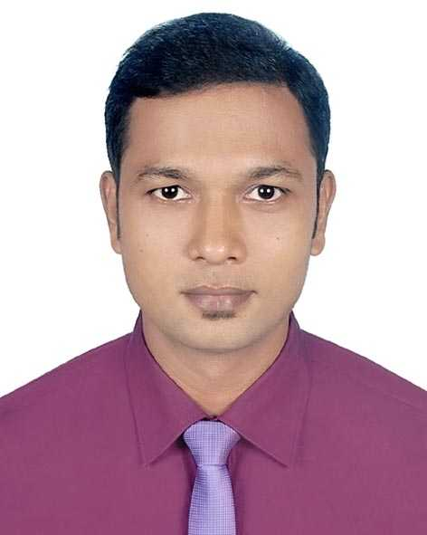

**Taposh Kumer Das**

**Experienced Distribution Sales and Key Account Management Professional**

PROFESSIONAL SUMMARY

[taposhkhulna1984@gmail.com C:\Users\EBD01183\Desktop\CV\download.jpg](mailto:taposhkhulna1984@gmail.com%20)

+8801962424212 C:\Users\EBD01183\Desktop\CV\download (1).jpg

Vhairab Stand Road, Khulna,C:\Users\EBD01183\Desktop\CV\imagesttt.png

Khulna- 9100 Bangladesh

[linkedin.com/in/](http://www.linkedin.com/in/mdsadiqurrahma)Taposh-das-তাপস C:\Users\EBD01183\Desktop\CV\download.png

-911a11132

**MBA**, Khulna university, 2019 ●

*Human Resource Management*

CGPA: 3.84 in Scale of 4

**BBA**, Khulna university, 2010 ●

*Marketing*

CGPA: 2.84 in Scale of 4

**HSC,** Govt. MM City College, ●

Khulna, 2002

*Business Saudis*

First Division

**SSC,** Khulna Zilla School, 2000 ●

*Business Saudis*

First Division

EDUCATION

WORK EXPERIENCE

Distribution sales and key account management professional with 9 years of experience. Groomed in MNCs, result-oriented and self-driven with exceptional communication and leadership skills, and the ability to adapt quickly to change. Rewarded as regional and national top performer for demonstrating 26% business growth in assigned zone and 28% revenue growth in particular customer segment respectively. Thrives in complex market context in extracting targets and business objectives. Skilled at devising sales and distribution strategies, sales force recruitment and training, sales data entry and report preparation, merchandising with and managing retail channel, operational problem solving, maintaining inventory requirement, payroll and incentive model planning for field force, managing trade campaigns and attaining queries of customers.

CONTACT

Zonal Manager, Banglalink Digital Communications Limited, **June,15 to Present**

■ Continuously modifying and implementing of distribution strategy to cope with dynamic

market demand and competition.

■ Developing human resource through training and consultation according market and

business demand.

■ Designing Payroll and incentive package for field force considering contribution and business

impact.

■ Assigning route and responsibility to field force and fixing Job Description for field force.

■ Driving business through retail channel expansion and with solidified business relationship

with retailers.

■ Leading a team of 22, achieving targets and ensuring growth on Business KPIs by rigorous

monitoring and Feedback.

■ Ensuring customer service thorough efficient utilization of customer care channel field force.

■ Rigorous reporting and providing feedback according to the requirement of management.

■ Guiding and reconciling trade marketing activities through efficient deployment of right people

at the right place

■ Ensuring effective utilization of POSM in the market to ensure brand visibility in the market.

■ Recognized for regional best initiative in distribution productivity enhancement Q1, 2020.

■ Awarded with a trip to Bali Indonesia for 10% overall business growth in Q2’2019 over

Q1’2019.

■ Recognized as regional best Zonal Manager for highest business growth in region (26%) with

sealing 17% growth on sales quality in the year 2018 over the year 2017.

■ Secured placed among the top three National Best Zonal Managers in 2018.

■ Selected as Regional Role Model for 40% growth in Mobile Finance Service (MFS) Business

in 2017.

■ Remodeled distribution demarcation and boosted daily productivity to 90% straight from

62% in assigned Zone.

OPERATIONAL SKILLS SET

Distribution channel management ●

Strategic planning and execution ●

Communication and negotiation ●

Trade campaign management ●

Retail channel management ●

Training and development ●

Field force management ●

Sales lead management ●

Continuous Learning ●

Client management ●

Customer Service ●

Team supervision ●

Team player ●

**Taposh Kumer Das +8801962424212 taposhkhulna1984@gmail.com**

LANGUAGE SKILLS

IT SKILLS

**Bengali**: Native ●

**English**: Fluent ●

Microsoft Excel ●

Microsoft Power Point

Microsoft Word

Mailing ●

Outlook and others

Tech Savvy to adopt with ●

operational modules.

IT SKILLS

**Md. Naimul Hasan** ●

Head of Sales and Distribution

SQUARE Food and Beverage Ltd.

+88 017 01211244

[naimul.hasan@squaregroup.com](mailto:naimul.hasan@squaregroup.com)

**Mahmudul Haque Bulbul** ● Regional Strategy & Planning Analyst, B2C Sales & Distribution Banglalink Digital Communications Limited

+88 019 11310458

[mhhaque@banglalink.net](mailto:mhhaque@banglalink.net)

REFERENCES

Territory Manager, Airtel Bangladesh Limited, **Dec’13 to June’15**

■ Expanded channel footprint by 25%, conducted a successful distribution demarcation and

ensured 38% growth in business extraction in six months from joining.

■ Headed a team of 20, trained distribution field force and remodeled distribution operation

process in the territory.

■ Lead team to foster excellence in execution and chasing stretching goals to set

extraordinary example.

■ Coordinated company’s central team for trade marketing activities and other channel

related issues.

■ Lead customer care team for the assigned territory to ensure customer retention through

care and problem solution.

■ Designing Payroll and incentive package for field force considering contribution and

business impact.

■ Assigning route and responsibility to field force and fixing Job Description for field force.

■ Awarded as “Distribution king” title in 2014 for significant advancement in sales and

distribution KPIs and outstanding expansion of distribution footprint and product placement.

■ Won the “Airtel Achievers Club” title for 38% Business growth in six months through

distribution demarcation.

SME Channel Manager, Banglalink Digital Communications Limited, **July’11 to Dec’13**

■ Performed comprehensive evaluation of B2B sales team on a regular basis and guided

them in solving day to day operational issues, trained sales force in caring customer,

strengthen after sales service, provided feedback upward on sales and market related

issues through rigorous analysis and reporting.

■ Developing human resource through training and consultation according market and

business demand.

■ Assigning route and responsibility to field force and fixing Job Description for field force.

■ Rigorous reporting and providing feedback according to the requirement of management.

■ Worked in various territories and ensured business growth in challenging markets.

■ Ensured proper management and effective utilization of company resources an assisted

assigned distributor’s business feasibility & profitability.

■ Became National Best SME Channel Manager in 2013 for highest (28%) revenue growth

in SME customer Segment

TRAINING

**Training Title Institute Duration Year**

■ Sales Excellence Banglalink Digital Communications Limited 2 days 2019

■ Sales Leadership Banglalink Digital Communications Limited 2 days 2017

■ TM Foundation Centum Learning India 2 days 2014

■ Neuro Linguistic Banglalink Digital Communications Limited 2 Days 2012

Programming (NLP)

**Taposh Kumer Das +8801962424212 taposhkhulna1984@gmail.com**

PERSONAL INFORMATION

**Father** : Lakki Kanto Das

**Mother**  : Shanti Rani Das

**Date of Birth** : 3rd September, 1984

**Nationality** : Bangladeshi

**Sex** : Male

**Height**  : 175 cm

**Weight** : 76 kg

**Marital status** : Married

**Blood Group** : B+ ve

WHY I QUALIFY

**√ Significant Experience in distribution sales and key account management.**

I am managing distribution sales for last 6.5 years and before that created and managed key accounts

for 2.5 years with a successful achievement track.

**√ Able to understand complex business issues and clearly articulate key message to target**

**audience.**

I am also playing the role as a mediator between company and local distributor. Hence, I need to

demonstrate the role of a successful mediator between company and local distributor.

**√ Ability to manage sales force and assist in improving their business performance.**

I have long experience of recruiting, coaching and measuring day to day business performance of the sales

force at the execution level through rigorous monitoring and giving analyzed feedback with plethora of

business insights.

**√ Excellent communication skills, both oral and written, ability to Stay calm under pressure.**

I am an effective communicator, inspiring mediator, excellent presenter and convincing responder to

customers’ quires and feedbacks. My profession entails being calm under pressure to become successful

in extracting business objectives from dynamic and competitive market context.

**Taposh Kumer das**

01962424212