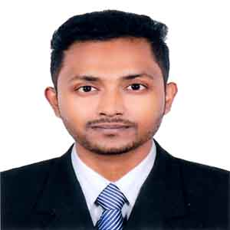**Ahmed Radwan Khan**

**Mailing Address:** H-8,B.G.Press Stuff Qarter,Satrasta,Tejgaon I/A, Dhaka-1215

**Mobile:** 01620610134

**Email:** radwan-khan@live.com

# Personal Traits

* Team player with strong analytical and communication skills.
* Have strong leadership ability along with exceptional presentation skills.
* Responsible, Dependable, Self-directed and self-motivated.
* Capable of learning new tools and technology very quickly and able to work under pressure

# Career Objective

Secure a position that will enable me to use my strong communication & organizational skills, customer service background and my ability to work well with people.

# Academic Qualifications

|  |  |
| --- | --- |
| **BBA**  Pursuing Education End Year : 2023 | **Bangladesh Open University**  Department: Bachelor of Business Administration , CGPA: Education Pursuing |
| **HSC**  Completion Year: 2016 | [**Tejgaon College**](https://www.tejgaoncollege.edu.bd/)  Department: Science  GPA: 2.90 (on a scale of 5.00) |
| **SSC**  Completion Year: 2012 | [**Tejgaon Govt. High School**](http://www.tghs.edu.bd/default.aspx)  Department: Science  GPA: 4.13 (on a scale of 5) |

# Computer Literacy

Major Software: Ms Office .

Internet: Browsing, E-mailing etc.

# Language

* Bengali - Native
* English - Well versed in both written and spoken English

# Personal Details

|  |  |  |
| --- | --- | --- |
| Date of Birth | : | 10th Oct 1997 |
| Nationality | : | Bangladeshi |
| Religion  Marital Status  Permanent Address | :  :  : | Islam  Single  Vill-Safipur,P.O&P.S-Bamna,District-Barguna | |
|  |  |  |