Resume of

**MOHAMMAD TAJMIRUL ISLAM**

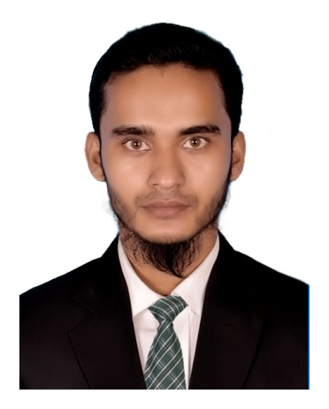

**Mailing Address:**

C/O- Mohammad Tajmirul Islam

Holding No: 1164/A, Jahanara Monjil

Shapla R/A, South kattali,

Post: Custom Academy, P.S: Pahartali

Dist: Chittagong

Mobile: 01914-420514

Email: [tajmir90bd@gmail.com](mailto:tajmir90bd@gmail.com)

**Career Objects:**

To work in a responsible position in organization where I can use my skill, knowledge and experience to achieve organizations goal and can stay in the process of continuous learning.

**Educational qualifications:**

|  |  |  |  |  |  |  |
| --- | --- | --- | --- | --- | --- | --- |
| **Degree** | | **Major** | **Institute** | **Result** | **Passing Year** | **Duration** |
| M.B.S | | Management | National University  Govt Commerce College ctg | **2nd Class** | 2016 | 2 Years |
| B.B.S (pass) | | Business Studies | National University  Govt Commerce College ctg | **2nd Class** | 2013 | 3 Years |
| H. S. C | | Business Studies | Govt. Haji Mohammad Mohosin College, ctg  Chittagong Board | **3.70**  (Out of 5) | 2008 | 2 Years |
| S. S. C | | General | Chittagong Nasaria Alia Kamil Madrasha  Madrasha Board | **5.00**  (Out of 5) | 2006 | 2 Years |
| **Employment History:** | | | | | | | |
| 1.Total Year of Experience : 3.0 Year(s) | | | | | | | |
|  | Position : Senior Sales & Marketing Officer  Period : June 2013 to May 2016 | | | | | | |
|  | Company : Apon Kraft (Ready Made Garments Showroom)   Company Location : GEC circle, Chittagong   Department : Sales & Marketing  2. Total Year of Experience :03 Years  Position : Jr. Executive (Bookkeeping, Banking & Recovery)  Period : August 2016 to August 2019  Company : Universal Traders (Ship Breaker)  Company Location : Sagarika Road, Chittagong  **Personal Details:**  Name : Mohammad Tajmirul Islam  Fathers Name : Md. Jalal Uddin  Mothers Name : Jahanara Begum  Date of Birth : 02.02.1991  Nationality : Bangladeshi  Gender : Male  Religion : Islam  Marital Status : Single  Height : [5.6]  Weight : 56 kg | | | | | | |
|  | **Blood : O+** | | | | | | |

**Language Skills:**

|  |  |  |  |
| --- | --- | --- | --- |
| **Language** | **Reading** | **Writing** | **Spoken** |
| English | Excellent | Excellent | Good |
| Bangla | Excellent | Excellent | Excellent |

**Computer Skills:**

|  |  |
| --- | --- |
| **Operation System** | Windows XP, Vista, Windows 7, 8 & 10 |
| **Application Software** | MS Word, MS Excel, MS PowerPoint |
| **Special** | Blogging,Social Networking,Web Content Writing,Email Communication |

**Personal Attributes:**

* Self-confident & positive
* Ability to work efficiently under pressure & meeting deadlines
* Ability to work in teams & maintain effective communication
* Optimistic & Non smoker

**References:**

|  |  |
| --- | --- |
| Name : Mohammad Nur-Un-Nabi  Position : Ex-Deputy General Manager  Company Name : Bangladesh Krishi Bank  Address :Muradpur Branch, Chittagong  Phone : +88017-18054834 | Name : Md. Hasan Chowdhury  Position : Advocate  Company Name : Judge's Court, Chittagong  Address : Room No-613 Ainjibi Annex Bhaban-1 Court Hill Chittagong  Phone : 01818768079  Email : mdhasanchowdhury09@gmail.com |

**Declaration**:

I, the undersigned declare that the information specified in this **Resume** is true to the best of my belief and knowledge and correctly describes my qualifications and myself.

**(Mohammad Tajmirul Islam)**