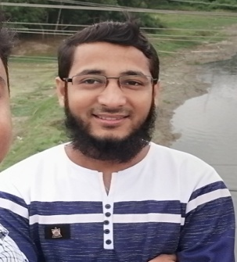Resume

Of

Md. Monirul islam

BMDC Reg:- D-10118

Mobile no : 01780858807

***Carrier object:-***

Looking for a carrier where there is an opportunity of self assessment & improvement in both individual & group based job that frequently face various critical problem challenges & services the community with individual skill.

***Personal information:-***

* Name : Md. Monirul islam
* Father’s name : Md. Abdus Samad
* Mother’s name : Morzina Khatun
* Date of birth : 27/03/1996
* Sex : Male
* Marital status : Unmarried
* Nationality : Bangladeshi
* Religion : Islam
* Present address : > Village : Khaspukhuria > post office : Chauhali College

: > Thana : Chauhali > District : Sirajganj

* Permanent address : Do,
* NID no : 19968812731000034
* Blood group : B (+ve)
* Mobile no : 01780858807

***Academic Qualification: -***

|  |  |  |  |  |  |
| --- | --- | --- | --- | --- | --- |
| Degree | Institute | Group | Result | Board | Passing year |
| D.M.F  (Diploma ) | Govt. MATS, Faridpur | Medical | Pass | The State Medical Faculty of Bangladesh | 2014 |
| S.S.C | Shambhudia Ajijia Alim Madrasah | Science | 4.94 | Madrasah | 2011 |

Computer Skill: > working with MS word , Excel, Power point, Graphic Design

>Mailing & Internet Browsing .

Ability : > Can work under pressure.

* Absolutely positive hard working with a positive attitude.
* Work independently as a team member.
* Capable of finding out & solving problems .

**Total Job experience ( 04 years & 07 Months) :**

* Ashik Composite Textile Mill’s Ltd : working as an Asst. Medical officer for 08 months from 01/03/2019 To still now.
* Gulshan Spinning Mill’s Ltd: : working as a SACMO for 01 Year & 07 month from 01/08/2017 to 26/02/2019
* Apon Medical services & Diagnostic center: working as a SACMO for 01 Year & 12 month from 25/05/2016 to 31/07/2017.
* Tangail General Hospital, Tangail : I have been successfully completed 01 year Internship from 20/05/2015 to 24/05/2016

Reference :

|  |  |
| --- | --- |
| Syed Abdul Mannan  Asst. Manager,  Gulshan Spinning Mill’s Ltd,  Zaina Bazar, Sreepur,Gazipur.  Mobile : 01724943643 | Dr. Amir Ali,  Ex- Asst. Director,DG_ Health,  Mobile :01718683710 |

Date: Signature

(Md. Monirul islam )