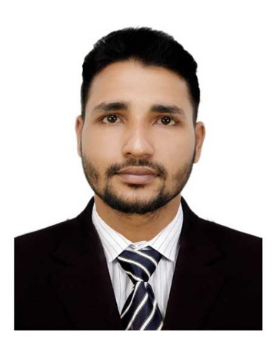

**CURRICULUM VITAE**

**OF**

**MD. ARIFUL ISLAM**

**+8801866591809**



**arifulislamhera1996@gmail.com**



**Career Objectives:**

­

Willing to build up carrier in a challenging position and to prove myself as a quick learner and highly energetic person to face any challenge in the Information Automobile Technology sector where the contribution will be acknowledged, if would be given an opportunity.

**Educational Qualification:**

* ***Diploma-In-Engineering: -***
* Name of the institute : Bangladesh Sweden Polytechnic Institute.
* Board : Bangladesh Technical Education Board (BTEB)
* Department : Automobile Technology
* Passing year : 2016
* Obtained C.G.P.A : 3.33 (out of 4.00)
* ***Secondary School Certificate (SSC): -***
* Name of the School : Charkanai High School.
* Board : Chittagong
* Group : Business Studies
* Passing year : 2012
* Obtained G.P.A : 4.50 (out of 5.00)

**Achievements:**

**🗌**Strong communication and interpersonal skills.

**🗌**Good analytical and problem solving skills.

**Computer Liability:**

* Working Operating System, Microsoft Office Application, Internet Browsing, etc.

**Industrial training & practice:**

* Organization Name : **“Project Solution Engineering & Consultancy Ltd.”**
* Address : BIDC Road, Gazipur-1700.
* Duration : Three Months.

**Experience :**

* **Organization Name** : **“KDA Motors”**
* Address : Muradpur, Punchlaish, Chittagong.
* Post : Working As a **Service Engineer.**
* Duration : May 2017 To June 2018
* **Organization Name : “Performance Motors Ltd.”**
* Address : HR Bhaban, 26/1, Kakrail, Dhaka.
* Post : Working As a **Assistant Engineer** at Swaraj Tractor Division.
* Duration : July 2018 to July 2020
* **Organization Name : “Janani Automobiles”**
* Address : 19/2 Rasulbagh, Mohakhali, Dhaka.
* Post : Working As a **Floor Engineer.**
* Duration : September 2020 to till now.

**Work Experience:**

1. Expert in Winsoft ERP software.
2. Car diagnosis by Scanner and find out the fault report.
3. CVT & ATF oil change by machine.
4. Sound knowledge about the price of Spare Parts, Lubricating Oil, Gear Oil and Brake Fluid.
5. Maintain spare parts stock.
6. Experience about marketing for develop company business.
7. Prepare daily report, monthly report and submit the reporting boss.
8. Able to maintain office management work.
9. Capable of working in a team as well as independently.
10. Capable to make good relation with customers.
11. Comfortable with working long hours in the site as well as an organization.

**Personal Information:**

* Name : Md. Ariful Islam
* Father’s Name : Mahamudur Rahman
* Mother’s Name : Khatija Begum
* Nationality : Bangladeshi (by birth)
* Religion : Islam
* Sex : Male
* Marital Status : Unmarried
* Date of Birth : 21-11-1996
* Height : 5 Feet 6Inch
* Weight : 56kg.
* Blood Group : O+ (positive).
* Birth Place : Chittagong
* National ID No. : 2362565976

**PresentAddress:**

* Town/Road/Flat : 19/2, Rasulbagh
* Post Office : Mohakhali
* Police Station : Banani
* District : Dhaka.

**Permanent Address :**

* Village : Charkanai
* Post Office : Charkanai
* Police Station : Patiya
* District : Chittagong.

**Reference:**

**Dr. Engr. Md. Anower Hossain** **Md. SelimAfradJoarder**

Senior Scientific Officer Chief Instructor (Automobile)

Irrigation and Water management Division Bangladesh Sweden Polytechnic Institute.

Bangladesh Agricultural Research Institute Cell: 01558487000

Joydebpur, Gazipur- 1701.

Cell: 01711249767

**Declaration:**

“I do hereby declare and certify that all the information stated above in this curriculum vitae are true and complete to the best of my knowledge and belief”

 Thanking Yours.

Date:

**Md. Ariful Islam**