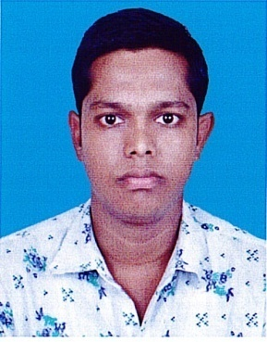

**RESUME**

**Of**

**Md. Merazul Islam**

Contact Number: 01933770779

|  |
| --- |
| **Career Objective:** |

Intend to work in challenging and competitive environment where strong sense of responsibility and commitment is required. Where dignity provides job satisfaction and the place of work provides potential. Avenue for learning, growing and achieving the higher level in the hierarchy of the organization.

|  |
| --- |
| **Academic Profile:** |

**Diploma in Engineering**

Institute Name :Digital Polytechnic Institute, Khulna

Group : Electrical

Board : BTED

Passing Year : 2018

Result : GPA- 2.79 out of 4

**Secondary School Certificate (S.S.C)**

Institute Name : Balntala Union Secondary School, Bagerhat

Board : BTEB

Passing Year : 2012

Result : GPA- 4.73 out of 5

|  |
| --- |
| **Exprience:** |

1. **6 Month** Electric Engineering Experience at **Khulna Khalishpur.**

|  |
| --- |
| **Computer Skills:** |

Microsoft Office Applications, Internet Searching & Browsing.

|  |
| --- |
| **Managerial Skills:** |

Interpersonal Skill, Team Management, Punctuality, Leadership, Smart, Personnel.

|  |
| --- |
| **Language Skills:** |

English & Bengali Proficiency in reading, writing & Speaking.

|  |
| --- |
| **Personal Profile:** |

Name : Md. Merazul Islam

Father’s Name : Mollick Abul Basar

Mother’s Name : Munjira Basar

Date of Birth : 31/12/1997

Religion : Islam

Nationality : Bangladeshi (By Birth)

Sex : Male

Marital Status : Married

Present Address : Village- kumlai, post- kumlai,P/S- Rampal, District-Bagerhat.

Permanent Address : Village- Kumlai, Post- Kumlai,

P/S- Rampal, District- Bagerhat.

|  |
| --- |
| **Declaration:** |

I do hereby declare, certify that, to the best of my knowledge and belief, this curriculum vita correctly describes qualification of me. My willful Mis-statement described here in my lead to my disqualification or dismissal if employed.

Merazul

Signature

(Md. Merazul Islam)