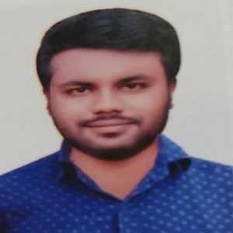

CURICULUM VITAE

**MUSHARRAF HOSEN**

**PROFILE**

**CARRIAR OBJECTIVES**

Young, energetic, hard working and quick learner. Capable to face exacerbate situation. Positive towards duties and responsibility.

To get a job and work in an environment where there is an opportunity of self-assessment and self-improvement in both individual and group based work that that will ultimately lend to the further development of the organization and me.

**CONTACT**

**🖂**

**ADDRESS**

**✆** 01799101576

musharrafhosen6872@gmail.com

**Present address:**

468/A West nakhalpara, Tejgaon, Dhaka.

**Permanent address:**

Vill : saituta

P.O :jangalbari

P.S : Karimganj

Dist : kishoreganj

**EXPERIENCE**

1 year job experience in PLCS and 1year job experience in A ONE POLAR LTD.

**COMPUTER SKILL**

Windows: 92, 2000, 2003, XP and Windows 7. Office application: MS word, MS Excel, MS Power point. Internet: Email, Browsing, Download, Online apply etc.

**HOBBIES**

**LANGUAGE**

Bangla, English and Arabic . bangle is mother tongue.

writing

reading

music

Travel

**🕮**

**✈**

**✍**

**🗀**

**Educational Qualifications**

# Degree Pass andSertificate course :-

* Name of the Institute : Gurudoyal govt. college kishoreganj.

* Passing year : 2017.

* Group : B.S.S.

* Result : CGPA- 2.76 (Out of 4.00)

* Board : National University.

# Higher Secondary Certificate (Alim):-

* Name of the Institute :

Karimganj shohania fazil madrasah.

* Passing year : 2014.

* Group : General

* Result : GPA- 4.19 (Out of 5.00)

* Board : Madrasah

# Secondary School Certificate (Dakhil):-

* Name of the Institute :

Saituta hossinia dakhil madrasah.

* Passing year : 2012.

* Group : General.

* Result : GPA- 3.42(Out of 5.00).

* Board : Madrasah.

**Personal Details**

* Name : Musharraf Hosen.

* Father’s Name : Lais uddin.

* Mother’s Name : Joymunnesa.

* Nationality : Bangladeshi (by birth).

* National Id no : 6431168100.

* Religion : Islam.

* Gender : male.

* Marital Status : Single.

* Date of Birth : 10/02/1996.

* Height : 5 Feet 6 Inch..

* Blood Group : A+ (positive).

* Birth Place : Kishoreganj..

**Declaration**

I certify that all information stated in this resume is true and complete to the best of my Knowledge. I authorize my potential bbbbbb employers to verify the information provided in this resume.

Musharraf hosen

……………………………..