**RESUME** 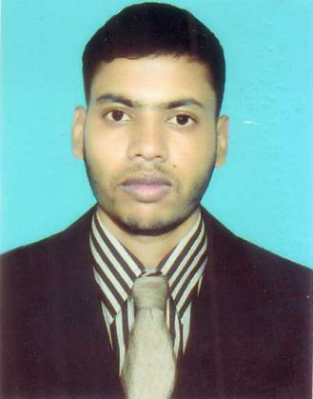

**OF**

**MD. ABDUL MUTTALIB**

C\O: Md. Sofiqul Islam

Mohishal Bari, Godagari, Rajshahi.

Mobile No:- +8801789-901074

[muttalib6888@gmail.com](mailto:muttalib6888@gmail.com)

|  |
| --- |
| **Career Object** |

I consider myself a responsible, creative, with initiative and punctuality, I accept with pleasure the challenges and goals that your organization could assign me, with good handle of the interpersonal relationships, ability to work in teams, ability to work under high pressure, so as to solve problems efficiently and achieve the goals set by the company and my work group.

|  |
| --- |
| **ACCADEMIC QUALIFICATION** |

**Diploma-In-Engineering:**

From : Bangladesh Technical Education Board(BTEB)

Institution : Rajshahi Polytechnic Institute , Rajshahi

Departmen : Mechatronics Technology

Session : 2015-2016

Passing year : 2019

Result : CGPA:- 2.68 Out Of 4.00

**Secondary School Certificate (S.S.C )**

From : Bangladesh Madrasah Education Board

Institution : Shah Sultan (RH:) Kamil Madrasah.

Group : Science

Session : 2013-2014

Passing year : 2015

Result : GPA 4.72 out of 5.00

|  |
| --- |
| **Professional & Key Strengths** |

* Good managerial and leadership skill .
* Strong desires for leading and honest life with dignity .
* Ability to increase both group and personal performances.

|  |
| --- |
| Personal information’s |

Name : Md. Abdul Muttalib

Father’s Name : Md. Sofiqul Islam

Mother’s Name : Nazera Begum

Permanent Address : Vill: Mohishal Bari Post: Mohishal Bari

P.S: Godagari Dist: Rajshahi

Present Address : Vill: Kushabo Post: Bhulta

P.S: Rupganj Dist: Narayanganj

Date of Birth : 2nd January 2000

Gender : Male

Home District : Rajshahi

Nationality : Bangladeshi ( By Birth )

National Id No : 6461058296

Height : 5′ 9″

Blood Group : A-

#### Marital Status : Single

#### Religion : Islam

Weight : 65kg

|  |
| --- |
| **Personal Specialty** |

## Cool minded, strong managing ability&convincing power.

## Have good communicative skills are always consistent &professional as the situation demands.

## Adoptive to new technology & a quick learner

## Self-motivated & good team-worker

## Enthusiastic, Creative, Routines & Sincere about own task

## Accept responsibility and do it honestly

|  |
| --- |
| **Skill** |

* **Computer:** Microsoft Office Program (MS Word, MS Excel, MS Access, MS PowerPoint, Bangla Typing), Web Browsing etc.

|  |
| --- |
| **Specialization:** |

* Computer Operator
* Graphic Designer
* Computer Technician
* Electrical Technician

|  |
| --- |
| Training: |

**Barind Multipurpose Development Authority (BMDA)**

Transformer Repairing and Fitting, Mortar Repairing and Fitting, Road Constriction, Computer Operating etc

**Godagari Upozila Computer Training Center**

Office Application and Database Programming

**Topics:** MS Word, MS Excel, MS Access, MS PowerPoint, Web Browsing, Windows Salutation .

|  |
| --- |
| **Language Proficiency:** |
| Bangla | High | High | High |
| English | High | High | Medium |
| Hindi | Medium | Medium | Medium |

## Experience: 01

### Name of Company : Best Tycoon (BD) Enterprise Ltd. (Vivo Mobile)

Location : Kushabo, Rupganj, Narayanganj

Designation : Sub - Assistant Engineer (Production)

Duration : 10th October 2019 to till now.

|  |
| --- |
| **Personal Interest & Hobby** |

## Traveling

* Human Service
* Reading Newspaper and Book
* Watching Movie, listening music in different cultural language

Declare that I will be responsible for any wrong information providedhere.

Md. Abdul Muttalib

Date: 27/01/2021