Documentation On

GIT REPOSITORY

AIM: Understanding GIT repository.
SOFTWARE REQUIRED: Any linux based OS
AUTHOR:- KAUSTUBH. K. BAGUL
The major difference between Git and any other VCS (Subversion and friends included) is the way Git thinks about its data. Conceptually, most other systems store information as a list of file-based changes. These systems (CVS, Subversion, Perforce, Bazaar, and so on) think of the information they keep as a set of files and the changes made to each file over time, as illustrated in Figure 1-4.
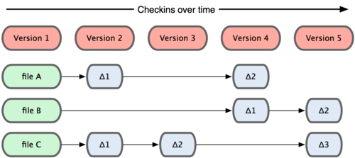
Figure 1. Other systems tend to store data as changes to a base version of each file.
Git doesn’t think of or store its data this way. Instead, Git thinks of its data more like a set of snapshots of a mini filesystem. Every time you commit, or save the state of your project in Git, it basically takes a picture of what all your files look like at that moment and stores a reference to that snapshot. To be efficient, if files have not changed, Git doesn’t store the file again—just a link to the previous identical file it has already stored. Git thinks about its data more like Figure 1-5.
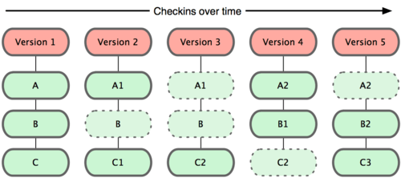
Figure 1. Git stores data as snapshots of the project over time.
This is an important distinction between Git and nearly all other VCSs. It makes Git reconsider almost every aspect of version control that most other systems copied from the previous generation. This makes Git more like a mini filesystem with some incredibly powerful tools built on top of it, rather than simply a VCS.

The Three States
This is the main thing to remember about Git if you want the rest of your learning process to go smoothly. Git has three main states that your files can reside in: committed, modified, and staged. Committed means that the data is safely stored in your local database. Modified means that you have changed the file but have not committed it to your database yet. Staged means that you have marked a modified file in its current version to go into your next commit snapshot.
This leads us to the three main sections of a Git project: the Git directory, the working directory, and the staging area.

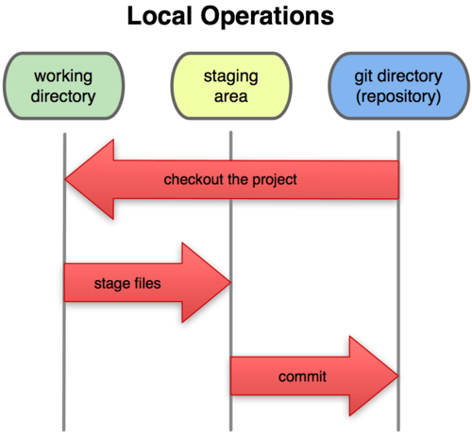
Figure: Working directory, staging area, and Git directory.
The Git directory is where Git stores the metadata and object database for your project. This is the most important part of Git, and it is what is copied when you clone a repository from another computer.
The working directory is a single checkout of one version of the project. These files are pulled out of the compressed database in the Git directory and placed on disk for you to use or modify.
The staging area is a simple file, generally contained in your Git directory, that stores information about what will go into your next commit. It’s sometimes referred to as the index, but it’s becoming standard to refer to it as the staging area.

The basic Git workflow goes something like this:
- You modify files in your working directory.
- You stage the files, adding snapshots of them to your staging area.
- You do a commit, which takes the files as they are in the staging area and stores that snapshot permanently to your Git directory.
If a particular version of a file is in the Git directory, it’s considered committed. If it’s modified but has been added to the staging area, it is staged. And if it was changed since it was checked out but has not been staged, it is modified. In Chapter 2, you’ll learn more about these states and how you can either take advantage of them or skip the staged part entirely.

HOW TO INSTALL GIT

(A)FEDORA

Step-1:
Open terminal and enter the following(without quotation):

Command>> yum install curl-devel expat-devel gettext-devel openssl-devel zlib-devel

These are the supporting libraries for GIT

Step-2:
Once the above file gets installed type the following command:

Command>> yum install git

This will install GIT to your present version of Linux

(B)UBUNTU (also for all Debian based OS)

Step-1:
Open terminal and enter the following(without quotation):

Command>> yum install curl-devel expat-devel gettext-devel openssl-devel zlib-devel

Step-2:
Once the above file gets installed type the following command:

Command>> yum install git-core

This will install GIT to your present version of Linux.

SET YOUR IDENTITY

In order to work on Git one must set their identity, so that the GIT repository will
recognise you when you need some data from it.

Step-1:
Write the following in your terminal:

Command>> git config --global user.name "Kaustubh Bagul"
git config --global user.name "Khairul Alam"

this will set your name as Kaustubh Bagul

Step-2:
Set your email ID with the user name you just defined:

Command>> git config --global user.email name@example.com
git config --global user.email embedded@fortunaindia.com

you need to do this only once if you pass the --global option,
because then Git will always use that information for anything you do on that system.

CHECK YOUR SETTINGS

Once you are done with the above setup, you need to check your settings

Step- Type the following command on your terminal line:

Command>> git config --list

The output should look something like this:

user.name=Kaustubh Bagul
user.email=kkblinux@gmail.com
color.status=auto
color.branch=auto
color.interactive=auto
color.diff=auto

GETTING HELP IN GIT

If you ever need help while using Git, there are three ways to get the manual page (manpage)
help for any of the Git commands:
Command>> git help <verb>
Command>> git <verb> --help
Command>> man git-<verb>

For example, you can get the manpage help for the config command by running

Command>> git help config

These commands are nice because you can access them anywhere, even offline. If the
manpages and this book aren’t enough and you need in-person help, you can try
the #git or #github channel on internet

INITIALISING GIT REPOSITORY

You can initialize a GIT repository in two ways 1. Making your own repository on your machine
in the PWD(present working directory) or in a directory where all your projects are listed.

2.Another way is getting a repository which is on a server.

Making your own repository

In order to make your own repository first, Make a directory where all your
projects (on which you want to keep track) are listed, For example

I made a directory named "FORTUNA" under which i listed some sub directories of different projects,
It looks something like this:

ROOT----FORTUNA(DIR)-----
|---Project1(Sub Dir)
|---Project2(Sub Dir)
|---Project3(Sub Dir)
|---Project4(Sub Dir)
|---Project5(Sub Dir)

One you do this, transfer/move/copy all your projects into their respective directories.

Now follow the steps listed below to make your own GIT repository on your machine:

Step-1: Change your pwd to "FORTUNA" or some the directory name that you had given earlier.

Step-2: Type the following command on your terminal(without quoatations):

Command>> git init

the output should look like this:

Initialized empty GIT repository in /FORTUNA/.git

Step-3: Now you have created a GIT repository under your directory. Now you need to add the file
to the git repository on which you need to keep track(for changes occured).

Write the following command (without quotation) on your terminal to add all the directories
(which are listed under FORTUNA) to .git

Command>> git add

this will add all the directories listed under FORTUNA to .git, so from now on whenever you make
any change to any of the file listed under Fortuna, .git will keep record of it.

TESTING YOUR LOCAL GIT REPOSITORY

Step-1
Create an empty file under your git repository (in my case its FORTUNA)

Command>> vim test.c
Step-2 Write any small C prog in test.c

#include<stdio.h>

int main()
{
printf("\nThis is a test prog for GIT\n");

return 0;
}

Step-3 Save it by pressing (i)shift+: and then (ii) wq + Enter

Step-4 Compile it(Optional)

Command>> gcc -o test test.c

Step-5 (optional) Run the program

Command>> ./test

Step-6: Now let us see of GIT has noticed this new file created
Type the following command on your terminal line:

Command>> git status

the output should look something like this:

# On branch master
#
# Initial commit
#
# Untracked files:
# (use "git add<file>..." to include in what will be committed)
#
# test
# test.c
nothing added to commit but untracked files present (use "git add" to track)

This means the GIT has notices the newly created file test.c and test.

Step-7:
Committng means adding to the repository. So, if in future you need this file you can get this from repository

To commit the changes type the following command in your terminal:

Command>> git commit -a

Here "a" represents "all changes"

Step-8:
Once you commit the compiler asks you to put a message so that you can remember what was the reason or why did you changed the contents of the file.

Viewing the Commit History

After you have created several commits, or if you have cloned a repository with an existing commit history, you’ll probably want to look back to see what has happened. The most basic and powerful tool to do this is the git log command.

Command>> git log

When you run git log in this project, you should get output that looks something like this:
$ git log
commit ca82a6dff817ec66f44342007202690a93763949
Author: Scott Chacon <schacon@gee-mail.com>
Date: Mon Mar 17 21:52:11 2008 -0700

changed the version number

commit 085bb3bcb608e1e8451d4b2432f8ecbe6306e7e7
Author: Scott Chacon <schacon@gee-mail.com>
Date: Sat Mar 15 16:40:33 2008 -0700

removed unnecessary test code

commit a11 bef06a3f659402fe7563abf99ad00de2209e6
Author: Scott Chacon <schacon@gee-mail.com>
Date: Sat Mar 15 10:31:28 2008 -0700

first commit

By default, with no arguments, git log lists the commits made in that repository in reverse chronological order. That is, the most recent commits show up first. As you can see, this command lists each commit with its SHA-1 checksum, the author’s name and e-mail, the date written, and the commit message.

Undoing Things

At any stage, you may want to undo something. Here, we’ll review a few basic tools for undoing changes that you’ve made. Be careful, because you can’t always revert some of these undos. This is one of the few areas in Git where you may lose some work if you do it wrong.

Changing Your Last Commit
One of the common undos takes place when you commit too early and possibly forget to add some files, or you mess up your commit message. If you want to try that commit again, you can run commit with the --amend option:

Command>> git commit --amend

Viewing old commits
The git checkout command serves three distinct functions: checking out files, checking out commits, and checking out branches. In this module, we’re only concerned with the first two configurations.
Checking out a commit makes the entire working directory match that commit. This can be used to view an old state of your project without altering your current state in any way. Checking out a file lets you see an old version of that particular file, leaving the rest of your working directory untouched.
Command>> git checkout a1e8fb56
This makes your working directory match the exact state of the a1e8fb5 commit. You can look at files, compile the project, run tests, and even edit files without worrying about losing the current state of the project. Nothing you do in here will be saved in your repository. To continue developing, you need to get back to the “current” state of your project

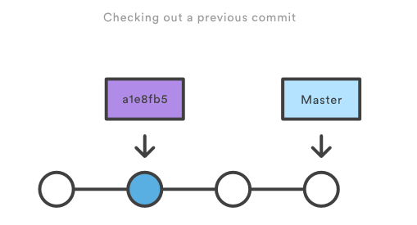

Coming back to your latest version
Return to the master branch.

Command>> git checkout master

Note-

$ git add README test.rb LICENSE
$ git commit -m 'initial commit of my project'
git commit -a -m 'made other changes'

git add .
git log --all
git checkout 5a7adb3742235afb

git branch -a //show the total branch
Git branch new-branch // create new branch

git remote add origin gituser@git.server.com:project.git
git push origin master

git clone gituser@git.server.com:project.git

…or create a new repository on the command line
echo "# CPUS32" >> README.md
git init git add README.md
git commit -m "first commit"
git remote add origin https://github.com/alam700014/CPUS32.git
git push -u origin master

…or push an existing repository from the command line
git remote add origin https://github.com/alam700014/CPUS32.git
git clone origin master

$ git remote show origin
* remote origin
URL: git://github.com/rails/rails.git
Remote branch merged with 'git pull' while on branch master
master
Tracked remote branches
1-2-stable 2-0-stable 2-1-stable 2-2-stable 3-0-unstable master

$ git ls-remote --heads origin
5b3f7563ae1b4a7160fda7fe34240d40c5777dcd refs/heads/1-2-stable
71926912a127da29530520d435c83c48778ac2b2 refs/heads/2-0-stable
2b158543247a150e8ec568becf360e7376f8ab84 refs/heads/2-1-stable
b0792a3e7be88e3060af19bab01cd3d26d347e4c refs/heads/2-2-stable
d6b9f8410c990b3d68d1970f1461a1d385d098d7 refs/heads/3-0-unstable
f04346d8b999476113d5e5a30661e07899e3ff80 refs/heads/master

