Artem Lamnin
03/20/22
IT FDN 110
Assignment 08

Object Oriented CD Inventory Script Creation

Introduction

This assignment required the creation of a Python script to perform most of the functions of the preceding assignment and incorporate the use of object oriented elements in the script in place of lists and dictionary data types.

As before, the script requests the user to input information about music CDs. It will now write that data to a binary data file instead of a text file. Alternately, the user can elect to output any of the input information directly to the screen. The rest of this document describes the steps taken for the creation of this script, as well as testing of the newly modified script on the author’s computer.

Script Description

The final program is shown in Figures 1-6 below.
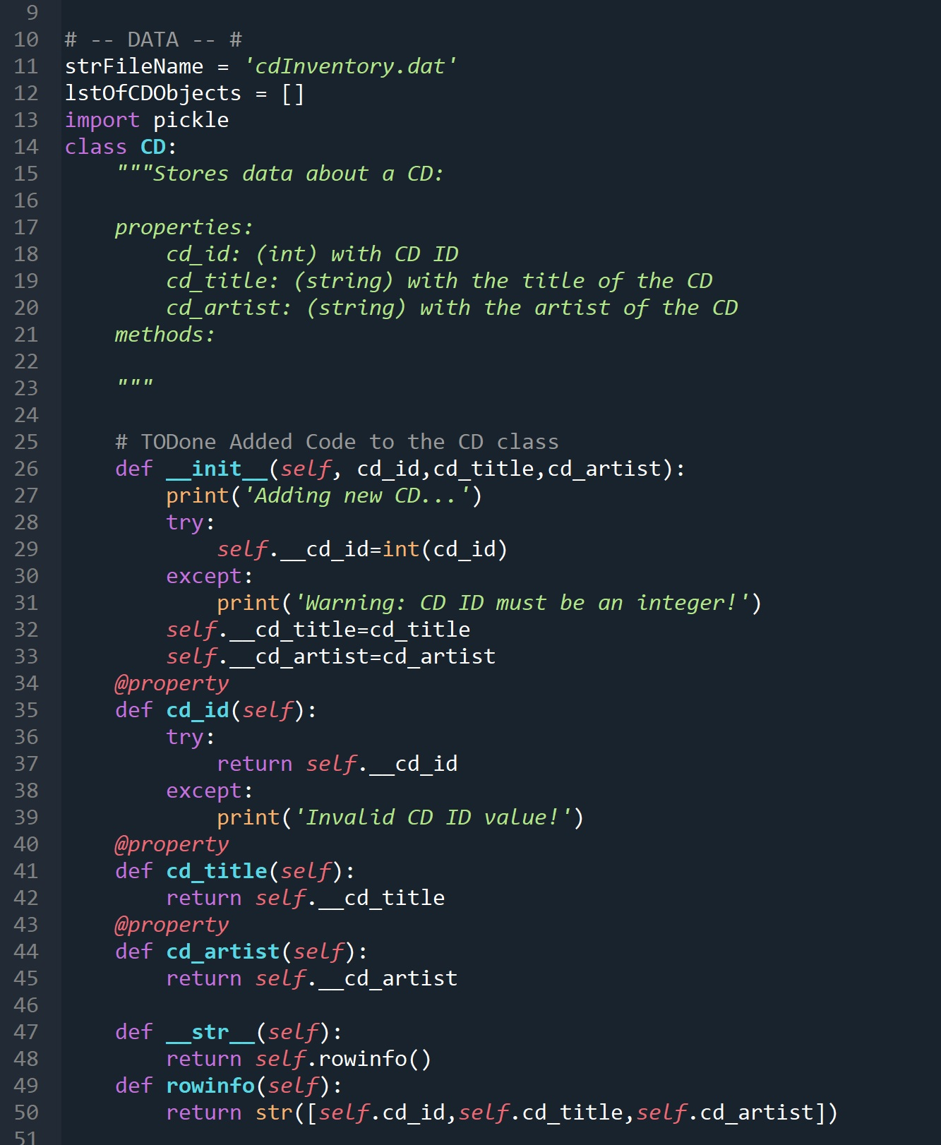
Figure 1 - CD Object Class

Figure 1 shows the primary CD object class. This class will be used to create objects representing each CD. Lines 26-33 show the content of the __init__ dunder. This dunder contains the setting statements for the three properties cd_id, cd_title, cd_artist, which in turn will contain the three pieces of data about each CD (ID, title, artist). Lines 34-45 show the property definitions themselves. The dunder also checks if the cd_id variable can be converted to the integer using the try-except function. If it cannot and this causes an error(because the user entered something other than a number), it will print a warning message and move to the next part of the code.

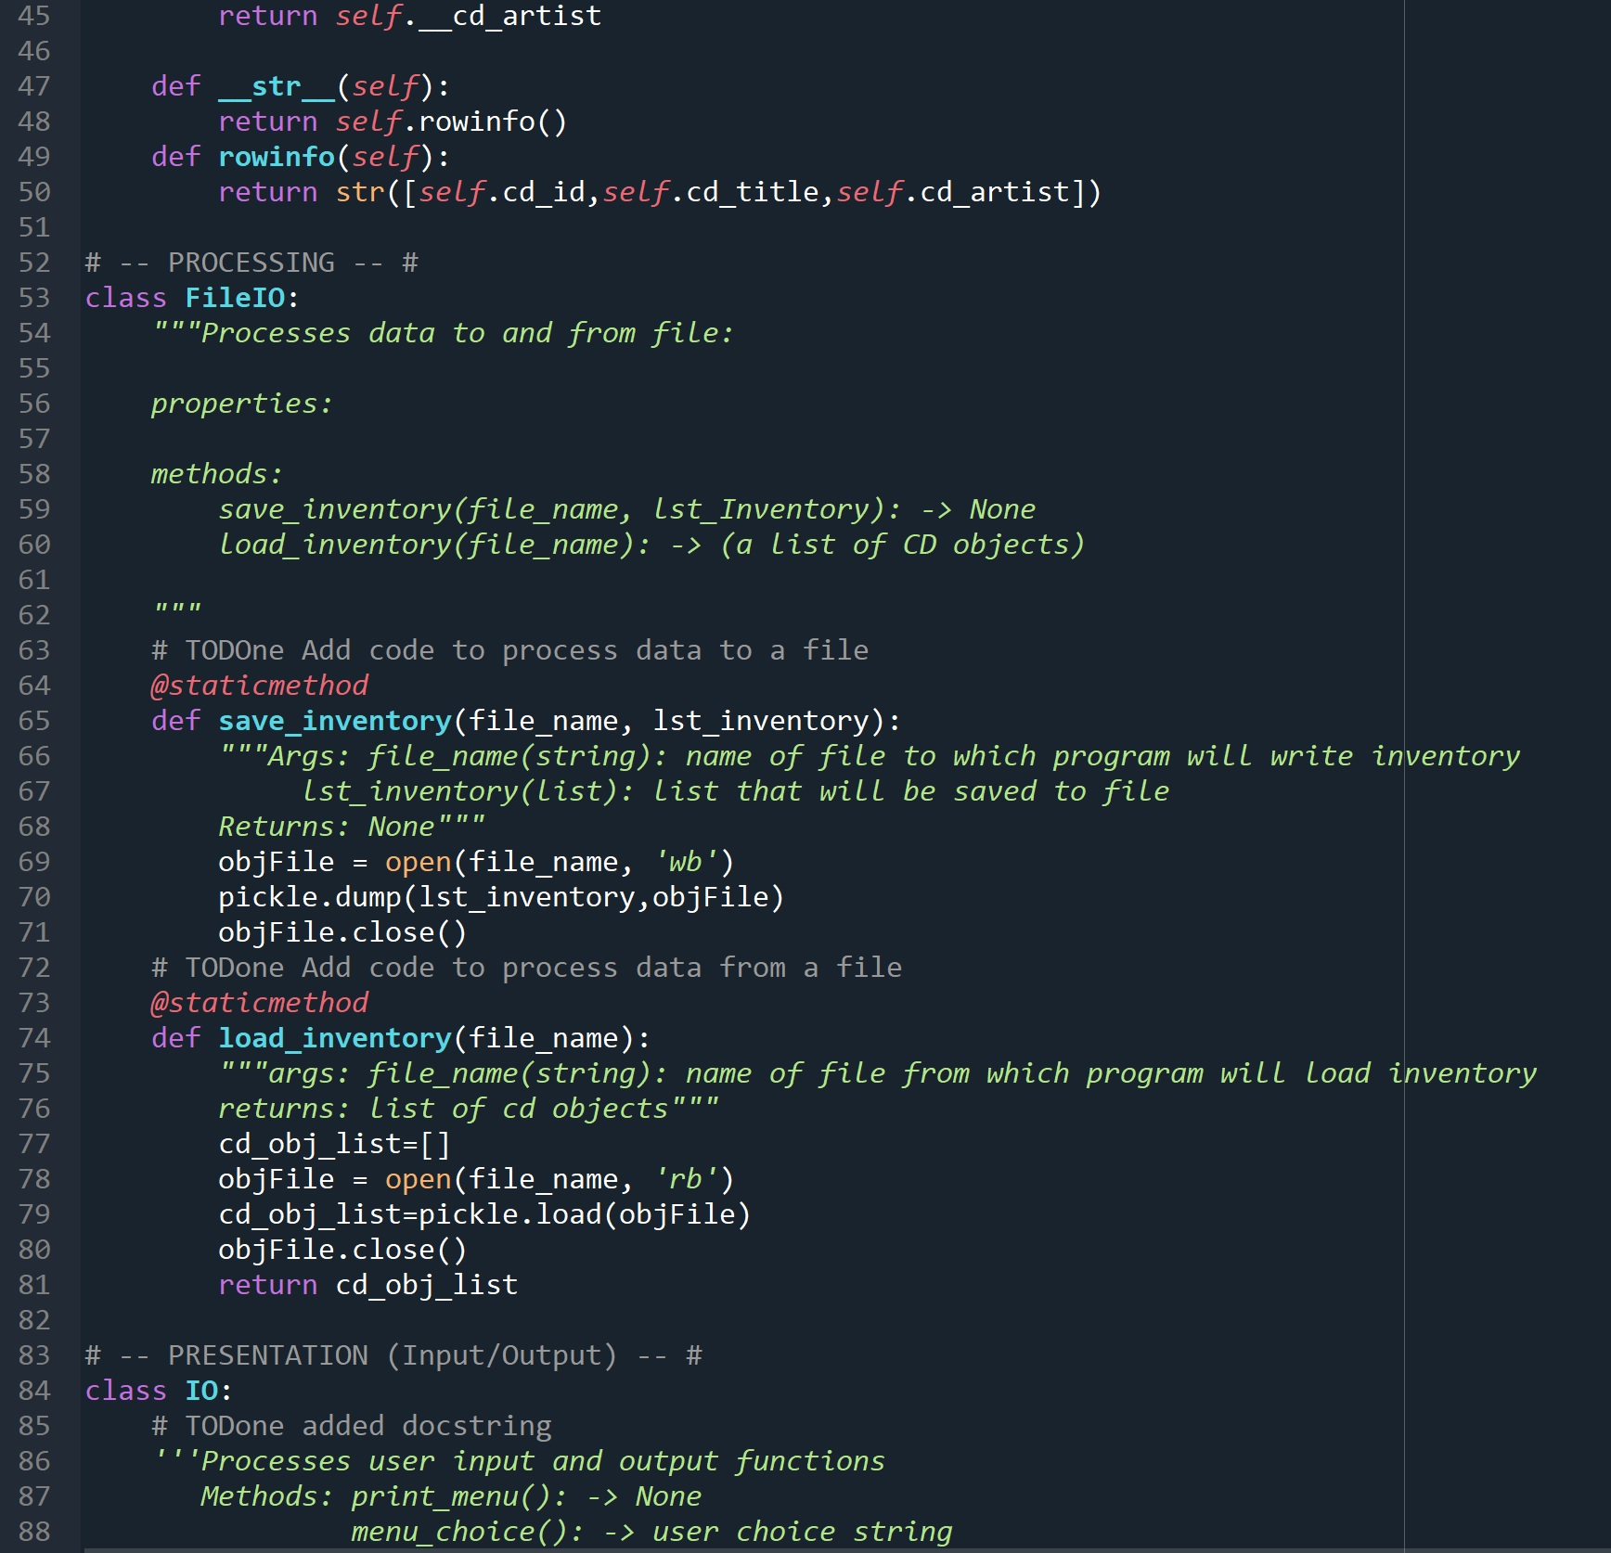
Figure 2 - File Input/Output Class

Figure 2 shows the FileIO class definition. This class contains the save_inventory() and load_inventory() methods on Lines 65-81, which are used to write to file and load inventory from file, respectively. In order to save the inventory to file, the program takes lst_inventory list, which the main program passes to it. As in the previous assignment, The method then uses the pickle.dump() function to write the list to the binary file. Similarly, the load_inventory() method uses the pickle.load() function to assign the contents of the ‘cdinventory.dat’ file to variable cd_obj_list and returns it to the main section of the program.

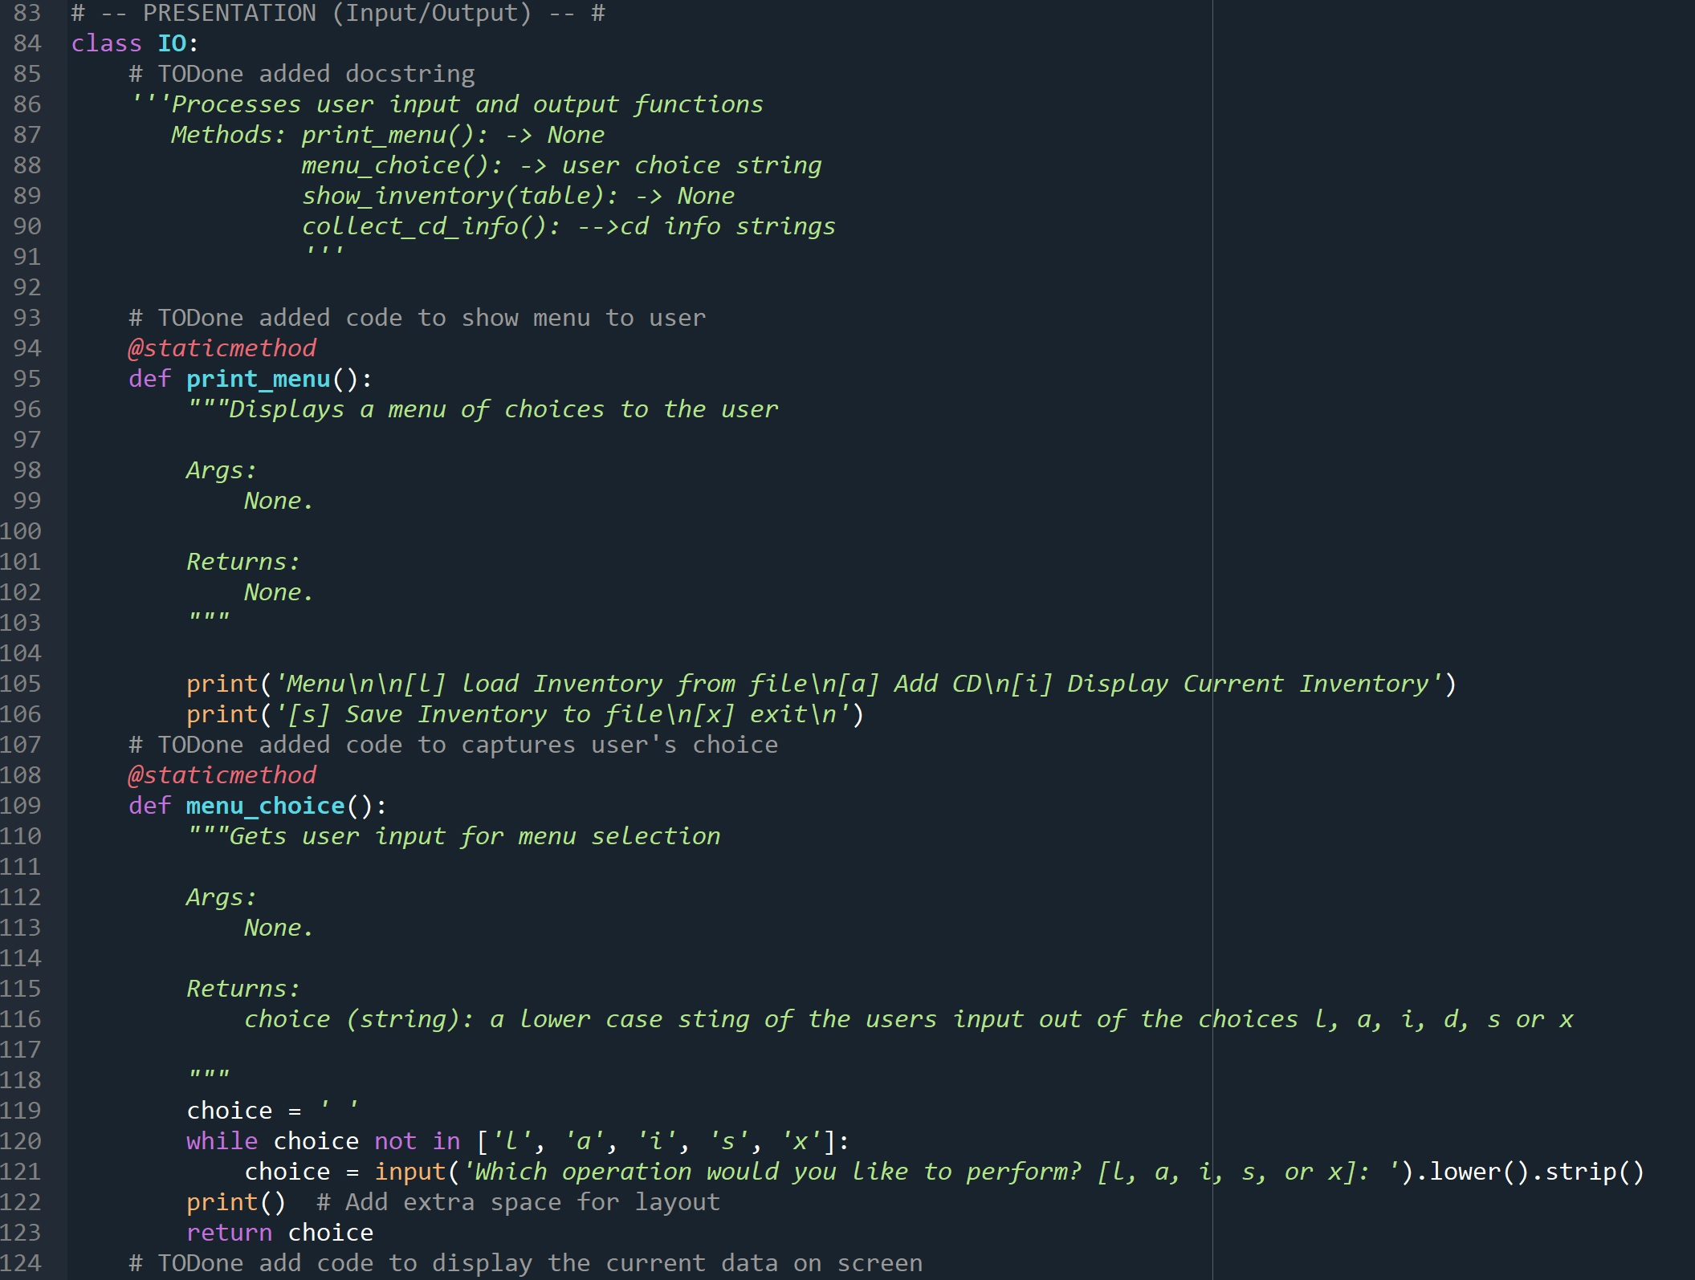
Figure 3 - Input/Output Class

Figures 3-4 show the definition of the IO class. This class contains definitions for the print_menu(), menu_choice(), show_inventory(), collect_cd_info() static methods. The print_menu() and menu_choice(), and collect_cd_info() methods are largely unchanged from the previous assignments. The show_inventory() function is modified to incorporate the object oriented approach.

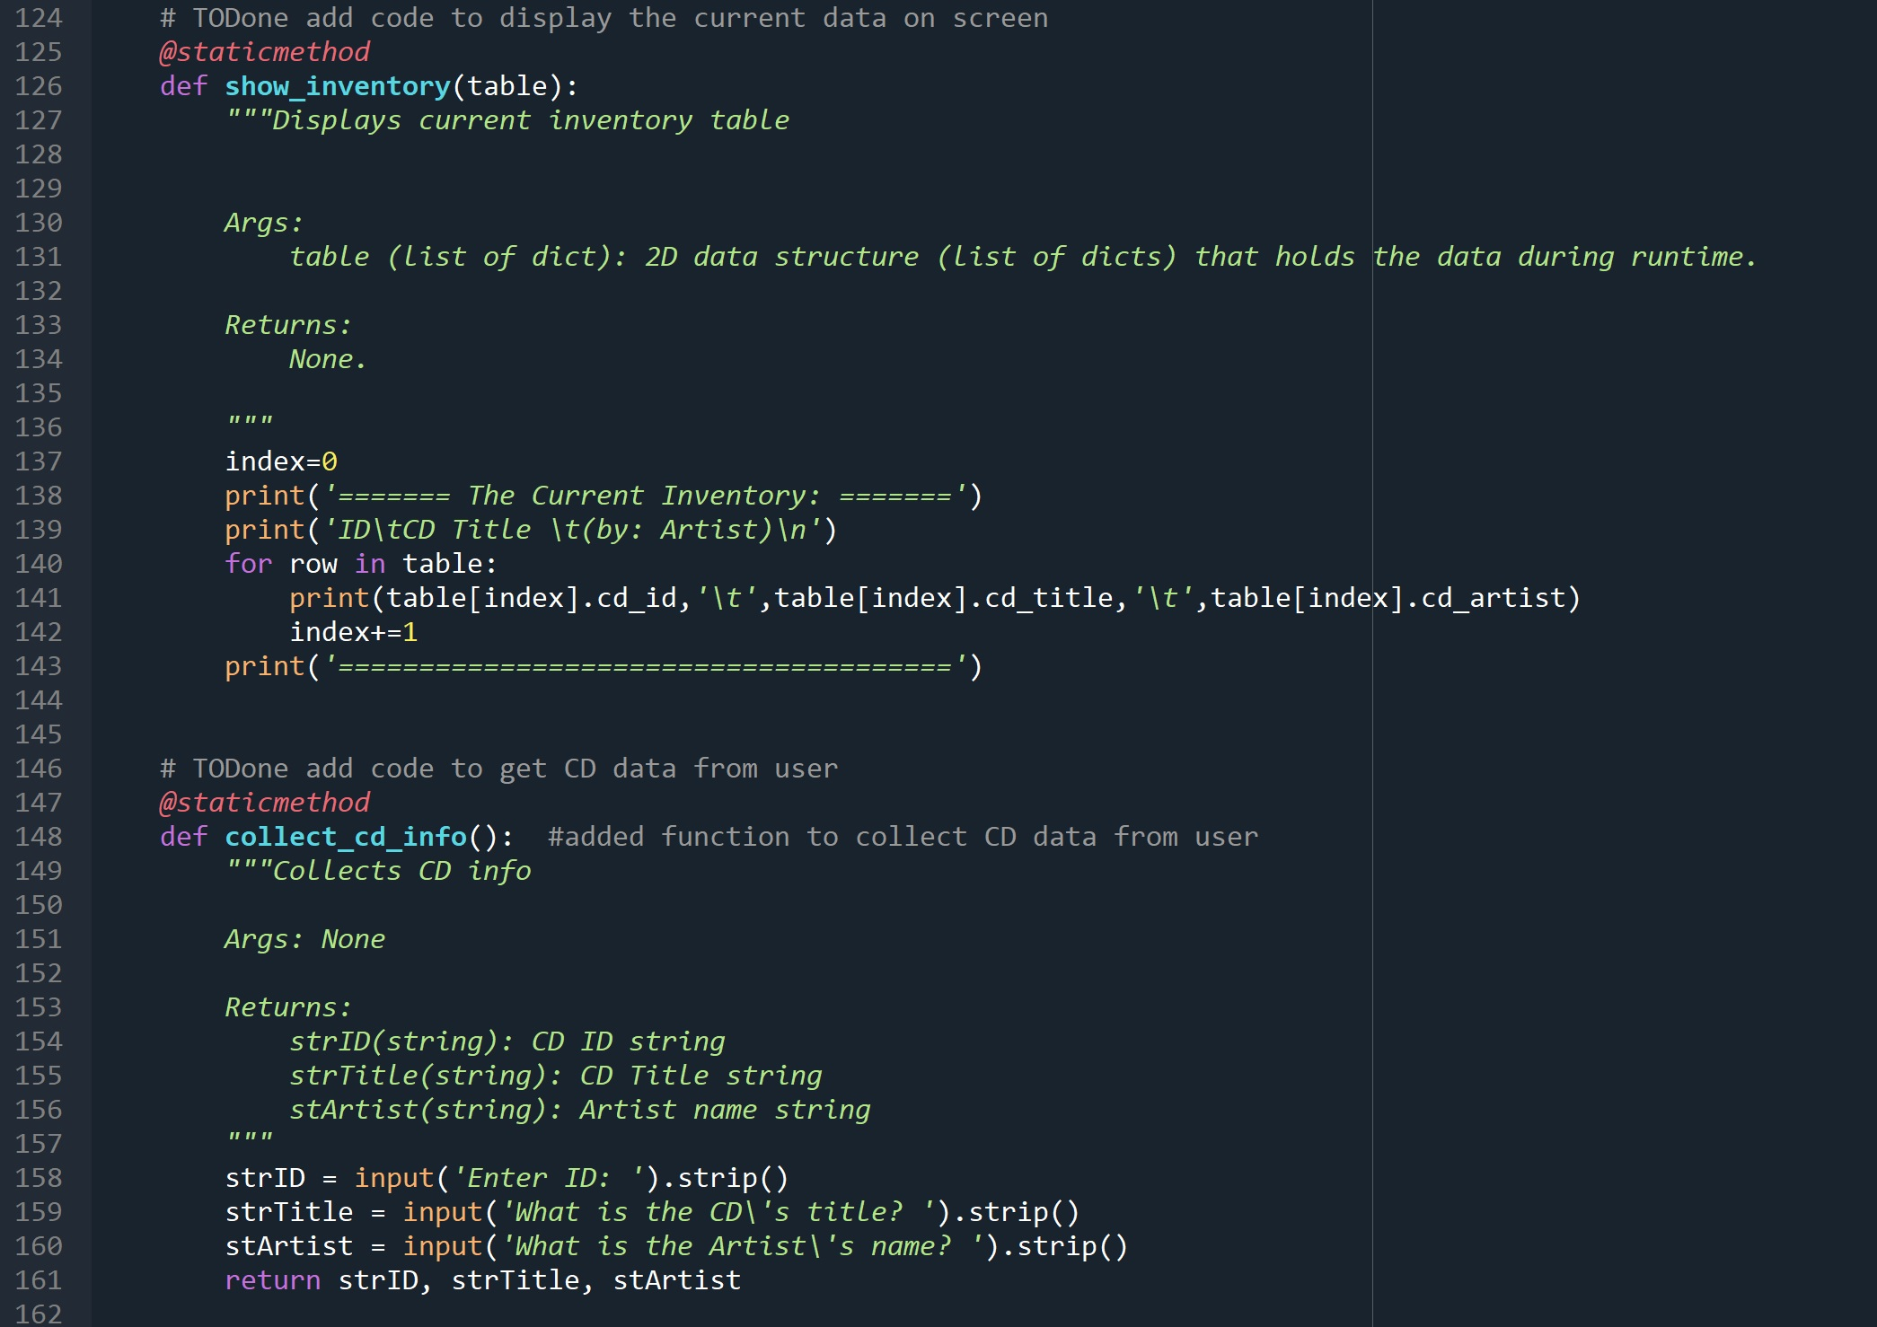
Figure 4 - Input/Output Class (cont.)

The show_inventory() method starts a for loop which iterates through the list of CD objects passed to it by the main loop. The print statement on line 141 then outputs the .cd_id, .cd_title, and .cd_artist properties for the CD object contained on each row of the table.

Figure 5 - Main While Loop

Figure 5 shows the main while loop definition, which contains the function calls for the classes described earlier. Just prior to starting the while loop, the program attempts to load the inventory from the .dat file using the load_inventory() method described above. After beginning the main while loop, the program calls the print_menu() and menu_choice() methods on lines 173-174. The program then checks if the user has entered ‘i’. If they did, the program calls the show_inventory() method, using the existing list variable lstOfCDObjects variable as the function argument. Lines 180-184 show that if the user enters ‘a’, the program initially calls the collect_cd_info() method and assigns its return to string_id, string_title, and string_artist variables. The program then creates a new object variable CD_obj by calling the CD class and using the three latter variables as arguments. It then appends the CD_obj variable to the lstOfCDObjects using the .append() function. If the user enters ‘s’, the program calls the .save_inventory() method described earlier in this document. Similarly, if the user selects ‘l’ the program calls the .load_inventory() method and assigns its return to the variable lstOfCDObjects. Using the try-except error handling command, if the program does not find the ‘cdInventory.dat’ file, it prints a message to the screen rather than terminates with an error. Finally, if the user enters ‘x’, the program exits the loop using the break command and ends the program.

Script Testing/demonstration

Figures 6-9 demonstrate the program being tested through spyder:

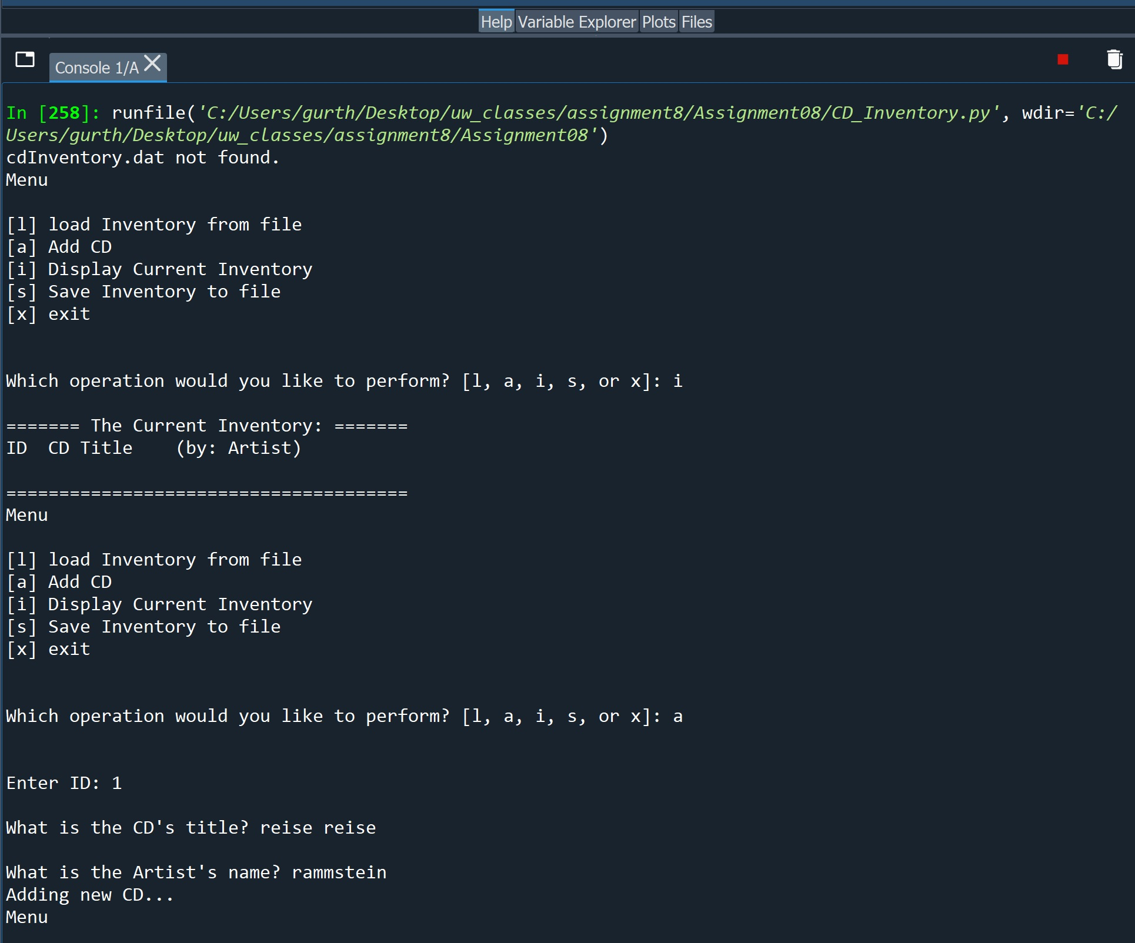
Figure 6 - Program Start Error Handling and Function Tests

Figure 6 shows that When the program starts, it attempts to load the ‘cdInventory.dat’ file. Since it does not find it, it correctly prints a message to the screen and moves on to showing the available function choices to the user. After the user selects ‘i’, we can see that nothing has been loaded yet and the table is empty. Selecting ‘a’ then correctly prompts the user for CD information.
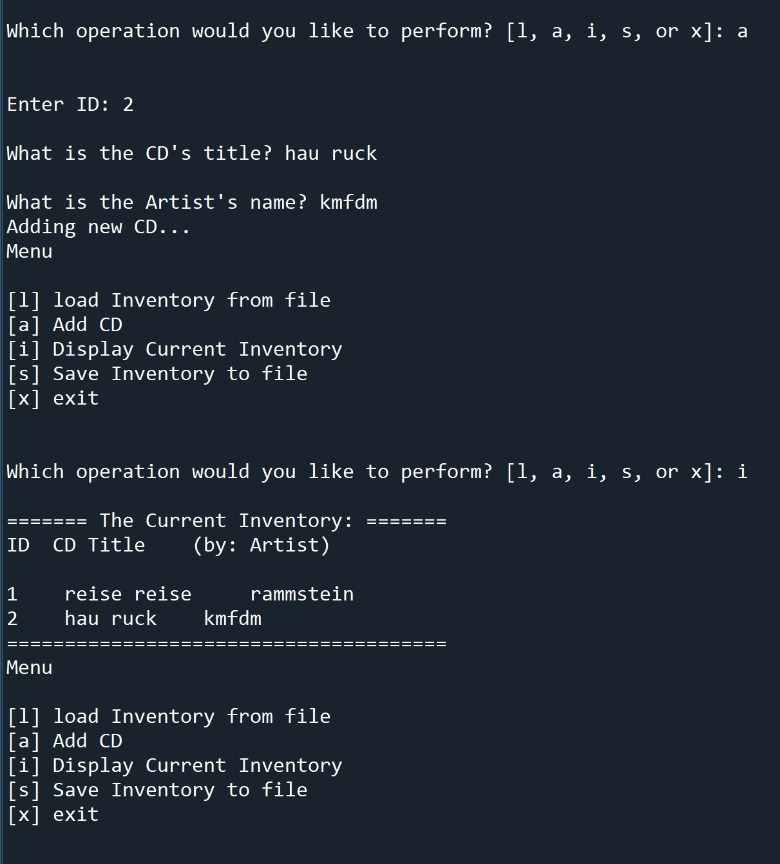
Figure 7 - Append Function and Inventory Function Test

Figure 7 shows that if the user selects ‘a’, the program prompts the user for CD information and correctly appends it to the existing table. Figure 8 shows the test of the inventory save function. By selecting ‘s’, the user is able to save the table as the ‘cdinventory.dat’ file. If we now start the program again, we can see that the program loaded the table contained in the .dat file.

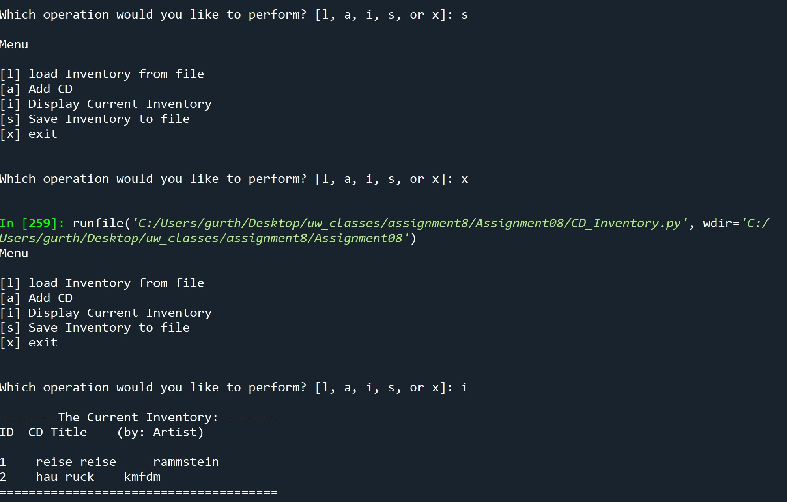
Figure 8 - Inventory Load on Start and Save Function Test

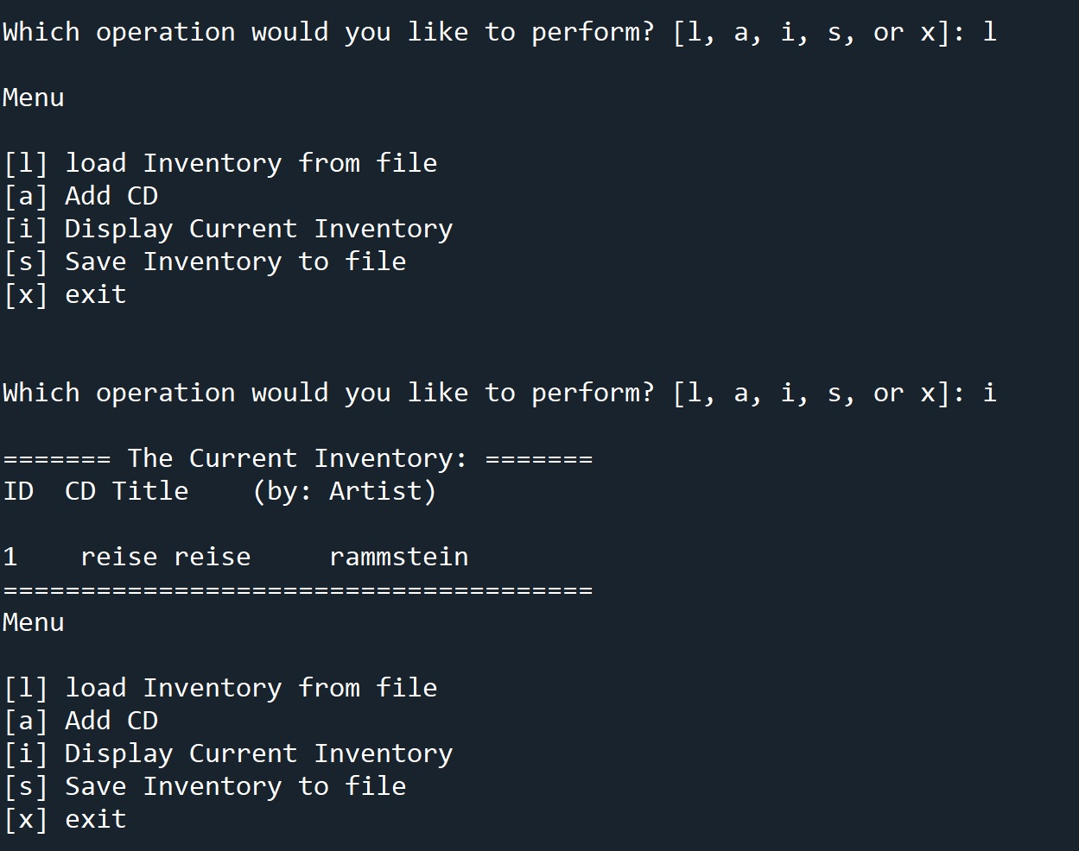
Figure 9 - Load Inventory Function Test

Figure 9 shows the test of the load inventory function. In this example, If we replace the dat file with one containing only one entry, we can overwrite the active inventory by selecting ‘l’. Selecting ‘i’ after loading the inventory from the .dat file shows that the active inventory now matches the one contained in the new dat file and only has one entry. Finally, selecting ‘x’ correctly ends the program. The program can also be run directly from the terminal as shown below:

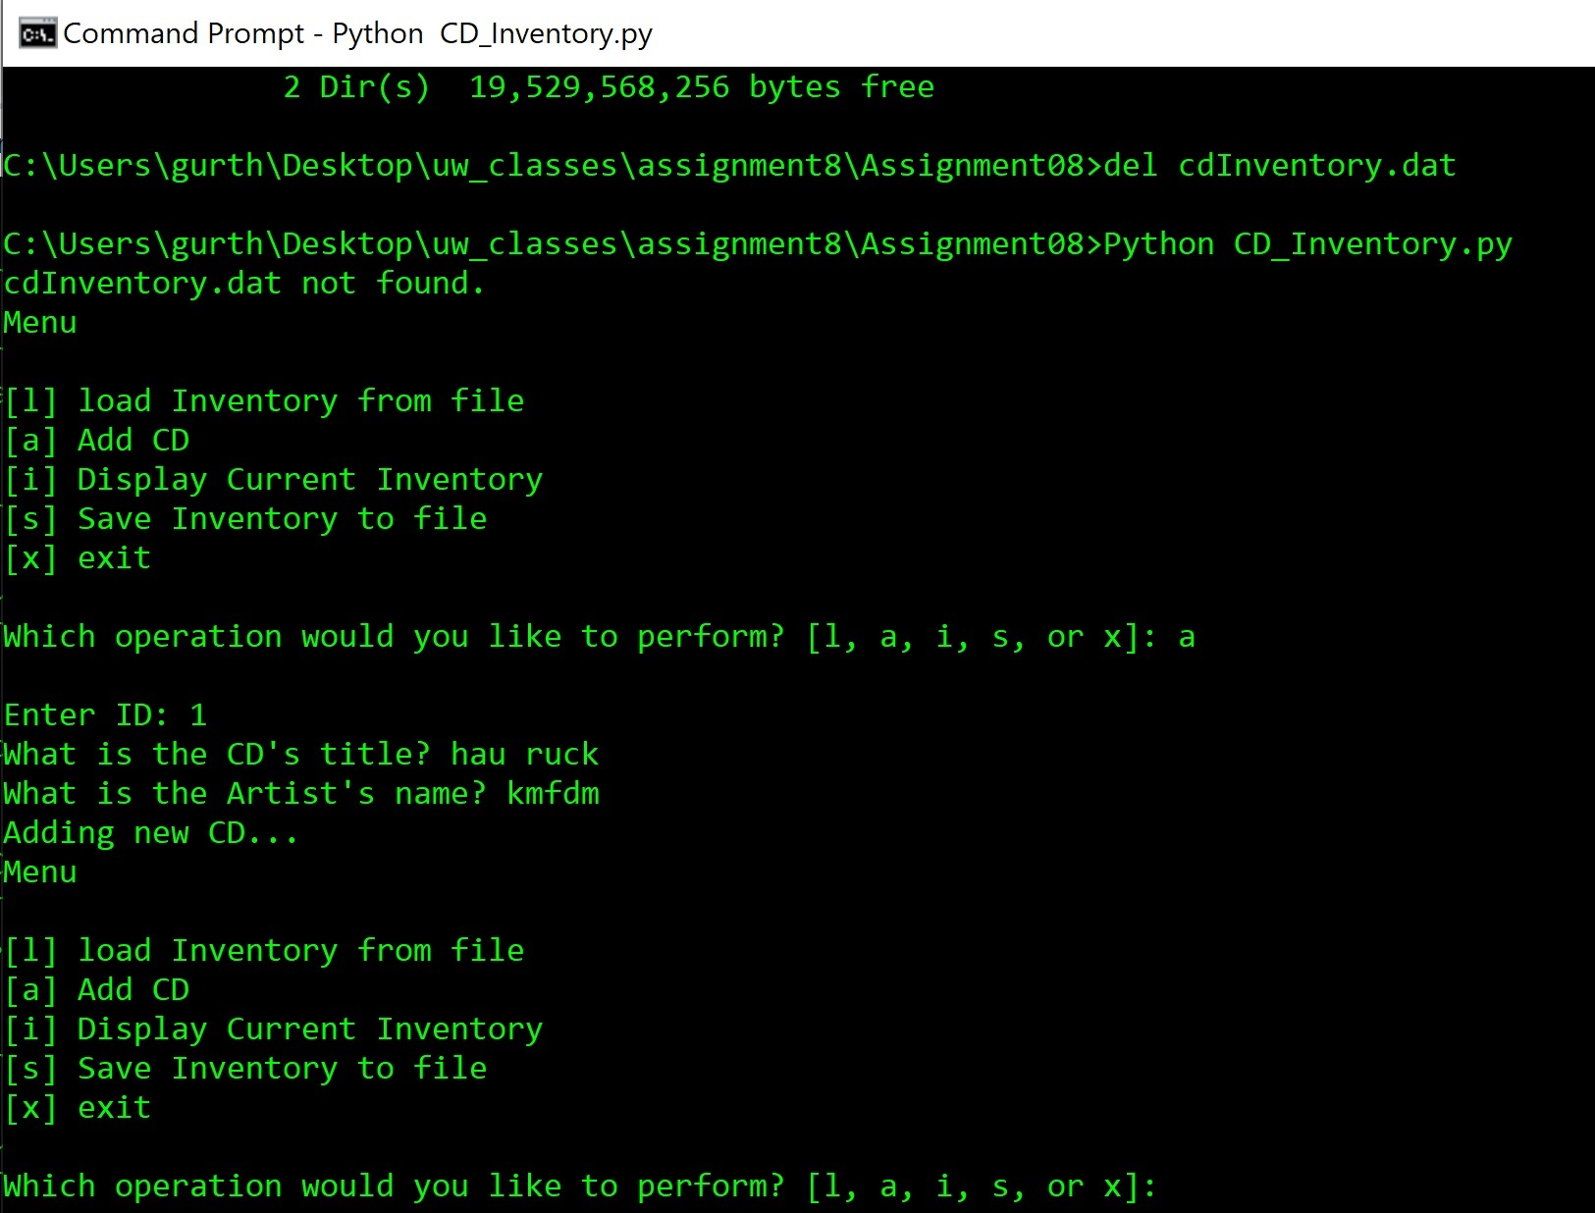
Figure 11 - Program Test in Terminal

Summary

The purpose of this assignment was to create a CD organization script that would use objected oriented programming. The script used for this program and this knowledge document are stored at the GitHub link below:

alamnin/Assignment_08 ()

