**Talend Enterprise version installation document**

1.Click on the below link

<https://iam.ap.cloud.talend.com/idp/trial-registration?_ga=2.172016096.2143738585.1681139246-1192640806.1619199698>

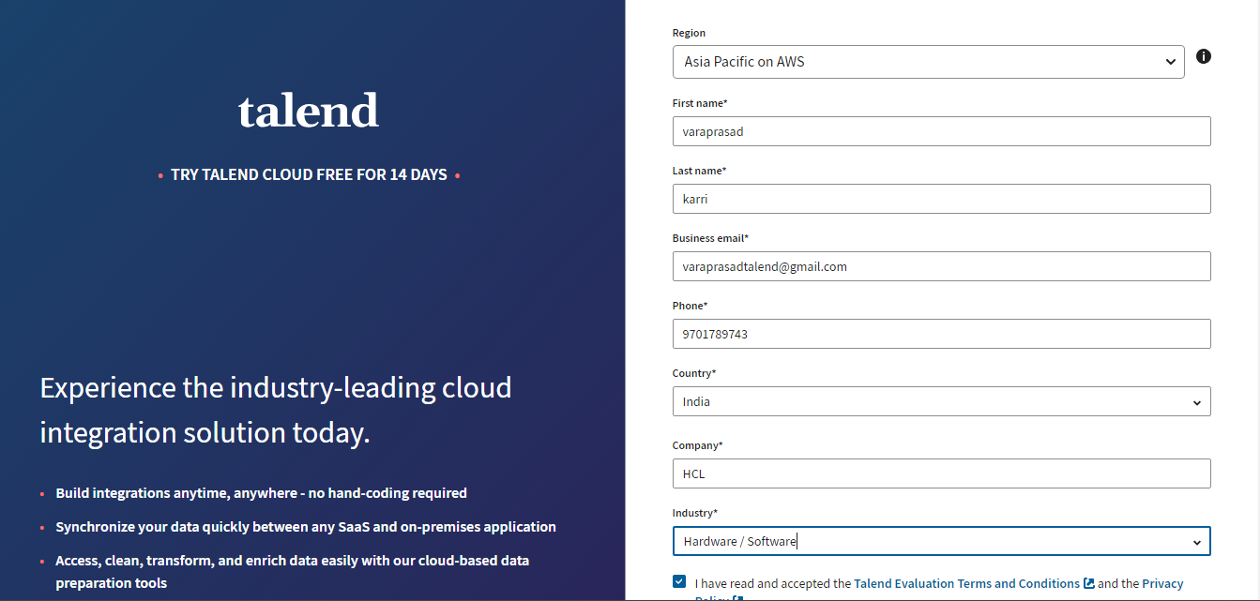

2. After clicking on start your trial, go to the mail and click on complete registration

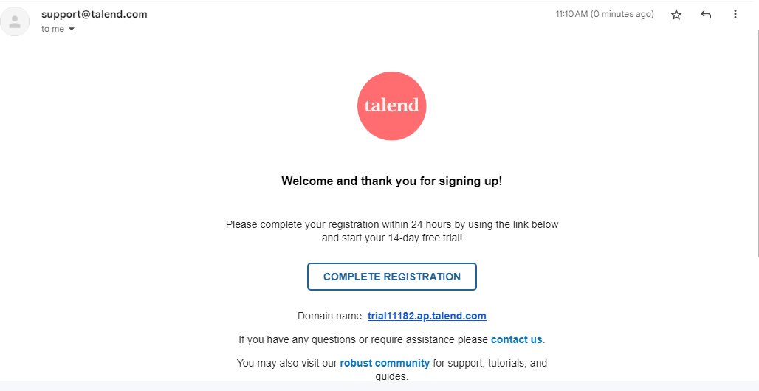

3. click on continue



4. Set your password and click on login

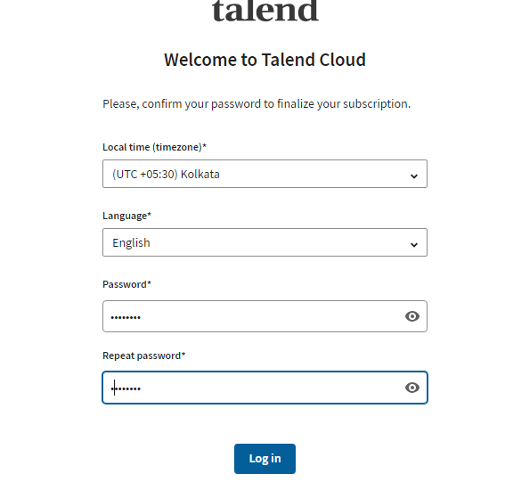

5.Click on Self Explorer

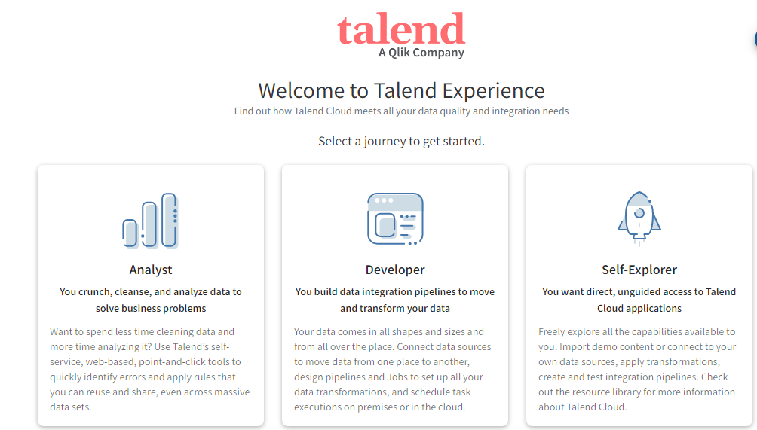

6.Click on watch and after watching the video click on launch

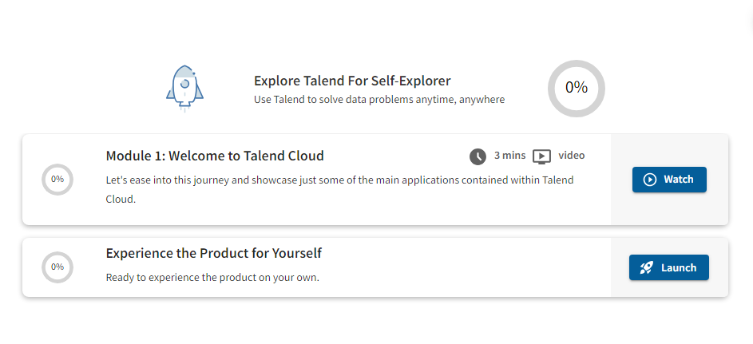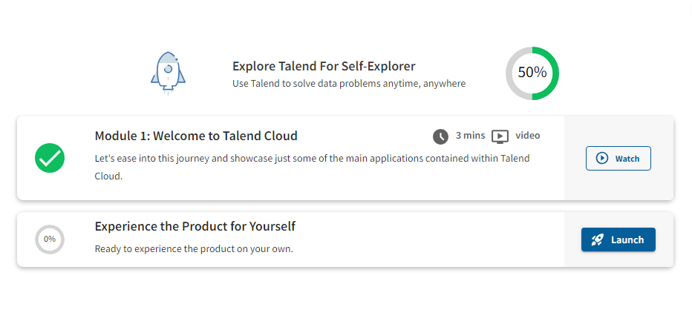

7.Click on select app and select management console

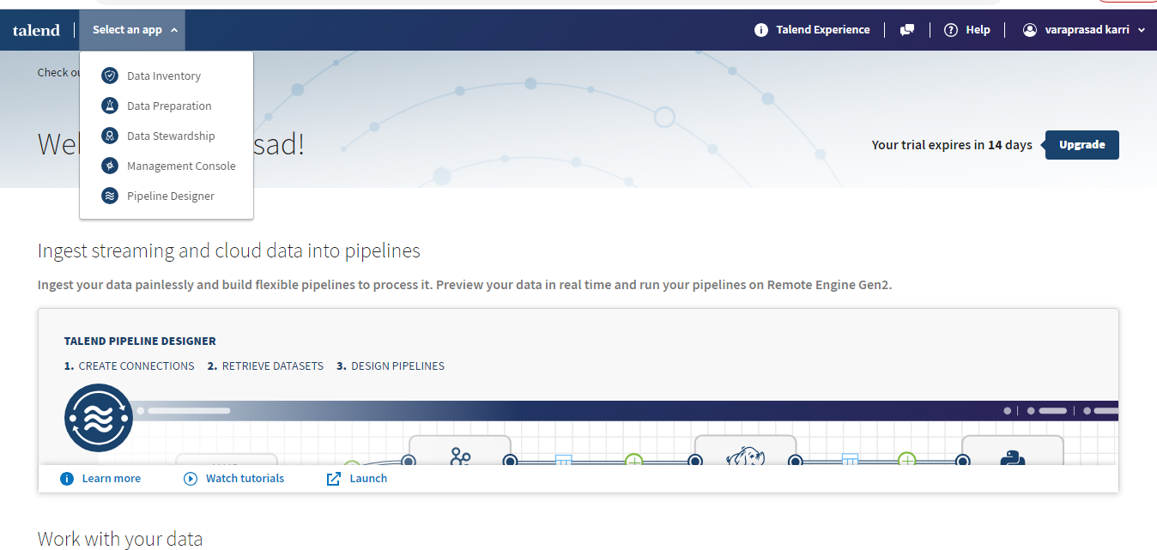

8.Click on project and add project

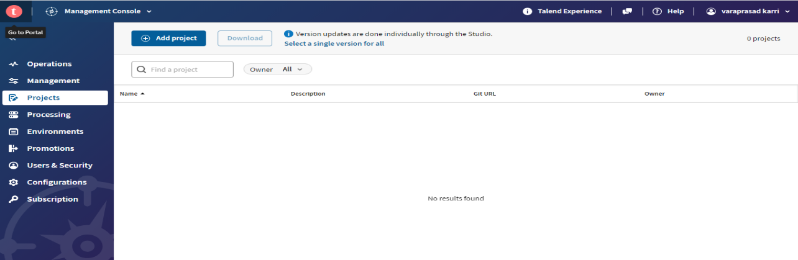

9. In the GIT URL box please give your GIT URL and click on save

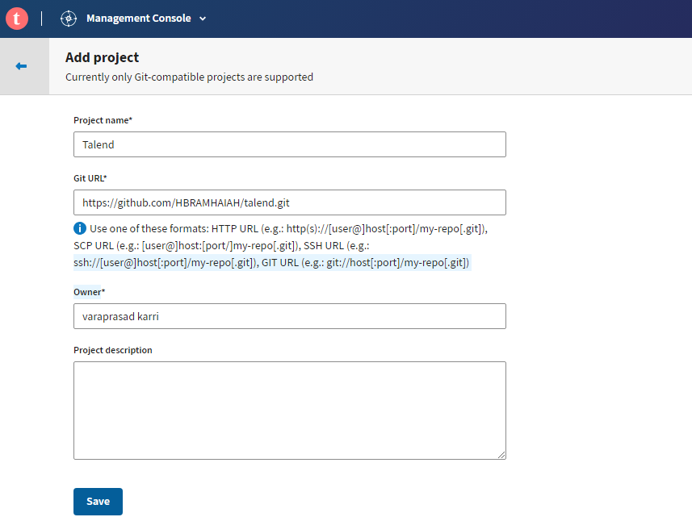

10. After creating the project click on share project

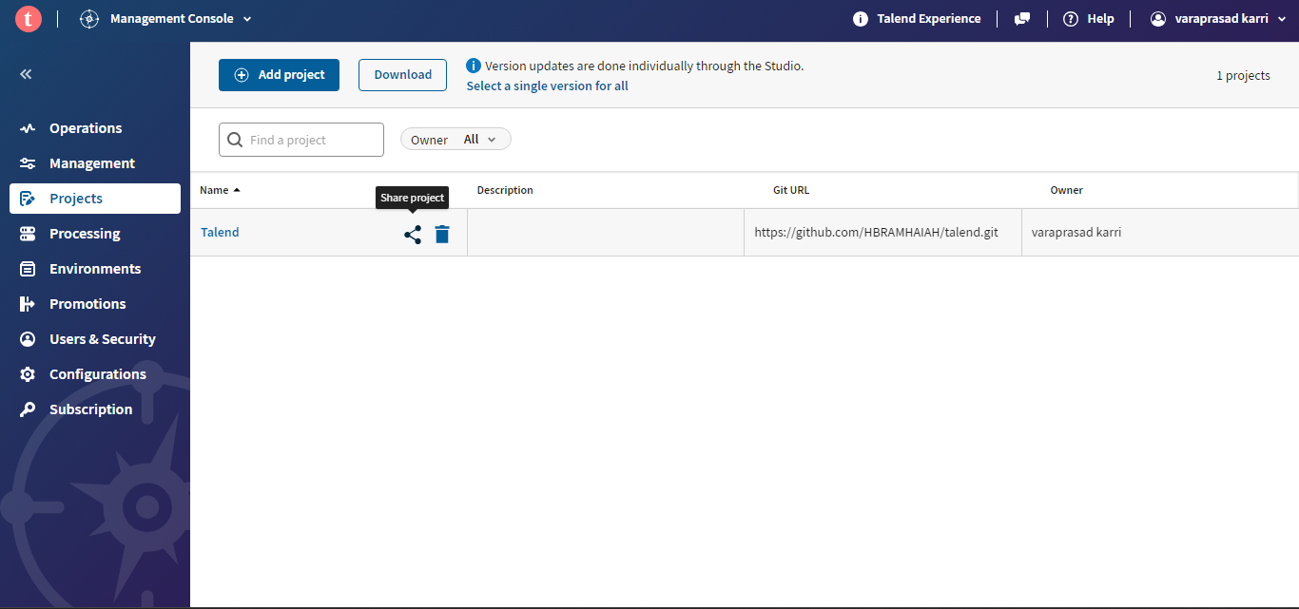

11.Click on users and select the user

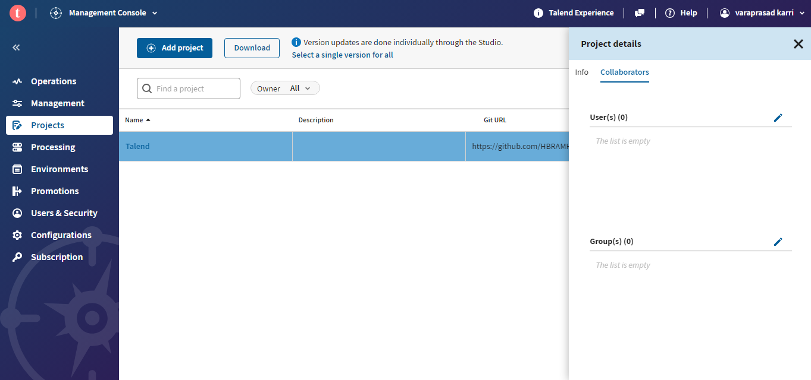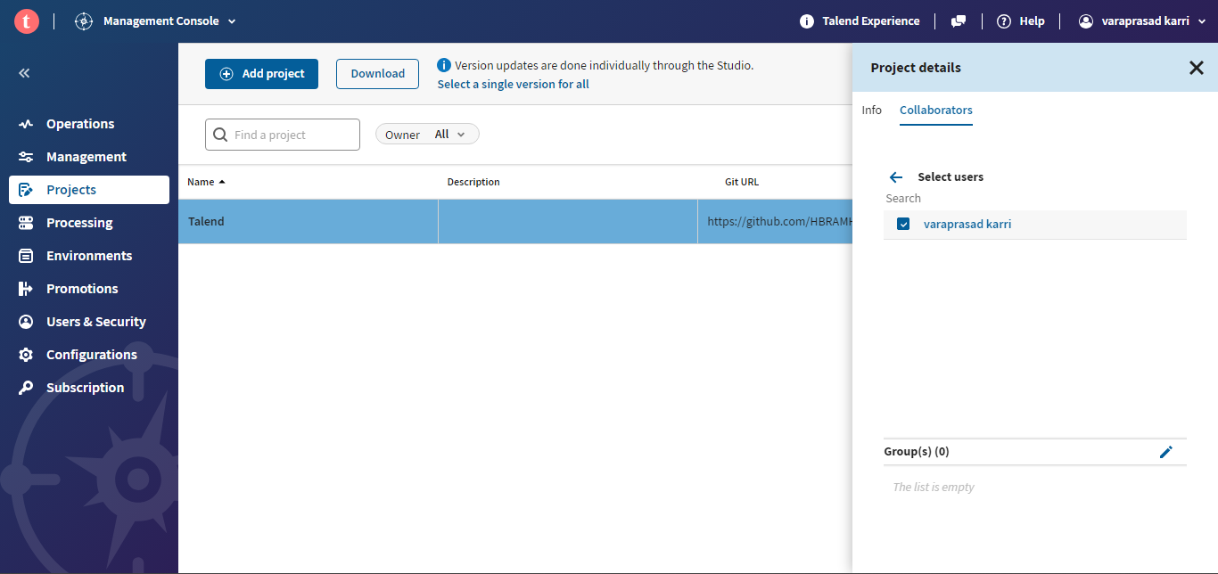

12. Click on download

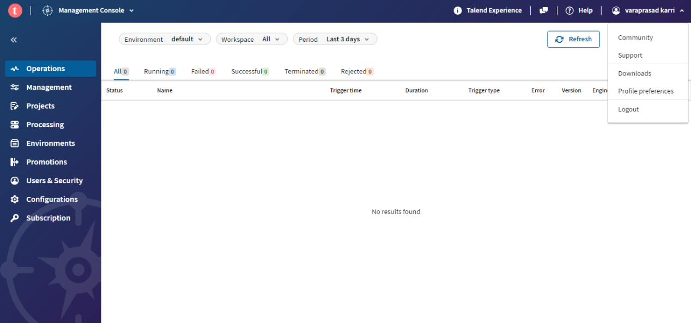

13.Select Talend studio & Hybrid apps and click on type and select installer for windows server (exe), click on download

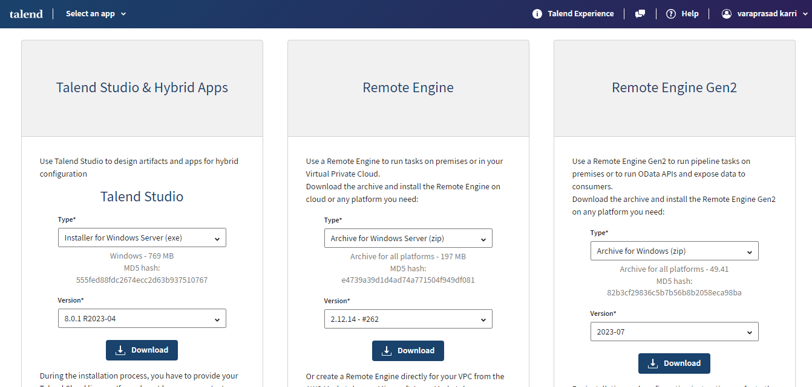

14. Once download is completed, in downloads tab select the exe file and install , click on next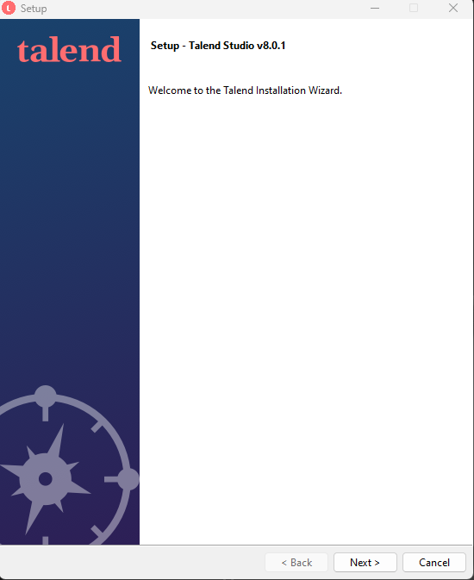

15.Select I accept the agreement and click on next

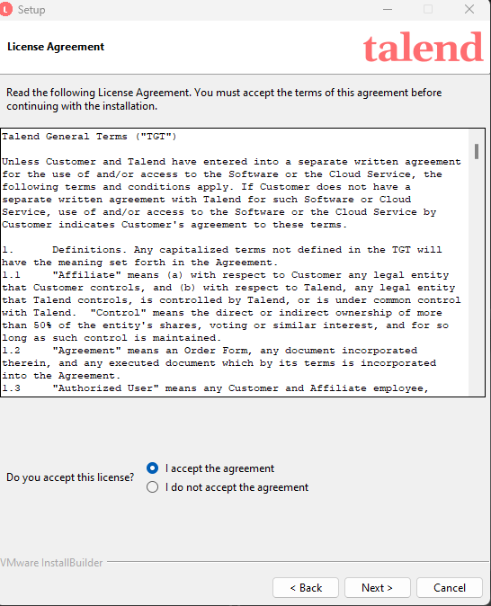

16.Click on next

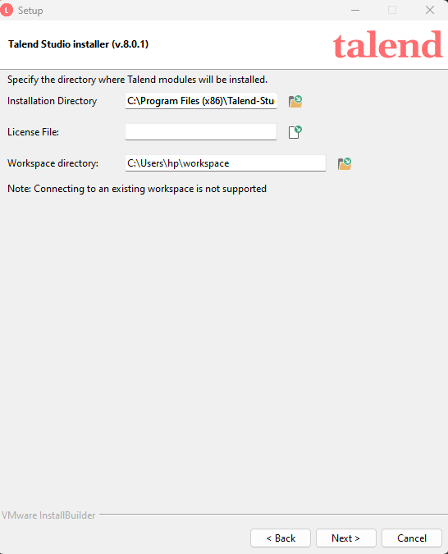

17.Click on next

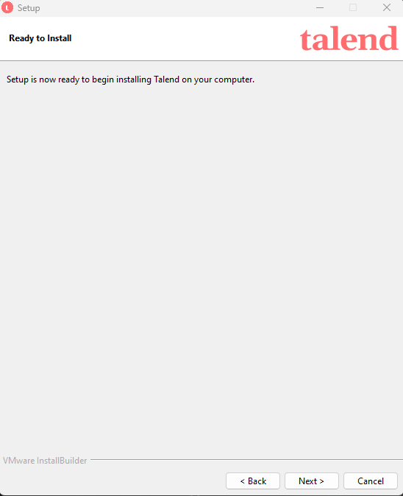

18.Click on finish

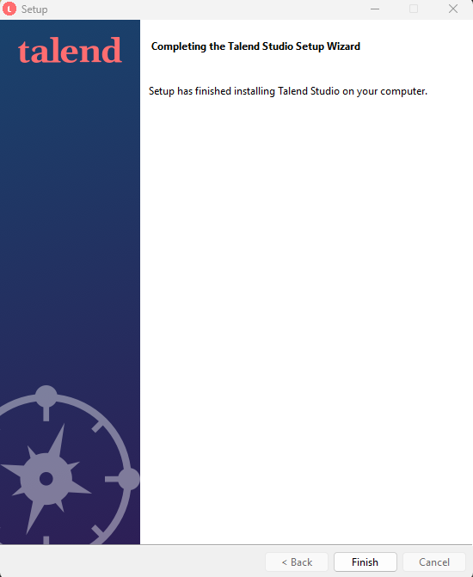

19. After installation is completed open Talend and click on accept

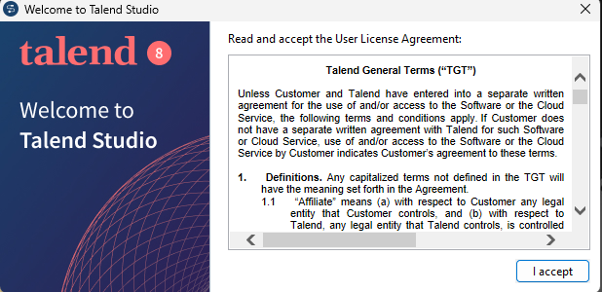

20. Click on Login with Talend Cloud

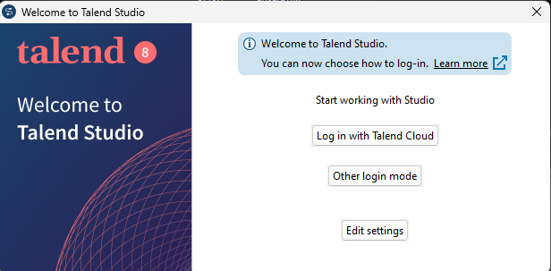

21.Provide the credentials and click on login

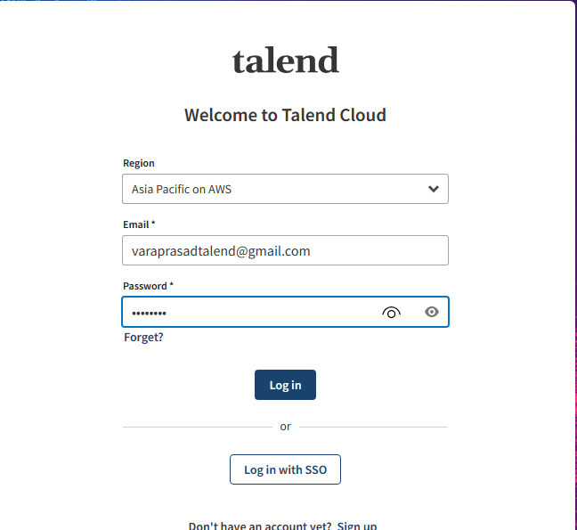

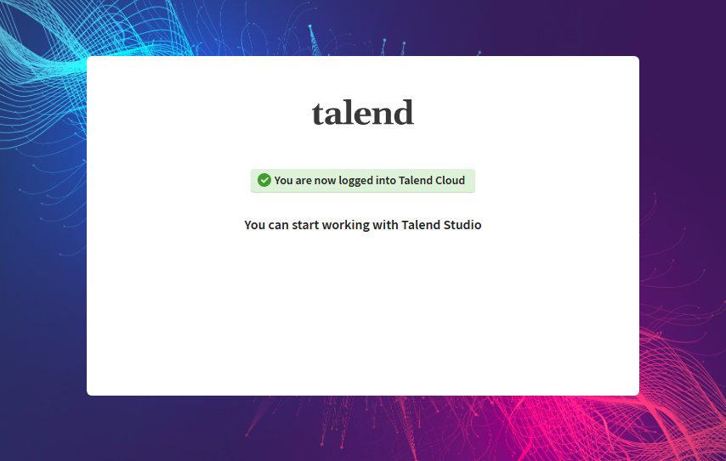

22.Select the existing project and click on open

