scan_detection.launch

This launch file can create a caution area shape of quadratic function and detect the obstacle in the caution area.

max_f : the parameter of the max range front of the laser center . (purple)

theta : the angle you want to start detection

max_d : the range of the caution area at the angle.(red line)

continues_points : how many continues points that we define to be an obstacle to make robot stop .

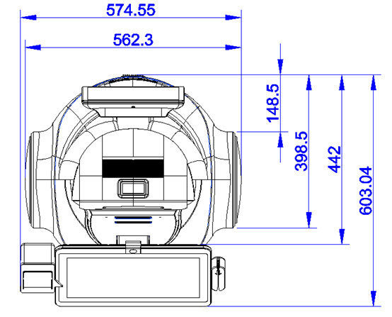

max_d

max_f

theta

detect_start

The launch file can be found under the laser package and under the launch folder.

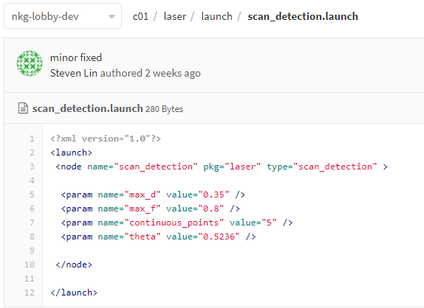

<http://crgitlab.eastasia.cloudapp.azure.com/allentsai/c01/blob/6729b48882f2b0e300e209a866571f95e1ed7d86/laser/launch/scan_detection.launch>

And the cpp file is also under the laser package and under the src folder

<http://crgitlab.eastasia.cloudapp.azure.com/allentsai/c01/blob/6729b48882f2b0e300e209a866571f95e1ed7d86/laser/src/scan_detection.cpp>



In the cpp file we use these two variable to get the start points from laser data.



y

x

x

y

theta

I rotate the axis xy -90 degree like the figure above and determine how many points between the angle I start detect and the angle_min. Then we will take the laser data start from scan_msg[detec_start] .