Lab 5

Cheng Zhang cz2532

Nov 18, 2018

# Instructions

Make sure that you upload an RMarkdown file to the canvas page (this should have a .Rmd extension) as well as the PDF output after you have knitted the file (this will have a .pdf extension). The files you upload to the Canvas page should be updated with commands you provide to answer each of the questions below. You can edit this file directly to produce your final solutions. The lab is due 11:59pm on Saturday, November 9th.

# Goal

The goal of this lab is to investigate the empirical behavior of a common hypothesis testing procedure through simulation using R. We consider the traditional two-sample t-test.

# Two-Sample T-Test

Consider an experiment testing if a 35 year old male’s heart rate statistically differs between a control group and a dosage group. Let $X$ denote the control group and let $Y$ denote the drug group. One common method used to solve this problem is the two-sample t-test. The null hypothesis for this study is:

$$H_{0}:μ_{1}−μ_{2}=Δ_{0},$$

where $Δ_{0}$ is the hypothesized value. The assumptions of the two sample pooled t-test follow below:

## Assumptions

## Procedure

The test statistic is

$$t_{calc}=\frac{\overline{x}−\overline{y}−Δ_{0}}{\sqrt{\frac{s_{1}^{2}}{m}+\frac{s_{2}^{2}}{n}}},$$

where $\overline{x},\overline{y}$ are the respective sample means and $s_{1}^{2},s_{2}^{2}$ are the respective sample standard deviations.

The approximate degrees of freedom is

$$
df=\frac{\Big{(}\frac{s^2_1}{m}+\frac{s_2^2}{n}\Big{)}^2}{\frac{(s_1^2/m)^2}{m-1}+\frac{(s_2^2/n)^2}{n-1}}
$$

Under the null hypothesis, $t_{calc}$ has a student’s t-distribution with $df$ degrees of freedom.

## Rejection rules

Reject $H_{0}$ when:

$$Pvalue≤α$$

# Tasks

1. Using the **R** function **t.test**, run the two sample t-test on the following simulated dataset. Note that the **t.test** function defaults a two-tailed alternative. Also briefly interpret the output.

set.seed(5)  
sigma=5  
Control <- rnorm(30,mean=10,sd=sigma)  
Dosage <- rnorm(35,mean=12,sd=sigma)  
t_test1 = t.test(Control,Dosage)  
t_test1$p.value

## [1] 0.05349343

If we set the significance level to be 0.05, then we cannot reject the null hypothesis.

1. Write a function called **emperical.size** that simulates **R** different samples of $X$ for control and **R** different samples of $Y$ for the drug group and computes the proportion of test statistics that fall in the rejection region. The function should include the following:

I started the function below:

emperical.size <- function(R=10000,  
 mu1=0,mu2=0,  
 sigma1=1,sigma2=1,  
 m=30,n=30,  
 level=.05,  
 value=0,  
 direction="Two") {  
   
 #Define empty lists  
 statistic.list <- rep(0,R)  
 pvalue.list <- rep(0,R)  
 size.list = c()  
 for (i in 1:R) {  
  
 # Sample realized data  
 Control <- rnorm(m,mu1,sigma1)  
 Dosage <- rnorm(n,mu2,sigma2)  
  
 # Testing values  
 testing.procedure <- t.test(Control,Dosage,mu = value)  
 statistic.list[i] <- testing.procedure$statistic  
 pvalue.list[i] <- testing.procedure$p.value  
  
  
 }  
 size.list <- c(size.list,testing.procedure$p.value<=level)  
  
 return(list(statistic.list=statistic.list,pvalue.list=pvalue.list,emperical.size=sum(pvalue.list<=level)))  
   
}

Evaluate your function with the following inputs **R=10**,**mu1=10**,**mu1=12**,**sigma1=5** and **sigma2=5**.

ans = emperical.size(R=10,mu1=10, mu2 = 12,sigma1 = 5,sigma2 = 5)  
ans

## $statistic.list  
## [1] -1.5594821 -1.6265940 -0.3916181 -3.0267377 -0.6315979 0.5023321  
## [7] 0.1796087 -2.7168991 -2.1448224 -0.7961500  
##   
## $pvalue.list  
## [1] 0.124574455 0.109418121 0.697191662 0.003707140 0.530363425  
## [6] 0.617452414 0.858106351 0.008684406 0.036512133 0.429195763  
##   
## $emperical.size  
## [1] 3

1. Assuming the null hypothesis
$$H_{0}:μ_{1}−μ_{2}=0$$

2. is true, compute the empirical size using 10,000 simulated data sets. Use the function **emperical.size** to accomplish this task and store the object as **sim**. Output the empirical size quantity **sim$size**. Comment on this value. What is it close to?

**Note:** use **mu1=mu1=10** (i.e., the null is true). Also set **sigma1=5**,**sigma2=5** and **n=m=30**.

sim = emperical.size(R = 10000,mu1=10,mu2=10,sigma1=5,sigma2 = 5,n=30,m=30)  
sim$emperical.size

## [1] 486

1. Plot a histogram of the simulated P-values, i.e., **hist(sim$pvalue.list)**. What is the probability distribution shown from this histogram? Does this surprise you?

hist(sim$pvalue.list)

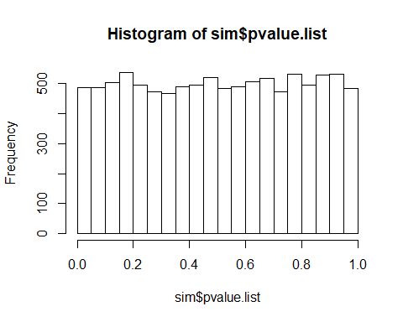

1. Plot a histogram illustrating the empirical sampling sampling of the t-statistic, i.e., **hist(sim$statistic.list,probability =TRUE)**. What is the probability distribution shown from this histogram?

hist(sim$statistic.list,probability = TRUE)

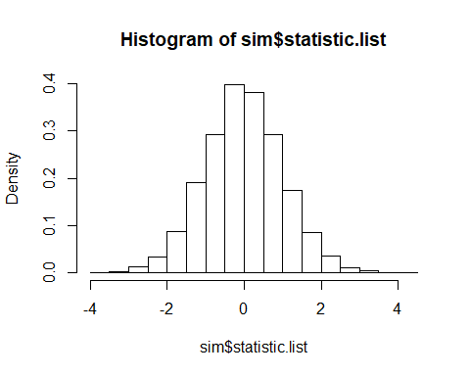

1. Run the following four lines of code:

emperical.size(R=1000,mu1=10,mu2=10,sigma1=5,sigma2=5)$emperical.size

## [1] 55

emperical.size(R=1000,mu1=10,mu2=12,sigma1=5,sigma2=5)$emperical.size

## [1] 315

emperical.size(R=1000,mu1=10,mu2=14,sigma1=5,sigma2=5)$emperical.size

## [1] 847

emperical.size(R=1000,mu1=10,mu2=16,sigma1=5,sigma2=5)$emperical.size

## [1] 998

When the difference of two mean get larger, we car more likely to find that there is a difference between mean of two groups.

1. Run the following four lines of code:

emperical.size(R=10000,mu1=10,mu2=12,sigma1=10,sigma2=10,m=10,n=10)$emperical.size

## [1] 658

emperical.size(R=10000,mu1=10,mu2=12,sigma1=10,sigma2=10,m=30,n=30)$emperical.size

## [1] 1242

emperical.size(R=10000,mu1=10,mu2=12,sigma1=10,sigma2=10,m=50,n=50)$emperical.size

## [1] 1702

emperical.size(R=10000,mu1=10,mu2=12,sigma1=10,sigma2=10,m=100,n=100)$emperical.size

## [1] 2896

When the sample size become larger, we are more likely to find that there is a difference between mean of two groups.