# **CA326 Functional Specification**

# 



**Dara Lynch - 19324446**

**Alan McGrath - 19392951**

**Table of contents**

**1 - Introduction**

1.1 Overview

1.2 Business Context

1.3 Glossary of terms

**2 - General Description**

2.1 Product/System Functions

2.2 User Characteristics and Objectives

2.3 Operational Scenarios

2.4 Constraints

2.4.1 Experience

2.4.2 Inappropriate Reviews

2.4.3 Gas Fees

**3 - Functional Requirements**

**4 - System Architecture**

**5 - High Level Design**

5.1 User Diagram

5.2 Sidechain Relationship

5.3 Context Diagram

**6 - Preliminary Schedule**

**1. Introduction**

**1.1 Overview**

We are building an online marketplace on the Ethereum sidechain Polygon. Our marketplace would be similar to the likes of DoneDeal and adverts. This allows buyers and sellers to keep their experiences and reviews as concrete evidence through the blockchain. When a sale is successful this is building up the users credibility and will only benefit their trustworthiness with future customers. A user will first register an account on the site which will allow them to gain access to advertising items for others to buy, or to buy items from other users.

**1.2 Business Context**

The project would provide competition to marketplaces such as DoneDeal and Adverts.ie. Both of these platforms are ripe with dishonest users and users with negative intentions. We hope to provide a marketplace where users are much more confident in their transactions. Small business owners can essentially choose to use our platform to sell their products if they wish, which can be attractive if we have built up a large core user base.

**1.3 Glossary of terms**

**NFT** - Stands for ‘Non Fungible Token’. This is a digital asset which is stored on the blockchain and is often used to represent real objects like artwork, music, even digital goods such as exclusive goods in a video game, access to exclusive offers/groups/opportunities and lots more.

**Blockchain** - A blockchain is a public digital ledger where data is stored.

**Ethereum** - Ethereum is an open source blockchain which allows transactions through the use of smart contracts.

**Polygon** - Polygon is an Ethereum sidechain. It essentially bundles up lots of data and transactions before communicating it to the Ethereum blockchain rather than sending every piece of data individually

**Matic** - The native asset (currency) on Polygon.

**USDT** - A stablecoin backed by the US Dollar

**Gas Fees** - The fee paid to the network to complete a transaction.

**TPS** - Transactions per second

**EVM** - Ethereum Virtual Machine

**Metamask Wallet** - This is a commonly used Ethereum soft wallet.

**2. General Description**

**2.1 Product / System Functions**

We have chosen to deploy on the Polygon blockchain which is an Ethereum sidechain. The reason we will use Polygon instead of simply deploying on the Ethereum network is because the gas fees are much cheaper using the Polygon network. Polygon also has a much better throughput than Ethereum. While Ethereum can process about 30tps, Polygon can handle about 65000tps. Polygon does this by ‘bundling up’ a number of transactions before sending the transactions to the ethereum blockchain. Polygon also has a test network called the Mumbai Test Net which will allow us to make test transactions without having to use real money.

Users will be able to browse, buy and sell a large range of items such as cars, clothing and electronics. There will be a very small fee when listing an item in order to minimise spam and bots. The seller will list the item with their desired price and will have the option to allow buyers to send offers. When listing an item, the seller will specify if the sale requires a shipping fee, which will then be displayed to the potential buyers and will be added to the price on purchase. The buyer will also have to pay a very small gas fee when completing any purchase.

After a successful sale or purchase, users will be able to write a review for the person on the other side of the transaction. This review will be on the blockchain and immutable. When you view someone's profile you will be able to see all of their past reviews and transactions. When a seller hits a landmark number of sales (10, 25, 50 etc.), the seller will receive an NFT which can only be obtained through making a landmark number of sales. When you view a sellers page they can display their NFTs on their profile which will help them show off to everyone that they are a legitimate buyer or seller. The same can also apply for repeat buyers who can be rewarded with a different set of NFTs for landmark numbers of purchases.

More and more people are beginning to hold cryptocurrencies or are choosing to earn their salaries in crypto. Our platform will allow people to actually use their crypto for a huge range of purchases or for sellers to earn crypto from making sales. If they wish they can use other platforms to stake their crypto which will allow them to earn interest on the crypto they hold. This can mean a seller can make even more money than the initial sale price as they can earn interest on the money they have made. ‘Celsius’ is an example of a platform that allows users to earn interest on their cryptocurrencies by simply having crypto in your Celsius wallet. Currently Celsius offers 8.99% APY for users that hold Matic, which is a much higher interest rate than those typically offered by banks. This interest is paid out weekly and hence compounds every week.

**2.2 User Characteristics and Objectives**

Users will be required to have a Metamask wallet which is extremely easy to set up. This allows users with little or no knowledge of blockchain technology to be able to easily use our platform.

Our site would be attractive to users who frequently use sites like DoneDeal and also for regular people who would like to sell their products that maybe they don't use anymore.

**2.3 Operational Scenarios**

**Scenario 1- Make an account:**

1. The user will be given an option to log in to an existing account or to register a new account.
2. When registering, the user must provide a username, email and password.
3. Once a user is registered they can access the site's options to list or buy items.

**Scenario 2 - List Item:**

1. Choose the item’s most suited category.
2. Upload pictures of the item.
3. Add a description of the item for sale.
4. Add price of the item and if offers/bids are accepted.
5. If required, add a shipping price which will be added to the order total.

**Scenario 3 - Search Item:**

1. Search words associated with the desired item, option to filter by category is also available.
2. Sort by price or newly listed items and scroll through options displayed.
3. Select the item you wish to view and click on it to view the item's description.

**Scenario 4 - Buy Item:**

1. When the desired item is selected click ‘Buy item’.
2. Fill in shipping and payment details.
3. Will then be taken to a secure payment page with the following information: item’s price, gas fees and shipping fees.

**Scenario 5 - Leave a review:**

1. Click into the ‘My Transactions’ tab.
2. Select ‘Leave Review’.
3. Choose a start rating from 1 to 5 with 1 being the lowest rating and 5 the highest.
4. Optionally also add more information to your review in the text box.
5. Click submit review.

**2.4 Constraints**

**2.4.1 Experience**

We have no previous experience creating Dapps and it will be our first time using Solidity to write Smart Contracts.

**2.4.2 Inappropriate Reviews**

As a result of the reviews being public on the Ethereum blockchain, they are immutable and cannot be changed or deleted under any circumstances. This means that a user may write a review which uses inappropriate or offensive language. We may be able to help combat this by not allowing reviews to be submitted if they contain any words which are on our list of inappropriate words and phrases.

**2.4.3 Gas Fees**

The gas fee for sending the currency must be low in order to make sales of a small amount viable. Sending ethereum can currently be extremely expensive so it may make more sense to only allow users to transact using Matic which should be much cheaper and faster.

**3. Functional Requirements**

**3.1 New users register an account**

**Description:**

* Users need to register an account before buying or selling on the platform. The user also must link a Metamask wallet to their account.

**Criticality:**

* The site requires registered users so that their actions can be recorded.

**Technical Issues:**

* Two users should not have the same username.

**Dependencies:**

* N/A

**3.2 Listing an item**

**Description:**

* Functionality for a user to list an item for sale on our marketplace.

**Criticality:**

* Provides items that customers can search and purchase.

**Technical Issues:**

* Must create functionality for a user to add an optional shipping price. In order to prevent spam, there may need to be a small listing fee.

**Dependencies:**

* User connects Metsmask wallet to account

**3.3 Buying an item**

**Description:**

* When a user finds an item they wish to purchase, they can buy the item for the full price or send the seller an offer for the item. When a sale is complete there must be a gas fee paid and the funds must be transferred from the buyers account to the sellers account.

**Criticality:**

* Essential in order for sales to take place on the platform.

**Technical Issues:**

* It will be our first time working with transactions and gas fees.

**Dependencies:**

* Buyer must have a Metamask wallet with sufficient funds to cover the purchase price and the gas fees. Buyers must be notified of what gas fee they will need to pay.

**3.4 Browsing the marketplace**

**Description:**

* The user can search for an item they would like to purchase.

**Criticality:**

* Helps users find items to buy or view similar items to that which they wish to sell.

**Technical Issues:**

* May require filtering functionality as well as keyword search.

**Dependencies:**

* Requires the seller to properly choose the category for their items and titles with the important key words which can be found when a buyer is searching for the item.

**3.5 Leave a review**

**Description:**

* Allows buyers and sellers to leave reviews on other users’ profiles in order to allow a user to build up a ‘reputation’. Using a star system where a transaction can be rated from 1-5 stars will make this simpler and allow us to show an average rating for each account.

**Criticality:**

* Important to our platform to show reviews on the blockchain in order to provide a clear difference to similar marketplace platforms.

**Technical Issues:**

* Reviews must be shown on the blockchain in order to create an immutable review system for the platform.

**Dependencies:**

* Gas fee will need to be paid in order to send a review to the blockchain. Possibly use listing fees to cover this.

**4. System Architecture**

**4.1 Architecture Diagram**

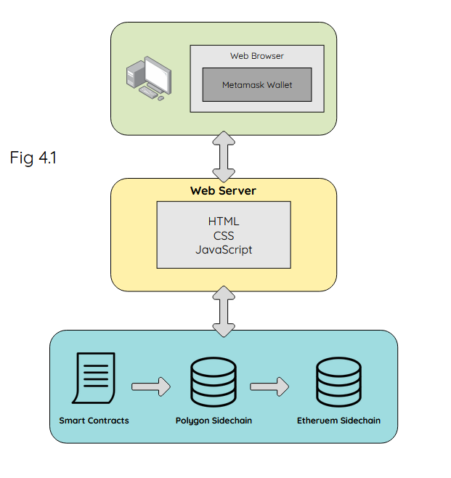

Shown in *Fig 4.1*, users will be able to access our platform through web browsers that support the metamask wallet extension (chrome, firefox, brave. etc.). The front end which the user sees will be made up of HTML, CSS and javascript. This front end will be the interface to communicate with the back end where the smart contracts will be written and executed over the Polygon blockchain which will also communicate this with the Ethereum blockchain.

**5. High-Level Design**

**5.1 User Diagram**

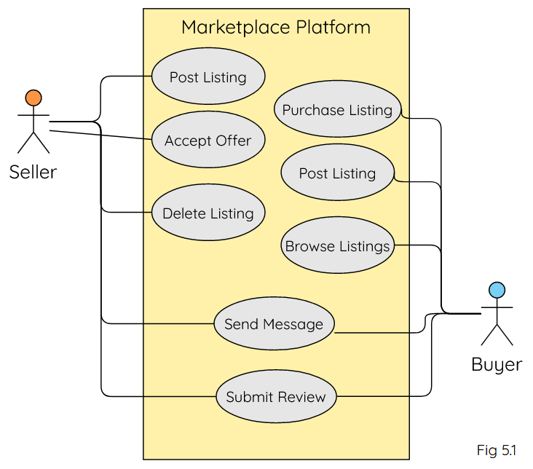

*Fig 5.1* shows the possible actions that users of the platform can take. The actions available to a seller are shown linked to the red icon and the actions available to a buyer are shown linked to the blue icon. Buyers have the option of outright automatically purchasing an item or negotiating with the seller by sending an offer which can then be accepted or rejected by the seller. Both buyers and sellers are able to submit a review following a completed transaction.

**5.2 Sidechain Relationship**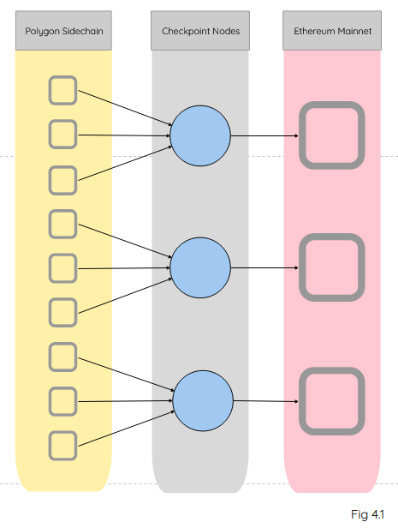

As shown in *Fig 4.1*, the Polygon blockchain is a sidechain to the Ethereum blockchain. It’s key purpose is to help scale the Ethereum blockchain, as the gas fees on the Ethereum network are currently very high for each transaction. Polygon works by ‘bundling’ a large amount of data and transactions together before sending it to the Ethereum blockchain meaning there are fewer ‘blocks’ of data being sent to and processed by Ethereum.

**5.3 Process Diagram**

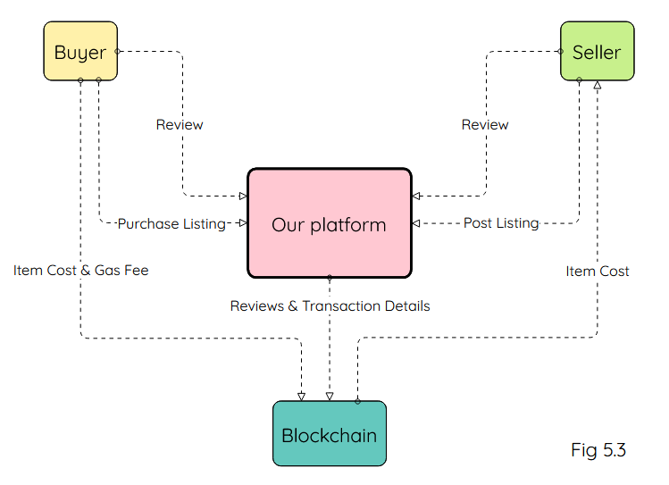

In *Fig 5.3* above you can see the communication between the users, our platform and the blockchain. The buyer will confirm a purchase through our platform. The cost of the item and the gas fee will be sent from the buyer to the blockchain and the blockchain then the cost of the item will be sent to the seller. Reviews will be created by buyers and sellers through our platform and then this will be communicated to the blockchain.

**6. Preliminary Schedule**

**6.1 Softwares**

We will be deploying our Dapp on the Polygon network. As Polygon is an Ethereum sidechain, the development process to deploy on Polygon is almost the exact same as if we were to develop for deploying to Ethereum Mainnet or other networks that use an EVM such as Binance Smart Chain or the Avalanche C-chain.

We will be writing the Smart Contracts using solidity and use next.js to develop the application. Hardhat is the solidity development environment we will be using. Tailwind CSS will be used to design the User Interface.

We will be using development management tools such as Trello in order to help us manage our workload and decide which tasks to prioritise.

**6.2 Pert Chart**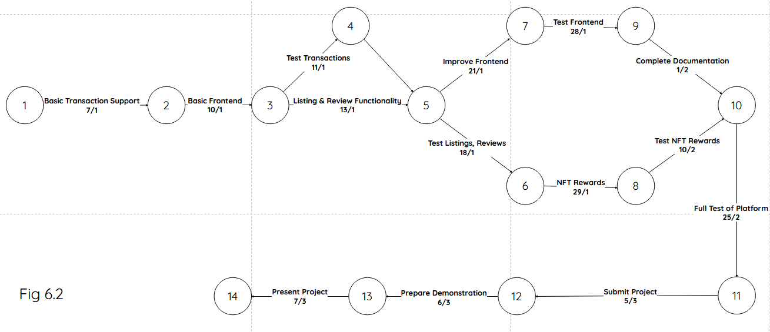

**7. Appendices**

* Understanding Polygon

[What is Polygon? MATIC Explained with Animations](https://www.youtube.com/watch?v=GWUwFDFOipo)

[What are Sidechains in Crypto? Rootstock + Polygon Explained!](https://www.youtube.com/watch?v=cFRj2-jzm8E)

* Developing and deploying a Dapp on the Polygon network

[How to Build a Full Stack NFT Marketplace on Ethereum with Polygon and Next.js - [2021 Tutorial]](https://www.youtube.com/watch?v=GKJBEEXUha0)

[Get Started](https://polygon.technology/get-started/) with Polygon

[Building a Full Stack NFT Marketplace on Ethereum with Polygon](https://dev.to/dabit3/building-scalable-full-stack-apps-on-ethereum-with-polygon-2cfb)

* Increased adoption of cryptocurrencies

<https://civicscience.com/crypto-is-creating-newfound-wealth-and-job-freedom-for-many-americans/>

[El Salvador plans first 'Bitcoin City', backed by bitcoin bonds](https://www.reuters.com/markets/rates-bonds/el-salvador-plans-first-bitcoin-city-backed-by-bitcoin-bonds-2021-11-21/)

[Invesco launches spot Bitcoin ETP on Deutsche Borse](https://cointelegraph.com/news/invesco-launches-spot-bitcoin-etp-on-deutsche-borse)

[Miami Mayor To Take His Entire Salary In Bitcoin](https://www.nasdaq.com/articles/miami-mayor-to-take-his-entire-salary-in-bitcoin-2021-11-04)