Usage

The purpose of this script is to compare the file contents of two directories, namely between fc, nx, and ground, in order to save storage space onboard the spacecraft. Specifically, file_ingest_verify.py compares the contents of two txt files and returns the intersection of these files. The format of the text files must be as follows: one file name per line, either with sole filenames or with path included before filename.

In order to run this script, ensure that the two txt files to be compared are located in the same folder/directory as the script itself. You will be prompted to enter the name of each file in addition to the name of the output file.

Note: when specifying an output filename, do not include the file extension. i.e. if you would like the output filename to be “results.txt”, when prompted for an output filename, simply type “output”.

Note: if user inputs the name of a file that already exists within the directory, this file’s contents will be overwritten.

Running script on Windows

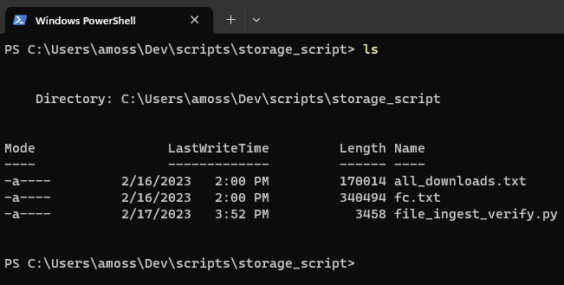

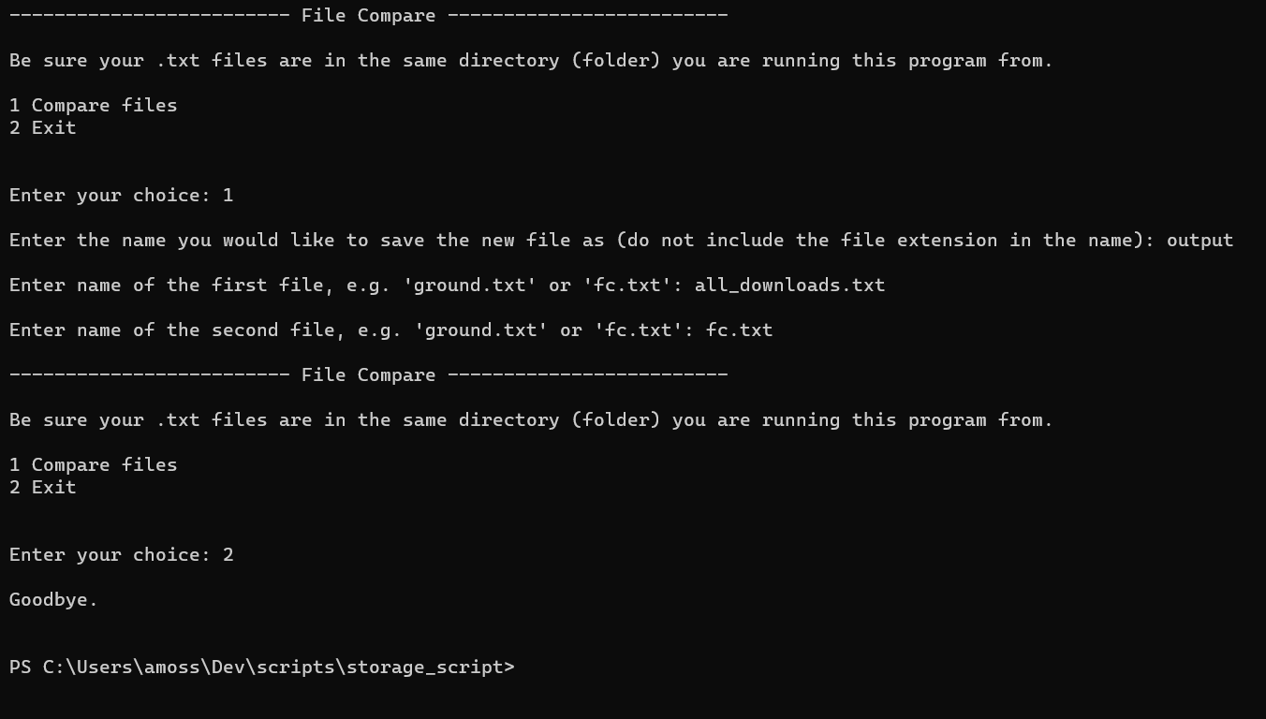

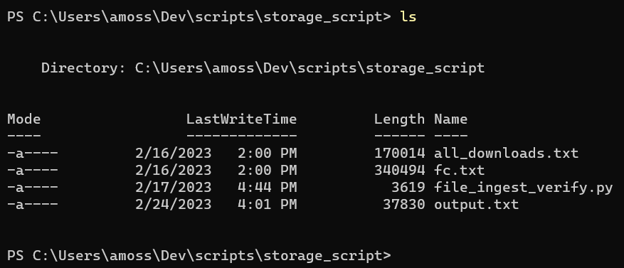

To print contents of output file to the terminal, enter “cat name_of_output_file.txt”, or in the above case, “cat output.txt”.

To open the output file in notepad, enter “start notepad name_of_output_file.txt”, or in the above case, “start notepad output.txt”.

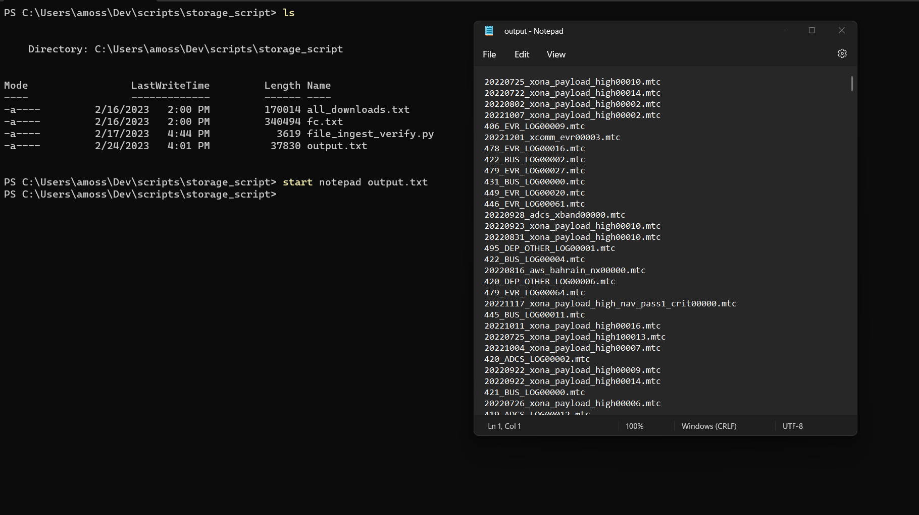

This script will continue to run until exiting by typing “2” from main menu.