Collage Name :- Lovely Professional university
Logo:-



Name:- Himanshu Jha
Card Image:-
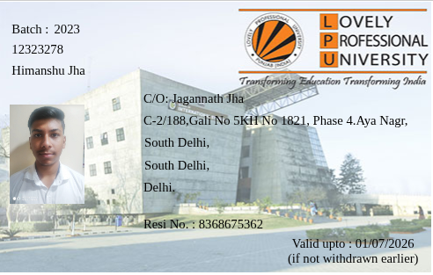

Class schedule :-

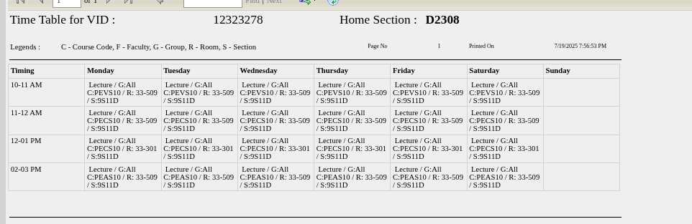

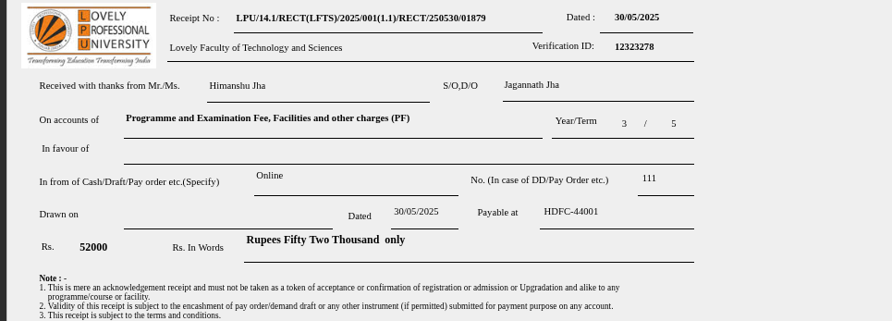
Tuition Recepit

