Intro
Node.js is a javascript runtime, so its an environment that we use for execute js outside of the browser. We can use js on the server side of web development, the backend. The node applications are fast and scalabe.
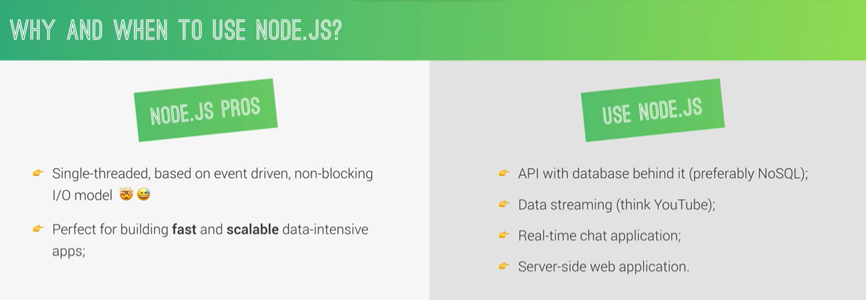
We shouldn’t use Node.js for applications with haevy server side processing: video convertion, editing… We should use rails, php or python for that. Companys that use node: netflix, uber, paypal.

Using node.js we will use the same language across the entire stack, on the front and back-end.
NPM: has a huge amount of packages that help the.

Node is built around modules. How to use:
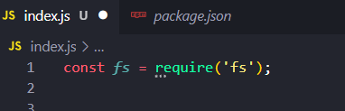

Asynchronous nature of nodejs
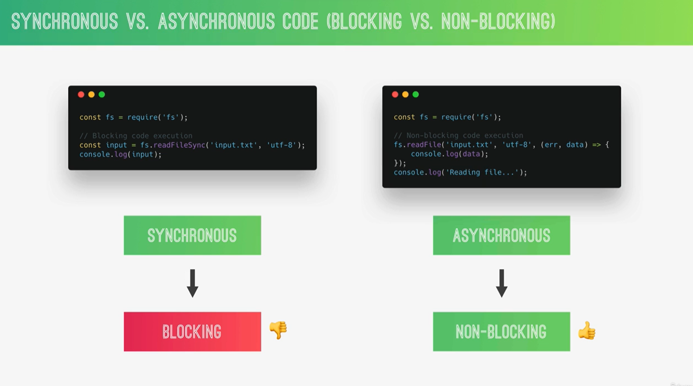
Because node is single thread, if we use blocking execution code, we block our application for every user when some function is called. Because of this, we should asynchronous function, sendind the heavy work for the background:
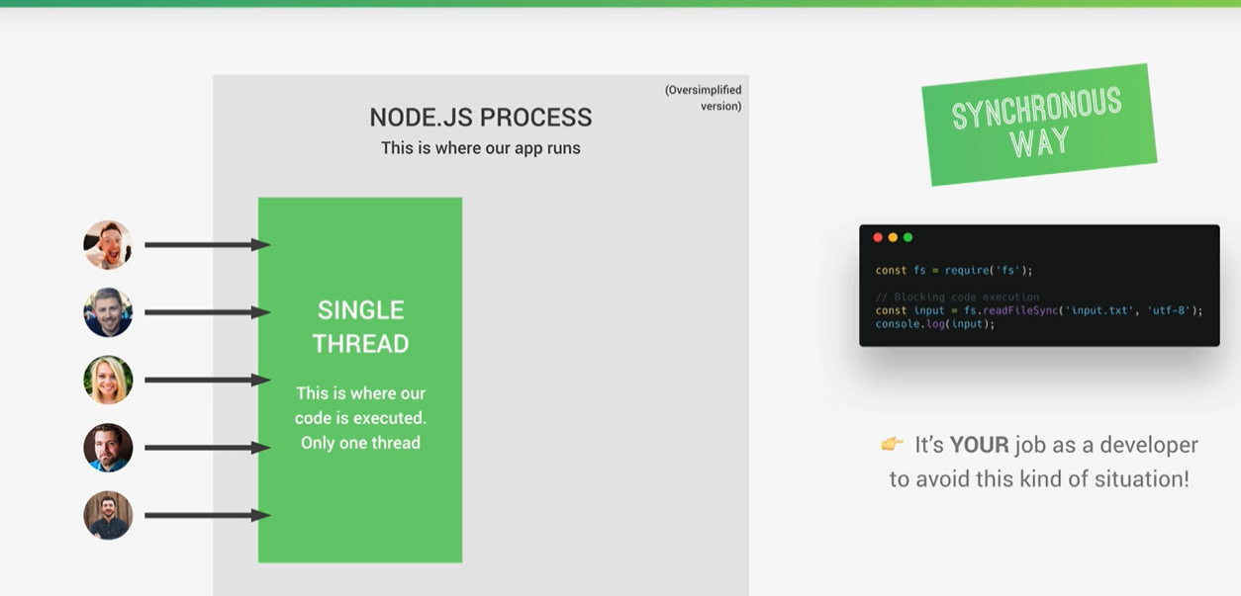

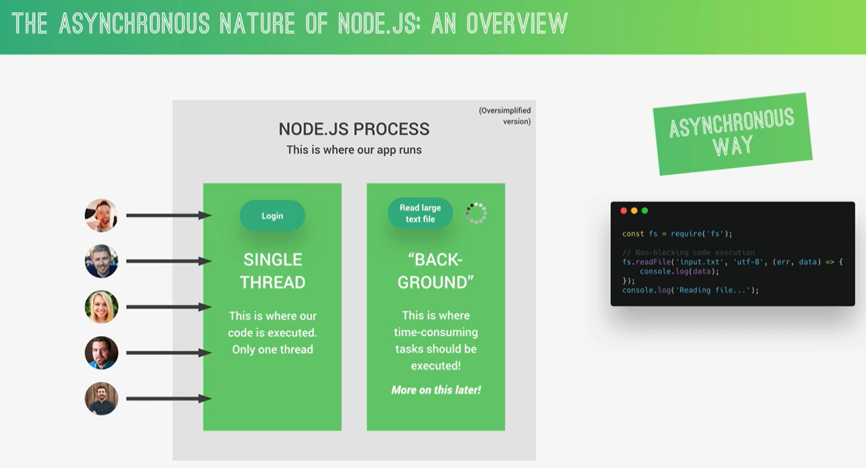
So in node we use non-blocking ipunt/output model, thats why we use a lot of callback functions. Just because we use callback doesn’t necessary means that the code is asynchronous.
Callback can become hard to read and unmanageable:
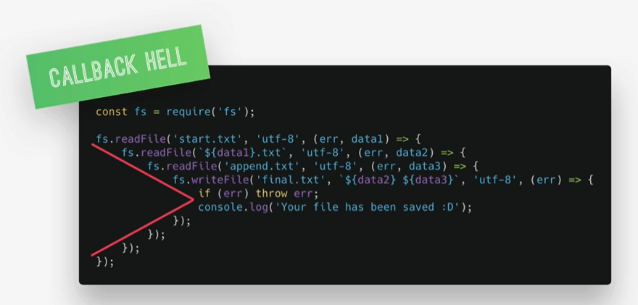
To solve this, we can user promises or Async/Await

