Haproxy日志收集主要分为三步

1. 定义Haproxy日志格式
2. Rsync开启Haproxy日志收集，并设置日切割
3. 安装filebeat并配置收集Haproxy日志
4. 配置Haproxy日志格式

编辑Haproxy配置文件

vim /etc/haproxy/haproxy.cfg

开启Haproxy日志记录功能

log 127.0.0.1 len 65535 local0

添加log-format如下格式，并注释option选项

log-format {"client_ip":"%ci","client_port":"%cp","local_date_time":"%Tl","frontend_name":"%f","backend_name":"%b","server_name":"%s","tq":"%Tq","tw":"%Tw","tc":"%Tc","tr:":"%Tr","tt":"%Tt","status_code":"%ST","bytes_read":"%B","bytes_uploaded":"%U","captured_request_cookie":"%CC","captured_response_cookie":"%CS","termination_state":"%tsc","actconn":"%ac","feconn":"%fc","beconn":"%bc","srv_conn":"%sc","retries":"%rc","srv_queue":"%sq","backend_queue":"%bq","captured_request_headers":"%hr","captured_response_headers":"%hs","http_request":"%r"}

#option httplog

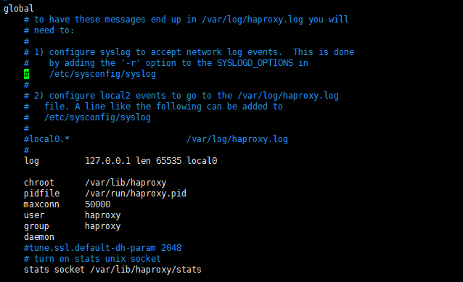

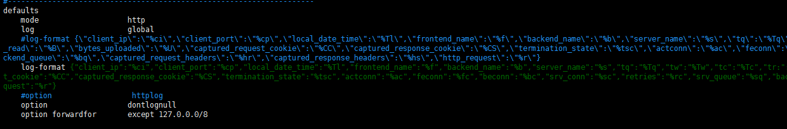

1. 配置Haproxy日志格式

Rsync开启Haproxy日志收集，并设置日切割

vim /etc/rsyslog.conf

开启syslog 日志监听端口，并设置自己的日志格式

$template mytemp,"%msg%\n"

添加Haproxy日志收集

local0.* /var/log/haproxy/haproxy.log;mytemp

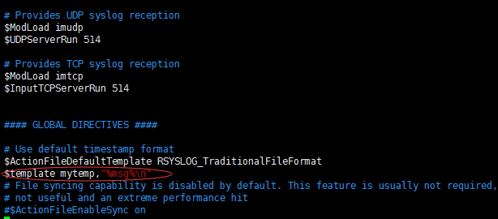

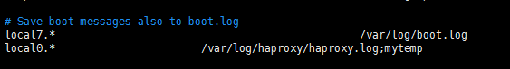

设置志轮询功能

vim /etc/logrotate.d/haproxy

/var/log/haproxy/haproxy.log {

daily

rotate 10

missingok

notifempty

compress

sharedscripts

postrotate

/bin/kill -HUP `cat /var/run/syslogd.pid 2> /dev/null` 2> /dev/null || true

/bin/kill -HUP `cat /var/run/rsyslogd.pid 2> /dev/null` 2> /dev/null || true

endscript

}

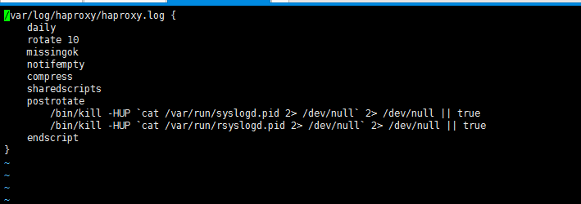

1. 安装filebeat并配置收集Haproxy日志

下载filebeat RPM包 并进行安装

wget <https://artifacts.elastic.co/downloads/beats/filebeat/filebeat-5.5.0-x86_64.rpm>

rpm –ivh filebeat-5.5.0-x86_64.rpm

设置开机自启动服务

chkconfig filebeat on

编辑配置文件

vim /etc/filebeat/filebeat.yml

添加haproxy日志收集

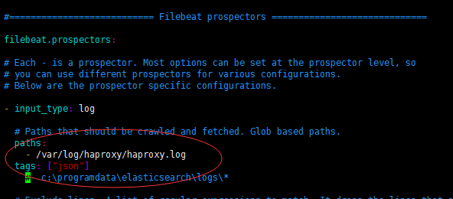

将收集到的haproxy输出到redis存储

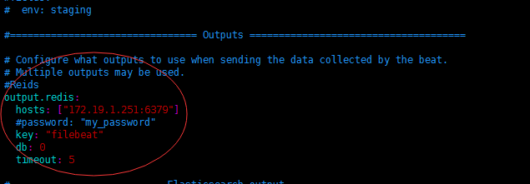

开启filebeat服务

/etc/init.d/filebeat start

在redis服务器上查看是否有日志传输过来

