VIETNAM – KOREA UNIVERSITY OF INFORMATION
AND COMMUNICATION TECHNOLOGY
FACULTY OF COMPUTER SCIENCE



GRADUATION THESIS
BUILDING AN AI RECIPE RECOMMENDER WEBSITE BASED ON INGREDIENTS

Student: | NGUYEN NGOC SON
Class: | 21SE5
Field: | INFORMATION TECHNOLOGY (IT)
Specialization: | SOFTWARE TECHNOLOGY
Supervisor: | M.SC. MAI LAM

Da Nang, December 2025
VIETNAM – KOREA UNIVERSITY OF INFORMATION
AND COMMUNICATION TECHNOLOGY
FACULTY OF COMPUTER SCIENCE



GRADUATION THESIS
BUILDING AN AI RECIPE RECOMMENDER WEBSITE BASED ON INGREDIENTS

Student: | NGUYEN NGOC SON
Class: | 21SE5
Field: | INFORMATION TECHNOLOGY (IT)
Specialization: | SOFTWARE TECHNOLOGY
Supervisor: | M.SC. MAI LAM

Da Nang, December 2025
SUPERVISOR'S COMMENTS

Da Nang, December 27, 2025
Supervisor

ACKNOWLEDGEMENTS

I would like to express my deepest gratitude to all those who have supported and guided me throughout my studies and the completion of this graduation project:
First and foremost, I would like to sincerely thank the lecturers at the Vietnam-Korea University of Information and Communication Technology for their invaluable support and the favorable conditions they provided throughout my studies and the completion of this project.
In particular, I would like to express my sincere gratitude to my supervisor, Mr. Mai Lam, M.Sc., for his direct guidance and continuous support throughout the completion of this project. His valuable contributions were essential to its success.
Despite facing many difficulties during the project's execution, I have tried my best to meet the requirements and complete the project to the best of my ability. However, due to limitations in skills, experience, and time, some shortcomings are unavoidable. I sincerely hope to receive feedback from the teachers to further improve and refine this project.
Thank you very much!

Student
Nguyen Ngoc Son

TABLE OF CONTENTS

Chương 1. GIỚI THIỆU TỔNG QUAN 1
1.1. Tổng quan về Node.js, Express.js, React, Blockchain, Smart Contract 1
1.1.1. NodeJs 1
1.1.2. Express.js 1
1.1.3. React 1
1.1.4. Blockchain 1
1.1.5. Smart Contract 1
1.2. Bố cục báo cáo 2
Chương 2. PHÂN TÍCH VÀ THIẾT KẾ HỆ THỐNG 3
2.1. Mô tả bài toán 3
2.2. Phân tích hệ thống 3
2.2.1. Đặc tả yêu cầu của người dùng 3
2.2.2. Yêu cầu chức năng 4
2.2.3. Yêu cầu phi chức năng 5
2.2.4. Yêu cầu hệ thống 5
2.2.5. Biểu đồ ca sử dụng 5
2.3. Thiết kế hệ thống 15
2.3.1. Thiết kế giao diện 15
2.3.2. Thiết kế cơ sở dữ liệu 22
Chương 3. KẾT QUẢ ĐẠT ĐƯỢC 24
3.1. Cơ sở dữ liệu 24
3.2. Website 24
3.2.1. Trang đăng nhập 24
3.3.2. Trang chủ 25
3.3.3. Trang danh sách tổ chức từ thiện 25
3.3.4. Trang về chúng tôi 26
3.3.5. Trang chi tiết chương trình từ thiện 26
3.3.6. Trang chuyển tiền từ thiện 27
3.3.7. Trang chi tiết tổ chức từ thiện 27
3.3.8. Trang quản lý tổ chức từ thiện 28
3.3.9. Trang tạo tổ chức từ thiện 29
3.3.10. Trang sửa tổ chức từ thiện 29
3.3.11. Trang quản lý chương trình từ thiện 30
3.3.12. Trang tạo chương trình từ thiện 30
3.3.13. Trang sửa chương trình từ thiện 31
KẾT LUẬN 33
1. Những kết quả đạt được 33
2. Hạn chế 33
3. Hướng phát triển 33
TÀI LIỆU THAM KHẢO 35

ABBREVIATIONS

STT | Cụm từ | Viết tắt
1 | Single page application | SPA

DANH MỤC CÁC BẢNG

Bảng 1. Đặc tả use case đăng nhập 7
Bảng 2. Đặc tả use case đăng xuất 7
Bảng 3. Đặc tả use case hiển thị danh sách chương trình từ thiện 8
Bảng 4. Đặc tả use case hiển thị chi tiết chương trình từ thiện 8
Bảng 5. Đặc tả use case chuyển tiền từ thiện 9
Bảng 6. Đặc tả use case hiển thị danh sách tổ chức từ thiện 9
Bảng 7. Đặc tả use case hiển thị chi tiết tổ chức từ thiện 10
Bảng 8. Đặc tả use case thêm tổ chức từ thiện 11
Bảng 9. Đặc tả use case sửa tổ chức từ thiện 12
Bảng 10. Đặc tả use case xóa tổ chức từ thiện 13
Bảng 11. Đặc tả use case thêm chương trình từ thiện 13
Bảng 12. Đặc tả use case sửa chương trình từ thiện 14
Bảng 13. Đặc tả use case xóa chương trình từ thiện 15
Bảng 14. Chi tiết bảng Charity 22
Bảng 15. Chi tiết bảng Program 23
Bảng 16. Chi tiết bảng Temp_transaction 23
Bảng 17. Chi tiết bảng Users 23

DANH MỤC HÌNH

Hình 1. Usecase diagram tổng quát 6
Hình 2. Thiết kế trang đăng nhập 16
Hình 3. Thiết kế trang chủ 16
Hình 4. Thiết kế trang danh sách tổ chức từ thiện 17
Hình 5. Thiết kế trang về chúng tôi 17
Hình 6. Thiết kế trang chi tiết chương trình từ thiện 18
Hình 7. Thiết kế trang chuyển tiền từ thiện 18
Hình 8. Thiết kế trang chi tiết tổ chức từ thiện 19
Hình 9. Thiết kế trang quản lý tổ chức từ thiện 19
Hình 10. Thiết kế trang tạo tổ chức từ thiện 20
Hình 11. Thiết kế trang sửa tổ chức từ thiện 20
Hình 12. Thiết kế trang quản lý chương trình từ thiện 21
Hình 13. Thiết kế trang tạo chương trình từ thiện 21
Hình 14. Thiết kế trang sửa chương trình từ thiện 22
Hình 15. Cơ sở dữ liệu 24
Hình 16. Trang đăng nhập 25
Hình 17. Trang chủ 25
Hình 18. Trang danh sách tổ chức từ thiện 26
Hình 19. Trang về chúng tôi 26
Hình 20. Trang chi tiết chương trình từ thiện 27
Hình 21. Trang chuyển tiền từ thiện 27
Hình 22. Trang chi tiết tổ chức từ thiện 28
Hình 23. Trang quản lý tổ chức từ thiện 28
Hình 24. Trang tạo tổ chức từ thiện 29
Hình 25. Trang sửa tổ chức từ thiện 30
Hình 26. Trang quản lý chương trình từ thiện 30
Hình 27. Trang tạo chương trình từ thiện 31
Hình 28. Trang sửa chương trình từ thiện 32

MỞ ĐẦU

- Problem Statement
In recent years, along with the rapid development of information technology and digital transformation in the field of education, students have increasingly been required to access and process a large volume of learning materials such as textbooks, lecture slides, reference documents, scientific papers, and various online learning resources. Learning is no longer confined to traditional classroom settings but has expanded to self-directed learning, online learning, and active learning models.
However, one of the major challenges students face is the effective utilization and exploitation of learning materials. Most students still rely on manual methods, such as reading entire documents or searching using basic keywords, which is time-consuming and may lead to missing important information. Moreover, current learning management systems primarily focus on storing and displaying documents, lacking the capability to understand semantics or provide question–answering functionality based directly on document content.
At the same time, the advancement of Artificial Intelligence (AI), particularly Large Language Models (LLMs), has opened new opportunities in supporting learning and natural language processing. Among these approaches, Retrieval-Augmented Generation (RAG)—which combines external knowledge retrieval with the generative capabilities of LLMs—has been recognized as an effective solution for delivering accurate, contextualized, and source-grounded answers.
For these reasons, we decided to choose the topic “Building a Student Learning Support System Based on Retrieval-Augmented Generation (RAG)”. This project aims to develop a platform that allows students to upload learning materials, ask questions directly, and receive intelligent answers grounded in the provided documents, thereby enhancing learning efficiency and self-study capabilities.

- Objectives
The main objective of this project is to build a web-based system utilizing Retrieval-Augmented Generation (RAG) to support students in searching, learning, and gaining a deeper understanding of academic materials. The system is designed to function as an intelligent learning assistant, enabling students to access information quickly, accurately, and in a context-aware manner.
- The website aims to provide a modern learning platform with the following key features:
- Accuracy and reliability: Generated answers are based on content retrieved directly from user-provided documents, minimizing hallucinations and ensuring source-grounded responses.
- Time efficiency: Helps students quickly locate relevant information without the need to read lengthy documents in full.
- Support for active learning: Allows students to ask personalized questions, facilitating deeper understanding and knowledge integration.
- User-friendly design: A simple and intuitive interface suitable for students and users without advanced technical backgrounds.
- Scalability: Built on a modern architecture that allows future extensions, such as supporting more document types, integrating additional AI models, or connecting with other learning platforms.
The purpose of this project is not only to develop an intelligent question–answering system but also to demonstrate the practical application of AI in education, contributing to improved learning quality and highlighting the potential of modern AI models in this domain.
- Research Content
- Conducting an overview study of the Retrieval-Augmented Generation (RAG) model, its core components, and operational principles.
- Reviewing and analyzing existing AI-based learning support and question–answering systems.
- Analyzing functional and technical requirements of a document-based learning support system for students.
- Designing the system architecture, including frontend, backend, and AI components.
- Developing the backend using Python, responsible for business logic, data processing, and AI integration.
- Applying LangChain to construct and orchestrate the RAG pipeline, including document processing, embedding, retrieval, and answer generation.
- Utilizing Qdrant (Vector Database) to store vector embeddings and perform semantic search.
- Developing the frontend using Next.js to provide user interaction and system accessibility.
- Research Methodology
- Literature review and document analysis: Studying academic papers, technical documents, and existing models related to RAG, LLMs, and AI applications in education.
- System analysis method: Analyzing business requirements, system architecture, data flow, and core functionalities.
- Design and implementation method: Designing the software architecture and implementing the system using web technologies combined with AI.
- Scientific Significance of the Project
- Contributing to the understanding of the practical applicability of Retrieval-Augmented Generation (RAG) in the education domain.
- Proposing an intelligent learning support system model that can be adapted and extended to various subjects and academic fields.
- Serving as a valuable reference for future research and projects related to the application of AI and LLMs in learning support and knowledge processing.
- Demonstrating the potential of modern AI technologies in enhancing educational quality and promoting active learning.
- Implementation Content
Chapter 1: Overview

Chapter 2: System Analysis and Design

Chapter 3: Results and Discussion

Chapter 1. OVERVIEW

Core Artificial Intelligence Technologies

1.1.1. Large Language Model (LLM)
A Large Language Model (LLM) is a type of language model in the field of artificial intelligence, developed using deep learning techniques and trained on large-scale textual data to learn the patterns, structures, and contextual relationships of natural language. LLMs mainly rely on the Transformer architecture, in which the self-attention mechanism enables the model to capture dependencies between words across an entire sentence or document rather than being limited to sequential word processing. Through self-supervised learning, most commonly next-token prediction, LLMs acquire the ability to understand context and generate human-like text.
The development of an LLM typically involves multiple stages: pre-training on massive unlabeled datasets to learn general linguistic representations; fine-tuning to adapt the model to specific tasks or application domains; and, in many cases, Reinforcement Learning from Human Feedback (RLHF) to improve response quality, alignment, and safety. Owing to their large number of parameters, LLMs demonstrate strong generalization capabilities and high flexibility, allowing a single model to perform a wide variety of language-related tasks without requiring separate task-specific models.
LLMs are widely applied in areas such as text generation, summarization, machine translation, conversational agents, and programming assistance. However, they also present several limitations, including high computational and resource costs during training and deployment, the possibility of generating incorrect or misleading information (hallucination), and the propagation of biases inherited from training data. Despite these challenges, Large Language Models are regarded as a core technology in modern artificial intelligence, significantly advancing the field of natural language processing and enabling large-scale, language-driven AI applications.

1.1.2. Retrieval-Augmented Generation (RAG)
Retrieval-Augmented Generation (RAG) is a technique that combines generative language models with information retrieval systems to improve the accuracy and freshness of generated content. Instead of relying solely on the knowledge acquired during training, RAG enables the model to retrieve data from external sources at inference time.
The RAG architecture typically consists of two main stages: retrieval and generation. In the retrieval stage, a user query is transformed into a vector representation and compared with document vectors stored in a vector database to identify the most relevant text segments. These retrieved segments are then incorporated into the input context of the language model during the generation stage to produce the final response.
This approach helps mitigate hallucination while enabling the model to operate on domain-specific, private, or frequently updated data. RAG is currently considered one of the most important approaches for building document-based question answering systems and AI assistants.

1.1.3. Vector Database
A vector database is a specialized data management system designed to store and search high-dimensional vector representations, commonly generated by embedding models. Vector databases play a crucial role in semantic search, information retrieval, and recommendation systems.
Modern vector databases employ Approximate Nearest Neighbor (ANN) algorithms, such as HNSW, to achieve efficient similarity search at scale. In addition to vector storage, many vector databases support metadata management, enabling filtered queries and contextual retrieval.
Due to their scalability and performance, vector databases have become a fundamental component of AI-driven applications, particularly those based on Retrieval-Augmented Generation.

Backend Technologies

1.2.1. Python
Python is a high-level, general-purpose programming language that emphasizes code readability, simplicity, and developer productivity. Its clean syntax and dynamic typing system allow developers to rapidly prototype and develop complex applications with relatively low development overhead.
Python supports multiple programming paradigms, including procedural programming, object-oriented programming, and functional programming. The language features automatic memory management and garbage collection, which reduce the risk of memory-related errors and simplify software development. Python is also highly extensible and can interoperate with other languages such as C and C++, making it suitable for performance-critical components.
Due to its extensive standard library and vast ecosystem of third-party packages, Python is widely used in backend development, data processing, scientific computing, and artificial intelligence. In the context of AI-driven systems, Python has become the de facto standard language, providing seamless integration with machine learning frameworks, data processing pipelines, and API services.

1.2.2. FastAPI
FastAPI is a modern, high-performance web framework for building RESTful APIs with Python. It is built on top of Starlette for web handling and Pydantic for data validation, combining speed, reliability, and ease of use.
One of FastAPI’s key strengths is its native support for asynchronous programming using Python’s async/await syntax. This enables efficient handling of I/O-bound operations such as database access, external API calls, and file processing, making FastAPI well-suited for scalable backend systems.
FastAPI also leverages Python type hints to automatically validate request and response data, reducing runtime errors and improving code correctness. Additionally, it automatically generates interactive API documentation compliant with the OpenAPI specification, which enhances maintainability and collaboration between development teams.

1.2.3. Relational Database Management Systems (MySQL)
Relational Database Management Systems (RDBMS) are designed to store and manage structured data using tables, rows, and columns, with well-defined schemas and relationships. MySQL is one of the most widely adopted open-source RDBMS solutions, known for its reliability, performance, and strong community support.
MySQL supports key database features such as ACID-compliant transactions, indexing, foreign key constraints, and data integrity enforcement. These features make it suitable for managing business-critical data, user information, and transactional records.
In modern application architectures, relational databases are often used alongside other specialized storage systems, providing a robust foundation for structured and consistent data management while maintaining compatibility with a wide range of backend technologies.

1.2.4. Real-Time Communication (Socket.IO)
Real-time communication technologies enable instant data exchange between clients and servers, allowing applications to respond immediately to user actions or system events. Socket.IO is a popular library that facilitates bidirectional, event-driven communication using WebSocket as its primary transport protocol.
Socket.IO provides additional features such as automatic reconnection, message acknowledgment, and fallback mechanisms to HTTP long polling when WebSocket is unavailable. These features enhance reliability and ensure consistent communication across different network environments and devices.
Real-time communication is essential for applications that require low-latency interactions, including messaging systems, collaborative platforms, live dashboards, and streaming applications.

Frontend Technologies

1.3.1. JavaScript
JavaScript is a high-level, interpreted programming language that serves as the core technology of the modern web. Initially developed to add interactivity to static web pages, JavaScript has evolved into a versatile and powerful language capable of supporting complex client-side and server-side applications.
JavaScript follows a single-threaded execution model but incorporates asynchronous programming through callbacks, promises, and the event loop. This design enables non-blocking execution of tasks such as network requests and user interactions, which is critical for responsive web applications.
The language supports multiple programming paradigms, including event-driven programming, prototype-based object-oriented programming, and functional programming. With its extensive ecosystem of libraries and frameworks, JavaScript has become the foundation for modern frontend development.

1.3.2. React and Next.js
React is a JavaScript library for building user interfaces based on a component-oriented architecture. It encourages the creation of reusable, self-contained components that manage their own state and lifecycle, leading to more maintainable and scalable user interfaces.
Next.js is a framework built on top of React that enhances application performance and developer experience by providing server-side rendering (SSR), static site generation (SSG), and file-based routing. These features improve initial page load times, search engine optimization (SEO), and overall application scalability.
Together, React and Next.js form a powerful frontend development stack widely adopted for building modern, high-performance web applications.

1.3.3. State Management and UI Frameworks
As frontend applications grow in complexity, effective state management becomes essential. Redux Toolkit is an official abstraction layer that simplifies the use of Redux by reducing boilerplate code and enforcing best practices for predictable state management.
TanStack Query (formerly React Query) focuses on managing asynchronous server state, providing built-in caching, background data synchronization, and automatic refetching. This approach reduces the complexity of handling API-driven data in frontend applications.
Tailwind CSS is a utility-first CSS framework that allows developers to build responsive and consistent user interfaces using predefined utility classes. This approach promotes design consistency while reducing the need for custom CSS code.

Infrastructure and Deployment Technologies

1.4.1. Docker
Docker is a containerization platform that enables applications to be packaged together with their runtime environment and dependencies into isolated containers. Containers ensure consistent behavior across different environments, from development to production.
Docker improves deployment reliability, simplifies dependency management, and enables efficient resource utilization. It also supports horizontal scaling and microservices architectures, making it a core technology in modern software infrastructure.

1.4.2. Docker Compose
Docker Compose is a tool used to define and manage multi-container applications through a declarative configuration file. It allows developers to specify services, networks, volumes, and environment variables in a centralized manner.
By orchestrating multiple containers as a single application, Docker Compose simplifies system setup, testing, and deployment. It is particularly useful for managing complex infrastructures that consist of interconnected services.

1.4.3. MinIO Object Storage
MinIO is a high-performance, open-source object storage system that is fully compatible with the Amazon S3 API. It is designed to store large volumes of unstructured data such as documents, images, videos, and backups.
Object storage systems like MinIO provide scalability, durability, and efficient access to large binary files. They are commonly used in modern architectures to complement relational databases by separating structured data from unstructured data storage.

Conclusion
This chapter has provided a detailed overview of key technologies commonly used in modern software systems, covering backend development, frontend technologies, and infrastructure solutions. These technologies form a solid foundation for building scalable, maintainable, and high-performance applications capable of addressing complex functional and non-functional requirements.

Chapter 2. SYSTEM ANALYSIS AND DESIGN

2.1. System Analysis

2.1.1. User Requirements Specification
- As a user, I want to sign in using my Google account so that I do not need to create a new account.
- As a user, I want to create multiple separate notebooks to organize documents by subject.
- As a user, I want to upload PDF/Word documents so that I can ask questions based on their content.
- As a user, I want to ask questions and receive answers based on the document content, along with source citations.
- As a user, I want the system to summarize documents so that I can quickly grasp the main ideas.
- As a user, I want the system to automatically generate flashcards from documents for effective revision.
- As a user, I want the system to automatically generate quizzes from documents to self-assess my knowledge.
- As a user, I want to manage and review the flashcards and quizzes that have been created.

2.1.2. Functional Requirements
The RAG For Student system is designed to meet users’ intelligent learning needs through interactive document-based functionalities. The main functional groups include:
1. Account Management and Authentication:
- User registration and login via Google OAuth (using personal Google email accounts).
- Secure session management using JWT (JSON Web Token).
- Automatic retrieval and storage of user information (e.g., name and avatar) from Google.
2. Learning Workspace Management (Notebooks/Chats):
- Create, rename, and delete learning sessions (Notebooks).
- Each Notebook operates independently with its own isolated data.
3. Document Management:
- Upload documents supporting multiple formats: PDF, DOCX, TXT.
- Automatic document processing, including text extraction, chunking, and vector embedding generation.
- Storage of original documents in MinIO and vector embeddings in Qdrant.
4. Intelligent Question Answering (RAG Chat):
- Chat with documents using Large Language Models (LLMs).
- Retrieval-Augmented Generation (RAG) mechanism ensures answers are grounded in document content.
- Support for source citation, clearly indicating the source page and text segment used in the response.
5. Smart Study Tools:
- Document Summarization: Automatically summarize entire documents or individual chapters.
- Flashcard Generation: Automatically generate flashcards (question–answer pairs) from documents for effective revision.
- Quiz Generation: Automatically generate multiple-choice quizzes to assess user knowledge.

2.1.3. Non-Functional Requirements
- Performance: The system provides real-time streaming responses for chat-based queries. Document ingestion and processing are executed as background tasks to avoid blocking the user interface. The system supports up to 1,000 concurrent users.
- Accuracy: A reranking mechanism is applied to ensure that the retrieved text passages have the highest relevance to the user’s query.
- Security: User data is isolated, with each chat session stored as a separate collection in the vector database. Authentication tokens are time-limited and securely encrypted.

2.1.4. System Requirements
Component | Technology | Minimum Version
Backend Runtime | Python | 3.10+
Frontend Runtime | Node.js | 18.x+
Container Platform | Docker & Docker Compose | 24.x / 2.x
Database | MySQL | 8.0+
Vector Database | Qdrant | 1.7+
Object Storage | MinIO | Latest
LLM Provider | Google Gemini API | 1.5 Flash/Pro
Embedding Model | Ollama (mxbai-embed-large) | Latest

2.1.5. Actors
- User (Student): End user who has learning and revision needs based on documents.

2.2. Use Case Analysis

2.2.1. Overall Use Case Diagram
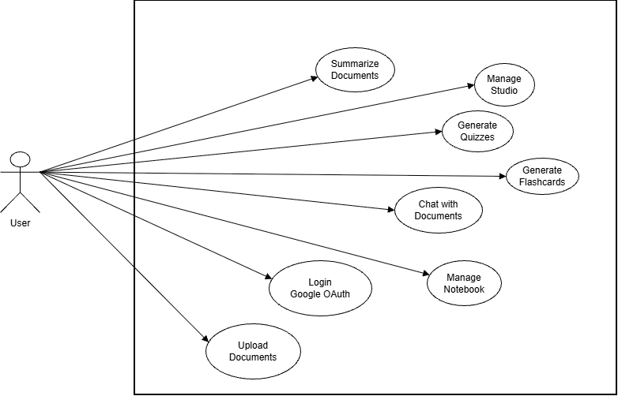
Image1. Overall Use Case Diagram

2.2.2. Detailed Use Case Specifications

a. Login with google
Item | Description
Description | Allows users to authenticate and log in using their Google account
Actor | User
Precondition | The user has a valid Google account
Main Flow | 1. The user accesses the login page  2. The user clicks “Sign in with Google”  3. The system redirects to Google Oauth  4. The user authenticates with Google  5. The system receives user info and generates a JWT token  6. Redirect to the dashboard
Alternative Flow | 4a. If authentication fails: Display an error message
Postcondition | The user is logged in with a valid session
Bảng 1. Đặc tả use case đăng nhập

b. Notebook Management
Item | Description
Description | Allows users to create, rename, and delete notebooks to organize documents
Actor | User
Precondition | The user is authenticated
Main Flow | 1. The user clicks “New Notebook”  2. The system creates a notebook with a default name  3. The notebook appears in the sidebar  4. Rename the notebook
Alternative Flow | 4a. Delete notebook: The system confirms and removes all related data
Postcondition | The notebook is successfully created, updated, or deleted
Bảng 2. Đặc tả use case đăng xuất

c. Document Upload and Processing (Document Ingestion)
Item | Description
Description | Allows users to upload documents for system processing and storage
Actor | User
Precondition | The user is authenticated and inside a notebook
Main Flow | 1. The user selects a file (PDF/DOCX/TXT)  2. The system uploads the file to MinIO  3. The system extracts text  4. The system chunks the text  5. The system generates vector embeddings  6. Vectors are stored in Qdrant
Alternative Flow | 3a. If the file format is invalid: Display an error message
Postcondition | The document is indexed and ready for querying
Bảng 3. Đặc tả use case hiển thị danh sách chương trình từ thiện

d. Document-based Question Answering (Chat with RAG)
Item | Description
Description | Allows users to ask questions and receive answers grounded in document content
Actor | User
Precondition | The notebook contains at least one indexed document
Main Flow | 1. The user enters a question  2. The system embeds the query into a vector  3. Retrieves top-k similar chunks  4. Reranks to select top-n most relevant chunks  5. Sends context and question to the LLM  6. Displays the answer with source citations
Alternative Flow | 3a. If no relevant documents are found: Answer based on the LLM’s general knowledge
Postcondition | The message is stored in the chat history
Bảng 4. Đặc tả use case hiển thị chi tiết chương trình từ thiện

e. Document Summarization
Item | Description
Description | Automatically summarizes document content for quick understanding
Actor | User
Precondition | The notebook contains at least one indexed document
Main Flow | 1. The user selects a document to summarize  2. The user clicks “Summarize”  3. The system retrieves document content  4. The LLM analyzes and generates a summary  5. The summary is displayed
Alternative Flow | 3a. If the document is too long: Split it and summarize each part
Postcondition | The summary is displayed and can be copied or saved
Bảng 5. Đặc tả use case chuyển tiền từ thiện

f. Flashcard Generation
Item | Description
Description | Automatically generates flashcards from document content
Actor | User
Precondition | The notebook contains at least one indexed document
Main Flow | 1. The user requests flashcard generation  2. The system retrieves document content  3. The LLM generates flashcards  4. The flashcard set is stored in the database  5. Flashcards are displayed in the Studio
Postcondition | Flashcards are saved and accessible from the Studio
Bảng 6. Đặc tả use case hiển thị danh sách tổ chức từ thiện

g. Quiz Generation
Item | Description
Description | Automatically generates quizzes from document content for knowledge assessment
Actor | User
Precondition | The notebook contains at least one indexed document
Main Flow | 1. The user requests quiz generation  2. The system retrieves document content  3. The LLM generates multiple-choice questions  4. The quiz is stored in the database  5. The quiz is displayed in the Studio
Alternative Flow | 3a. If the content is insufficient: Display a notification requesting more documents
Postcondition | The quiz is saved and accessible from the Studio

h. Study Studio Management (Flashcards & Quizzes)
Item | Description
Description | Manages and utilizes generated flashcard sets and quizzes
Actor | User
Precondition | At least one flashcard set or quiz exists
Main Flow | 1. The user opens the Studio panel  2. The system displays flashcard sets and quizzes  3. The user selects an item to study or take a quiz  4. The system displays the appropriate interface  5. The user interacts and completes the session
Alternative Flow | 2a. If no items exist: Display guidance for creating new ones
Postcondition | The user completes the study or quiz and can view results

2.3. System Flow Design

2.3.1. RAG Pipeline with Reranking

2.3.1.1. Query Processing Workflow in RAG with Reranking
This is the core processing pipeline of the system, designed to significantly improve answer accuracy by combining vector-based retrieval with a reranking model.
Process Description:

1. Retrieval (Initial Search):
When a user submits a question, the system converts the query into a vector embedding and performs a similarity search to retrieve the top-k (e.g., 20) most relevant text chunks from the Qdrant Vector Database.

2. Reranking (Relevance Scoring):
The retrieved results from the first step are passed to a Cross-Encoder model (ms-marco-MiniLM-L-6-v2). This model performs a deeper semantic evaluation by jointly reading each (question–passage) pair and assigning a more accurate relevance score compared to pure vector similarity.

3. Selection:
The system selects the top-n (e.g., 5) passages with the highest relevance scores after reranking.

4. Generation (Answer Generation):
The selected passages serve as the context and are combined with the user’s question before being sent to the Large Language Model (LLM) to generate the final answer.
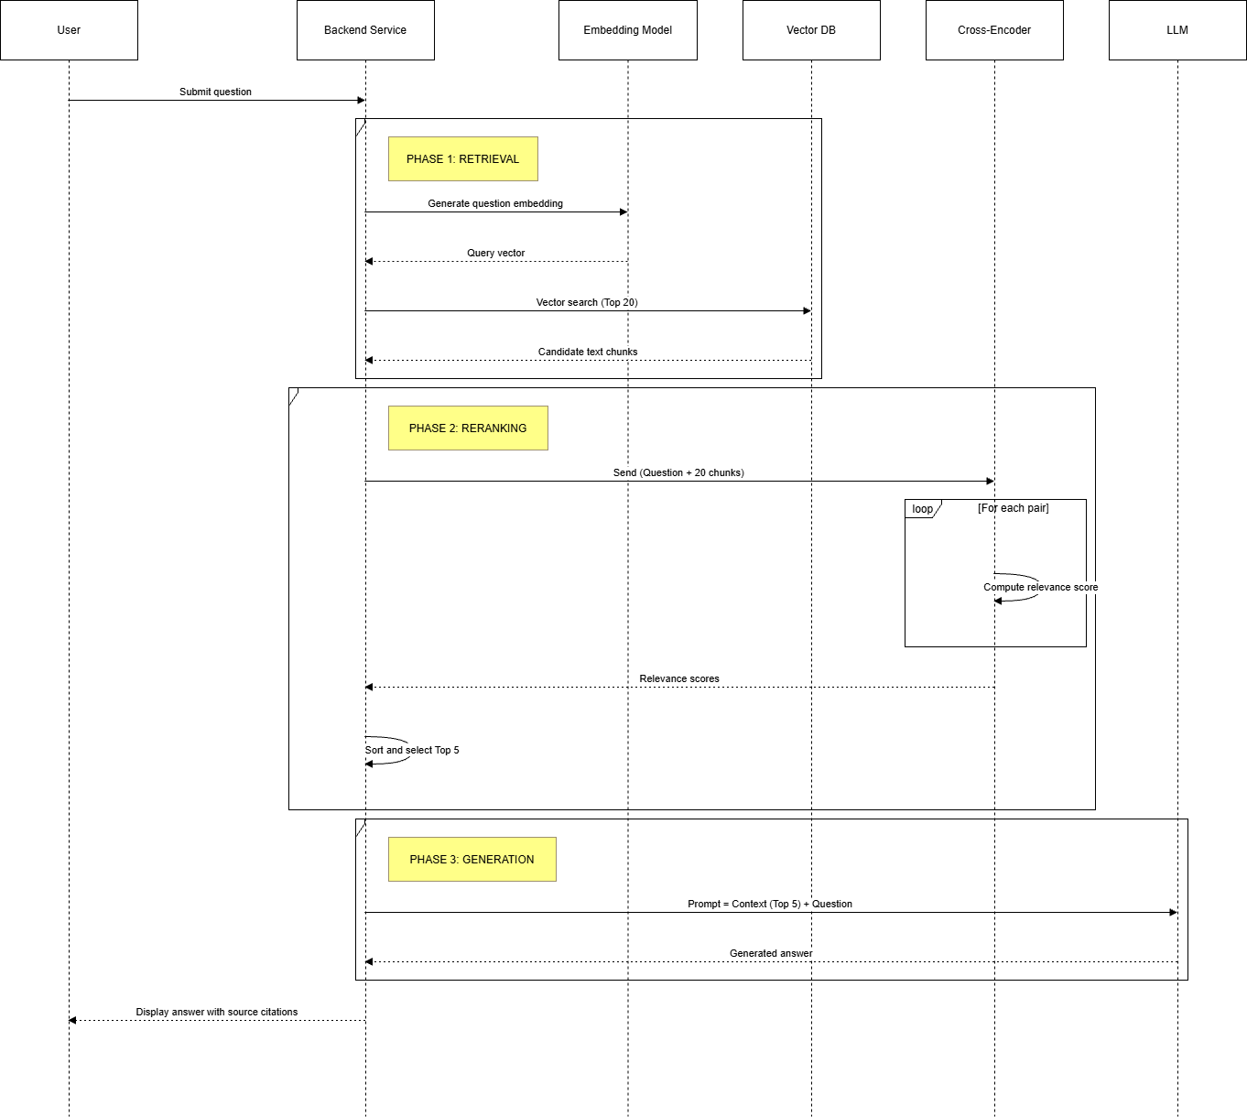

2.3.1.2. Detailed Analysis of the RAG Model

a. RAG Architecture in the System
The system adopts a RAG with Reranking architecture—an enhanced variant of the traditional RAG approach—which significantly improves the accuracy of information retrieval results.
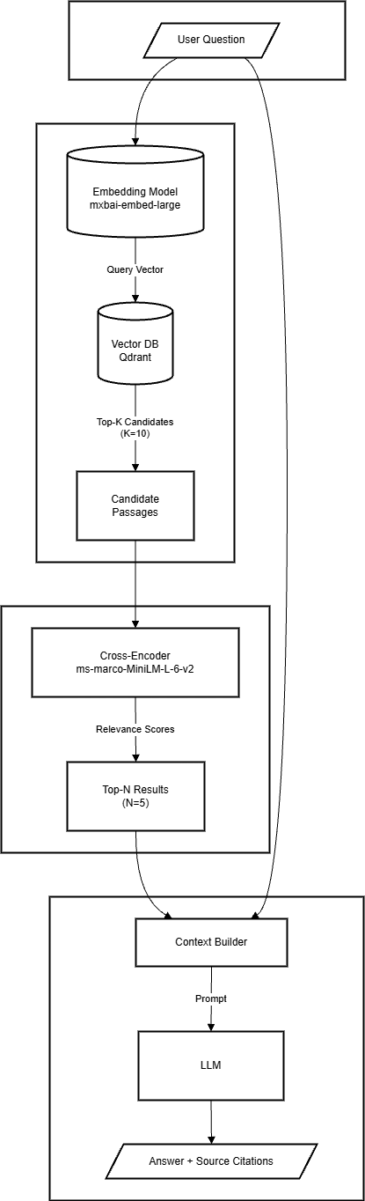

b. Comparison of RAG Approaches
Criteria | Basic RAG | RAG + Reranking (This System)
Scoring Method | Cosine similarity on embedding vectors | Cosine similarity + Cross-Encoder scoring
Accuracy | Medium (dependent on embedding quality) | High (Cross-Encoder provides deeper semantic evaluation)
Speed | Fast | Slightly slower (due to the additional reranking step)
Ambiguity Handling | Weak | Strong (Cross-Encoder captures contextual semantics more effectively)
Trade-off | Speed-focused | Accuracy-focused

c. Core Components
- Embedding Model (`mxbai-embed-large`):
- Deployed on a local Ollama server
- Converts text into 1024-dimensional vectors
- Supports multilingual processing, including Vietnamese
- Vector Database (Qdrant):
- Stores vectors in collections (each chat session corresponds to one collection)
- Supports HNSW indexing for efficient similarity search
- Stores metadata alongside vectors (e.g., document_id, page, filename, etc.)
- Cross-Encoder Reranker (ms-marco-MiniLM-L-6-v2):
- Independently evaluates each (query, document) pair
- Generates relevance scores for reranking
- Loaded once and cached using the Singleton pattern
- Large Language Model (Google Gemini):
- Model: Gemini 2.5 Flash, balancing inference speed and response quality
- Uses a low temperature setting (0.1) to ensure consistency and deterministic outputs

2.3.2. Activity diagram
2.3.2.1
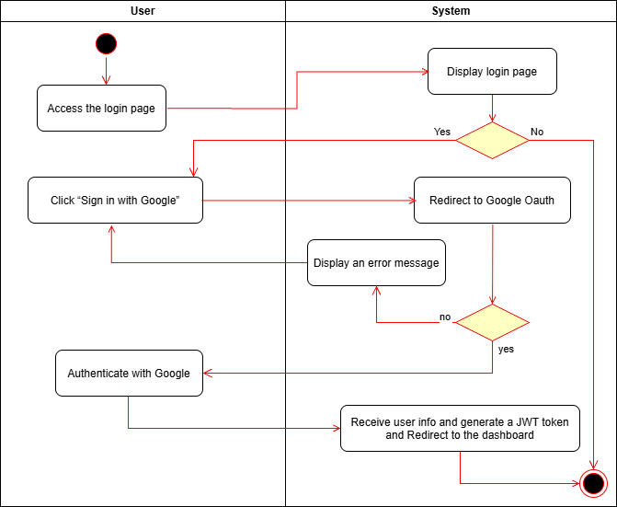
2.3.2.2
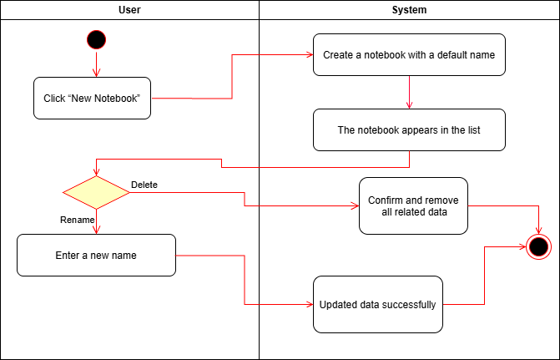
2.3.2.3.
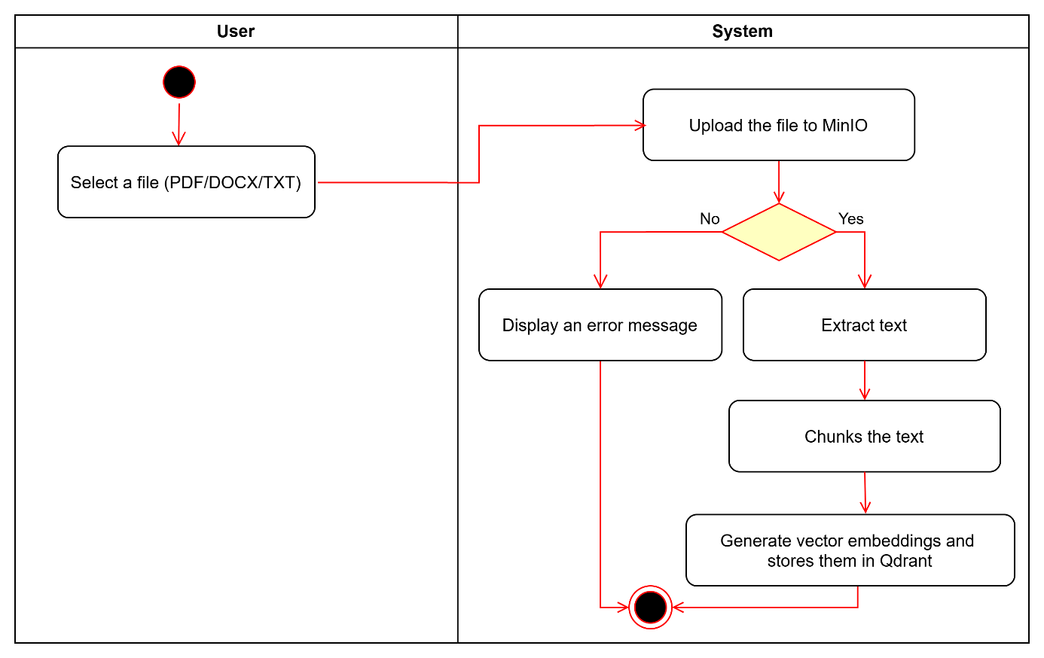
2.3.2.4.
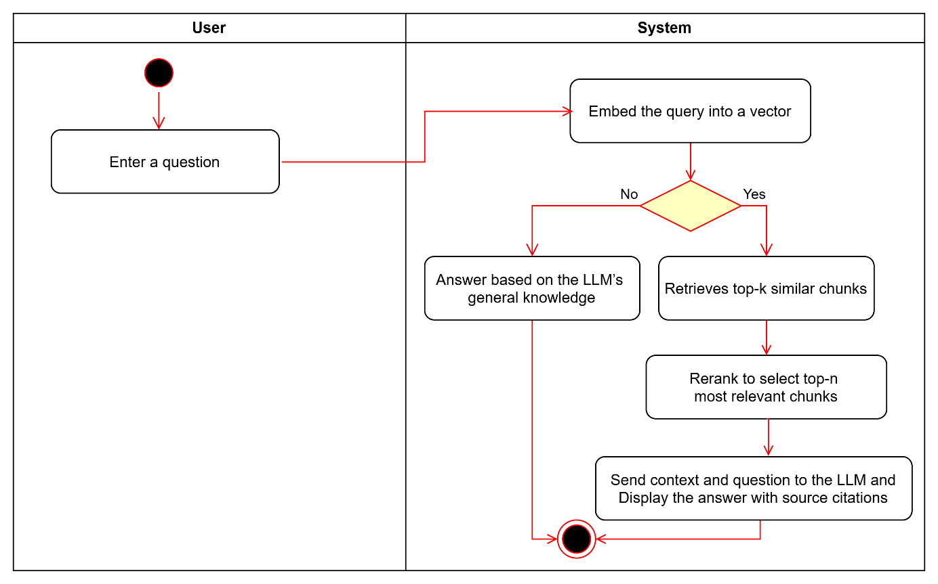
2.3.2.5.
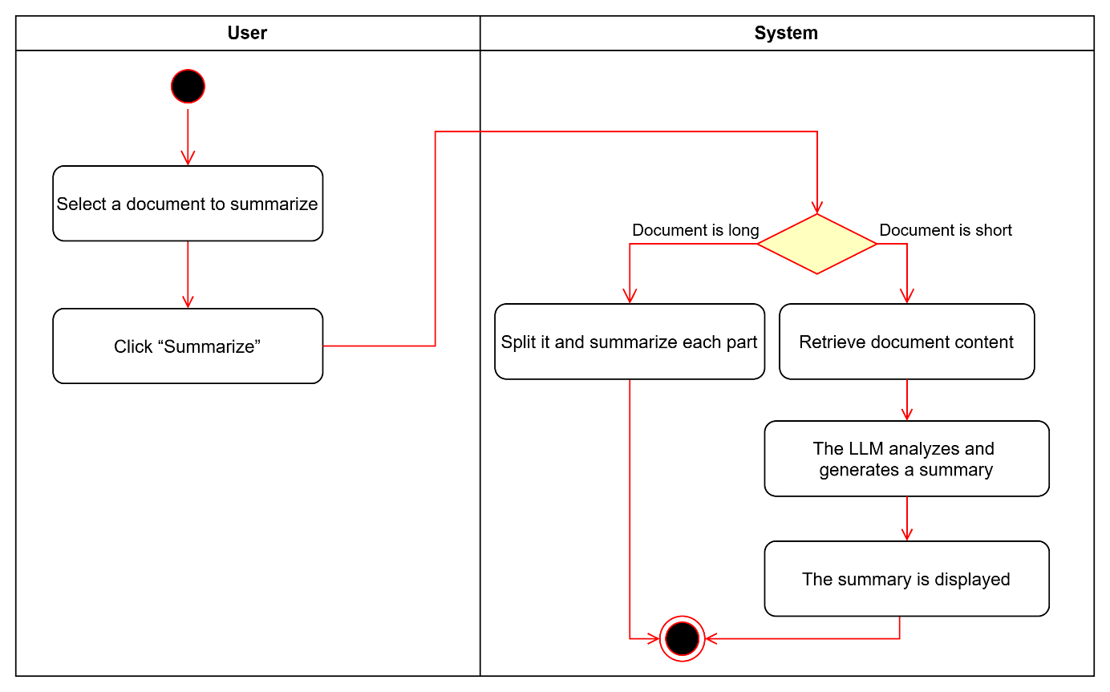
2.3.2.6.
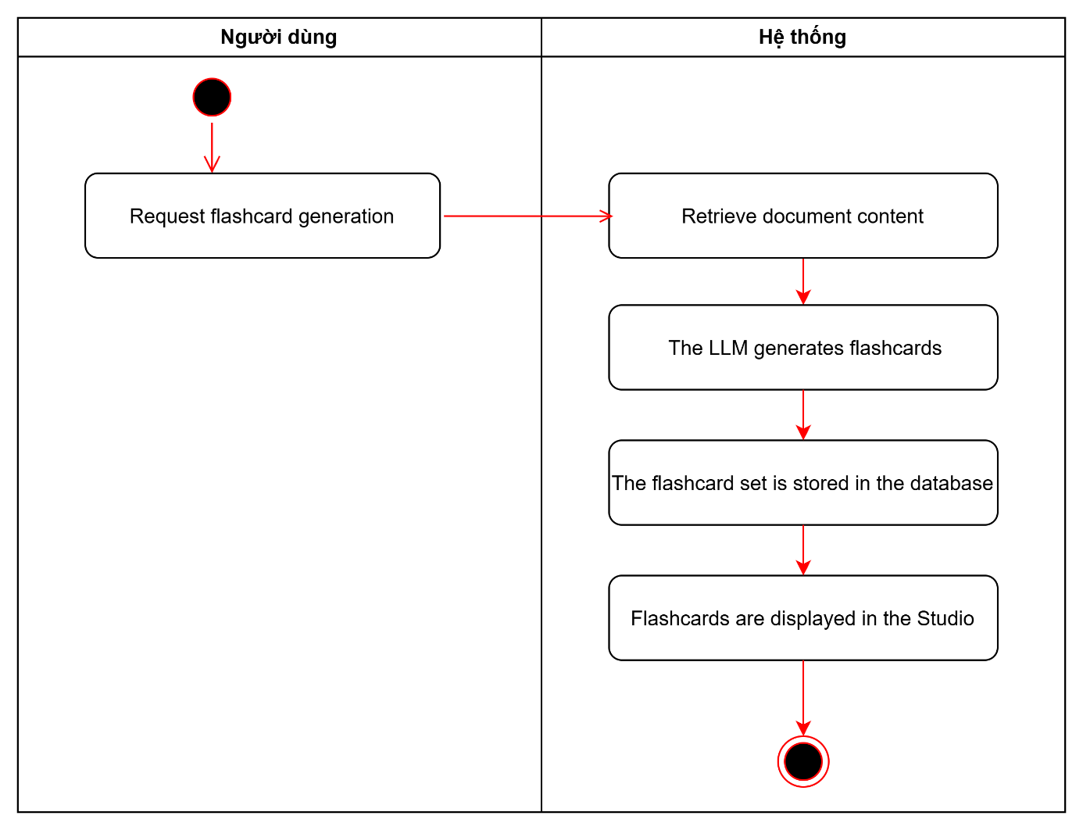
2.3.2.7.
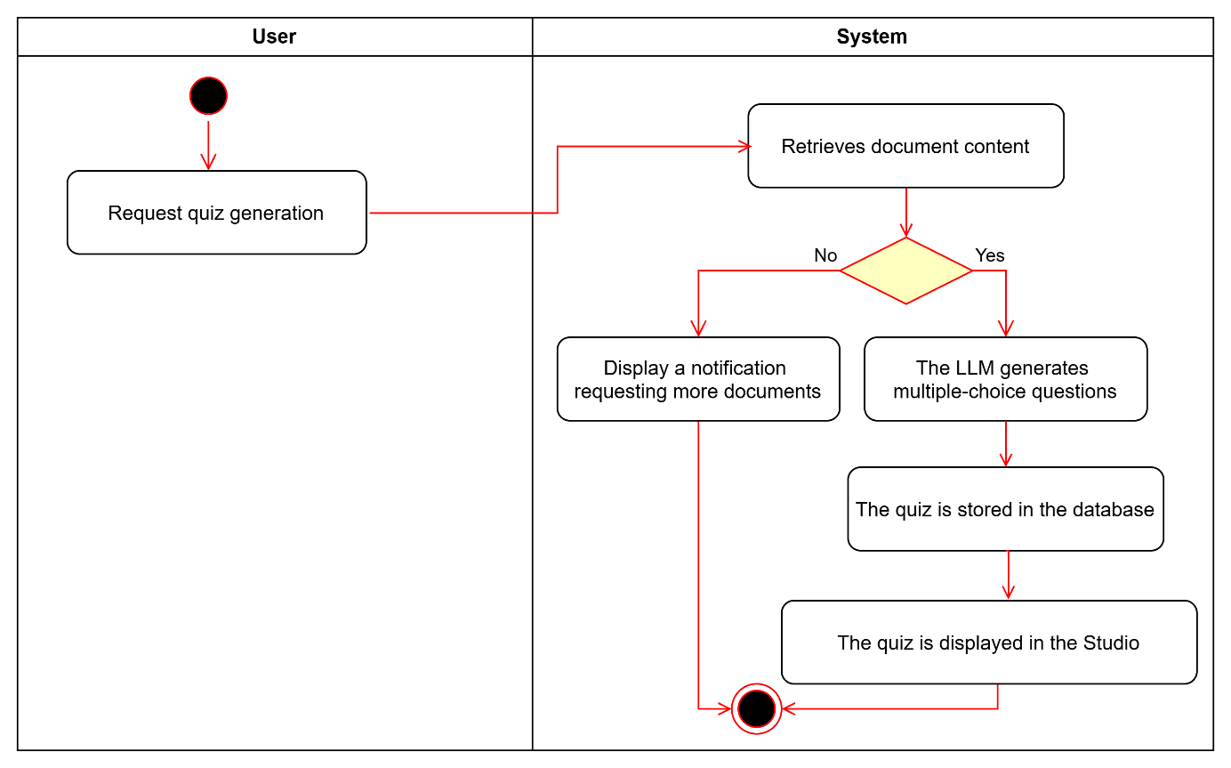
2.3.2.8.
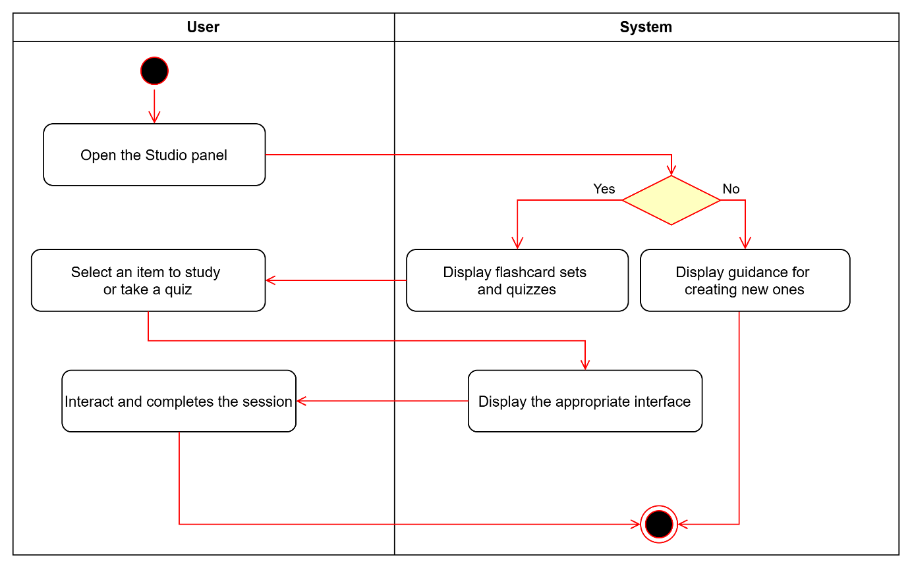

2.3.3. Sequence diagram
2.3.3.1.
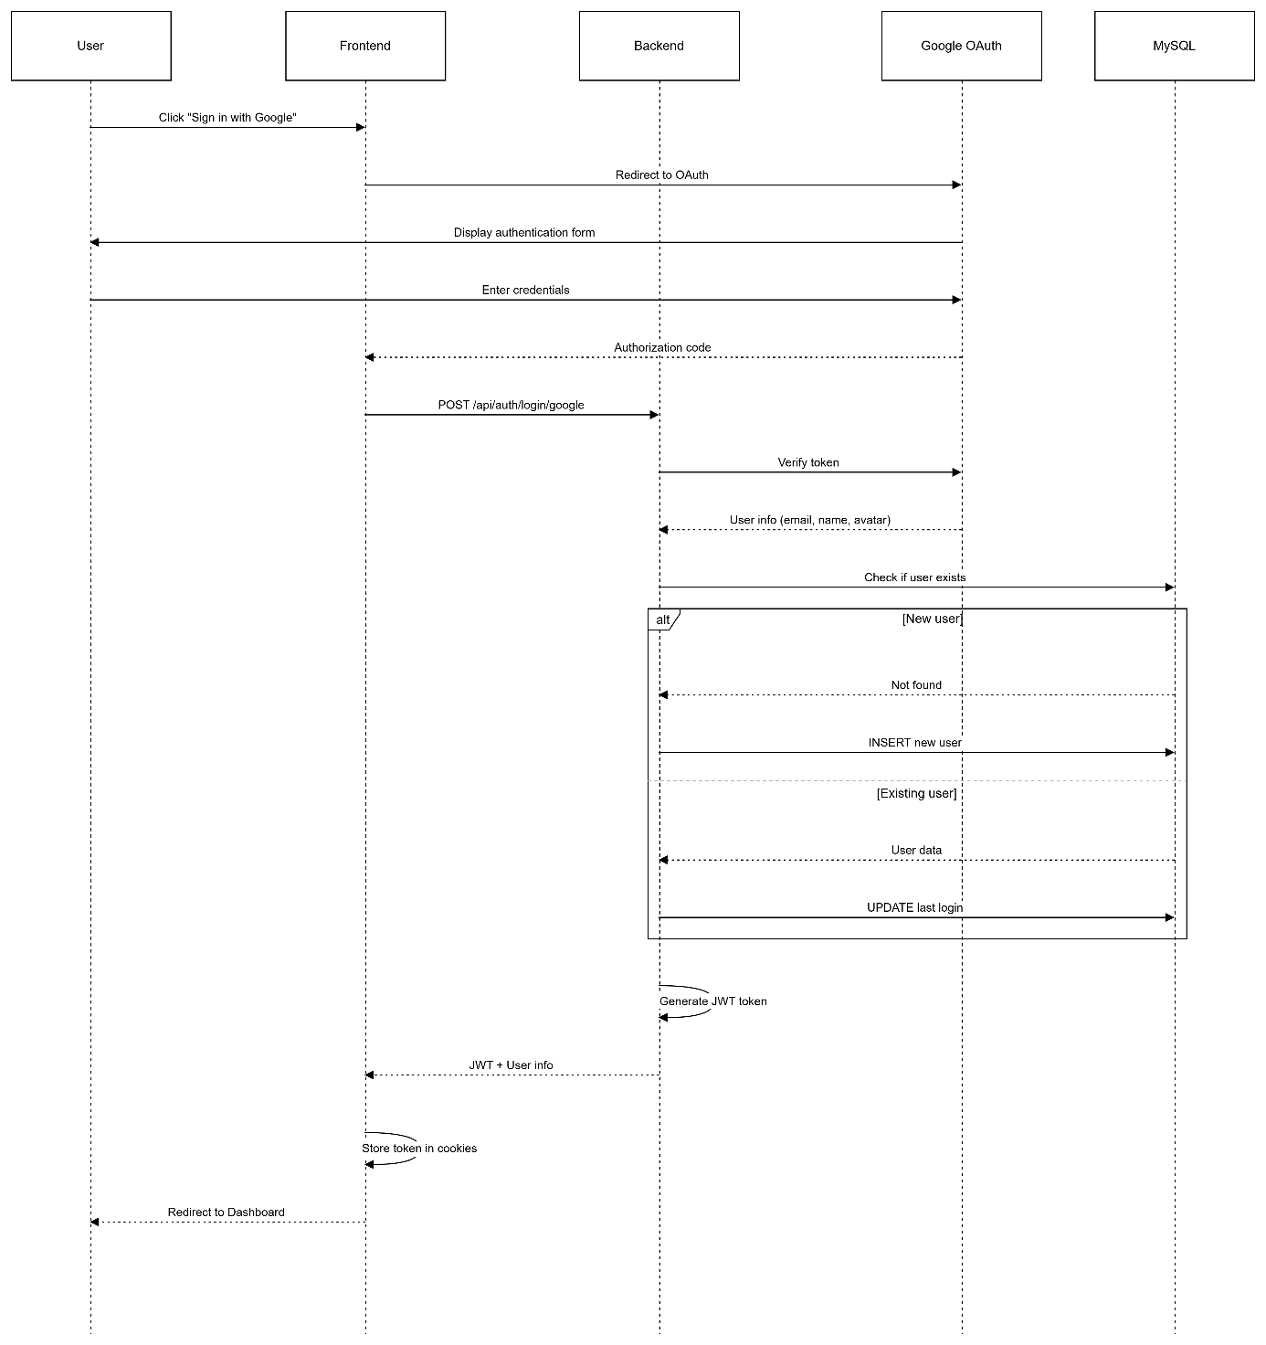
2.3.3.2.
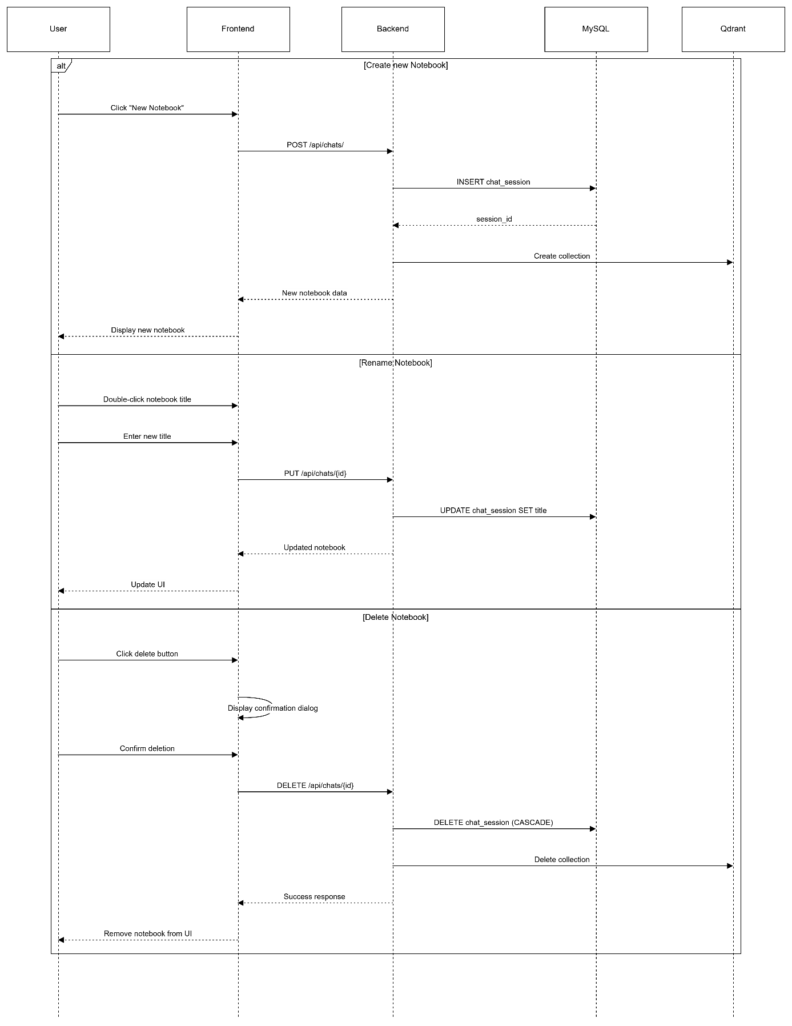
2.3.3.3.
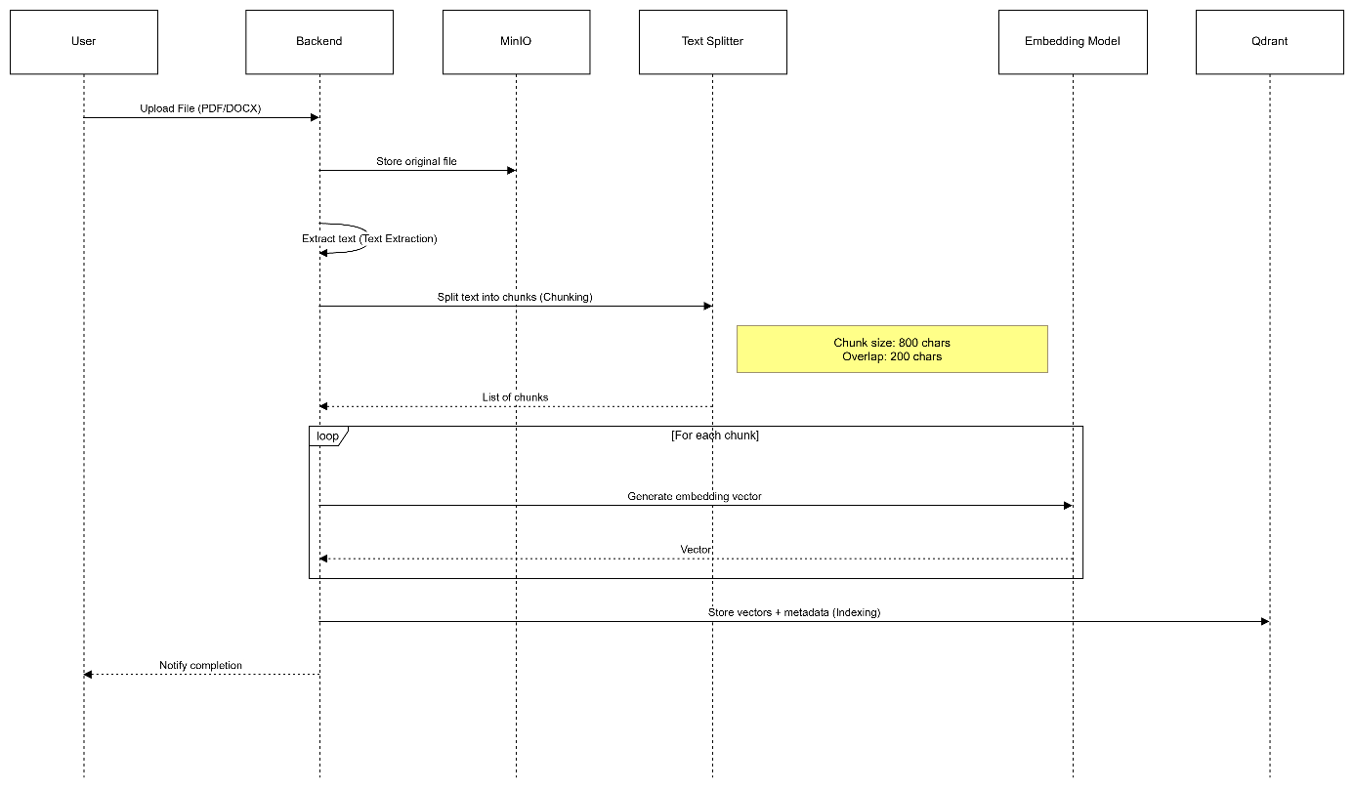
2.3.3.4.
2.3.3.5.
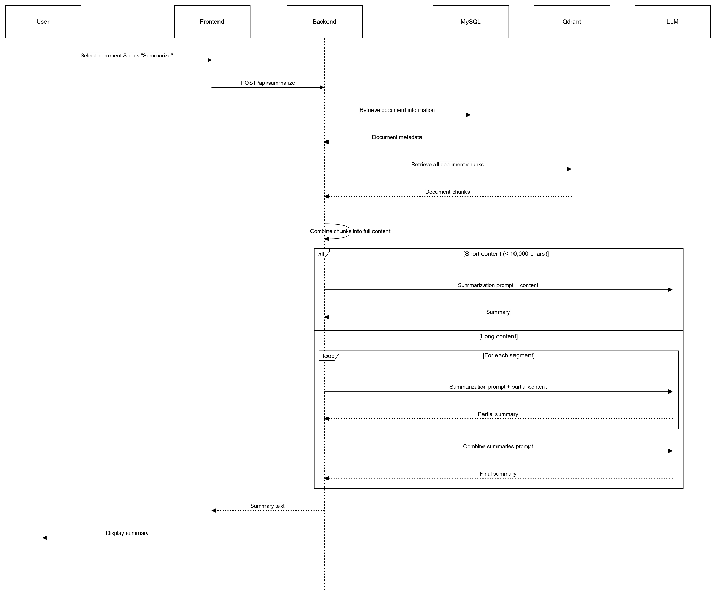
2.3.3.6.
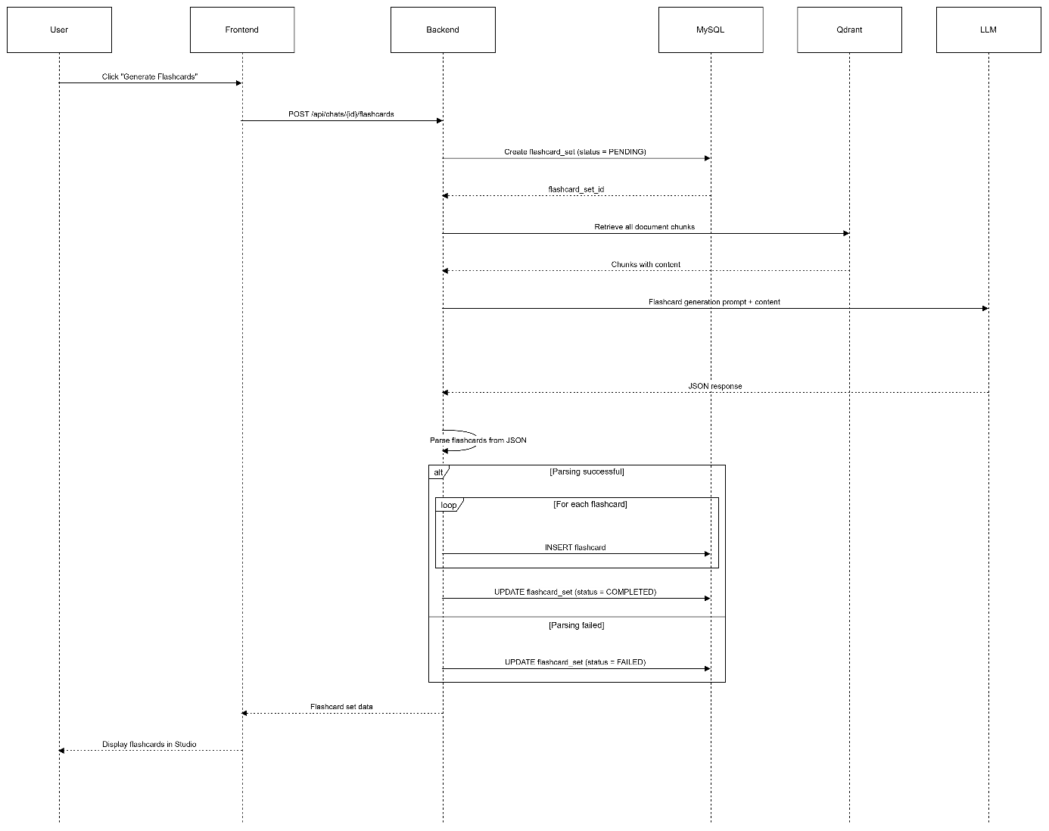
2.3.3.7.
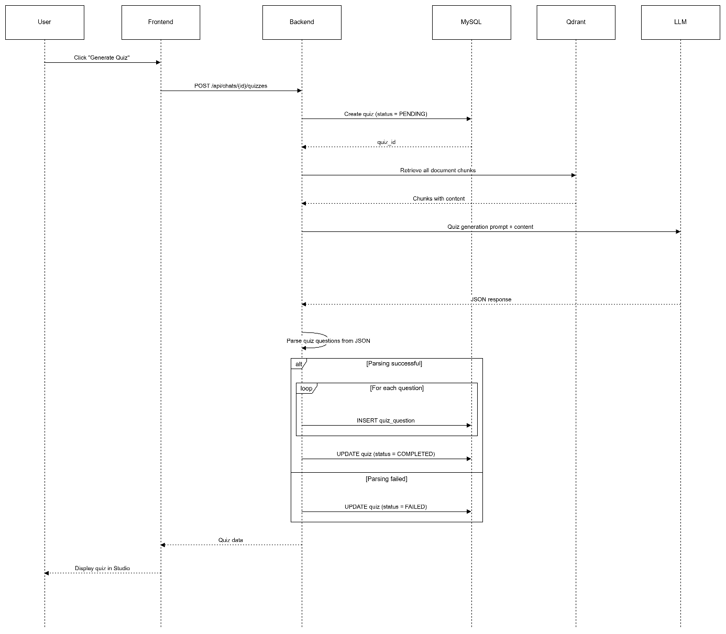

2.4. Database Design

2.4.1. Entity–Relationship Diagram (ERD)
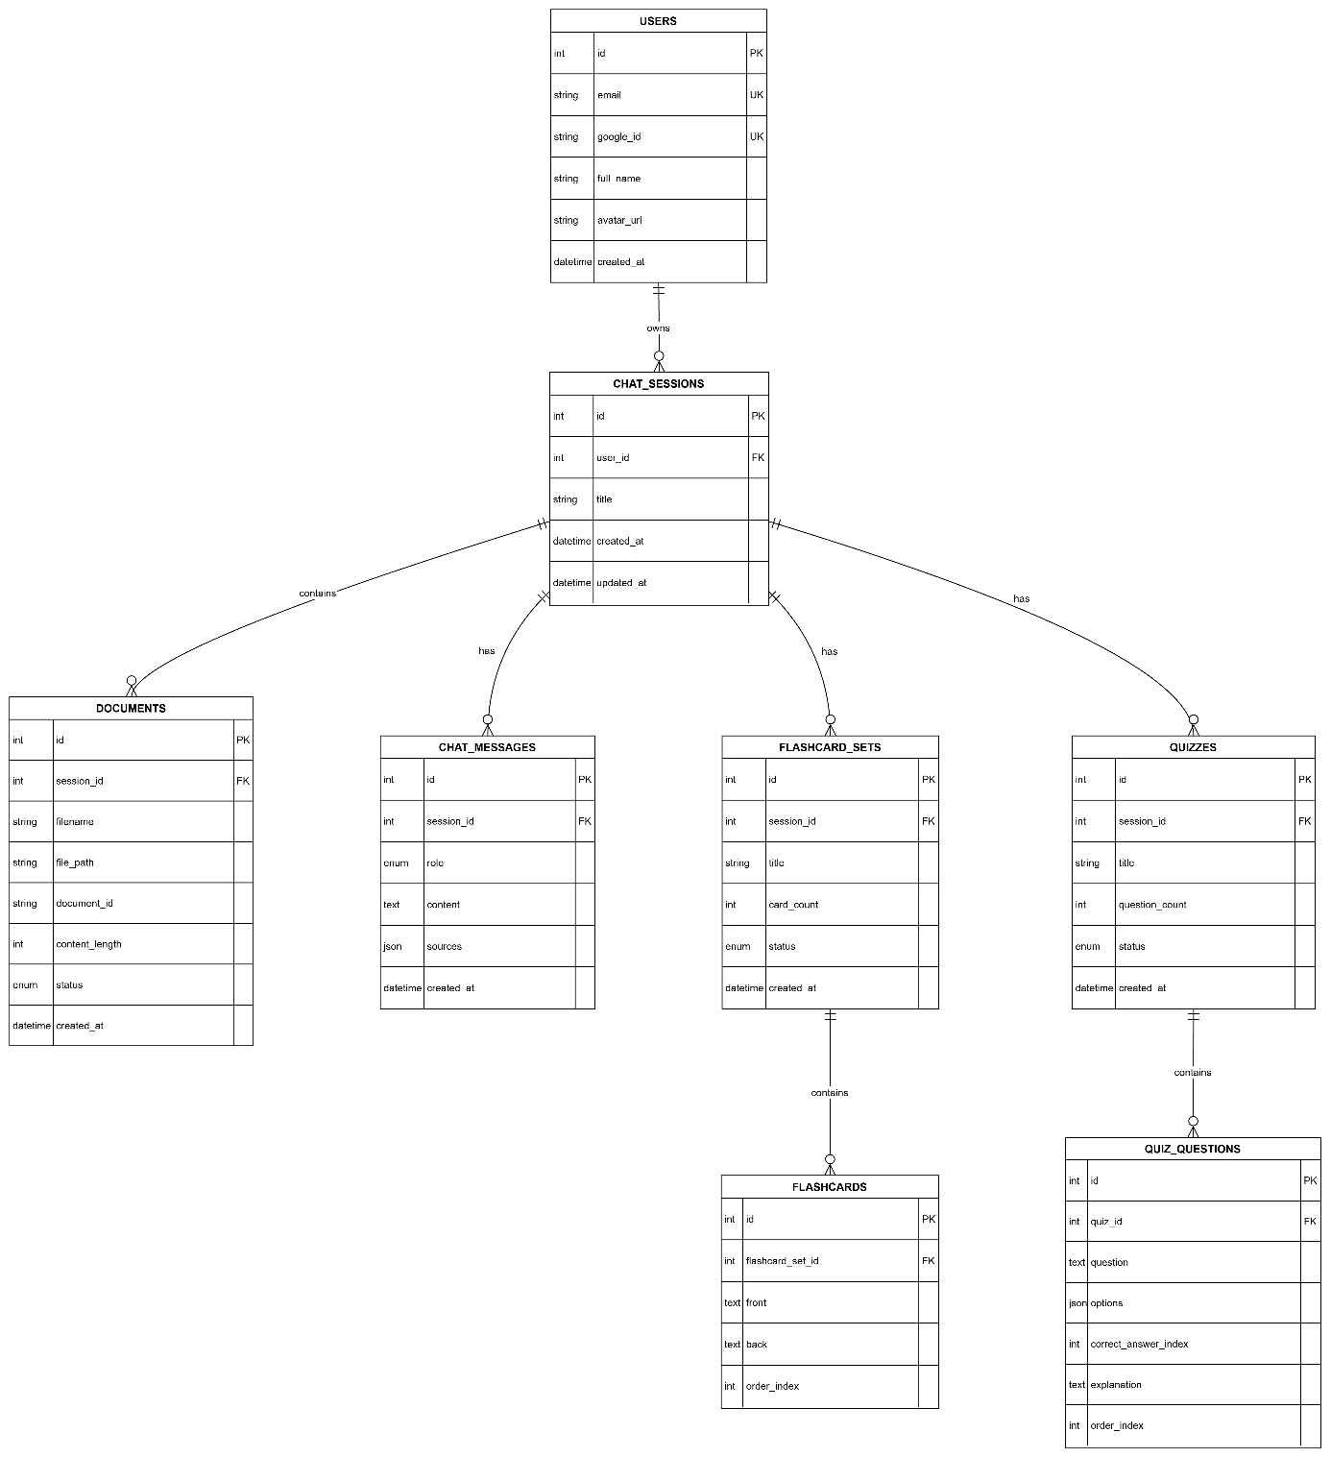

2.4.2. Data Dictionary
- users Table
Column Name | Data Type | Constraints | Description
id | INT | PK, AUTO_INCREMENT | Primary key
email | VARCHAR(255) | UNIQUE, NOT NULL | User email address
google_id | VARCHAR(255) | UNIQUE, NOT NULL | Identifier from Google OAuth
full_name | VARCHAR(255) | NOT NULL | Display name
avatar_url | VARCHAR(500) | NULLABLE | Profile image URL
created_at | DATETIME | DEFAULT NOW() | Account creation timestamp

- chat_sessions Table (Notebook / Working Session)
Column Name | Data Type | Constraints | Description
id | INT | PK, AUTO_INCREMENT | Primary key
user_id | INT | FK → users(id) | Reference to the user
title | VARCHAR(255) | NOT NULL | Notebook title
created_at | DATETIME | DEFAULT NOW() | Creation timestamp
updated_at | DATETIME | ON UPDATE NOW() | Last update timestamp

- documents Table
Column Name | Data Type | Constraints | Description
id | INT | PK, AUTO_INCREMENT | Primary key
session_id | INT | FK → chat_sessions(id) | Reference to the notebook
filename | VARCHAR(255) | NOT NULL | Original file name
file_path | VARCHAR(500) | NOT NULL | Storage path in MinIO
document_id | VARCHAR(36) | UNIQUE | UUID for mapping with Qdrant
content_length | INT | NULLABLE | Content length (characters)
status | ENUM | NOT NULL | Processing status: PENDING, INDEXED, FAILED
created_at | DATETIME | DEFAULT NOW() | Upload timestamp

- chat_messages Table
Column Name | Data Type | Constraints | Description
id | INT | PK, AUTO_INCREMENT | Primary key
session_id | INT | FK → chat_sessions(id) | Reference to the notebook
role | ENUM | NOT NULL | Message role: user or ai
content | TEXT | NOT NULL | Message content
sources | JSON | NULLABLE | Source citations (for AI responses)
created_at | DATETIME | DEFAULT NOW() | Message timestamp

- flashcard_sets Table
Column Name | Data Type | Constraints | Description
id | INT | PK, AUTO_INCREMENT | Primary key
session_id | INT | FK → chat_sessions(id) | Reference to the notebook
title | VARCHAR(255) | NOT NULL | Flashcard set title
card_count | INT | DEFAULT 0 | Number of flashcards
status | ENUM | NOT NULL | Status: PENDING, COMPLETED, FAILED
created_at | DATETIME | DEFAULT NOW() | Creation timestamp

- flashcards Table
Column Name | Data Type | Constraints | Description
id | INT | PK, AUTO_INCREMENT | Primary key
flashcard_set_id | INT | FK → flashcard_sets(id) | Reference to flashcard set
front | TEXT | NOT NULL | Front side (question)
back | TEXT | NOT NULL | Back side (answer)
order_index | INT | DEFAULT 0 | Display order

- quizzes Table
Column Name | Data Type | Constraints | Description
id | INT | PK, AUTO_INCREMENT | Primary key
session_id | INT | FK → chat_sessions(id) | Reference to the notebook
title | VARCHAR(255) | NOT NULL | Quiz title
question_count | INT | DEFAULT 0 | Number of questions
status | ENUM | NOT NULL | Status: PENDING, COMPLETED, FAILED
created_at | DATETIME | DEFAULT NOW() | Creation timestamp

- quiz_questions Table
Column Name | Data Type | Constraints | Description
id | INT | PK, AUTO_INCREMENT | Primary key
quiz_id | INT | FK → quizzes(id) | Reference to the quiz
question | TEXT | NOT NULL | Question content
options | JSON | NOT NULL | List of answer options (array of strings)
correct_answer_index | INT | NOT NULL | Index of the correct answer (0-based)
explanation | TEXT | NULLABLE | Answer explanation
order_index | INT | DEFAULT 0 | Display order

2.5. API Design
The backend provides a set of RESTful APIs built on the FastAPI framework.
2.5.1. Authentication Group
[POST] /api/auth/login/google: Authenticate users and issue a JWT token.
[GET] /api/users/me: Retrieve the current user’s profile information.
2.5.2. Chat & Notebook Group
[GET] /api/chats/: Retrieve a paginated list of notebooks.
[POST] /api/chats/: Create a new notebook.
[POST] /api/chats/{id}/messages: Send a chat message.
2.5.3. Document Group
[POST] /api/chats/{id}/files: Upload a document file.
[GET] /api/chats/{id}/documents: Retrieve the list of documents within a notebook.
[POST] /api/summarize: Invoke the document summarization functionality.
2.5.4. Studio Group (Flashcards & Quizzes)
[POST] /api/chats/{id}/flashcards: Request flashcard generation.
[POST] /api/chats/{id}/quizzes: Request quiz generation.
[GET] /api/chats/{id}/studio-items: Retrieve the aggregated list of generated study resources.

2.5. Thiết kế hệ thống

2.3.1. Thiết kế giao diện
- Trang đăng nhập

Hình 2. Thiết kế trang đăng nhập
- Trang chủ

Hình 3. Thiết kế trang chủ
- Trang chat

Hình 4. Thiết kế trang chat
- Trang danh sách món ăn đã thích

Hình 5. Thiết kế trang danh sách món ăn đã thích
- Trang chi tiết món ăn

Hình 6. Thiết kế trang chi tiết món ăn

2.3.2. Thiết kế cơ sở dữ liệu

Tên trường | Kiểu dữ liệu | Ràng buộc | Ghi chú
avatar | varchar(255)
detail | text
id | int | PRI | Khóa chính
name | varchar(255)
qr_code | varchar(255)
Bảng 14. Chi tiết bảng Charity
Tên trường | Kiểu dữ liệu | Ràng buộc | Ghi chú
avatar | varchar(255)
charityId | int | MUL | Khóa ngoại
code | varchar(255)
descriptions | text
donateCount | int
id | int | PRI | Khóa chính
name | varchar(255)
target | int
total | int
Bảng 15. Chi tiết bảng Program
Tên trường | Kiểu dữ liệu | Ràng buộc | Ghi chú
code | varchar(255) | UNI
id | int | PRI
name | varchar(255)
programId | int | MUL
Bảng 16. Chi tiết bảng Users

2.6. Summary
In this chapter, we have an overview of the system, diagrams, plans to build features for the website.

Chapter 3. IMPLEMENTATION & BUILDING SYSTEM

3.1. Cơ sở dữ liệu
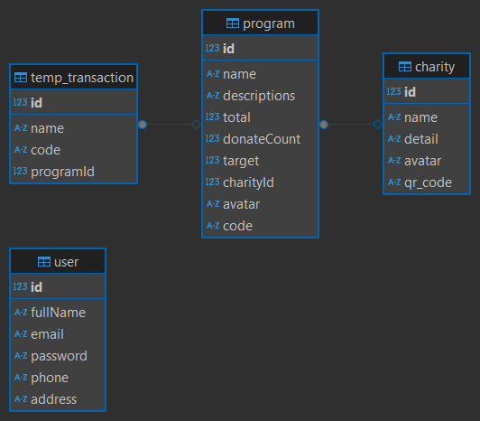
Hình 15. Cơ sở dữ liệu

3.2. Website

3.2.1. Trang đăng nhập
Trang đăng nhập gồm có chữ ĐĂNG NHẬP, ô nhập email, ô nhập mật khẩu, nút đăng nhập và chữ đăng ký nhỏ để người dùng có thể chuyển sang trang đăng ký nếu muốn đăng ký tài khoản.
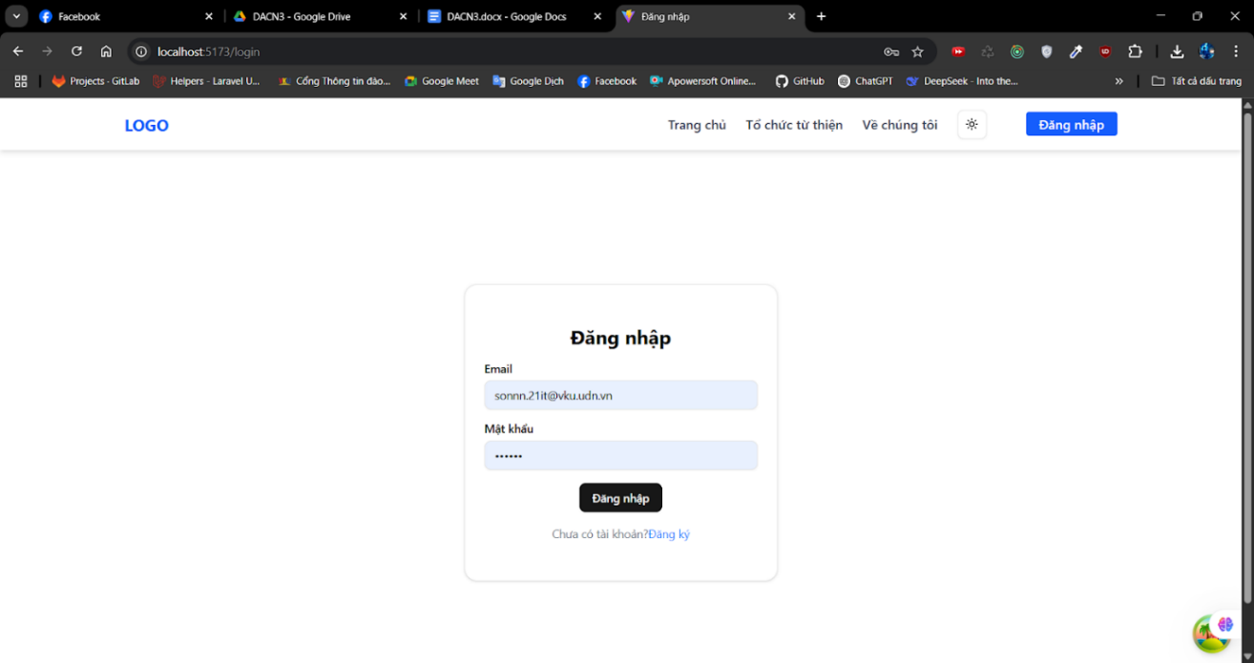
Hình 16. Trang đăng nhập

3.3.2. Trang chủ
- Trang chủ gồm có:
- Phần đầu trang gồm có logo trang web, thanh điều hướng và nút đăng nhập.
- Phần thân trang gồm có danh sách các chương trình từ thiện.
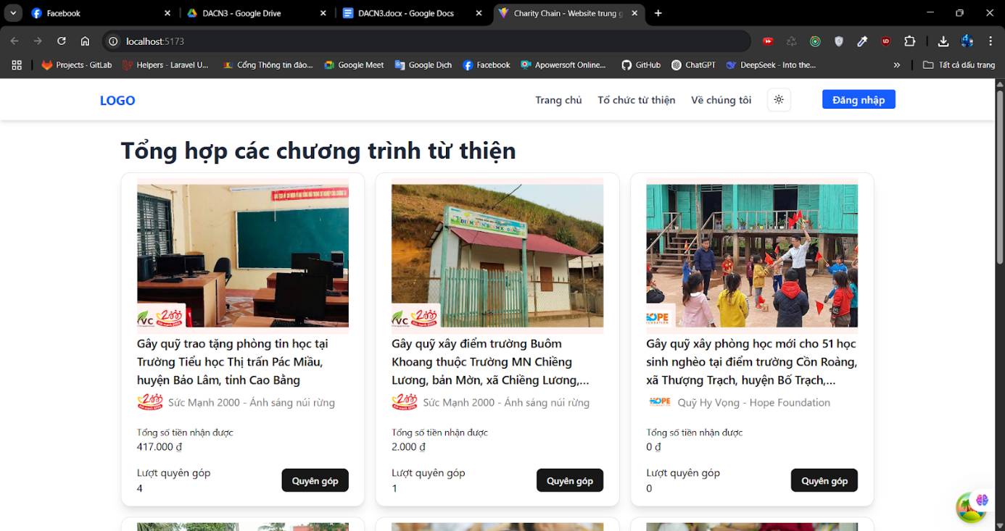
Hình 17. Trang chủ

3.3.3. Trang danh sách tổ chức từ thiện
- Trang danh sách tổ chức từ thiện gồm có:
- Phần đầu trang gồm có logo trang web, thanh điều hướng và nút đăng nhập.
- Phần thân trang gồm có danh sách các tổ chức từ thiện.
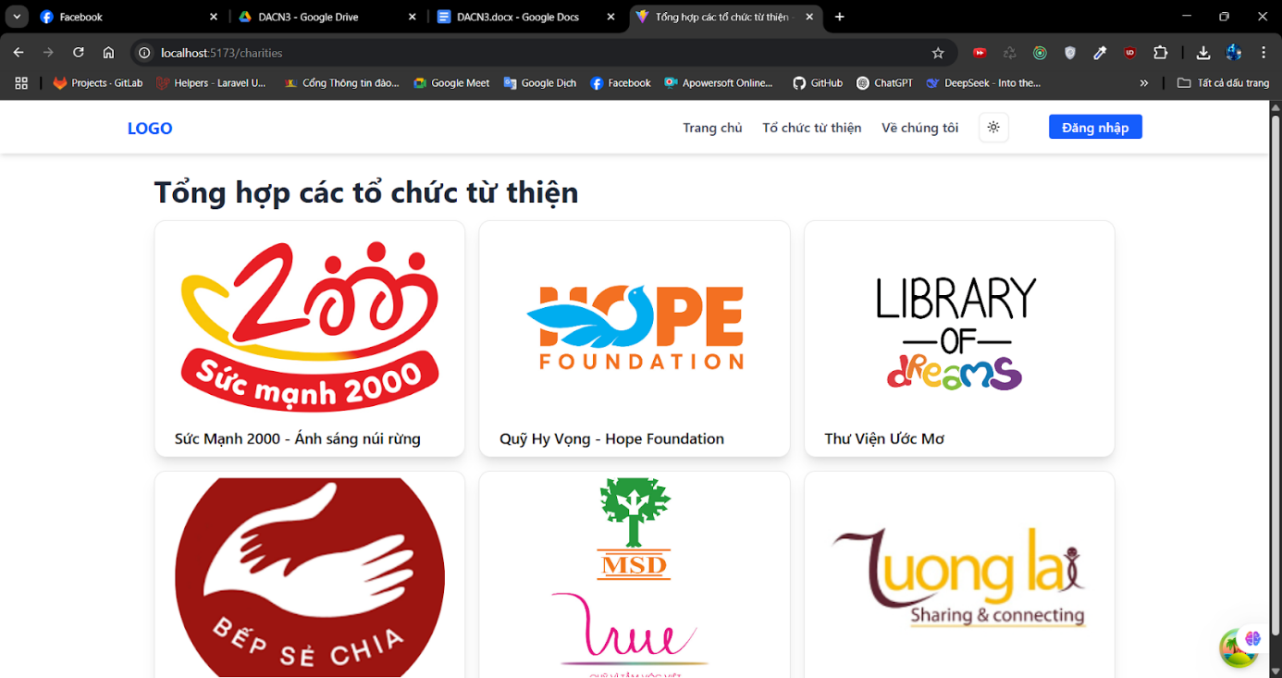
Hình 18. Trang danh sách tổ chức từ thiện

3.3.4. Trang về chúng tôi
- Trang về chúng tôi gồm có:
- Phần đầu trang gồm có logo trang web, thanh điều hướng và nút đăng nhập.
- Phần thân trang gồm có thông tin về website.
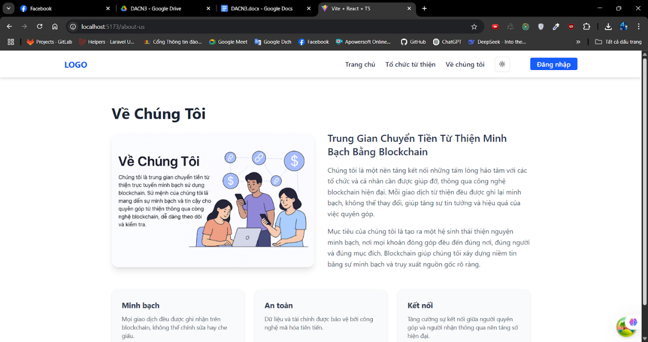
Hình 19. Trang về chúng tôi

3.3.5. Trang chi tiết chương trình từ thiện
- Trang chi tiết chương trình từ thiện gồm có:
- Phần đầu trang gồm có logo trang web, thanh điều hướng và nút đăng nhập.
- Phần thân trang gồm có tên chương trình, ảnh đại diện, câu chuyện, thông tin quyên góp và nút quyên góp.

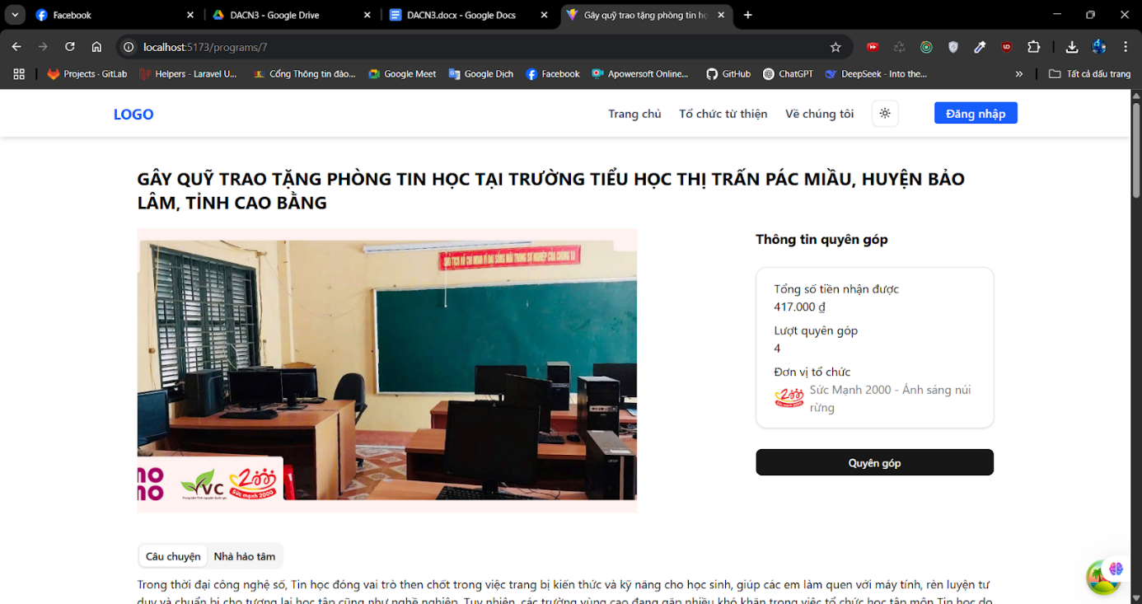
Hình 20. Trang chi tiết chương trình từ thiện

KẾT LUẬN

1. Những kết quả đạt được
- Quản lý tổ chức từ thiện
  - Website cho phép đăng ký, xác thực và quản lý nhiều tổ chức từ thiện khác nhau.
  - Mỗi tổ chức có trang thông tin riêng, bao gồm: Tên, mô tả tổ chức, lịch sử hoạt động và các chương trình đang thực hiện.
  - Người dùng có thể dễ dàng tìm kiếm, theo dõi và lựa chọn tổ chức phù hợp để đóng góp.
- Quản lý các chương trình từ thiện
  - Mỗi tổ chức có thể tạo nhiều chương trình từ thiện khác nhau: hỗ trợ người nghèo, cứu trợ thiên tai, học bổng, y tế,...
  - Thông tin từng chương trình được trình bày rõ ràng: mục tiêu, thời gian, số tiền cần huy động và tiến độ thực hiện.
- Tích hợp blockchain để minh bạch hóa giao dịch
  - Mọi khoản quyên góp đều được ghi nhận lên blockchain.
  - Người dùng có thể theo dõi lịch sử đóng góp công khai, không thể chỉnh sửa.
  - Mỗi giao dịch đều có mã xác minh và liên kết tới block explorer, giúp kiểm tra minh bạch tuyệt đối.
- Giao diện thân thiện, dễ sử dụng
  - Website được thiết kế tối giản, phù hợp với cả người dùng phổ thông.

2. Hạn chế
- Chưa có tự động hóa phân phối tiền từ thiện.
- Chưa có hệ thống đánh giá và xếp hạng tổ chức.

3. Hướng phát triển
Dựa trên những hạn chế hiện tại, hướng phát triển của dự án bao gồm:
- Tự động hóa phân phối tiền từ thiện
  - Thiết lập các smart contract (hợp đồng thông minh) để tự động giải ngân khi chương trình đạt đủ điều kiện (ví dụ: đủ số tiền hoặc đến hạn).
  - Giảm thiểu sự can thiệp thủ công, đảm bảo minh bạch và đúng cam kết.
- Hệ thống đánh giá và xếp hạng tổ chức
  - Cho phép người dùng đánh giá mức độ tin cậy và hiệu quả của các tổ chức từ thiện sau khi tham gia hoặc theo dõi chương trình.
  - Tạo bảng xếp hạng minh bạch để người mới có cơ sở lựa chọn.

TÀI LIỆU THAM KHẢO

[1] Node.js. (2021, August 11). In Wikipedia. https://vi.wikipedia.org/wiki/Node.js.
[2] Express.js. (2010, November 16). In Wikipedia. https://en.wikipedia.org/wiki/Express.js.
[3] React. (2013, May 29). In Wikipedia. https://vi.wikipedia.org/wiki/React.
[4] Blockchain. (2025, February 25). In Wikipedia. https://vi.wikipedia.org/wiki/Blockchain.

https://en.wikipedia.org/wiki/Large_language_model
https://en.wikipedia.org/wiki/FAISS

