HW1-3

* How to run the program?

Install TensorFlow & Keras

$ python hw1_2-4-3-1.py # for hw1-3-1

$ python hw1_2-8-6-2.py # for hw1-3-3

Dataset plot:

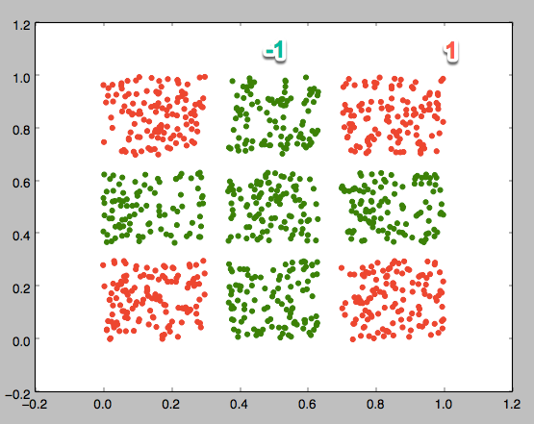

1. 2-4-3-1

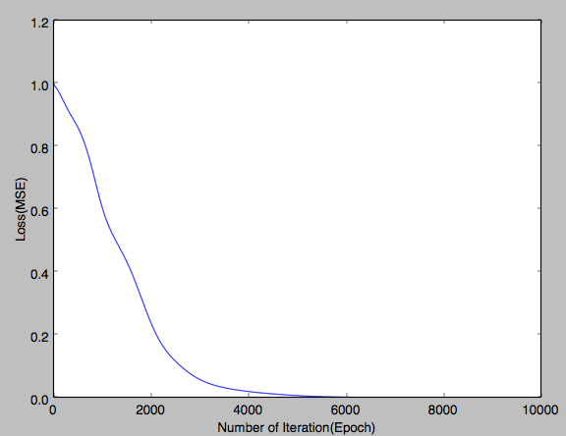

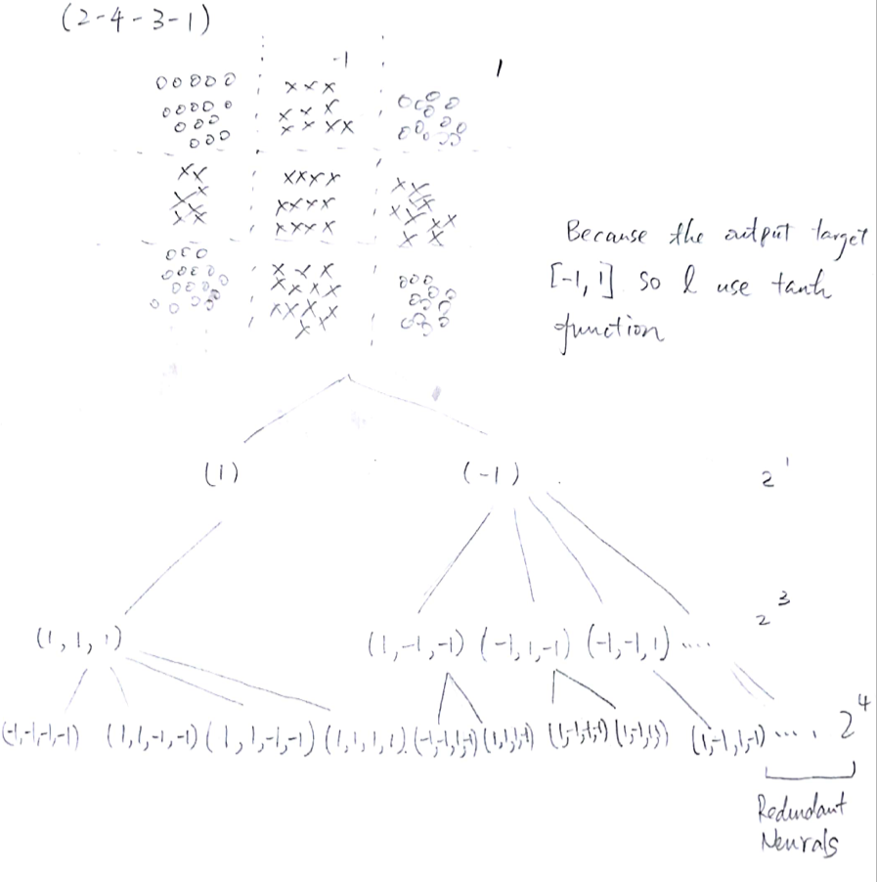

1. 2-8-6-1

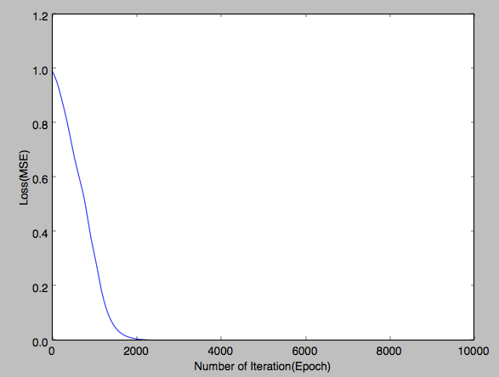

2-8-6-1 learns faster than 2-4-3-1, with fewer iterations got better loss value.

There’re more redundant neural in 2-8-6-1, but it is stronger.